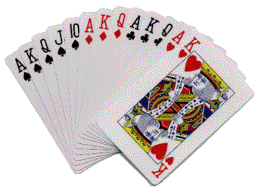
♠ ♥ ♦ ♣
BRIGHT LEAF UNIT 191
2023-2024 MENTORING PROGRAM ꟷ Mentee Sign-Up Form
NAME (Please Print) ____________________________________ DATE _____________
EMAIL ______________________ PHONE ______________ BBO Name ___________
How many ACBL Master Points do you have? _________________
Playing Time Preference: ___ Daytime (face-to-face) ___ Evening (online) ___ Both
What is your general approach to bidding?
___ Standard American ___ Two over One ___ Other (Please state) ___________________
Please know that mentors are really interested in helping mentees learn more about this wonderful game. They put time and effort in addition to their store of knowledge to do this.
Each person has her or his own valid reasons for participating in the program. To facilitate matching a mentor with your level of interest, please respond to the following questions:
What do you hope to gain/learn from this coming year’s program? (Check as appropriate)
- I would like to learn more so I can have fun at social bridge (no interest in tournament play). _____
- I enjoy competitive bridge but am not interested in serious competition at this time. _____
- I want to progress in competitive bridge but prefer to learn by playing & classes. _____
- I want to progress and am willing to put some time (not a lot) into reviewing to learn. _____
- I enjoy studying & learning bridge and would like to become a good solid player eventually. _____
- I (describe your personal goal) ________________________________________________________
- I would like to learn more about bidding. ______ IF checked, specifically:
O Basic bidding _____
O Conventions _____ Please list 1-3 conventions you are interested in learning:
___________________________________________________________________________
___________________________________________________________________________
___________________________________________________________________________
O Others
___________________________________________________________________________
• I would like to learn more about play of the hand. _____
• I would like to learn more about defense. _____
• I would like to learn more about how to think during the game. _____
• Any further comments about what you’d hope to gain this year:
______________________________________________________________________________
Please place this completed form in the Mentoring Program Folder at Triangle Bridge Academy or email it to <brightleaf.mentee@gmail.com>.
Mentoring Program Committee
Michael Lavine, Beverly Craig, Ed Fuller, & Maggie Lindquist Barbara Butte, Board Liaison

