PLAYING AT YOUR VIRTUAL CLUB
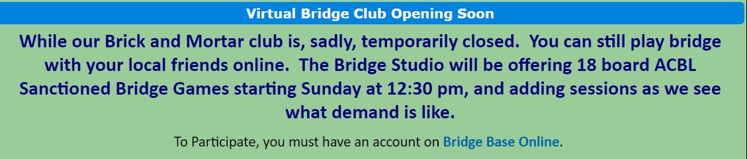
YOU HAVE REGISTERED WITH BBO AND NOW WANT TO PLAY IN A VIRTUAL TOURNAMENT SPONSORED BY YOUR LOCAL CLUB. HERE’S WHAT YOU DO.

- SIGN IN TO BBO
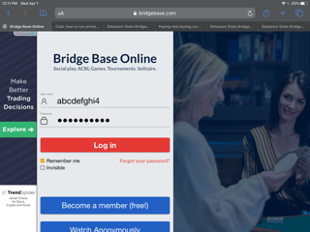
- ON THE NEXT SCREEN SELECT “COMPETITIVE”
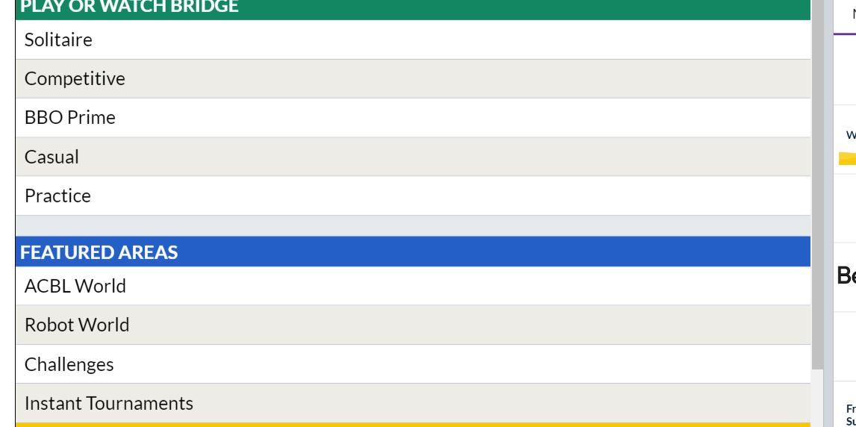

- NOW SELECT “ACBL VIRTUAL CLUBS”
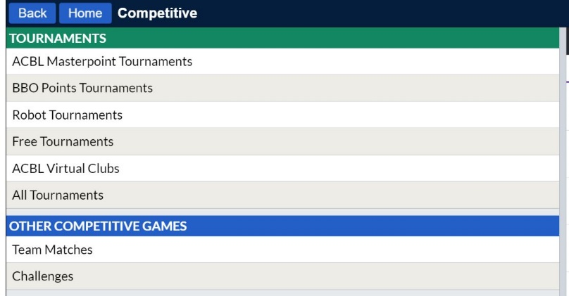
- FIND YOUR CLUB TOURNAMENT (BRIDGE STUDIO, VALLEY FORGE, UNIT 190 ETC) CHOICES WILL LOOK SOMETHING LIKE THIS. PLEASE NOTE: YOUR EVENT WILL BE POSTED 2 HOURS BEFORE SCHEDULED START; AND YOU NEED TO HAVE PURCHASED BBO$ IN ADVANCE TO REGISTER
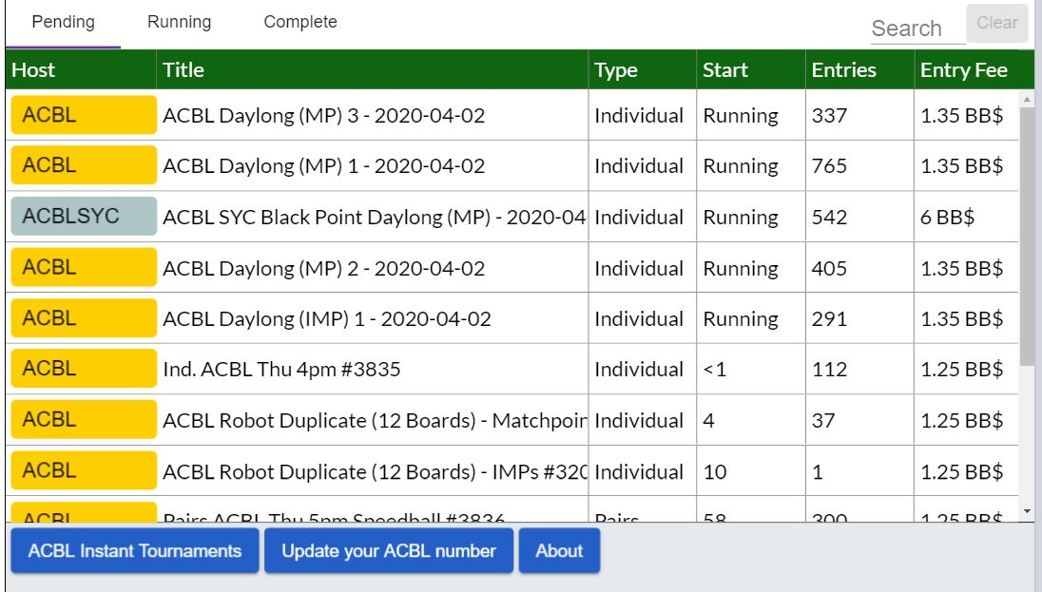
- HERE IS WHERE YOU REGISTER YOU AND PARTNER. BBO4 WILL AUTOMATICALLY BE DEDUCTED FROM YOUR ACCOUNT. ONCE REGISTERED YOU ARE FREE TO LEAVE, EVEN LOG OFF. BUT YOU MUST BE ON BBO 5 MINUTES BEFORE GAME TIME. WHEN THE GAME STARTS YOU WILL AUTOMATICALLY BE TAKEN TO YOUR SEAT.
