USING BBO HISTORY TAB
Maybe the best feature of BBO is the wealth of detailed data contained in your “History Tab”. On a PC it is a vertical tab all the way to the right
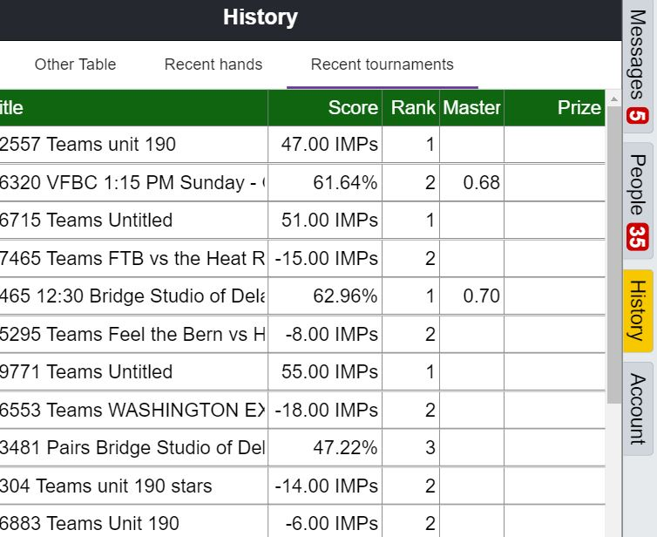
All of the team matches and tournaments you have participated in are listed with the most recent at the top. Click on any one. This is what you see
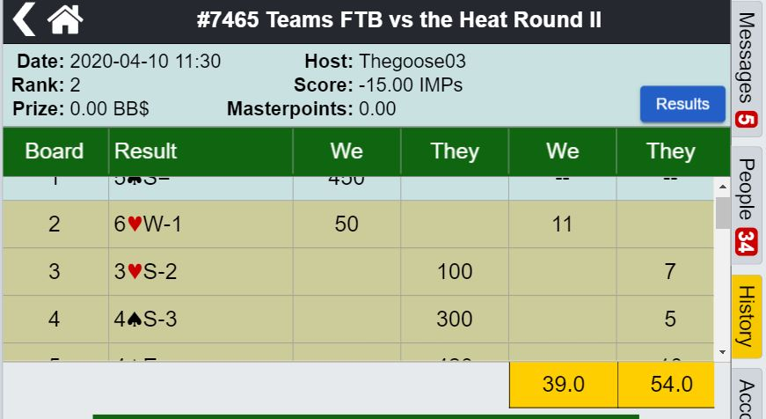
All the boards are listed with results and scores. Click on board 1 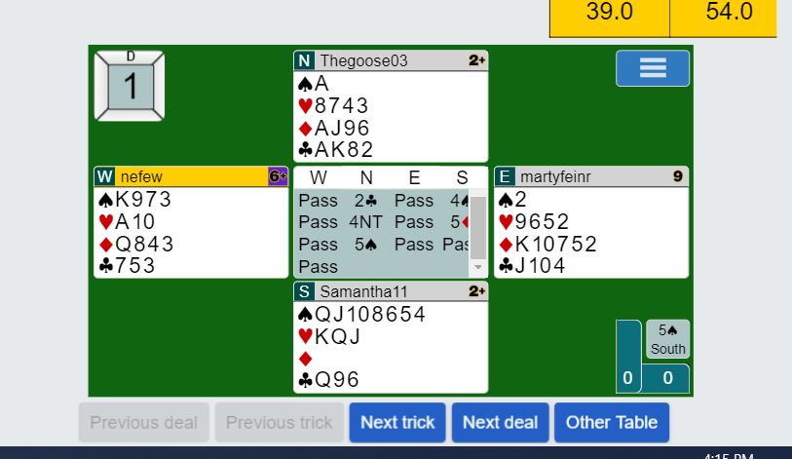
All hands, complete auction as it happened; note the blue tabs at the bottom.
Next trick: Replays the trick as it happened
Next deal: Moves to the next hand
Other table: Switches to the complete hand record at the other table

Select “Next Trick” This is trick 1, won by EW
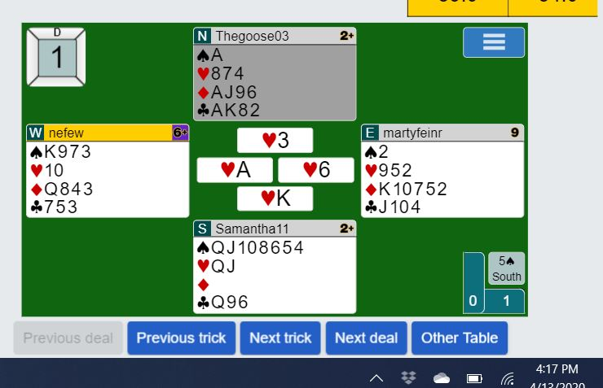
Its easy to review what happened trick by trick at the “OTHER TABLE”
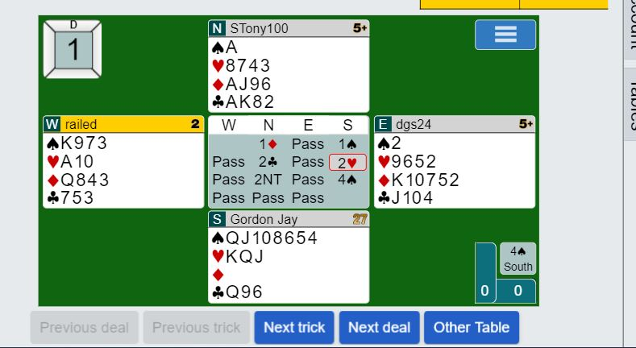
You want to know more! Check out the “Double Dummy” feature by clicking on the blue button with three horizontal lines
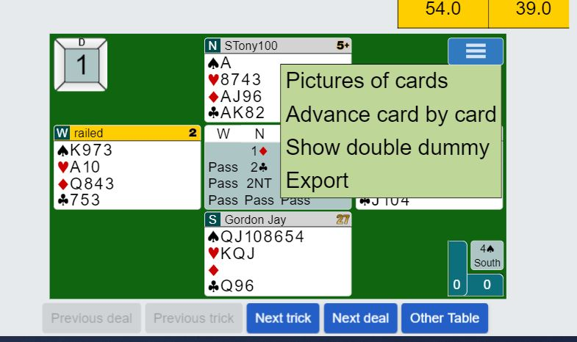

This takes a little description. Railed is on lead. No matter what he leads declarer can make one overtrick. If he is sill enough to lead the King of spades, declarer could make 2 overtricks
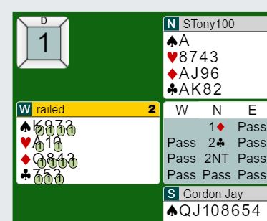
A few tricks later if South leads a high spade or club, declarer is still on track to make an overtrick. However leading the Queen of hearts is likely to result is one less trick for declarer.
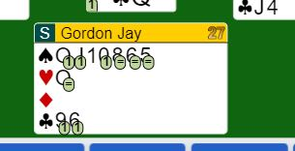
Finally if the ovals around the numbers are colored pinkish, the contract is likely to go down by the number in the oval.

Try it out, experiment. The software has even more to offer….. Its good for hours and hours of learning and finger-pointing.

