Summertown Bridge Club Bulletin No. 8

Long time no see. We self-isolated on 1 March, so we’ve been missing you all for a long time. Thank goodness for the amazing weather.
Valerie and I hope everyone is keeping safe. Let’s get down to business. Here’s a board to kick off with. Dealer West, nobody vulnerable, pairs. You and your partner are North/South:

Perhaps the bidding goes 1H-P-2H- or 1H-P-3H-. What do you bid as South? 3S or 4S.
Assuming South bids 4S and West passes or bids 5H, what does North bid? Pass, (Dbl), 5S?
At the club (Summertown Board 8, 18 November 2019), one pair was in 4S and eight in 5S. One pair played in 5H. Tony and Loris Lewis were the only pair to reach the excellent 6S for a 100% Top. This was Tony’s last visit to Summertown. A great memory.
Sherlock Holmes and The Case of the Intertwined Cs
As some of you know, Valerie runs an antiques business. Just before lockdown, she spotted this handbag in an auction.
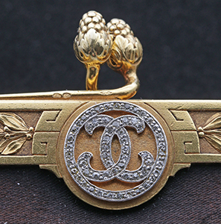
It is early 20th century French silk bag with a monogram engraved 1er Jun 1912. Valerie noticed the pattern below the clasp. The Chanel logo was first used (on a perfume bottle) in 1925. The story of the logo’s creation is a mystery. One theory is that Chanel came up with the logo following a visit to the Château de Crémat, a castle owned by her friend, the socialite Irene Bretz. The intertwined C symbol can be found in the Château in a set of beautiful stained glass windows. So what’s the story of the bag and its motif? We have no idea. Yet. Valerie bought the bag anyway in the hope that it might just have an interesting (and profitable) backstory!
Bridge tip
We’re not keen on playing online, but that doesn’t mean we ignore bridge. There are so many resources online, including articles from EBU magazines and Mr Bridge magazines.
[You might have to press Control (Command on Mac) and click to activate the links]
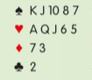
Here’s a change to our system that we are going to make when we return to action:
North opens 1D. What do you bid as East in 2nd eat?
We’d bid 2D – Michaels, showing 5+/5+ in the majors. We’d be wrong. Michaels (and Ghestem & the Unusual 2NT) should only be used with weak hands (5-10 HCP) or strong hands (16+ HCP).
Andrew Kambites explains all: Part 1, Part 2, Part 3
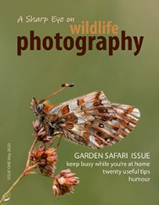
Photography tips
Like most people, we’ve had holidays cancelled. We were supposed to be at La Scala in Milan on 4 March, so we studied developments in Italy very closely (hence our early lockdown).
My camera has been touring around our garden, but there are few rare species to be found. So I decided to produce a free magazine with a few tips for a garden safari. And some ‘groan animals’ humour. In case you wondered, my full name is Charles James Sharp Bentley!
Household tips
Valerie has spent hours in the garage hunting through boxes. She turned up a handwritten list of household and cooking tips written by her Grandma over 100 years ago. Here are two of them:
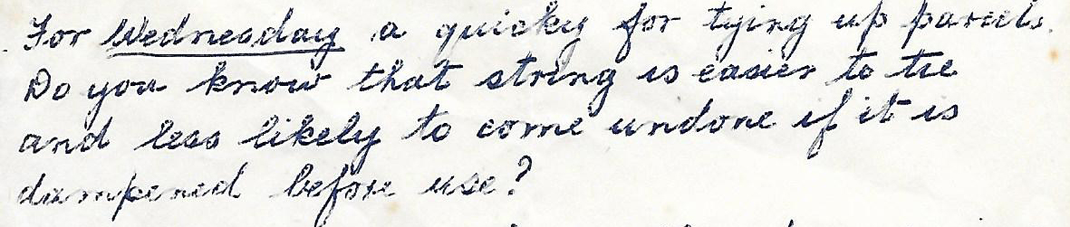
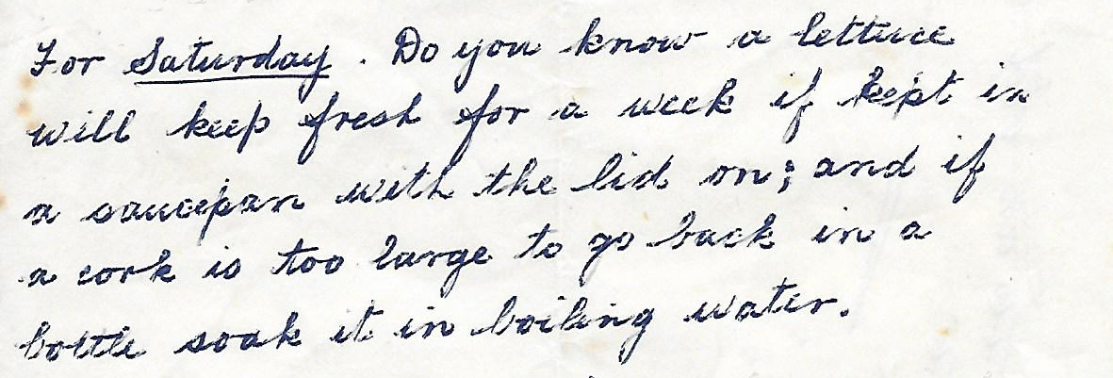
Cooking tip
We use the microwave for bacon. Four rashers of streaky bacon on two squares of kitchen roll. Put another square of kitchen roll on top on the bacon. Three minutes at 900w for the crispiest bacon ever.
Another bridge tip
Here is something we do now (playing weak NT). I can’t remember who recommended it to us, but the idea is in bridge writer Paul Mendelson’s books (though they are dated now). Hopefully you’ll have forgotten by the time we return to Summertown…

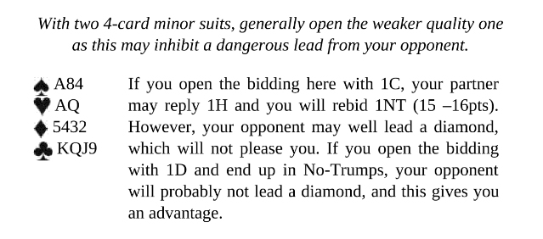
Shopping tip
Hopefully we’ll never need it, but we have just bought the Contec Pulse Oximeter model CMS50M from Amazon. It seems to work well.

Dangers of lockdown
As well as clearing on the garage and sorting out drawers that haven’t been examined in decades, Valerie’s been cleaning silver. Now she’s got RSI in her shoulder!

War stories
By the time you read this, we’ll have celebrated VE day. Valerie’s father was an RNVR Officer and was torpedoed, but he never talked about the war. My father was reticent too, but spent a lifetime at sea. A Merchant Navy Captain, he was an RNR Officer in the war. In 1941 he was Gunnery Officer on the battleship HMS Queen Elizabeth which was berthed in Alexandria in Egypt.

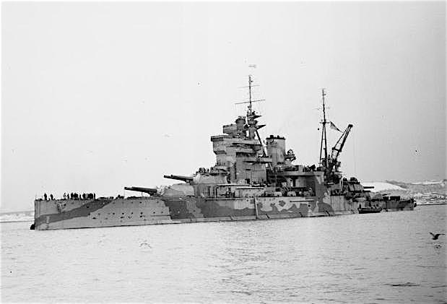 HMS Elizabeth

In December, the Italians attacked HMS Elizabeth (and her sister ship HMS Valiant) with human torpedoes. Nine sailors were killed on HMS Queen Elizabeth. The Italians were captured. The Royal Navy decided to pretend nothing had happened. The ship was holed below the line (vulnerable) and took on a lot of water, but she didn’t sink. The two battleships were patched up without the enemy knowing how successful they’d been.

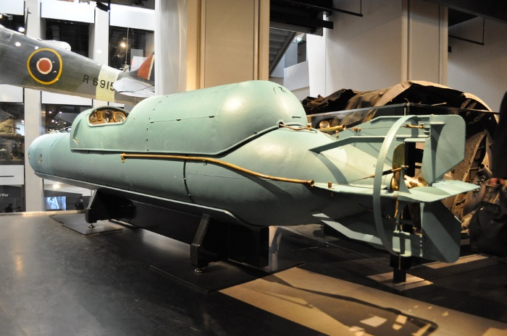 Italian human torpedo (Imperial War Museum)

HMS Queen Elizabeth was named after Queen Elizabeth I, as is the Royal Navy’s new aircraft carrier. Both vessels, like all ships, are designed with a large bridge room, colloquially known as ‘the bridge’. In early warship design there was one bridge, often on the port side. As ships got larger, they provided a second on the starboard side. This is known as the duplicate bridge. Both have excellent all-round views and access to outside space. The outside space is designed for wildlife enthusiasts. Large binoculars are provided and powerful lights for night viewing and spotting any predators. Photographers are well catered for. Alfred T. told me that he visited with 599 colleagues and found ‘Canon to right of them, and Canon to left of them’. There was no charge.

Stay Safe, James & Valerie

