Setting up a table on BBO (random hands).
I use a club BBO account BBOName to set up the tables. This is not essential but I prefer it. Why? Other club members can take turns help organise. Also, all club members are ‘friends’, (this will need updating for new players) so you know whose logged on. Invitations seem to expire after a couple of minutes (you can reinvite), so best to wait till the players are all online. Also this account has some BBO$ funded by the club which you will need if robot(s) are required eg for a half table.
Steps…
- Make sure all 4 players are all online. You must know their BBO account names.
- From the Home page under “Play or Watch Bridge” click “Casual”.
- Under “Find your own game” click “Start a table”.
- Change the scoring from IMPS to “Total points” using the drop down. This cannot be changed later!
- Arrange the slider bar options as below.
- Click “Start table - competitive game”.
- Click on the “North” seat then click “Reserve” and invite an experienced* player (BBO name) that you want to have the crown. Click “OK”. The invitation to the crown player will now be sent.
- Wait until they appear at the table. Currently you still have the crown even if you’re not seated, they (North) will inherit the crown when you leave the table.
- Invite the other 3 players “East, South & West” to their seats one by one by clicking on the vacant seats and “Reserve” them. Once all 4 players are present you should see the cards dealt so you can leave the table using the “Back” button. The crown will then be inherited by North (step 7).
- If required, repeat steps 3 to 9 for another table.
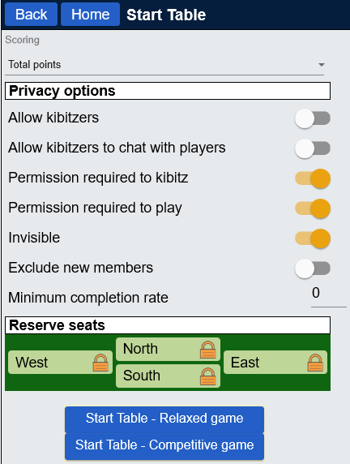
* Experienced with BBO.
The crown. When you ‘start a table’ you are the ‘host’ (ie you have the crown). This gives you control of who can play at your table. If the host leaves the table the crown is inherited in order of player invitation. Thus, inviting an experienced BBO player first is important in case others lose connection. The host with the crown is responsible for inviting players back. They won’t be able to find the table if it’s invisible. I send out the steps to do this every week with the table setup.

