Overview of the procedure to organise multiple casual tables on BBO.
First realize that this is not duplicate. Players can play as many hands (I recommend 18) as your club suggests but nobody moves seat. There are advantages! It’s free and there is no hand time limit ..…. this is casual remember!
- Review and edit the 2 documents JoinBBO* and TableSetupRandomHands. You’ll need to change everything in RED. So, decide when and how many sessions to play per week.
* I really recommend both youtube videos. They visually explain a lot about BBO and how it works.
- Email out the JoinBBO document to all members (and new enquiries) who might be interested. I suggest you use a club email address and not your own private email. If you can convert (export) it to a PDF doc first.

- As soon as you get play requests (which should be for a partnership). Reply to both players with something like….
You are now both registered to play on ?????day dd/mm/yy.
I will email you the table setup by noon tomorrow.
Regards.
Club BBO Organiser.

- I organise the tables in an excel spread sheet about 3 hours before the start. I email this to all players at least 2 hours before the start with the following example text….
Below is the Table set up for Wednesday 3/6/20.
Please login to BBO at least 5 mins before your start time. With a smooth setup you might start early if everyone's logged on. Also note that if you are in the crown seat (or you inherit it) you will need to invite other players back to the table if they lose connection. After a few moments to allow them to log back on...
- Click on the empty seat label.
- Select "Reserve"
- Enter their BBO name.
- Click OK and they should reappear.
Club BBO Organiser

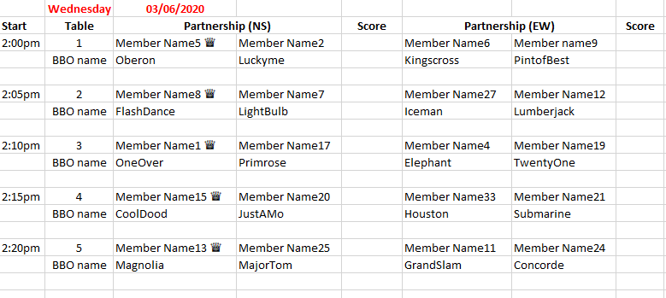
- 10 mins before start time logon to BBO (club account) and follow the steps in the TableSetUpRandomHands doc.
- If/when players have emailed in their scores, I enter the scores above resend to the players.
- To make life a little more interesting I have an excel macro (computer program) that calculates a club league table based on the best 3 scores from the most recent 6. This stops complaints from those who (apparently) have poor cards. I am happy to provide this to anyone on request.
- Finally, be aware that those using tablets have a slightly different user interface (BBO display) from those using a windows or mac laptop/pc. This can make it very confusing when trying to guide some-one over the phone!

