Set up a table on BBO (viewgraph hands).
This has not been tested but it is an interesting idea (all tables play the same hands). Similar to the procedure with random hands but with the following steps…
- Make sure all 4 players are all online. You must know their BBO account names.
- From the Home page under “Play or Watch Bridge” click “Casual”.
- Under “Find your own game” click “Start a table”.
- Make sure the scoring is IMPS. This cannot be changed later!
- Arrange the slider bar options as above.
- Click “Start table - competitive game”.
- Click on the “North” seat then click “Reserve” and invite the player (BBO name) you want to have the crown. The invitation to the crown player will now be sent.
- Click on the “3 white bars” to reveal the table menu. Figure 1.
- Click “Deal source” then click “Select a specific Vugraph”. Figure 2.
- Click “Get matches”. Figure 2.
- Pick a match (at least ?? boards). Make it the same for each table but different from any previous session. Note the match name and the date. Click “OK”. You might see the 1st deal.
- Currently you still have the crown, North will not inherit the crown until you leave the table.
- After North has arrived at the table invite the other 3 players one by one by clicking on the vacant seats “East, South & West”. Once all 4 players are present leave the table using the “Back” button. The crown will be inherited by North (step 7).
- If required, repeat steps 3 to 13 for another table (using the same Vugraph match).
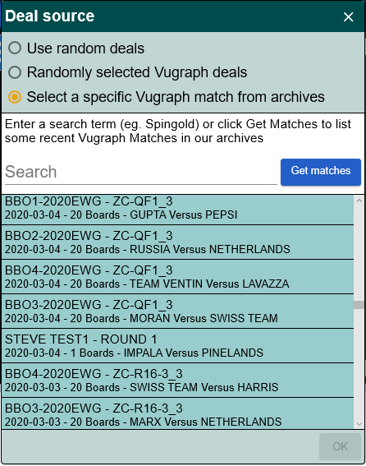
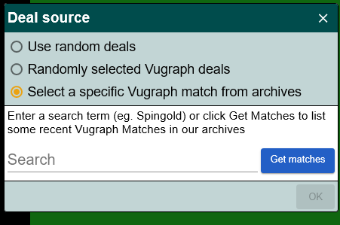
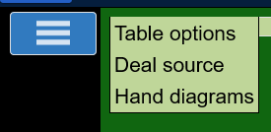
Figure 1 : Deal source.
Figure 2 : Select Vugraph.

Figure 3 : Pick a match.

