Sedona Bridge Center History
Sedona Bridge Center History
Sedona Bridge History – 2026

Sedona Bridge History – 2025
Sedona Bridge Center (SBC) continues to play at The Jewish Community Center.
Ron Mohney became president in April 2025
Sedona Bridge History – 2024
SBC continues to play at The Jewish Community Center.
Proof of COVID vaccinations is no longer required.
Jackie Haugan retired as president on August 20.
Carolyn Blecha became president on September 17.
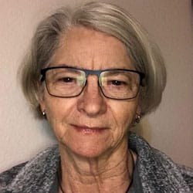
Sedona Bridge History – 2023
The Sedona Bridge Club (SBC) reopened after the COVID Epidemic. Players and Directors had to show proof of a COVID vaccination.
Jackie Haugan became the president.
The club received a new contract from the Sedona Elks Lodge #2291. The contract contained added terms that were not accepted by the Sedona Bridge Club (SBC). A search resulted in moving to the Jewish Community Center of Sedona and Verde Valley.
SBC received a community grant of $2,200.00 for the purpose of growing club membership.
Jackie Haugan
Sedona Bridge History – November 2023
After 14 years on the Board of Directors (most of them as President), Marsha Helton has decided it is time to step down from the Sedona Bridge Center Board of Directors. She is certainly owed some time off and has indicated that she and Darryl will continue to play online with the club.
We owe Marsha a great deal of gratitude for all the time and effort that she contributed to building the Sedona Bridge Center into one of the larger clubs in Arizona and establishing a sound financial footing to ensure our continued success.

Sedona Bridge History – 2020 – 2023
Club games were replaced by BBO. Regular games were initially directed by Anne Neeter. Jackie Haugan and Pat McCreary became directors due to the popularity of games in these on-line games. SBC members kept in touch with each other during COVID. The club continued to pay a reduced rent to the Elks Club even though games were not being played in the facility.
Sedona Bridge History – February 2009 – November 2021
March 12 – 14, 2020

The Sedona Bridge Club hosted a Regional Bridge Tournament at the Elks Lodge. This tournament was hit by decreasing enrollment and no-shows because it was when COVID was becoming a known health problem. It was the last tournament before ACBL shut down all Face-to-Face games. Mark Itabashi was one of the very few players who completed the tournament.

In 2008, attendance at The Sedona Bridge Club was struggling. It was frequently necessary to cancel the Tuesday and Saturday games. Four members joined the club including Marsha and Darryl. Marsha joined the board and became president. She and Darrly donated substantial sums to help support the club.
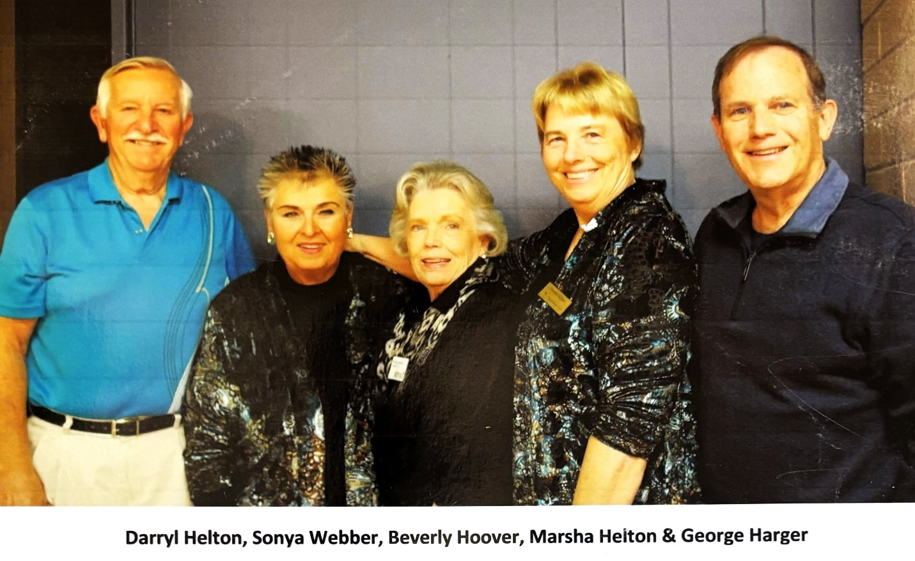
In 2009 Marsha Helton was Club Manager and President of the Sedona Bridge Club. She was named ACBL Goodwill Member of the Year, in part for leading the club towards success. Nine members of the club took a one-week Mexican Riviera cruise with famous bridge teacher Audry Grant. Marsha took a Better Bridge class (Audrey Grant was one of the teachers) and earned her teacher accreditation.
The above photo titled “The 4 Amigos and George!”
As the club membership grew, members enjoyed meeting new friends. Snacks were added to the all-important “Coffee “and several members took the Food Handlers Class to become certified Food Handlers: providing safe food and snacks to club members.
Mimi Esser, Marcia Stearns, Patricia Dodd, Ann Shaylor and Marsha and Darryl Helton formed a team to recruit new members and teach the game of bridge. Their membership drive was named “We Wanna Hold Your Hand.” Marsha went to an Audrey Grant seminar in Palm Springs in January 2009 before starting the novice education program.
Marsha created the Mimi Esser Award, supporting new players in honor of Mimi Esser. Scholarships to the Sedona Red Rock High School began during Marsha’s era.
Sedona Bridge History – November 2012
Club games grew to 256 tables a month. In 2012, the Sedona Bridge Center was the 12th largest club in District 17. A weekly 199er game had been added to the 5-days-a week open pair games. Over 130 new ACBL members have been enrolled in 4 years.
Marsha’s history would not be complete without recognizing her ability to create partnerships and get people to help create a better club. One of the most important people to recognize is Sonya Weber, the Partnership Chair Position. Sonya not only organized partnerships: she supported the club and coordinated volunteers for events. Gail Edwards said, “she really rang the bell, and we came running!”
Sedona Bridge History – 2009-2011
Bob Nord, Ron McIlroy, and Beverly Atwell were club presidents during 2009, 2010 and 2011.
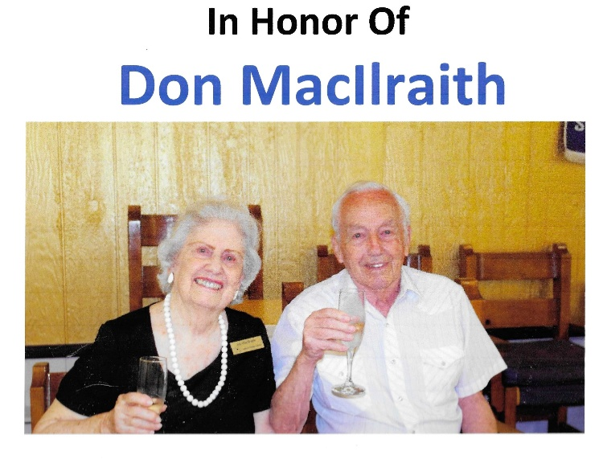
Sedona Bridge History – 1991
Joy and Don MacIlraith
In 1991, Don MacIlraith formed Northern Arizona Unit 355. He familiarized himself with the ACBL requirements and then visited the Northern Arizona Clubs to obtain membership support and to ensure the unit met the ACBL requirements, which included forming a Board of Directors and writing by-laws that had then to be voted upon and approved by the members. Don also served on the first Board of Directors and continued in this capacity for many years. In 1993 he became heavily involved with the local bridge club in Sedona when the club transitioned to a non-profit membership organization. Don served as President and was also on the Board of Directors for many years.

MEMORIES……AND MUSINGS BY BREWER
JULY 2004
(Revised, November 2007)
It occurred to me some time ago that our venerable and historic institution (namely, the Sedona Oak Creek Duplicate Club, ACBL 101402) is worthy of archival status so, with the assistance of many past and present members, I am putting it together. There may be some numerical, chronological, and spelling errors: the passage of time fades faces and facts.
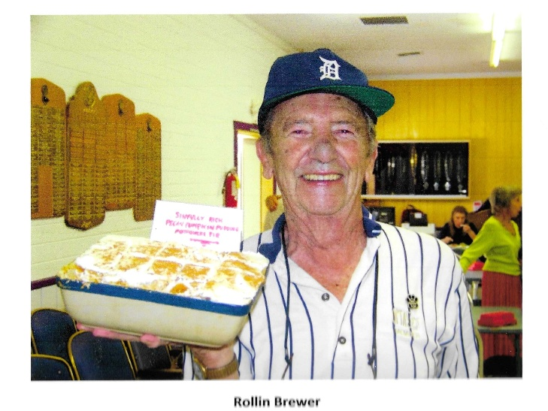
The Club was formed in the late 1960’s or early 1970’s by Hannah Chansky, who owned, managed and directed. (Remember Hannah, with her ear-piercing whistle? I bought her a whip for her birthday to replace it.) According to Jo Moore, a charter member, it first met in the basement of a funeral home in the wilds of West Sedona. It was relocated about 1975 to the Harmony Hills Club House, now the Adult Community Center. I recall a lone ashtray on top of an ancient piano, where we smoking sinners would gather during the breaks. Then, in 1982 we moved to the Vista Montana facility, behind the “Marketplace” complex on 89A. Hannah died in the summer of 1991, and after much feudin’ ‘n’ fussin’ with the I.R.S., we reorganized as a non-profit activity in the fall. A 7-person governing board was voted in and a set of bylaws was adopted, available to the present members. A manager was appointed and four directors alternated in running the games. Also, a 7-person unit board was created sometime later.
Joan Holliday reminds me that for a time, evening games were held in the Sedona Shadows Clubhouse, on the way to Cottonwood. It was short-lived; too few members chose to drive at night!
Our first Club President was Joan Scritchlow, now residing in South Carolina, followed by Bertha Phillips, Joy MacIlraith, Pat Gill, Frank Hendricks, Arne Schjeide, Don MacIlraith, Beverly Atwood, Bob Nord, and Marsha Helton, now serving.
In 1993, the Club moved to its present location at the Elks Lodge, where I hope we remain ad infinitum! Special holiday events and providing lots of snacks during games helped create a sense of community for the club. Post mortems were regularly held in the Elks Club bar.
As I recall, ACBL had five criteria to be met for club members to receive full Master-point recognition, not all of which are currently required. They were:
- Al least one Charity Game to be held annually. We had two.
- A certified Director was mandatory. We had two, plus several qualified.
- A minimum of 15 new members to be acquired annually. We garnered 17.
- Teaching sessions for beginners were required. Harry Hoefle capably handled this need.
- A separate game for beginners (optional attendance) was called for under the supervision of the overall Director. This was met.
The early scoring mechanism, pre-computer, involved the Director(s) informing the Manager of the winners, who went through complicated scoring lists depending on the number of tables, to determine the master points awarded. This information was provided on official ACBL scoring slips. Do you remember plowing through the little recipe box, hoping to find your name? Winners were responsible for sending their results to “Headquarters Memphis,” where they were, (eventually) recorded - very different from our, present efficient recording system, including stratification for B and C members. Introduction of bidding boxes about nine years ago helped further a smooth operation, calming the confusion, clutter, and clamor.
Several years ago, Peter Wahl and wife Karen arrived on the scene. In no time, he organized an additional club, 263443, meeting three times a week in Sedona, Flagstaff and Cottonwood. His efforts have resulted in increased interest and membership. His club was recently purchased by our club and now we regularly meet five times a week.
Our current membership roster lists 165 names, of which some 70 show up only rarely. I count 39 Life Masters in the group including three Golds. Quite a record…I estimate an average of 40 tables per week or 2080 annually. This adds up to ?? hands dealt well; you do the math!
Our thanks to Lenian Keith, Warren Palmer, Al Brewer and Peter Wahl for their help in keeping the semi-annual membership list up-dated; to Don and Joy McIlraith who came along just in time to keep the Club afloat; to Bea and Malin Wing for years of table assignments and table set-ups; to Pat Kirby for her excellent financial record keeping; to Kress Alexander for his carpentry skills; to Mimi Esser for her assistance inputting this thing together; and to the many who have provided refreshments and other services over the years.
Personal comment: I have been involved with quite a few bridge clubs. This is by far the most courteous, civil, and congenial group I have ever encountered.
Now to the names and numbers of pasts deceased and past members. Mourn, reminisce, and remember all those who made #101402 what it is today. Additions and corrections are welcome.
Respectfully submitted:
Rollin Brewer

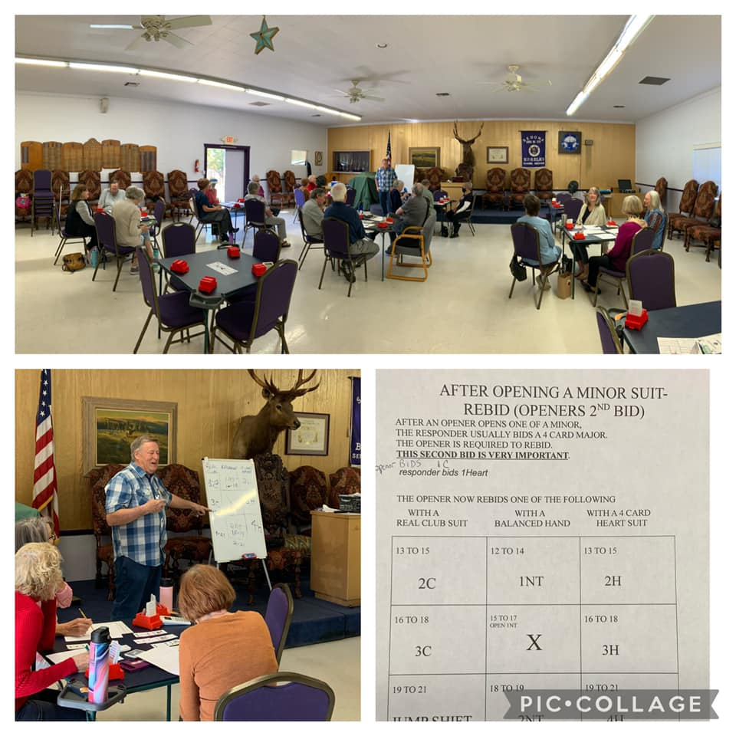

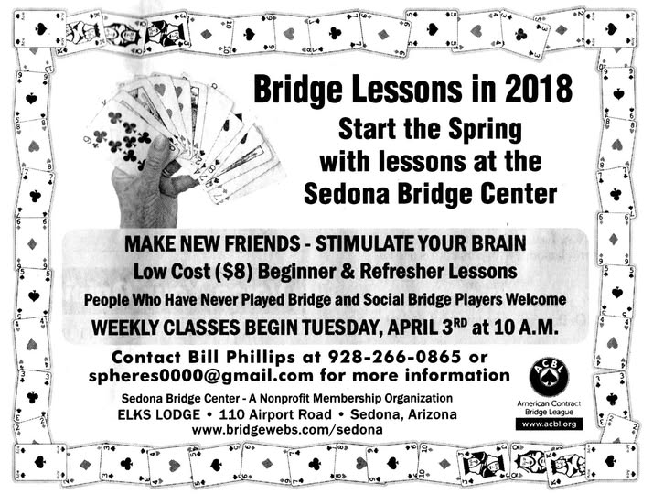

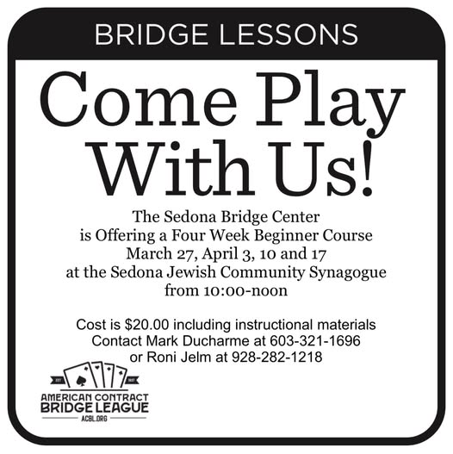

Keep updated by adding SBC as a Facebook friend!
https://www.facebook.com/search/top?q=sedona%20bridge%20center

Thank you to our teachers!
Peter Wahl - 2008
Marsha Helton – 2009 – 2019
Bill Phillips – 2018
George Welch – 2021
Jackie Haugen – OLLI at Yavapai College, Bridge online Classes
Mark Ducharme – 2024


