Alzheimer’s Fundraiser Dinner for 6

North Indian Cuisine at Rahul and Shakti Chandra’s house

Menu
Appetisers
- Cauliflower and eggplant pakoras with chutney
- Sheekh Kabab
Main Course
- Butter chicken / Lamb curry
- Kabuli channe (chickpeas)
- Mater Panir (peas and homemade cheese curry)
Rice and bread
- Pulao
- Roti (whole wheat flat bread)
Desserts
Besan Burfi
Wine, beer and liquor served
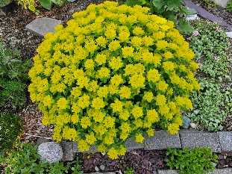

Alzheimer’s Fundraiser Cooking Class for up to 5

  - BY
Shakti
Come at 4, help cook four dishes and sit down to enjoy the meal with rice and wine
Menu:
Chicken or pork. (butter chicken, chicken curry or pork kabab)
Chick pea or lentil
Vegetable (cauliflower, eggplant or red peppers)
Dessert - Besan burfi

For the road – plain yogurt without a yogurt make!

