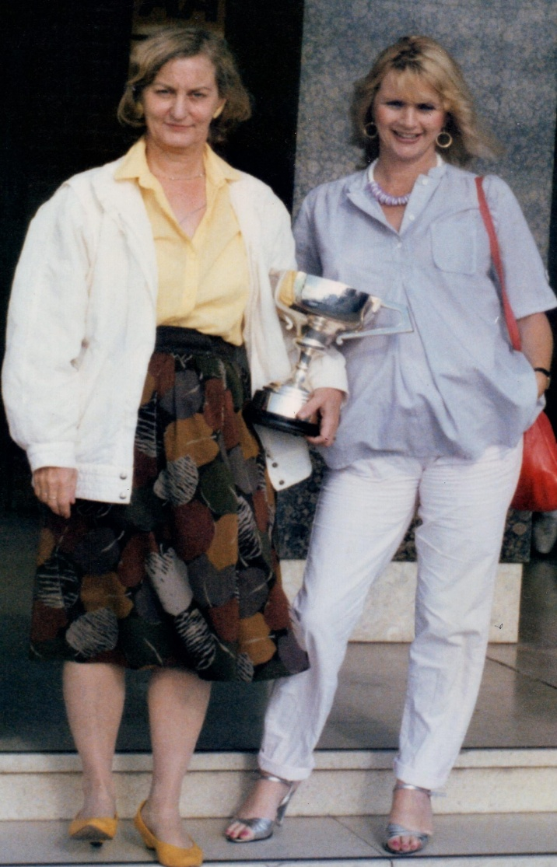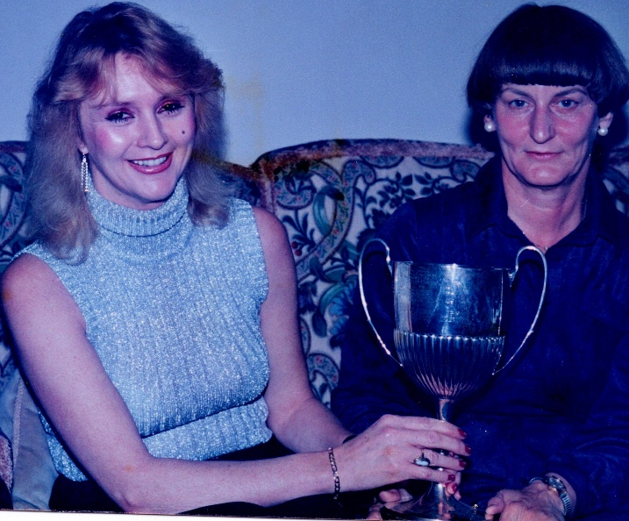JUNE MANNING “The Good Old Days”

Not many people know that June was one of the top players in the county. In this picture she had won the Blackpool Championship Pairs again with Carole Kelly.

For many years June trod the boards (no pun intended) picking up trophy after trophy. She took no prisoners. Here she is with Carole Kelly with the Harrogate Ladies Pairs Trophy.

June played for Yorkshire and secured third place in the EBU Lady Milne trials.

A highly skilled bridge player with a passion for creating systems much to the dismay of her bridge partners. Learn them or else. They were to be fair excellent. The end of an era, a very sad time for her many friends.

June was a member at Olicana Bridge Club for over thirty years and she will be very much missed.