To allocate Green Points on EBU Score

Example
7 Teams of 4
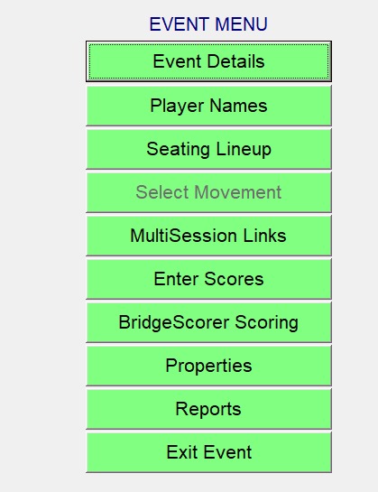
Event Details
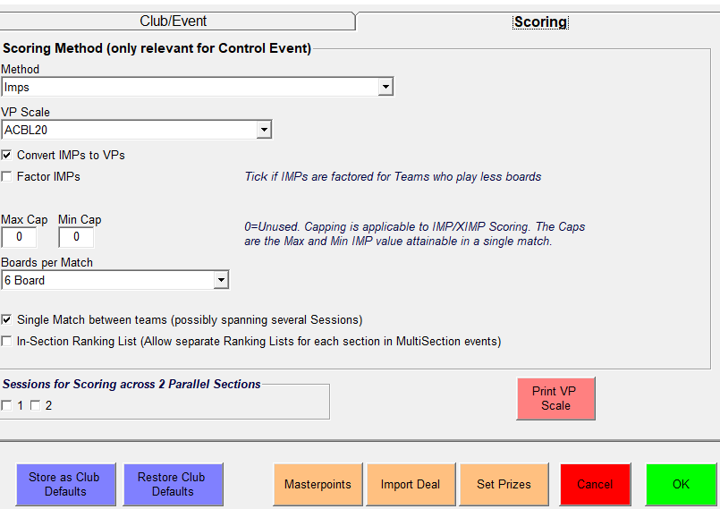
Master Points

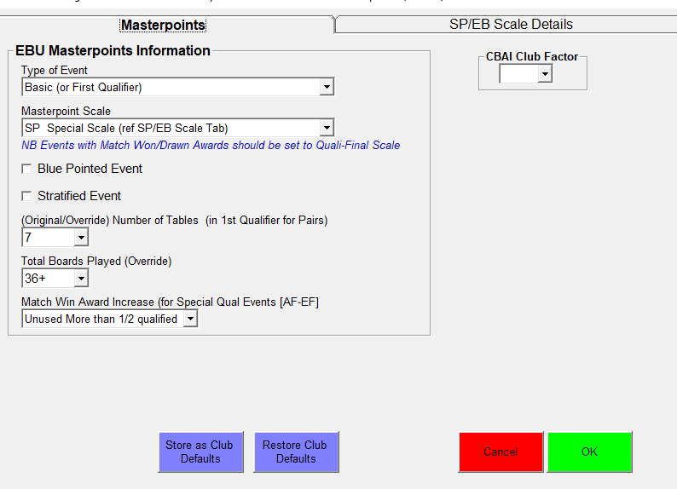
Type of Event: Basic First Qualifier
Masterpoint Scale: SP Special Scale (ref SP/EB scale tab)

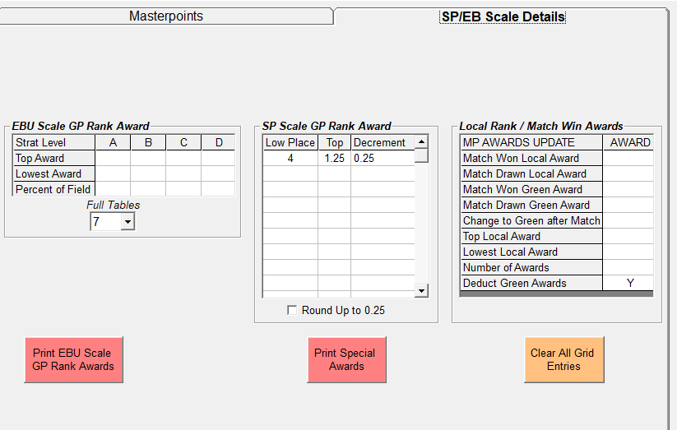
SP Scale GP Rank Award
Low Place: 4
Top: 1.25
Decrement: 0.25
This gives
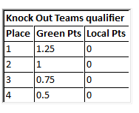
Master Points Tab
OK

