EBU Score with BridgeMates

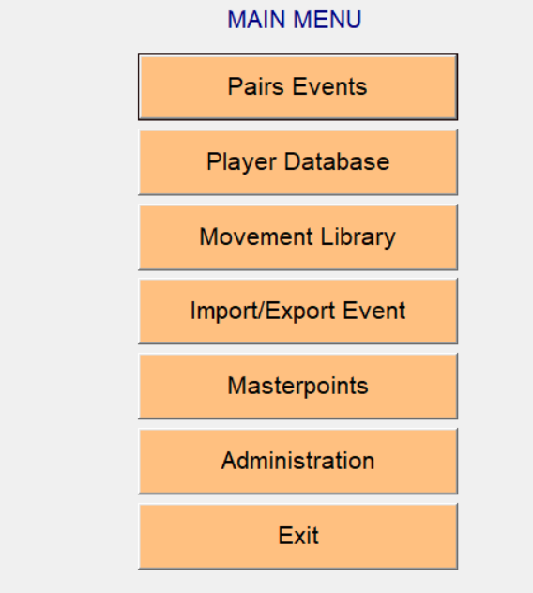

Select Pairs Event

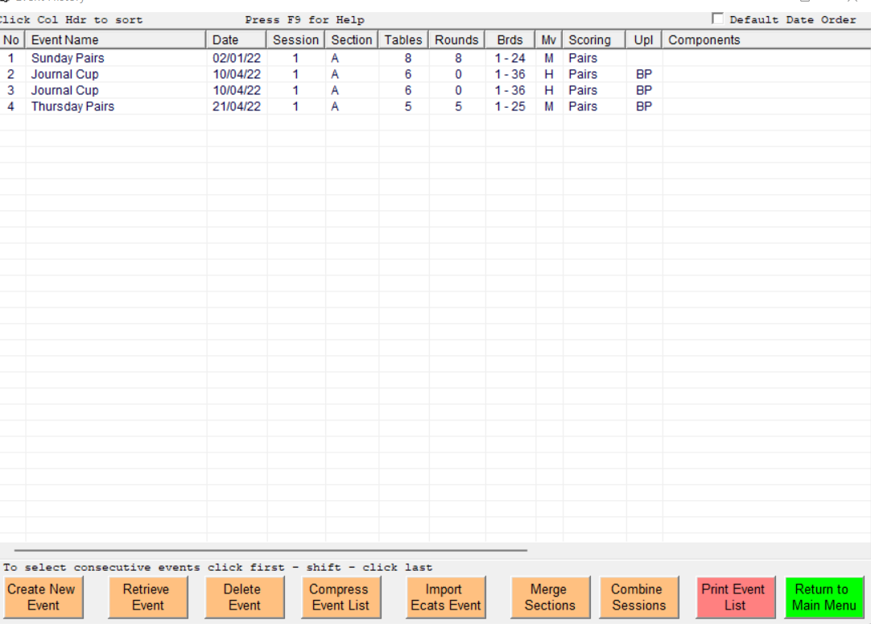

Select Create New Event

Should be auto filled out, just check looks OK.

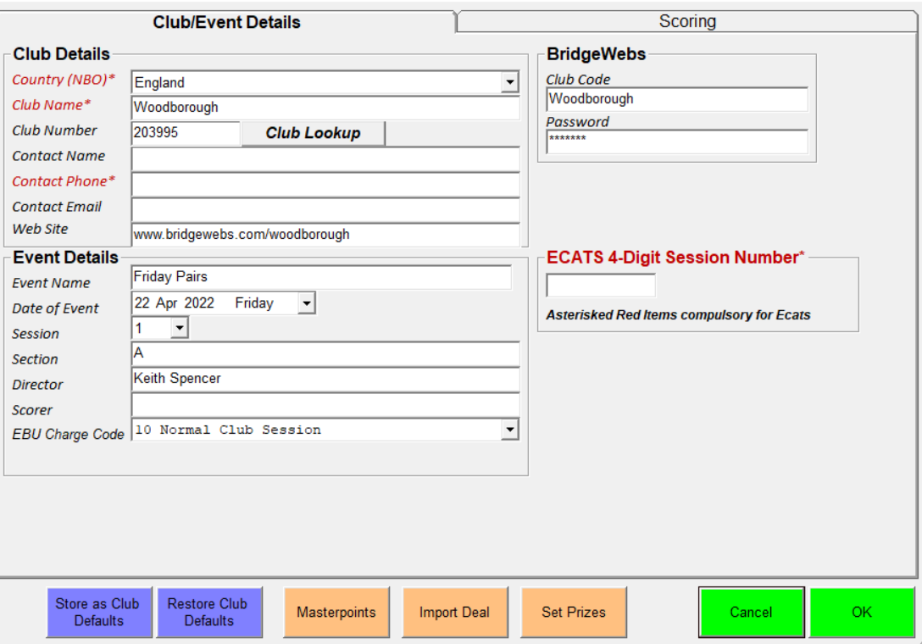

OK
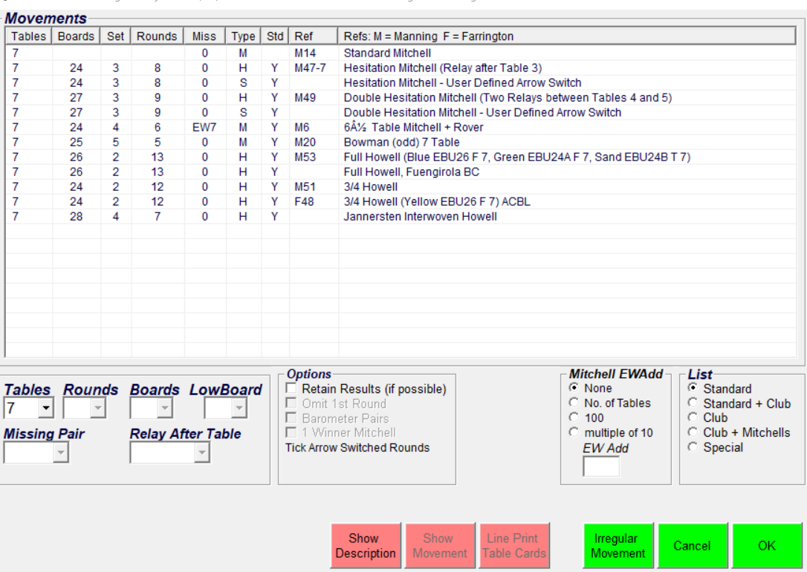

Select number of Tables
EBU Score will then give you a selection of Movements.
Highlight required movement

This will fill in Rounds and Number of Boards. Amend as required.
Select OK

Confirm Details Yes

This takes you back to Menu.
Select Bridgemate Scoring

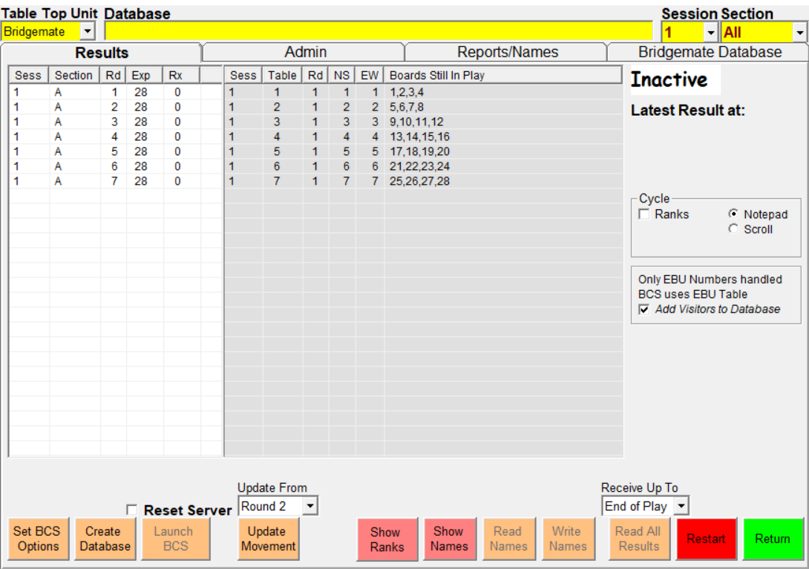

Set BCS Options: this allows you to change settings on the Bridgemates.
Select Create Database
Select Launch BCS

Advantage of EBUScore is it is much easier to amend movement.
Return
Select Movement
Amend Movement
Bridgemate Scoring
Select Update Movement. Just make sure you amend from the correct Round.

Results

Select Reports from Menu

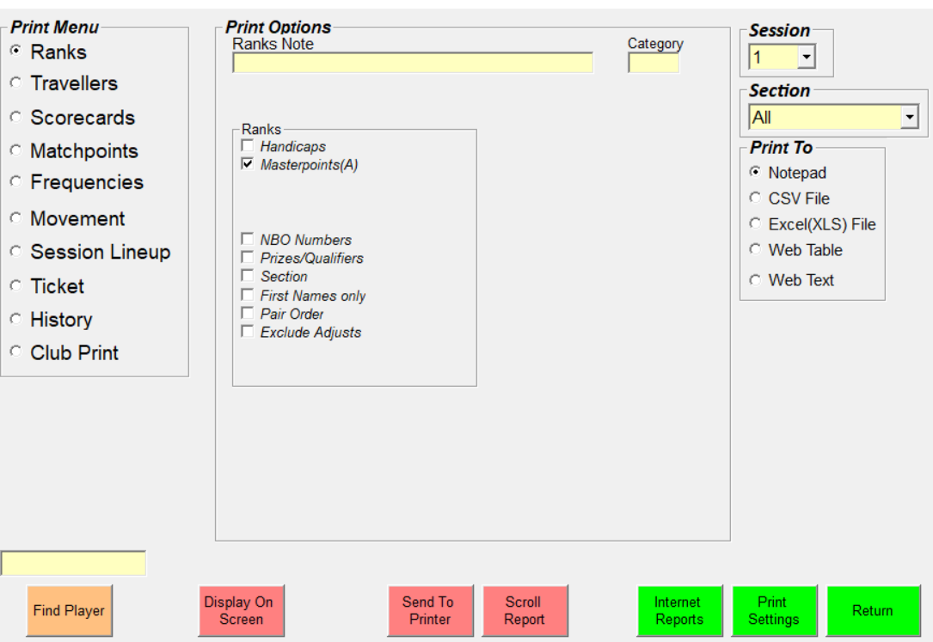

Select Display on Screen. This shows results.

To Publish Results, select Internet Reports

This page should be prefilled.

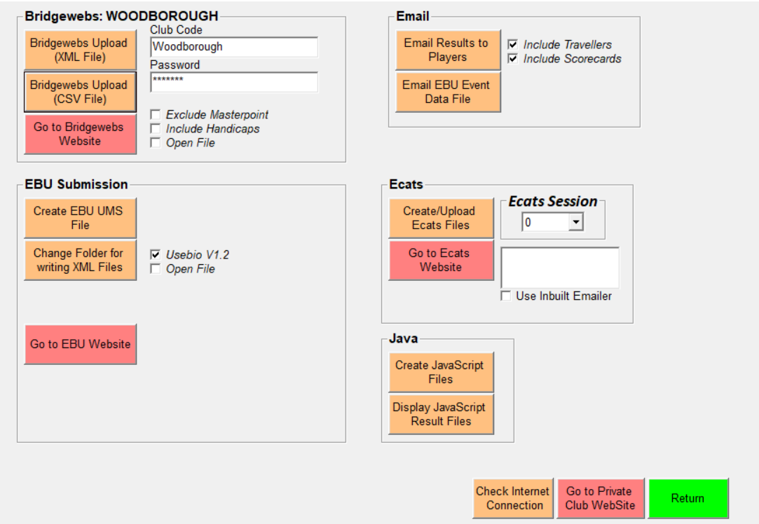

Select Bridgewebs Upload (XML File)

All should be OK?

To manually enter missing Names,

From Menu select Player Names
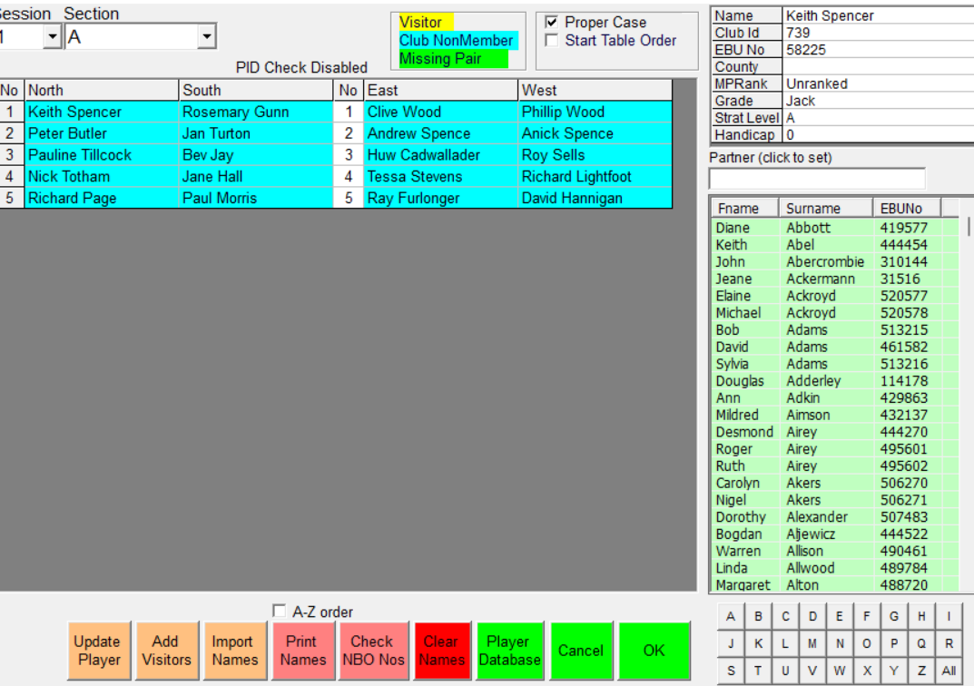

Just be careful to make sure you are entering Names into correct Field!!

