Allocate Green Points for Journal Cup

I set Mater Points for each session to ”None”
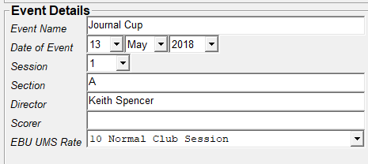

Make sure you have sessions 1 and 2
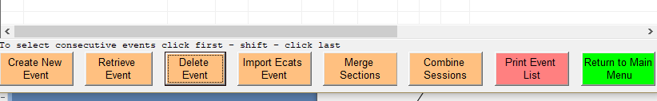
Highlight the two sessions, then Combine Sessions
Select the combined session, then Retrieve Event
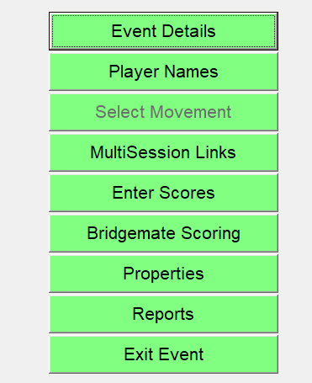
MultiSession Links

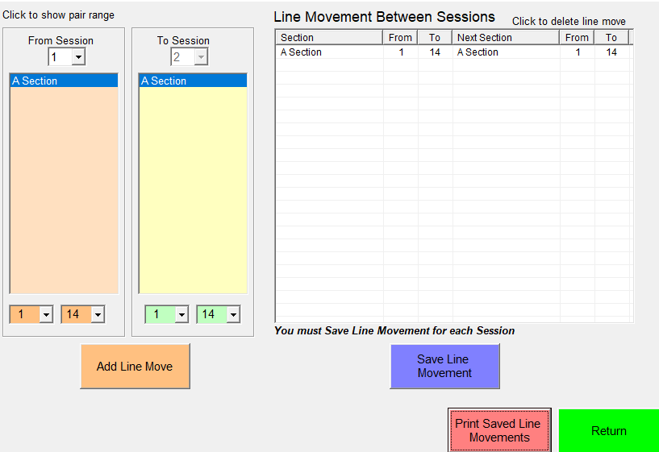
Highlight A section in both columns
Add Line Move
Hopefully this will give
This copies the names across from session 1 to session 2

Navigate to MasterPoints (Return – Event details – Master Points)

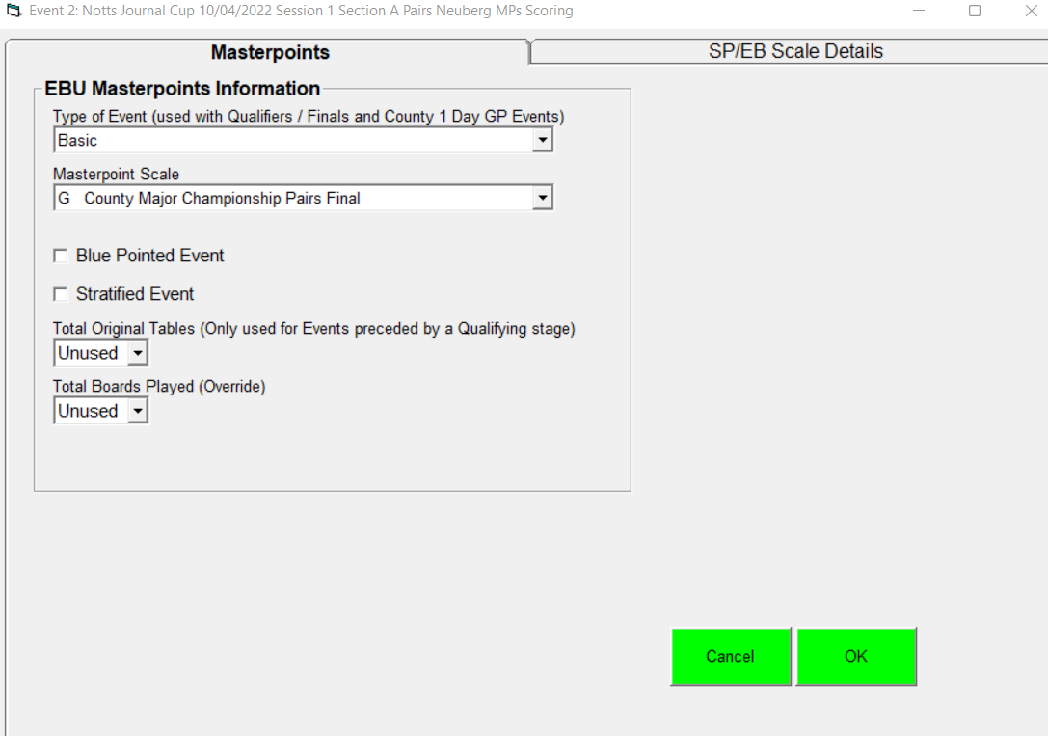
Select MasterPoint Scale G
The following no longer required since version 1.2.12 (hopefully)

Then SP/EB Scale Details
Use Green Point Calculator http://www.ebu.co.uk/masterpoints/green-point-calculator
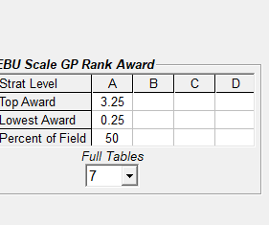
Example above is for 14 Pairs, top 50% awarded Green Points.
Navigate to reports
Check results and publish to Bridge Webs and EBU.
6.3.4 (a) In all cases, the top Green Point award is 2.50 + TOE/20, rounded up to the nearest 0.25 GP, and subject to a maximum award of 7.00 GPs. N.B. the TOE is expressed in terms of the number of pairs (not tables).
(b) The last pair to receive an award receives 0.25 GPs. Awards for intermediate places are calculated in accordance with the standard EBU formula referred to in 6.6
(c) Where fewer pairs qualify for a final than the prescribed proportion of pairs due to receive Green Points, points are NOT carried over either to a consolation or to the leading nonqualifiers. The ‘last pair to receive an award’ for the purpose of paragraph (b) above is deemed to be the lowest-placed pair in the final.

