Using the Members Area at
Nottingham Bridge Club

This FAQ sheet has the following sections

1.How to access the members area

2.How to request a partner

3.How to respond to a partner request

4.How to amend your (published) details

--------------------------------------------
Updated 11/2022
Produced by Membership Secretary (P.G)

1.How to access the members area
- Open a browser tab
- Go to https://www.bridgewebs.com/nottingham/
- The members area is top right hand side of the screen
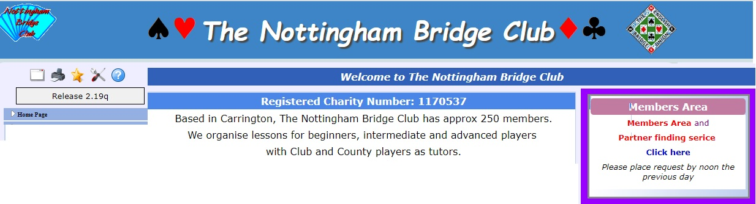
- Click anywhere in the purple box
- You will be taken to the log-in page
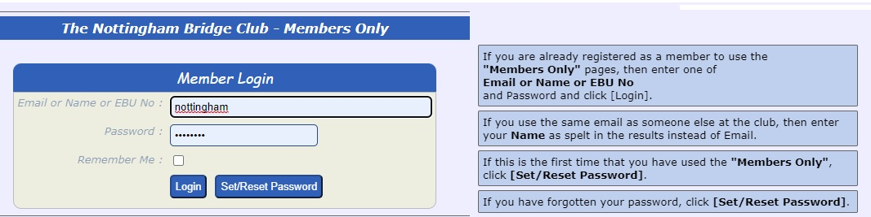
- if it is your first visit - Enter your EBU number, name or email
- Then click select Set/Reset Password
- Check your email inbox, and complete the password set (or reset)
- Then return and complete the log in details
- The next screen has a number of options – but 2 are important, Find a partner, and Account
- Find a partner is self explanatory but details follow.
- Account is governed by the Data Protection Act and will only have your
EBU number and email. It can be edited (discussed later)

2.How to request a partner
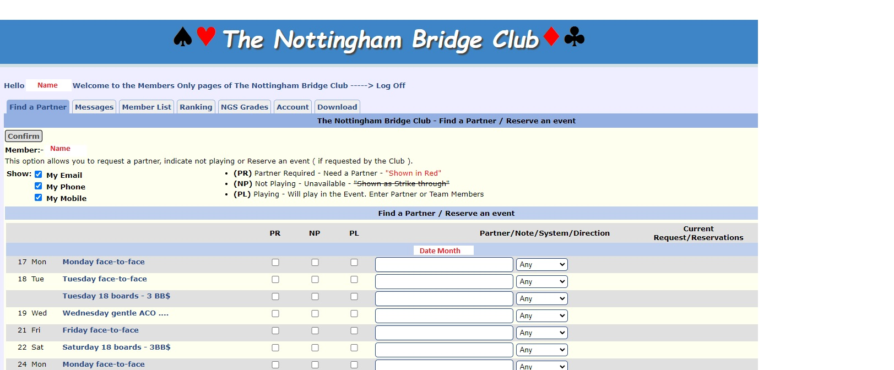
- The members area opens at Request a partner
- Your name will be shown, as will the next 6 drives
- The options chosen below are Monday and Friday face to face, partner required, contact me by email or mobile, but not home phone
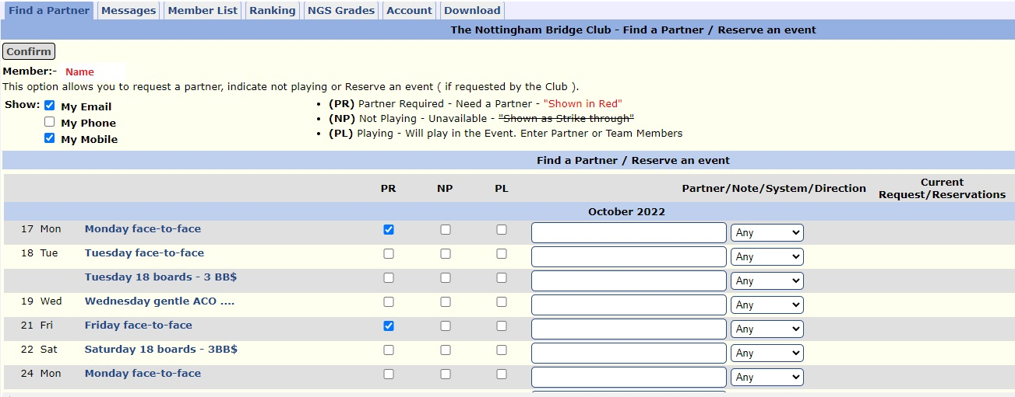
- When you have made YOUR choices click confirm
- A request is automatically posted on the club website and (hopefully you will be contacted

3.How to respond to a partner request
- On the club calendar, a Partner required message appears under the date of the drive that someone is interested in
- Click on Partner? Details are shown for contact between the 2 of you.
4.How to amend your (published) details
- Click on your Account Tab the window below opens
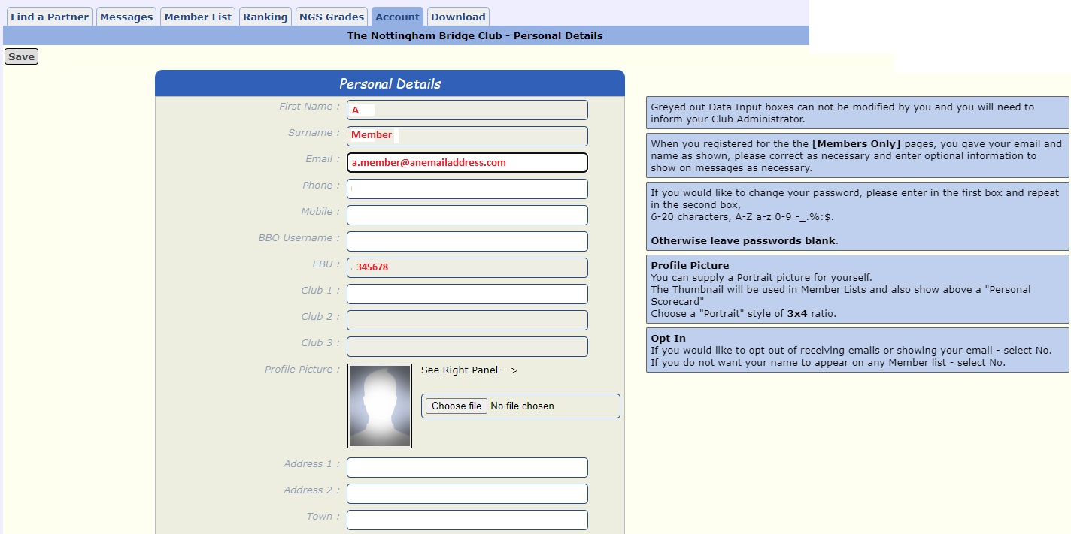
- You can delete any or all of the information
- You can add any information you wish to. The options are numerous and only a few are shown here. Your data is shared by you (or not) and is not published other than here for contact purposes.
- Save when you have finished.
- You can amend the information at any time.

