EBU Number FAQ
This FAQ sheet has the following sections

1.How to generate a new EBU number

2.How to find a member’s EBU number

3. How to edit a members details

4.How to delete a member

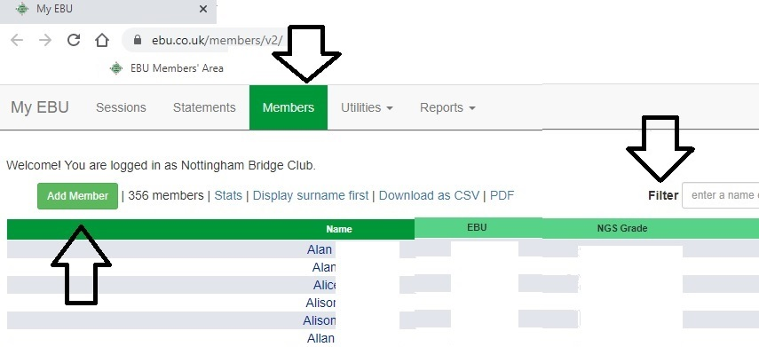
--------------------------------------------
Updated 11/2022
Produced by Membership Secretary (P.G)
If you are using the club computer, the first 5 steps (below) are automatic, just click on the EBU member’s Area Tab in the toolbar.

1.How to generate a new EBU number
- Open a browser tab
- Go to https://www.ebu.co.uk/members/v2/
- EBU Number – enter ****** (Club’s EBU number) First
It can be found on the back of the Office door 5
- Password – On the back of the Office door (case sensitive) steps
- Click Login
- Click on Members Tab (Top of screen)
- Click on Add Member (Green box is top left of screen)
- The series of Qu’s should be self explanatory – for a new member just answer No to the first question, then enter Forename and Surname, then click create. (DoB is for under 25 year old – you won’t need it !!)
- A new window appears with the (unique) EBU number shown at the top, make a note of it.
- Enter any member details you know.
- Send an email to the club so that the Membership Sec knows about the new number, and can edit the preferences.
- Tell (face to face or email) the member their number, explain it’s for life, never changes, and is used at all clubs and events.
- Relax you have succeeded.

2.How to find a member’s EBU number
- Follow the first 5 steps above – to get to the members area.
- Click in the filter entry box and type the first few letters of the surname you want to find out about.
- The list of members will show the person you want (if they are a club member)
- Make a note of the number
3. How to edit a members details
- Follow the first 5 steps above – to get to the members area.
- Click in the filter entry box and type the first few letters of the surname you want to find out about.
- Select the name (double click)
- Existing details appear.
- Edit as required.
- SAVE before leaving the window.
- Send an email to the club so that the Membership Sec knows about the changes made.

4.How to delete a member
- Follow the first 5 steps above – to get to the members area.
- Click on the members name
- Click on Revoke, then click OK (and confirm if asked)
- Send an email to the club so that the Membership Sec knows about the changes made.

