
Bridge Basics 2
Commences 10th Feb 2026
Tuesday Evenings - 5 weeks - $80

Should I enrol?
This course is for those who have completed BB1, or are looking to improve their Bridge in the areas covered or are returning to bridge after an absence.

What will I learn?
- Extended Bidding concepts – Pre-empts, Opening Strong Hands,
Slam Bidding, Responding to NT openings
- Defender card play strategies
- Reinforcement of BB1 teachings

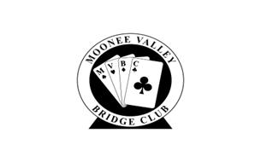
Teacher: Lynda Young - Register on MyABF - Class size limited to 15
For further details contact: Lynda Young mvbc.lessons@gmail.com
Photo by Amanda Jones on Unsplash

