Outline of the presentation
We have three objectives: (in reverse order of presentation)
- Replay numerous hand examples from Terence Reese and & Roger Trezel’s book When to Duck, When to Win book
- Replay a Gavin Wolpert YouTube Master Class video on Matchpoint Scores. (Sorry, I am not a premium YouTube subscriber. You have to tolerate and skip any adds).
- Introduce you to some of online bridge resources
OK, here we go….
Yesteryear we would read the bridge column in the daily newspaper. Now we have bridge newsletters, blogs and hand-players.
Here is an example (first of 2).
This Andrew Robson's column on today's topic: ducking - Click on “CLICK” to play the hand.
It’s a simple example of the “Hold Up” or “Duck” to maintain Hand-to-Dummy communication while establishing a long suit.
Aside Question: Did anyone consider opening the hand 1NT instead?
Type-of-thinking thought 1: In the above hand, West led the ♠6! His partner played the Jack. Why did declarer win with King and not the ACE?

Another type of resource (example 2of2) that is freely open to you, is the Gavin Wolpert Interactive Problem YouTube series. In this series, Gavin presents a play problem, allows to play the hand, and then presents how he would play the hand. He does a great job at outlining the thinking process required to determine how to play the hand.
So we start with the YouTube video, GAVIN1 , temporarily stop the YouTube session, logon to Wolpert bridge site (You must have an account, but accounts are freely available), play the hand as many times as we like and the return/restart the Gavin video.
Aside discussion: The problem is titled “Capitalizing on Honour Leads”. Could someone please explain the title?

………end of resource introduction, now the video

This video highlights the requirement that you absolutely must know how to score if you are going to play duplicate pairs bridge.
Secondly, it suggests that it might be your bidding strategy not your play that is limiting your ranking.
GAVIN ( master class; the link is only good to 2/15/2026)
Specifically, he states:
Respect the vulnerability
Don’t Over compete with balanced hands.
He likes to be first into the auction
Don’t be afraid to go down
Double more often
Prioritize plus scores – don’t lose the hand in the bidding, win in it the play. Grind the overtricks.
Mentality for pairs events.
WHILE WE ARE WATCHING THE VIDEO, IF ANYONE WOULD LIKE TO QUESTION OR DISCUSS A POINT, JUST RAISE YOUR HAND AND WE WILL PAISE THE VIDE0.

And now the final lesson section – curated hands from

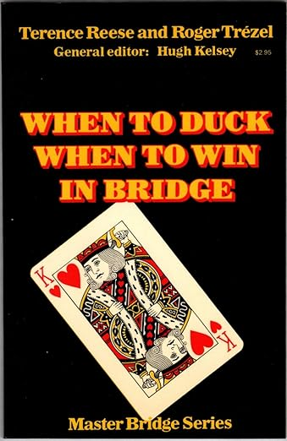
When to duck, when to win
The hold up is one of the most important and many-sided plays in the game.
In the following lessons, we will see examples of ducking play:
To prevent an opponent from establishing a long suit.
To establish a long suit in the dummy or in his own hand.
To prevent a dangerous opponent from gaining the lead.
To retain trump control.
To protect against an over ruff.
To retain control of a side suit.
And as a preliminary measure for each of the standard forms of end play.

First example - Hand 1 This hand introduces the concept of the “Dangerous Hand” and how we choose our line of play based on the existence of a dangerous hand.
Example 2 - Hand 2 In this NT example, we are continually assessing tricks taken, tricks potentially lost if lead is lost, and identifying the dangerous opponent.

Example 3 – Hand 3 Similar to previous example, but bidding is influential.
Hand 4 Sometimes declarer must Hold-Up twice
Hand 8 Playing a trump suit with a long side suit.
Hand 18 When deciding whether to win the first trick in no trump or to hold up, consider:
- How many cards is the leader likely to hold in the suit led?
- How many stoppers does declarer hold?
- How many entry cards does the leader hold, and does their partner have entries to return the suit led?
- If the first trick is ducked, is there a risk that opponents will switch to another suit with the trick already won?
The next step after analysing the lead is to determine which entries must be attacked first. This principle is fundamental in many hands and is illustrated by several examples throughout the series.
General Principle: Attack the entries of the dangerous hand first.

Hand 24 There are many times, both in a suit contract and at no trump, when it is slightly inconvenient to discard on one’s own winners. Sometimes it is possible to make a waiting move, as they call it in chess, postponing the discard until a later moment.
Hand 37 Exam question. Reviews key concepts of “dangerous hand” hand developing side suit.

Bonus A link to my ONENOTE file.
Another internet source A reference to Larry Cohen’s site. This is another example of Hold Up example.

