 Codiac Bridge Club
Invites you to a
Christmas Bridge Party
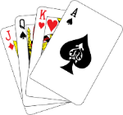 Saturday, November 22, 2025
Dan Bohan Centre – 5 Fatima Dr. Riverview
Game starts at 1:00 p.m.
Game and Dinner: $25.00
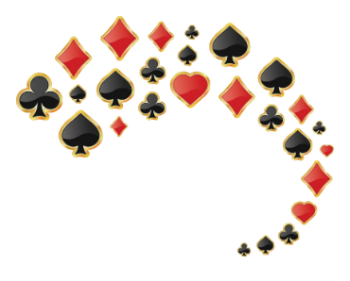
Happy hour following the game
Dinner served at 5: 15 p.m.
Please contact Linda before November 15th at linbelliveau@gmail.com to register!


