MBC Website Management
Contents
1. Overview 2
1.1 About this Document 2
1.2 Terminology 2
1.3 Document Location 2
1.4 Version History 2
2. Getting Started 3
2.1 Logging In 3
2.2 Overview 3
2.3 Logging Off and Getting Help 3
2.4 Index by Role 4
2.5 Index by Function (where do I go to …) 4
2.6 When making updates 5
3. Administration Tabs 5
3.1 Menu 5
3.2 Support 7
3.3 Calendar 7
3.4 News 8
3.5 Competitions 11
3.6 People 12
3.7 Membership 12
3.8 Attendance 15
3.9 Social 18
3.10 Member Only 19
3.11 Where 19
3.12 Settings 20
3.13 Pictures 25
3.14 Documents 25

1. Overview

1.1 About this Document
This document is intended to assist new Mollymook Bridge Club committee members to manage the administration of our website: www.bridgewebs.com/mollymook.
The website administration function is laid out as a set of tabs along the top of the screen. Selecting any one of these tabs then brings up the first screen for that tab and a secondary set of screen selection tabs. In this document, each screen will be identified by the primary tab followed by the secondary tab (eg the View screen on the Menu Tab is identified by Menu -> View)

1.2 Terminology
Term
LHP | Left Hand Panel
LHS | Left Hand Side
Main Menu | The main menu found on the LHS of most pages
RHP | Right Hand Panel
RHS | Right Hand Side
Results Upload | Process managed by the director of a session to upload session results to the website.

1.3 Document Location
The latest version of this document can be found on the MBC computer in the C:\Data\Manuals directory.

1.4 Version History
Ver | Date | Who | What
0.1 | 17/3/2024 | JR | Initial version
0.2 | 26/3/2024 | KM | Includes updates to Attendance section
0.3 | 17/3/2026 | JR | Updated Documents section to include instructions for uploading minutes.
TO DO |  | RD | Please review membership creation and amendment info

2. Getting Started

2.1 Logging In
The website appears to be browser agnostic – so using your preferred browser (all screenshots have been taken using chrome on a PC):  - Browse to www.bridgewebs.com/mollymook;  - Click on Administration on the main menu;  - Click on Web Administration on the sub menu items;  - Then click on Web Administration Login on the new page  This will then bring up a new window: | 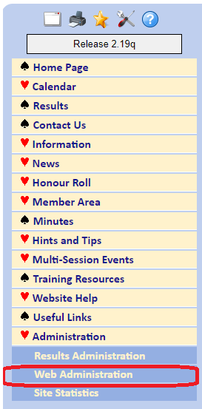
The club code is mollymook (all lower case).  If you don’t know it, obtain the current password from the club secretary.  Enter the password and press Login. | 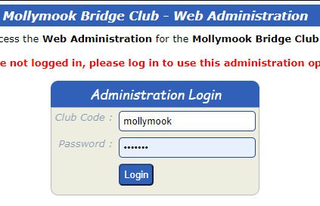

2.2 Overview
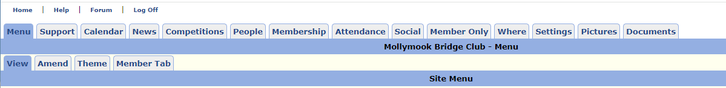
The Administration screen has several tabs across the top and selecting a tab will then present a sub menu of options below. The current tab and sub-menu are highlighted in dark blue. For example, in the screenshot above we are currently in the View submenu of the Menu tab. As noted above, each screen will be referenced by the primary tab name -> screen tab name (ie the View screen under the menu tab will be referenced as Menu->View). The following chapters will go through each of the tab options providing an overview of what can be done there and how.

2.3 Logging Off and Getting Help
At the very top left of the admin screen there are four links: Home, Help, Forum and Log Off. Clicking on Help will bring up the help pages for bridgewebs which provides in greater detail all of the information below. Clicking on Log Off will …. Hmm maybe I shouldn’t spoil the surprise :p

2.4 Index by Role
Role | Recommended Reading
All | 3.7 Membership  3.10 Member Only  3.2 Support->Sent Emails  3.13 Pictures  3.14 Documents
Event Coordinator | 3.3 Calendar  3.4 News (update Honour Roll)  3.5 Competitions
Publicity Officer | 3.4 News  3.12 Settings->Bulletin
Secretary | 3.1 Menu  3.4 News  3.6 People  3.11 Where  3.12 Settings->Site Details  3.12 Settings->Passwords  3.14 Documents
Site Administrators | 3.1 Menu  3.2 Support  3.4 News  3.6 People  3.9 Social  3.11 Where  3.12 Settings  3.14 Documents
Treasurer | 3.8 Attendance  3.12 Settings->Subscriptions  3.14 Documents
Welfare Officer | 3.4 News  3.12 Settings->Bulletin

2.5 Index by Function (where do I go to …)
Function | Location in document
Bridgewebs Subscription Status | 3.2 Support->Subscription
Content - create new page | 3.4 News->List News Item
Content - update page content | 3.4 News->List News Item
Emails - check status | 3.7 Membership->Email Log  3.2 Support->Sent Emails
Emails - send | 3.7 Membership->Email Members
Library - list books | 3.10 Member Only->Library
Member - check activity | 3.7 Membership->Last Played
Member - check information | 3.7 Membership->List Membership
Member - check site logins | 3.2 Support->Member Login History
Member - update information | 3.7 Membership->List Membership
Member->Export list of members | 3.7 Membership->Import/Export
Minutes - list current year | 3.10 Member Only->Minutes
Minutes - Upload | 3.14 Documents->Upload; 3.4 News->Add News Item
Password (member) - manage | 3.7 Membership->List Membership
Passwords (site) - manage | 3.12 Settings->Passwords

2.6 When making updates
I would recommend that after making any updates some advice be provided to the relevant stakeholders on the committee advising of the changes.

3. Administration Tabs

3.1 Menu

Overview
This section allows you to manage the presentation of the main menu and sub-menus on the main site, as well as the tabs presented in the Members Only section. NB. There is a Save button at the top left of the Amend screen. If you don’t click this after making any menu changes, your changes will be lost when you leave that screen.

Primary Users
Site Admins – Update access

How To Use

Menu->View
Double clicking a menu item will take you to the relevant News item

Menu->Amend
Note that menu items can be created either from an existing page (these may be pages which we have created ourselves, or predefined bridgeweb pages), or can be created directly from a document (bu clicking on Add a document). To add a new page; firstly create the page in the News section, and then add it to the appropriate location in the menu. Pages which haven’t yet been added to the menu can be found in the Add BridgeWebs Pages not already in your menu column:
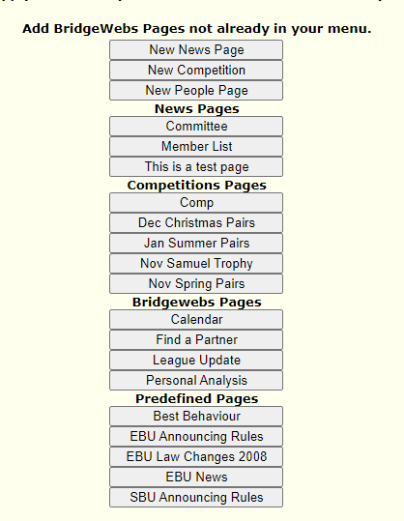
Highlight the menu item to adjust in the LHP. Select the action from the first table (eg Move Up/Down etc).
See Menus Items, Pages and News Items for an attempted explanation of the relationship and differences of these content management objects.

Menu->Theme
Config to change the presentation of the menu. Current values copied below.
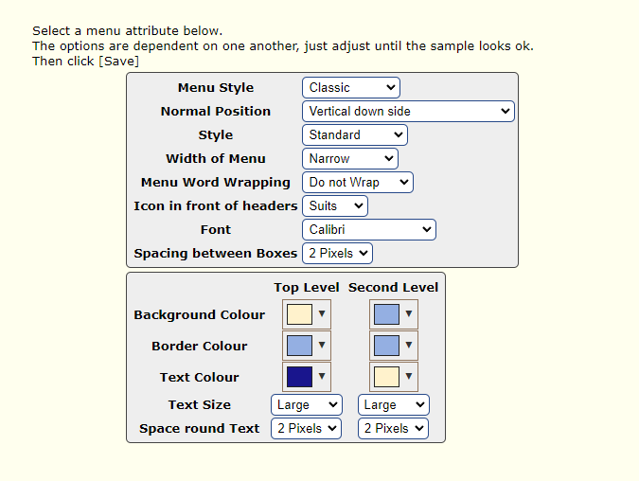

Menu->Member Tab
Here you can change which and how tabs are presented in the Member Only section

3.2 Support

Overview
Principal use is for sending support requests to bridgewebs support.

Primary Users
Site Admins – Update access

How to Use

Support->Contacts
Details of MBC contacts for Bridgewebs use

Support->Request
Use this screen to send support requests to Bridgewebs. See also 3.12 Settings->Messages

Support->Support Log
History of support requests

Support->Reply
QED. See also Settings->Support

Support->Sent Emails
This is the easiest way to view emails sent out as it shows on the same page the content as well as the recipient information. Alternatively see 3.7 Membership->Email Log

Support->Subscription
Information relating to our current paid subscriptions and service details. See also Settings->Subscription.

Support->Member Login History
QED – though I do have some doubts about the accuracy of the information presented as some logins don’t appear to be listed.

3.3 Calendar

Overview
Provides an interface for creating and updating calendar events. NB: like most screens on this site, if you create or edit any calendar entries you must click Save at the top left of the screen before exiting the screen – otherwise all changes will be lost.

Primary Users
Event Coordinator – Update access

How to Use

Calendar->List Calendar
Presents a month-by-month view of calendar events. An event can be edited here by clicking on it. Use this screen to update special events. Note that there is a slight trap with creating a repeating event if regular sessions already exist for those future dates – as the Event No needs to be unique for each day. Delete the future regular sessions before trying to create a repeating event.

Calendar->Quick Update
Use this screen to quickly setup regular sessions. It would be beneficial to be able to change the fields presented here for quick updates (eg add the session cost); but I have yet to find a way to do this – one day I will check with support :p

Calendar->Schedule
I haven’t used this screen yet – it looks like it has potential to be useful though.

Calendar->Options
Mostly I have just used this screen to define the meanings of the various colours used for special events.

Calendar->Usage
Not used.

Calendar->Attendance
Can be used to show a summary of #tables for a specified period of time

Calendar->Sharing
Not used.

3.4 News

Overview
This is principally where page content is created and updated. Note that some content is also maintained within the Where tab. Note also that I am uncertain about the backup and retrieval capabilities of Bridgewebs – so if you are making significant changes, or deleting significant quantities of content – it would be prudent to take a copy of the text prior to any changes. NB: Most pages will have a Save option at the top left. If you do not click Save after making any edits your edits will be lost when you leave the page.

Menus Items, Pages and News Items
I find it easy to get a bit confused by the different content creation options:
Menu Item: A menu item is created, deleted or updated via the Menu->Amend screen. A menu item can be sourced from either a page or directly from a document. By far the majority of menu items are created from existing pages, but the menu item Information->Info – Club History for example, is actually created directly from the club history document.
Page: A page is the principal container for content. Generally, pages must contain News Items, though I note that there are certain pages which are generated from database content – eg the Info – Committee page (these are still a bit of a mystery to me at this stage). Pages are created via the News->List News Items->Add Page button. Newly created pages are not presented until added as a menu item.
News Items: A news item can only exist when it is saved on a news page. A page may contain one or more news items. News Items are generally created via the Add News Item button from the News->View Page screen.

Primary Users
All – Update Access

How to Use

News->List News Items
Lists all MBC created Pages and any News items contained therein. The Home page, Home LHP and Home RHP are listed at the top followed by all other pages sorted by Page Title alphabetically.
- You can edit any page by clicking on the View Page button on the LHS of the page title banner.
- You can edit any News Item by clicking on the News Item link underneath it’s page.
- New pages can be created from this page by clicking on the Add Page button at the top left.
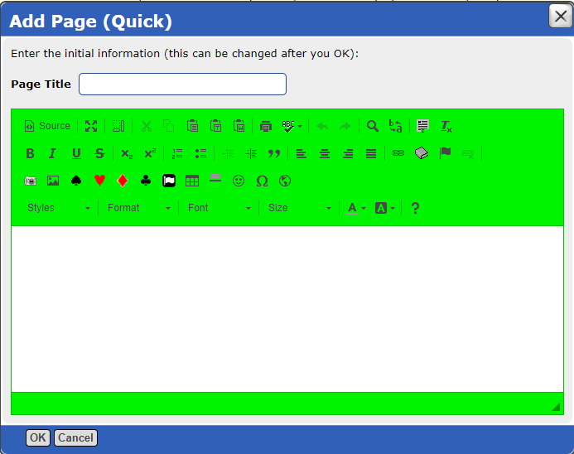
- I would recommend just creating a skeleton page via this process and then using the News->View Page to edit it properly.
- Though you can also create new News Items from this page via the Add News Item button, most commonly you would create news items while editing a page.
For information on creating or amending Pages refer to News->View Page.
For information on creating or amending News Items refer to News->View Item

News->View Page
This screen is presented whenever you click on the View Page button of a page in the List News Items screen. From here you can either:
- amend existing news items on the page – clicking Amend will take you to the News->View Item screen; or
- Add News Items – by clicking Add News Item
NB: the Home Page, Home Left Box and Home Right Box pages have additional editing functions

News->View Item
This is where you can update the news item content for a particular page or add additional content. I will use the Help – Home Page page as an example:
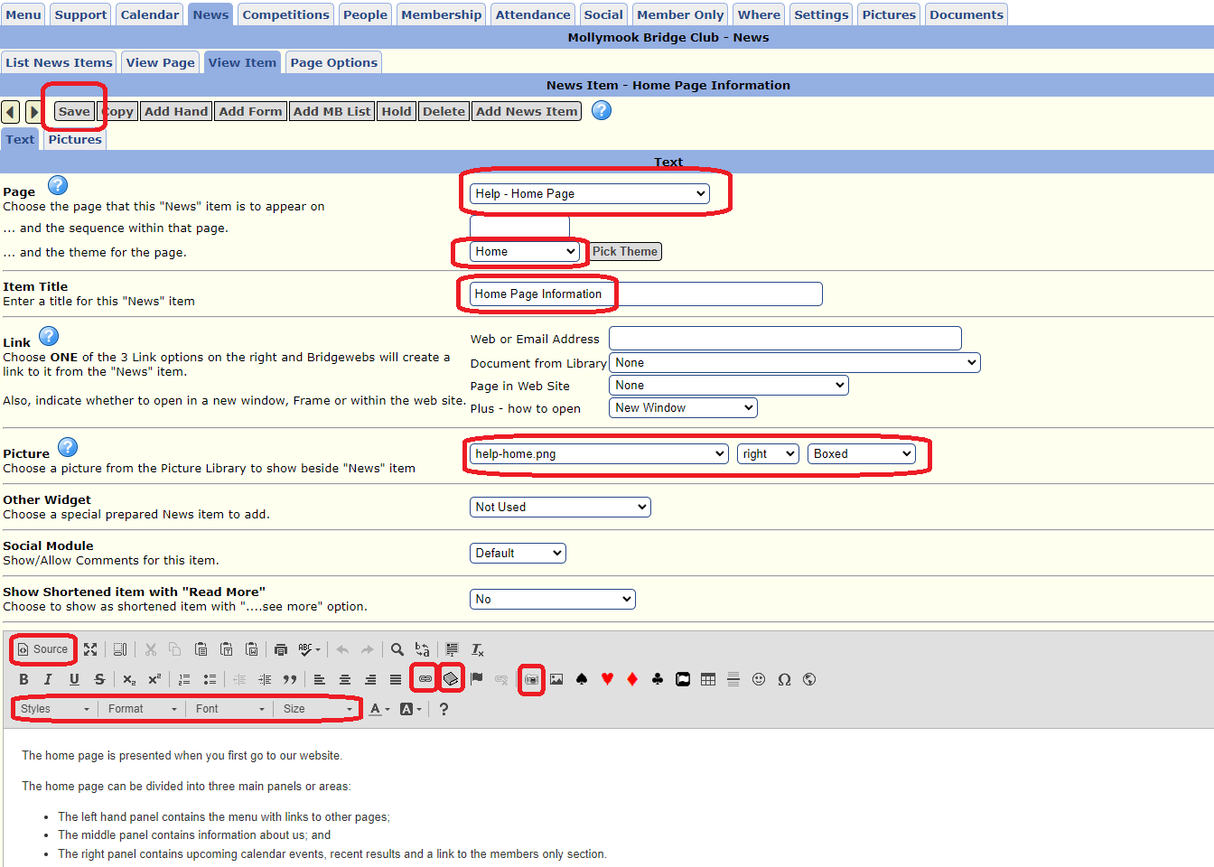
Some comments
- Page Title: Try to use a naming system for pages which results in them being displayed contiguously when ordered alphabetically on the News->List News Items screen
- Theme: unless you know what you are doing, choose Home;
- Item Title: if this page just contains one news item, you might want to leave this blank – otherwise the page is presented with two banner titles – the page title and then the item title (note that I removed this item title after writing this document);
- Picture: If the news item is to include an image at the top of the article – this is the place to specify what and where to show
- Content Management: The lower section of the page allows you to edit and manage the page content. If you are familiar with HTML, you can see the HTML source by clicking the Source toggle. Other useful options are for inserting links (eg email info), images and documents from the library. NOTE: if you are copying and pasting text from another source, I strongly recommend copying and then pasting into something like notepad which will remove all formatting meta data – and then copying from notepad and pasting.
I note that there are some additional content management options available on this screen:
Which to be quite honest I had paid scant regard to previously. So *this* is how we add content from the database :p
News-> View Item -> Add Form allows you to create an enquiry form such as the one from the menu option Contact Us
News-> View Item -> Add MB List allows you to create a page presenting information from the database

News->Page Options various config options for page presentation. The Page Header section may be useful for pages where you want to include content prior to the first news item etc.

3.5 Competitions

Overview
The jury is still out as to whether this functionality is of any use. The current site (in conjunction with the move to compscore) doesn’t have a way of presenting an aggregate view of a multi-session event. The Competition area is how the site tries to provide this functionality. It works correctly if all sessions produce identical result information (eg matchpoints, IMPs, VPs etc) (generally this is true, and perhaps over time this will always be true).
JR: if this functionality proves to be useful, then I will document it. For the nonce – refer to JR if you want to know more about this.

Primary Users
Event Coordinator – Update Access

How to Use

Competitions->List Competitions

Competitions->Amend Competition

Competitions->View Competition

Competitions->Options.

3.6 People

Overview
Currently just used to maintain and display the list of committee members and their roles

Primary Users
Secretary or site Admins

How to Use

People->List People
Click on an existing entry to edit or delete that entry. Click on Add Entry to add a new person.

People->View Entry
This screen allows you to edit the existing list entries. Use the Left/Right scroll arrows at the top left to move through the list. NOTE make sure to click Save at the top left of the screen after making any edits

People->Page Options
Some config options for this page

People->View Page

3.7 Membership

Overview
Herein the functionality to list and maintain the membership database for our club. This information is the source of truth for club membership (previously this had been maintained in an excel workbook, but that has now been decommissioned). There are two primary means by which this data is updated:
- New database entries are created automatically when a visitor or new member plays their first scored game (since we moved to bridgewebs) at the clubhouse. These entries are automatically flagged as Visitors (RD ??)
- The Secretary may manually add New members when their membership forms are approved.
NB: no one other than the MBC Secretary or a person approved by the Secretary should update membership data.

Primary Users
All – view access to membership. Update access for emails.
Secretary – update access

How to Use

Membership->List Membership
Presents a list of all persons in the Membership Database. This includes Members, Visitors and Leavers (previous members who have left the club – ie no longer a financial member). Note that
- the screen presents some filter options including status and Email Group which can be used to filter a subset of members;
- Clicking on a column header (eg First Name will sort the list by that column);
- Clicking on a member will display that member’s information in the Membership->View Member screen, allowing editing of the member information.
- There is a search field at the top middle of the screen.

Membership->View Member
Allows you to edit a member’s information.
NB: if changing mobiles, or phone numbers, please include standard spaces – so that when the data is exported and loaded into excel, it treats it as a text field and retains leading zeroes.
NBB: When changing the status of a member – most commonly for leavers – please ensure that the two fields Status and Club Status are consistent. There may be some underlying reason which I am aware of which requires that we maintain these two fields separately. It is not something which I would recommend.

Membership->Find a partner
Woot I had been looking for this. This screen allows an administrator to remove someone else’s Looing for Partner (LFP) request. I know, I know, they can do it themselves – easier done than said. To remove someone else’s request:
- select their name in the Member drop down at the top left;
- Scroll down and find the LFP request; and remove the blue tick in the PR column
- Click Confirm - top right.
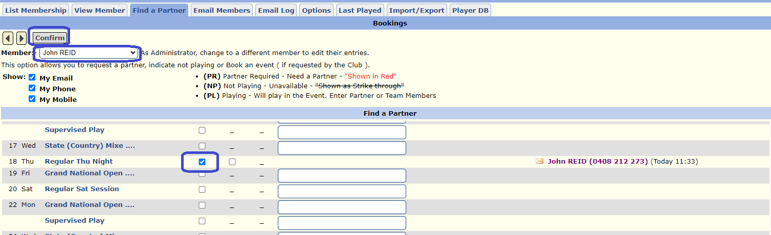

Membership->Email Members
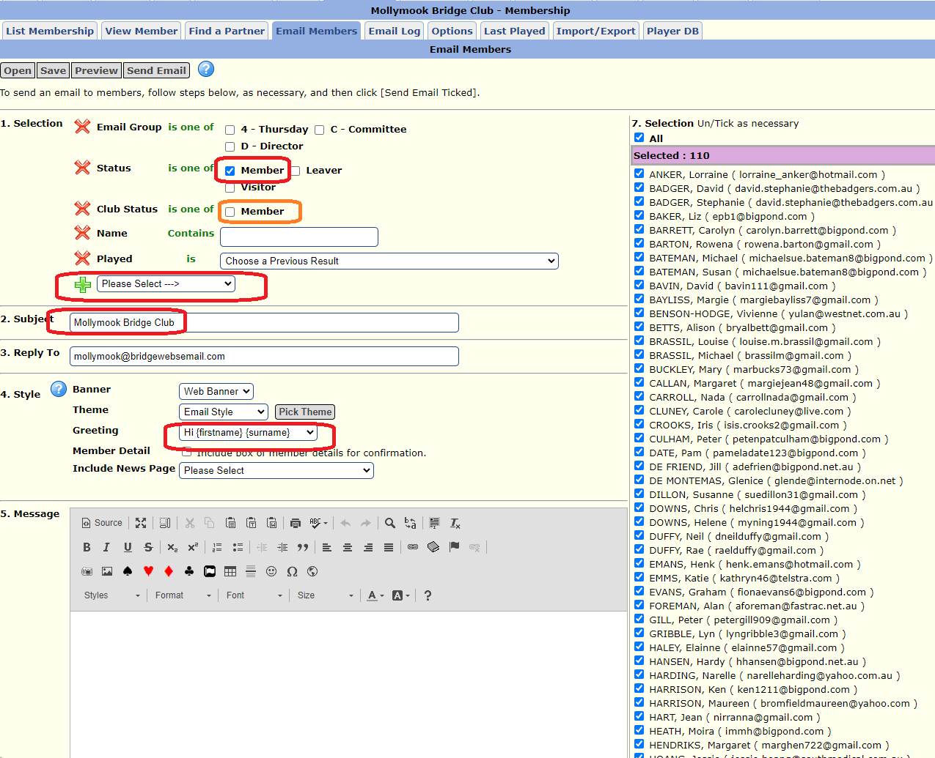
- Unless you know what you are doing, make sure that the Status field has Member selected (this is the default).
- For now, you can ignore Club Status (the two fields should produce identical results)
- If you want to restrict the distribution further, you can click on the green + sign to add a further filter (for example, you might just want to send something to the people with a Paid Status of Underpaid).
- Subject should always contain Mollymook Bridge Club – then add whatever suffix is relevant to your email.
- If you are creating a lengthy email, you might want to click the expand icon which is at the top second from the left – as working in the small screen area can be challenging otherwise. Same editor functions available as with news articles.

Membership->Email Log
Provides a list of all emails sent. You can click on View to see the contents of the email. NOTE the Blocked Emails lists users who have clicked Unsubscribe on a previous email or chosen to flag a previous email ad Junk. Instructions for allowing them to resubscribe can be found here

Membership->Options
Various config options

Membership->Last Played
Lists the last time that game data was uploaded for each member

Membership->Import/Export
Upload or download membership data. Please note – data should be treated as confidential. Downloading and then uploading a single members information may be an interesting way to recreate a member if she needs to be deleted and recreated (at one stage this was the only way to reinstate her account for receiving emails)

Membership->Player DB
Beyond me at this stage :p

Questions
What is the process to create a new MB List – is this a support request, or can we do it
What exactly is the Scoring Player DB (SPDB) vs the Bridgewebs Membership DB (BWMDB). How is each populated. We appear to only have populated the BWMDB

3.8 Attendance

Overview
The attendance module is principally the domain of the Treasurer. It allows the treasurer to manage all aspects of attendance and table money ins and outs.

Primary Users
All – view access to Attendance.
Treasurer – update access only

How to Use

Attendance->Overview
This page shows for each Month of the current financial year (or what period is set within Attendance/Options – ‘Start Period’) the total amount of table money received (Credit (+)) from members, versus the amount of table money charged against members accounts for the month (Debit (-)) based on the sessions played by them.
This Debit total for the month is further broken down of the right hand side into Sessions (updated when a session’s results are uploaded by director – aka Results Upload) and Input Manual Session (from Supervised play) e.g. January 2024 – Sessions ($1,780) plus Input Manual Sessions ($100) = Debit (-) total of $1,880.
Note the Credit (+) column is agreed and reconciled on an ongoing basis by the Treasurer, to the Table Money balance reflected in financial accounts for the month.
Note:- Total No represents the number of players that the Debit or Credit balance relates to e.g. Fri 22/3/24 – 22 players played and $88 charged. Table money received 14/3/2024 for $208, was from 6 players, however their TM was of differing value. Consequently, the total No. does not necessarily represent the members that played during the month.

Attendance->Summary
This tab provides a summary of the current monthly Debits (-) table money allocated to members for sessions played during that month vs Table money receipts, Credit (+), paid by members during the month. The figures shown for the current month selected reflect the breakup of the balances shown in the Overview tab for that month.
Beneath the Daily summary of sessions there is a listing of any ‘ONLINE’ entries made during the month. These entries can reflect cash received from Members and/or table fee allocation for sessions (e.g. Supervised play) that aren’t collected or recorded via the Results Upload and are entered manually by the Treasurer.

Attendance->Players
This tab primarily shows the financial status of members/ players, and facilitates the creation of an email for members whose table money balance has been exhausted and are now in a debit (they owe for sessions played) situation. This email advises members that their credit balance has been exhausted and that they are required to deposit some additional funds.
You can select any period from drop down menu.
The balance due Column reflects the Table Money paid in advance by individual members and provides a breakup of the balance shown in Overview tab with respect to the Bal C/F total for the month selected.
The system appears to be set at $20 debit balance as being acceptable – need to figure out what happens in system when this exceeded?

Attendance->Adjustments
This screen allows the treasurer to make manual adjustments when the Results Uploaded have incorrect names listed. This issue occurs very infrequently. To date, there have only been two issues which have required this modules use:
- Some Swiss Pairs events have the player names pre-loaded. This is fine for the first session of the event, but if in the second session of the event, if some players need to be substituted out/in; the player names uploaded will reflect the first session players and so some members will be incorrectly charged (see amendments required for 15th December 2023 as an example);
- With the move to compscore, the website does not easily reflect the final result and rankings for some multi-session masterpoint-scored events. After one multi-session event, the director decided to upload the final results to the website – with the undesired side-effect that all players were incorrectly charged for an additional session. This was corrected at the time via this module (see amendments for August 2023); but ideally Directors need to be advised not to upload additional sessions.
Note that once off incorrect name uploads (for example when someone recently entered her ABF number incorrectly and the results were attributed to another player) are corrected automatically when the corrected results are re-uploaded by the director.

Attendance->Name Check
Name matching is a bit of a nightmare between different systems; and it can be quite a challenge to get a person’s name in ABF, Compscore and Bridgewebs to match up. This screen shows the failures :p. Ultimately from a club perspective, the source of truth is the membership database – currently loaded in Bridgewebs.
When a person’s name uploaded from Compscore via the Results Upload doesn’t exactly match the expected name in Bridgewebs, the ABF number is used where available to try to match the result to the correct person in Bridgewebs; and an entry is created on this page for information to reflect the matching. If Bridgewebs is unable to correctly match up a name it will show up as No Match.

Attendance->Import
Allows for CSV file upload – not used at this stage

Attendance->Online
This is to be used only by the Treasurer
This allows the treasurer to enter payments, credit adjustments as shown below.
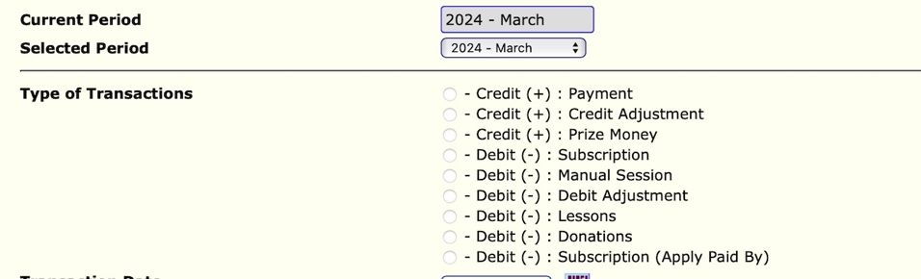

These transactions generally capture receipts of table money on the day or in advance by members. It allows that recording of sessions for which members attendance is not captured in the Results Upload (e.g. Supervised Play), allowing the debit of $4 for the session played.
*Refer Treasurer handover notes for detailed instructions to enter any adjustments and how they then reflected in the Clubs financial accounts.

Attendance->Options
This tab allows the committee to set a number of parameters with respect to the attendance module – including the setting of Standard session fee, visitors fees, and what members can see on their Payment tab in the member area.

Attendance->Member List
This tab provides a list of all members, visitors displaying their Bridgeweb (BW) status (eg Member, Leaver, Visitor) as well as their Paird Status (eg In Credit Underpaid etc)
By clicking on Name it will take you to the Membership/ View Member tab detailed earlier in document

Attendance->Email
This tab allows the Treasurer or Committee member to send out emails to members whose attendance summary show them as having a debit balance (they owe money for sessions played).

This is generally completed on a weekly basis and both ‘underpaid’ boxes should be ticked.
When ticked review names of members that email will go to ensure the system has correct selected the members whose balances are showing as owing to the club.
There are options to save, preview and then send email.
Also note that If the "Member Detail" is ticked in section 4, a summary of the latest balance and status will be merged into each member email together with a "Personal Link" to view the detail

Attendance->Help
This tab provides a little more information on some of the features of the Attendance module – limited value.

Attendance->Payments
This tab provides a general statement of why financial data for members should be kept on Bridge web and advises that members can pay the club for sessions played through the club bank account or by cash.

Attendance->Latest
Provides a summary of system update release notes specific to the attendance module – last update Feb 2022 – for reference only

3.9 Social

Overview
Bridgewebs provides the ability for members to add comments to certain pages. At present this is controlled on a page-by-page basis by the Social Module config within each news item

Primary Users
Site Admins

How to Use

Social->List
Lists any social comments received on pages

Social->Options
Toggle to turn on or off social comments as the default

3.10 Member Only
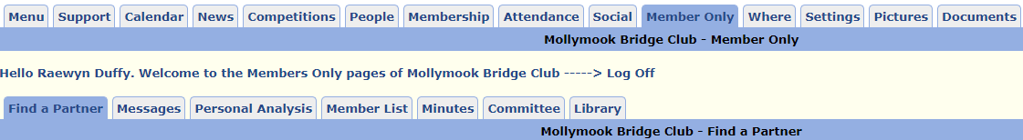

Overview
This just presents the Member Only page options for the logged in administrator (mollymook). No admin functions available per se. The only other useful function here is another means by which to Log Off :p

Primary Users
n/a

How to Use

Member Only->Minutes
Lists news items on the Minutes page

Member Only->Library
Overview of library and links to worksheet with all books categorised and rated.

3.11 Where

Overview
Maintain the information presented under the Where and When sub menu of the Information tab on the main menu.

Primary Users
Site Admins

How to Use

Where->Where & When

Where->Find Us

3.12 Settings

Overview
Various config relating to site presentation etc. I have included screenshots of current config settings in case of accidental loss or changes.

Primary Users
Site Admins

How to Use

Settings->Bulletin
Chuckle I had never used this before. If you add text here, it will be presented towards the bottom of the LHP. Remember to clear any text when it is no longer relevant.

Settings->Options
Various general config options
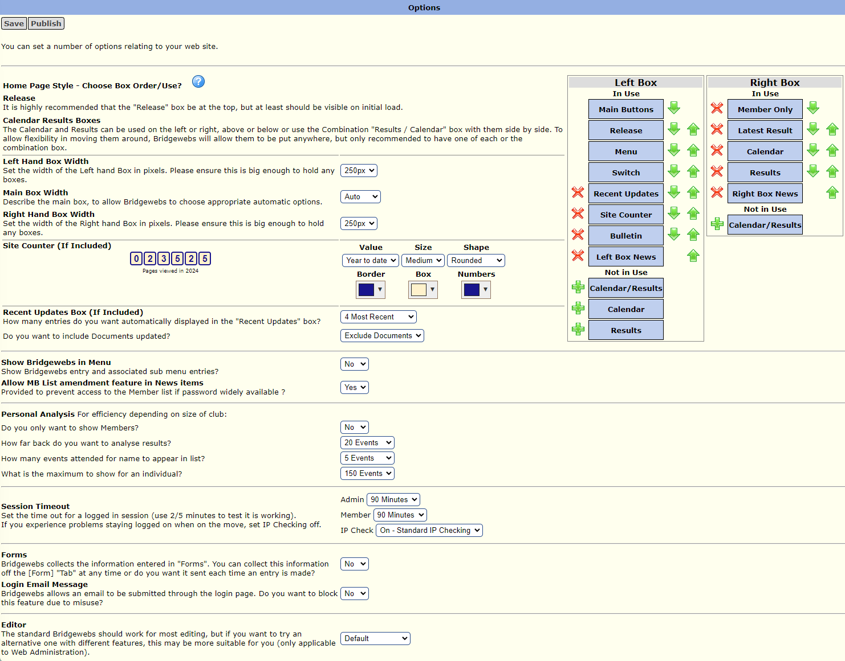
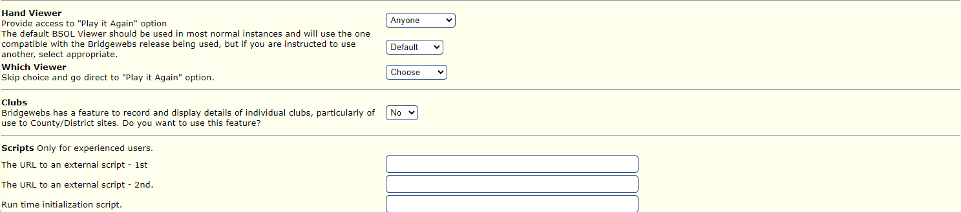

Settings->Members
Config related to member features
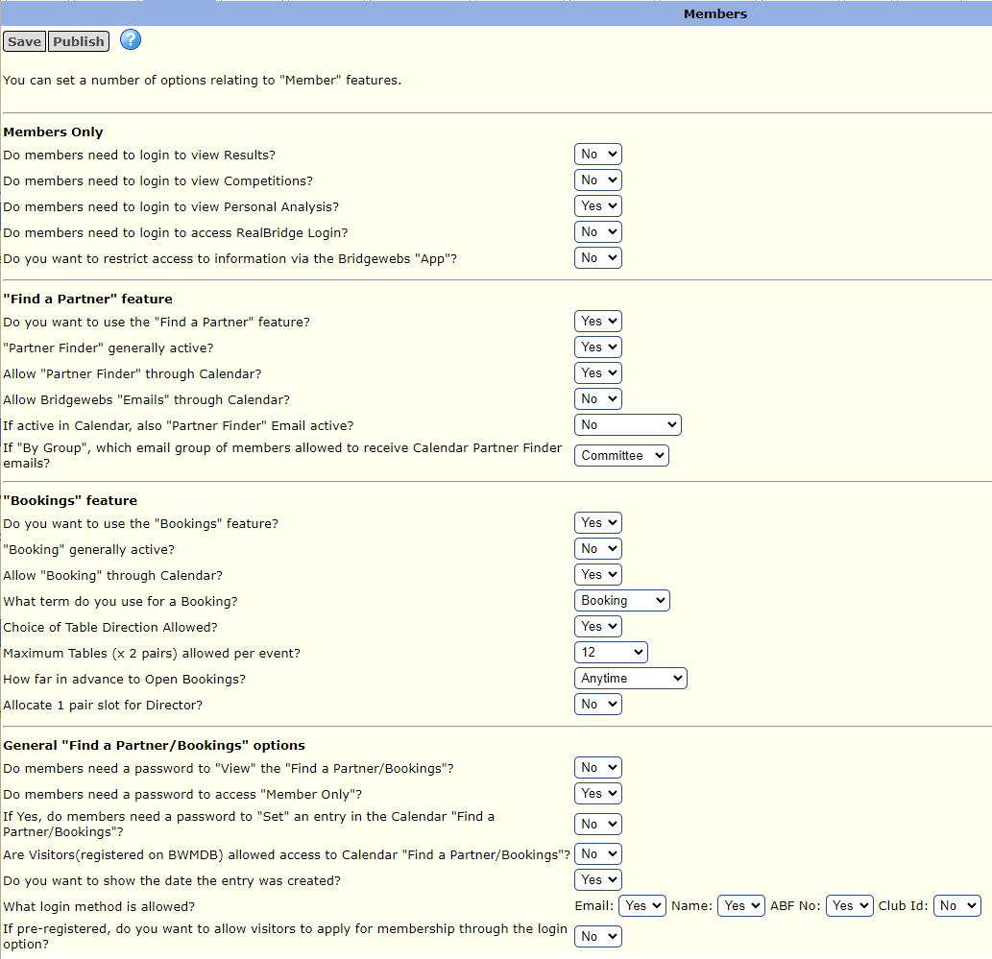

Settings->Scoring
Config options for presentation of scoring etc.
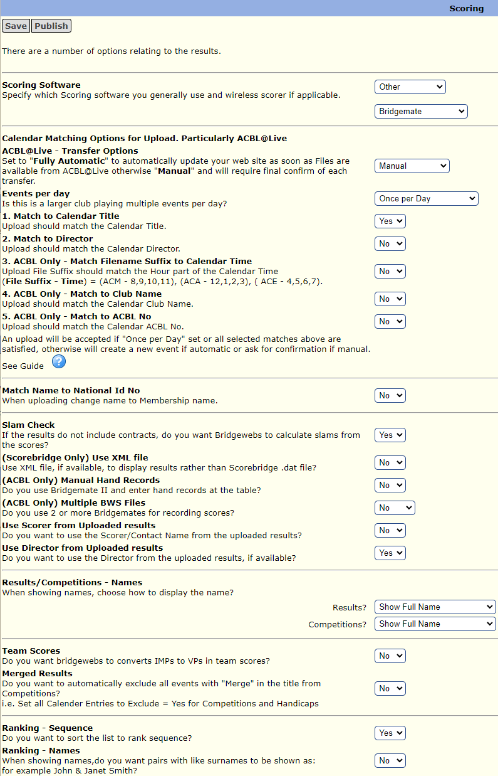
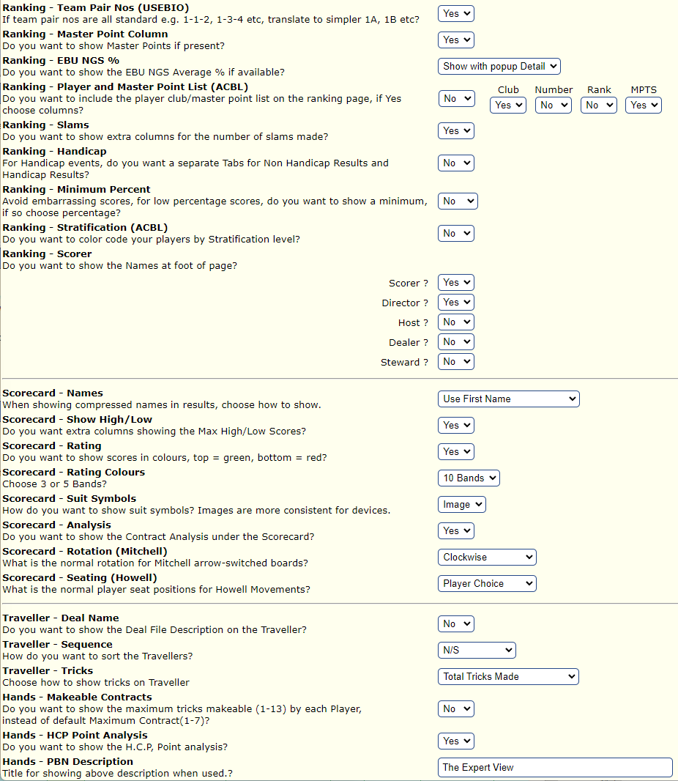

Settings->Site Style
Herein you can change the overall presentation of the site.

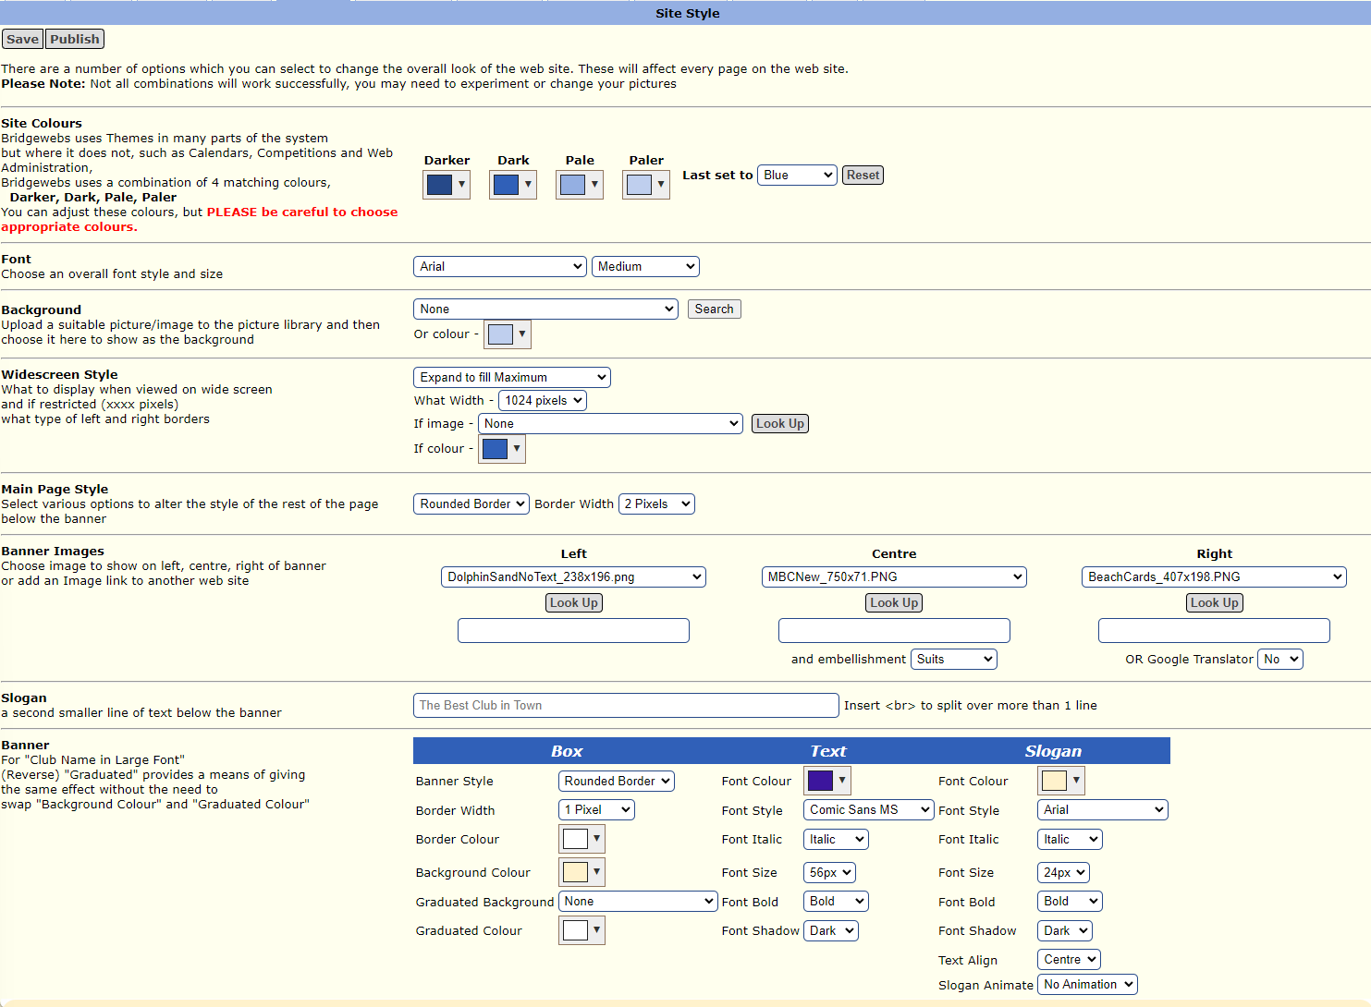

Settings->Results Style
Used to maintain format for results presentation.
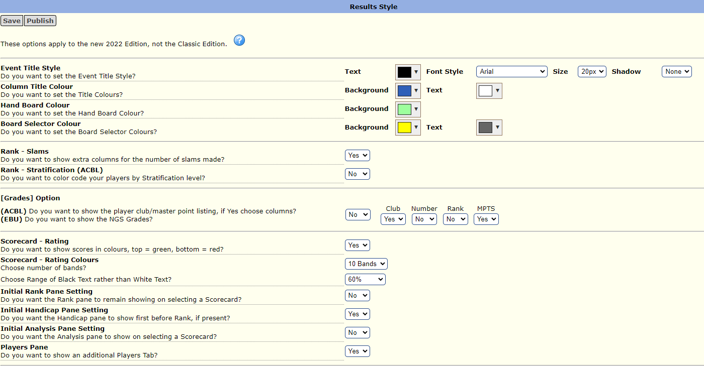

Settings->Site Details
Used to enter and update club information used by Bridgewebs.

Settings->Passwords
Change login passwords for Administrators and Scorers

Settings->Subscription
See Support->Subscription

Settings->Messages
See Support->Request

Settings->Spam
Lists messages flagged as spam

Settings->Support
See Support->Support Reply

3.13 Pictures

Overview
Used to upload and maintain images which can be used either on the site or included in emails.

Primary Users
All committee members

How to Use

Pictures->Picture Library
Lists all images. Unless the image is too large, it will show a thumbnail of the image, the date uploaded, the size in bytes and where the image is used on the site (if at all). Click on any image to have it displayed on the Pictures->Picture View page. Any images not used on website pages may be directly deleted from here.

Pictures->Picture View
Images are displayed here.

Pictures->Upload
When uploading, consider the naming convention for your image. Being consistent with existing naming conventions will help to keep related images listed alphabetically together. Similarly adding a date prefix in the form of yyyymmdd can be very useful for ad hoc pictures relating to events.

3.14 Documents

Overview
Used to manage the site’s document library. Wherever possible, uploaded documents should be PDFs if they are to be displayed on the site. .DOC is also supported – but you should be aware that some users may not have word installed and thus may not be able to read those documents. Note that content created in Microsoft Word can be saved in PDF format.
The two principal purposes for uploading documents to the site are to display on the site, or to send out as email attachments. Just try to remember to upload the document before you start writing your email or creating a news item :p

Primary Users
All committee members

How to Use

Documents->Document Library
The Used In column shows on what page a document is currently being used. Clicking on a document name will attempt to display the document on the Documents->View Document page (or if the doc type is not natively supported it will be downloaded by your browser)

Documents->View Document
Used when displaying a document

Documents->Upload
When uploading, consider the naming convention for your document. Being consistent with existing naming conventions for that document type will help to keep documents with similar content listed together. Similarly adding a date prefix in the form of yyyymmdd may be useful for some documents.
To upload a new document, click the Choose File button to bring up a file requester, find the document to upload and click Open; then click on the Save button at the top left of the page.

Minutes

Document Naming Standard
I propose that all minutes have a standard naming format of Minutes yyyy mm dd.pdf. For example Minutes 2036 03 25.pdf for the minutes of the meeting for 25th March 2026. Why ? Just go to the documents list and try to find something and you will quickly see the value.

Process
Save the minutes as type pdf (So assuming you are using Microsoft word: File -> Save As and select PDF in the second drop down (it will default to something like .DOC or .DOCX normally)
Upload that document to the website document repository (see notes above).
Now you need to include that document in the News area of the website:
Click on the News tab
Scroll down the list until you see the page entitled Minutes. Click on View Page to present the current page.
Click the Amend button on the top left of the Minutes news item.
Scroll down to the Minutes section in the text area of the page (down the bottom). You want to insert a blank line above the previous minutes and insert a link to the new document you just uploaded:
Place your cursor in front of the top Minutes link (it will be highlighted in blue and underlined, for example Minutes 2026 01 28.pdf), and press return to create a blank line.
Move your cursor to the blank line.
To insert a link to your new minutes document click on the book icon in the menu bar:
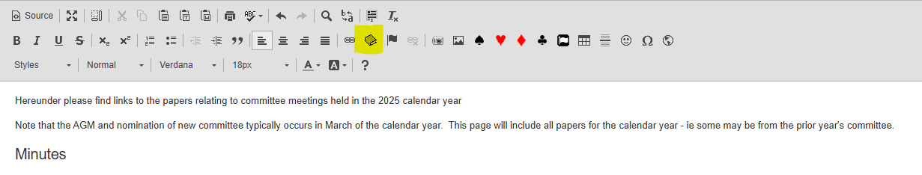
… and find your new document from the Document drop down list then click OK.
You now need to Save your changes by clicking on the Save button towards the top left of the page:
