The Club is Born
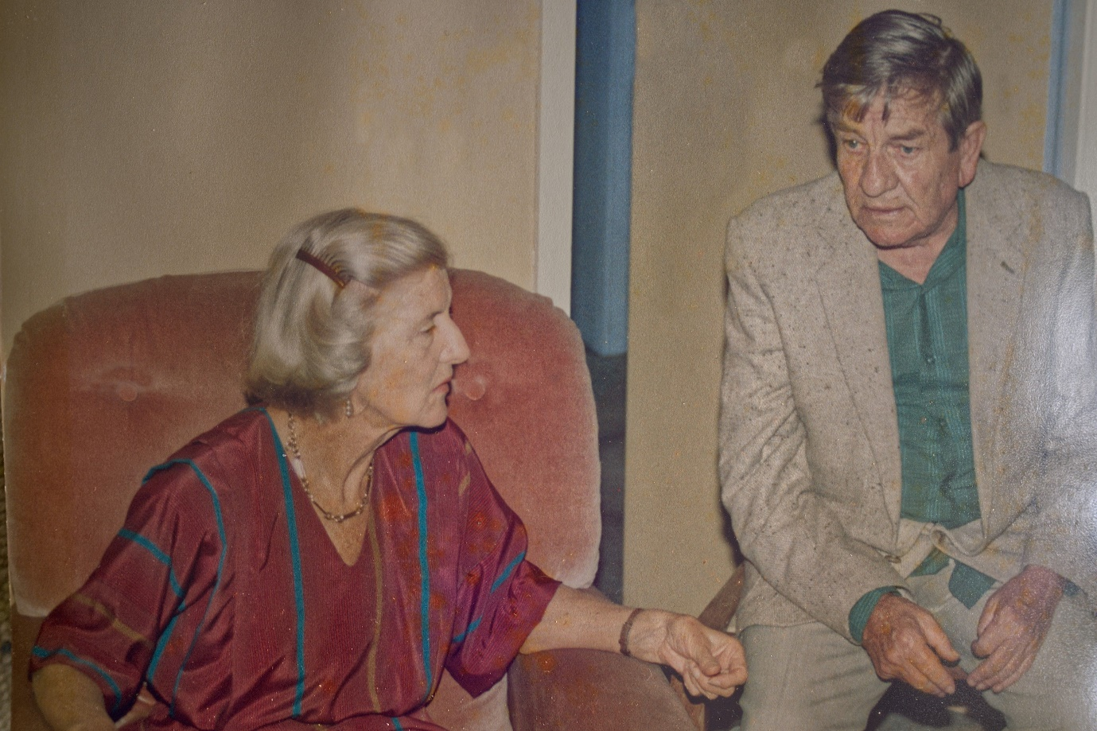
Ruth and Eugene Lumbers moved to Mollymook from Adelaide. Eugene, a freelance writer had adapted several works for TV and radio series, as well as writing a number of books. Ruth, born into a South Australian pastoral family, was a keen horse woman, and one of Eugene’s novels, A Taste for Blue Ribbons, was dedicated to a favourite horse of hers.
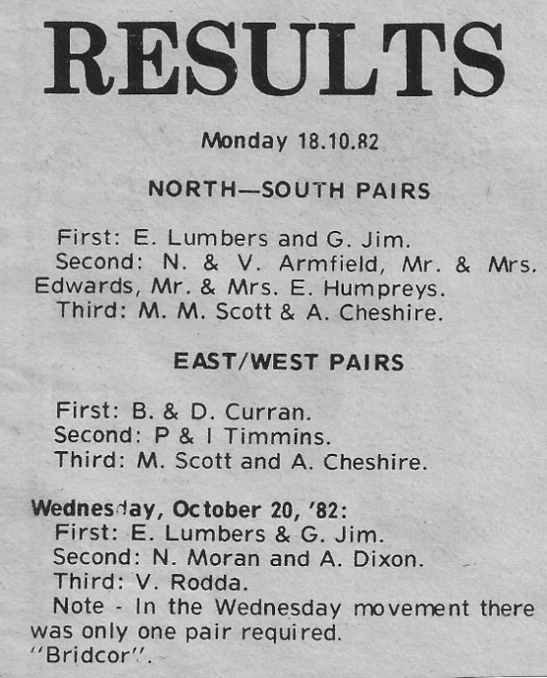
While Eugene was a competent bridge player, his interests generally lay elsewhere, Ruth on the other hand was not only a very talented and passionate bridge player, but also a tireless ambassador for bridge in the region. Towards the end of 1982, Ruth and Eugene started up a private bridge club, called the Mollymook Bridge Club and the first duplicate bridge game was held at the Mollymook Beach Bowling Club in early October 1982.
During the 1980s many of the club’s members also played at Nowra and Batemans Bay and Ruth was a well-respected player at all three clubs; recognised for fostering duplicate bridge in the region.
In the early years the club ran two sessions, one at the Mollymook Bowling Club on Wednesday morning at 09:30 (with around four tables) and the second at the Sarah Claydon Retirement Village on a Thursday night starting at 7:30 pm (with around two tables). Both sessions ran for three hours.

On June 21 1985 Mollymook bridge club was granted affiliation with the Australian Bridge Federation; and around this time the Wednesday morning session was moved to the Mollymook Surf Live Saving Club. By this time the club was averaging around seven tables on the Wednesday morning and around four tables on the Thursday night.
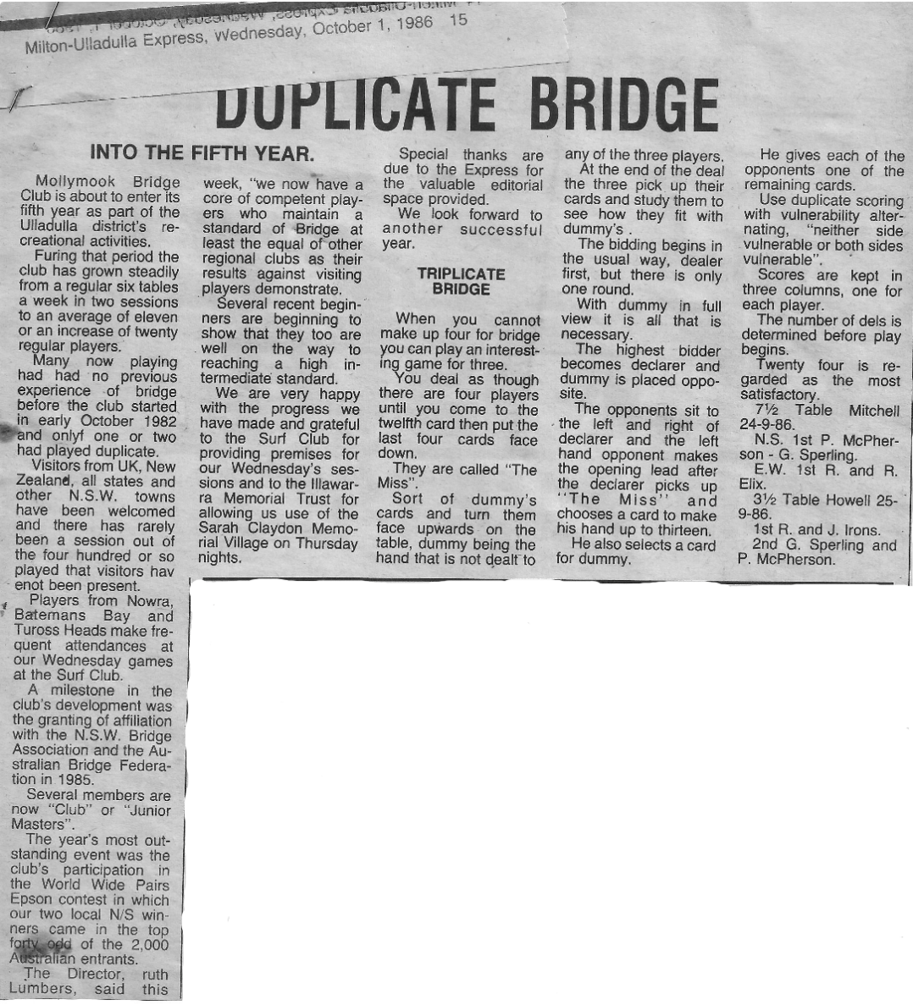
In Jan 1988 the Wednesday session moved to the Royal Coastal Patrol HQ on Ulladulla wharf and the Thursday evening session moved to Monday evenings, still at Sarah Claydon. At the end of March in 1988, the Wed morning session returned to the Mollymook Bowling Club.
Nance Tierney recalls:
When we took up residence in Mollymook in January 1989, the Mollymook Bridge Club was the property of Ruth and Eugene Lumbers. Ruth, a highly accomplished player, directed and Eugene did the scoring on his computer. If an odd number turned up, he would partner them, or he’d be quite content to pass the time reading.
Before proceeding I will describe the venues. On Monday nights, the session was held in the dining room at Sarah Claydon. A Mollymook doctor, Phil Timmins, a bridge player, was able to persuade the management to allow this. There were tables in place, and kitchen facilities available.
On Wednesday mornings, the ground floor of the Mollymook Bowling Club was the venue. All equipment (including tables) had to be brought in and taken out at the completion of the session. The Lumbers’ car was only a small one, so the boot was really crammed with card tables, cloths, boards, stationery, tea, milk, sugar, biscuits and a large teapot.
Early in December 1989, the Lumbers’ car crashed on the way back from Canberra. Ruth was killed instantly, and Eugene, though severely injured, survived till mid-January. On the night of the accident (a Monday) the night’s session was given over to mourning, and a decision was made to play on as usual and pass on the proceeds to Eugene when he recovered. Sadly, this didn’t come to pass.
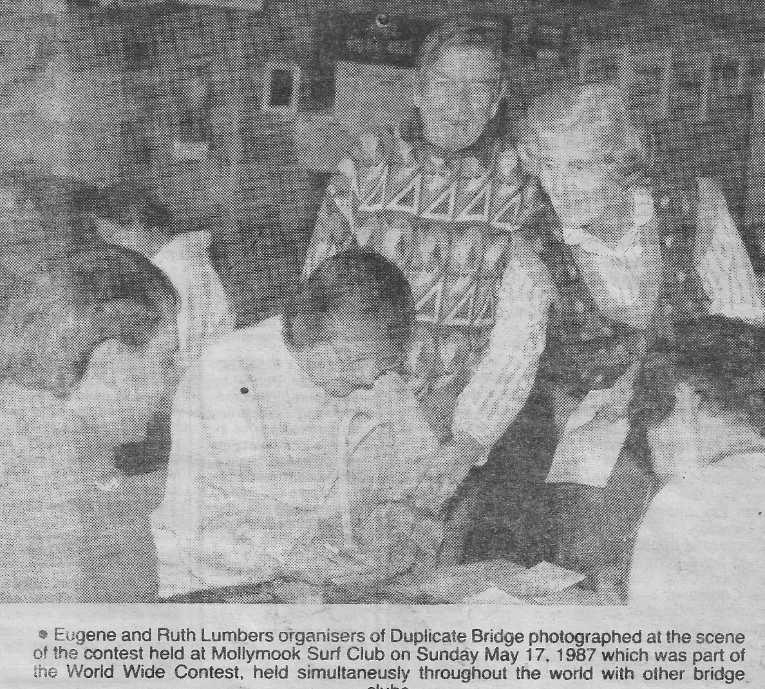

The Club is Incorporated
Ruth and Eugene’s daughter Eugenie offered the club's equipment to Ron Irons. Ron did not want to run a private club so, following a meeting on 23rd January 1990 at Pat Broben’s home, a committee was elected.
The first committee was as follows:
- President Ron Irons
- Vice President Les Hulbert
- Secretary Nance Tierney
- Treasurer Jo Smith
- Committee Betty Hulbert, Joyce Irons, Lorraine Deane (who taught herself to be masterpoint secretary and Len Bickel who did publicity)
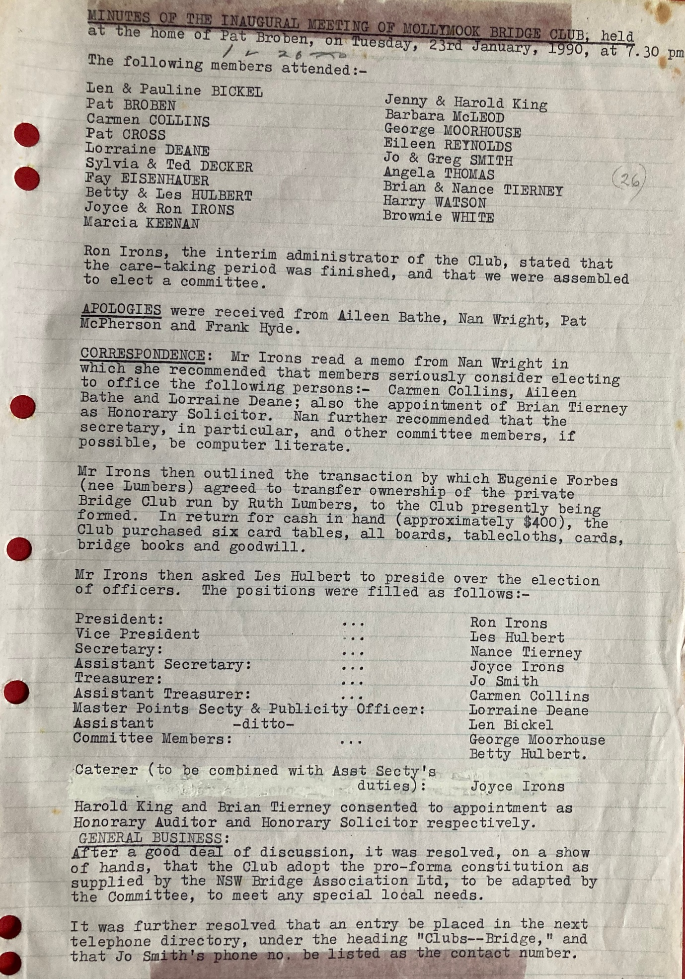
Kevin Farrell, Secretary of the Leeton Bridge Club, a regular visitor, and a top player, was present. At his suggestion a copy of the sample constitution provided by the NSW Bridge Association was obtained from Leeton and was adapted to local needs.
As Ron lived close to the Club, he used to bring all the implements (previously brought in the Lumbers’ boot) in his wheelbarrow. After a few months, the club managed to buy a second-hand wardrobe from Vinnies. Its innards were mostly removed so that the tables, boards, etc could be housed at the Club. It was stored in the vestibule section of the Gents’ Loo!
Ron, Les, George Moorhouse and Robert Mura did the Director’s course, and the following year Bill Samuel and Tony Howell did likewise.
With the loss of Ruth, there was no bridge teacher. Aileen Bathe took on this job, under the aegis of the U3A. Her first group of four were Betty Milstead, Myee McGinnis, Ida Bourke and Betty Greening. Soon after that, Tony & Ros Simpson and Arlie & Kell Martin joined the fray.
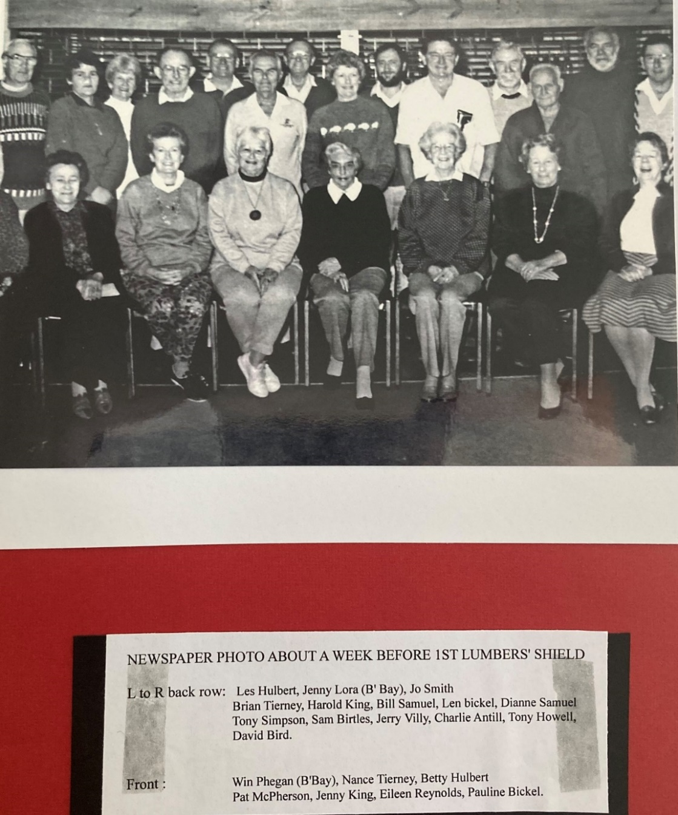
We were interested in enlarging the Club’s horizons and I described a fixture (the McCormack Shield) which was held twice a year between Leeton and Griffith with four teams from each club. The committee was agreeable that I write to Nowra, Bateman’s Bay and Moruya to suggest an annual competition with four teams from each centre. Moruya regretted that they couldn’t field four teams, but the others were enthusiastic. Thus was born the idea of the interclub event which we decided to name the Lumbers Shield

The first Lumbers Shield was held in 1991, and we felt that we were really on our way. Professor Eugenie Lumbers and James Lumbers attended the first presentation of the Shield, which was constructed by Tony Howell.

Mollymook Bridge Club won the first Lumber’s Shield in 1991, but since then, up until end of 2022, honours have been very evenly shared, with Nowra slightly edging out the competition with 11 wins, Mollymook with 10, Batemans Bay with 9 and covid beat all comers for two years in 2020 and 2021.

The Mollymook Bridge Club was officially incorporated on 17th December 1992.

Around this time the first Mollymook Congress was held. NSWBA records go back to 1994 and they do not record a congress in 1994, but do record a congress from 1995 onwards (1995, 1996 and 1997 all were held in May). KT recalls that there was at least one year after commencement, when the congress was not held but is not certain of the year, and Nance has a vague memory that it may have first been held in 1992 or 1993. All searches online have so far proved fruitless. For now, I will assume 1995 as the starting year for the congress, though it could have been a few years earlier than that.

A House is Built
Extract from 2007 Ten Year Anniversary Photo Album (@ Clubhouse):
At the end of 1991 Sarah Claydon asked the club to move as the noise of departing cards disturbed the residents. We then started playing at the Milton CWA hall and then at Bannisters Lodge at night and continued using the Mollymook Bowling Club on Wednesday mornings.
On 31 December 1991 a special meeting was called to explore the possibility of owning our own clubhouse.
For six years we battled with Council, the Local, State and Federal Members together with Sport and Recreation to be granted a piece of land on which to build. We even offered the Bowling Club the use of our club room if they allowed us to build an extension. The offer was declined.
Ultimately, we decided to bite the bullet and buy land ourselves.
We had $80,000 odd in the bank all raised from table money and three Christmas raffles – each of which raised just short of $2,000 [JR note: I thought there were lots of cake stalls etc also? – were these pre purchase, post purchase , both ??]
Eventually we bought 127 St Vincent Street Ulladulla on 4th April 1997. Certificate of title 30th May 1997
Cost of Land $45,000
Solicitor’s fees $839.75
Stamp Duty $677.50
TOTAL $46,517.25

This left a balance in the bank of $33,500.
The club secured a loan from the Colonial State Bank. Baylander Builders built the Clubhouse for $68.420 plus some extras. By the time we built, carpeted, installed blinds, bought tables and plastic chairs we had $9,000 in the bank.
When we realised the car parking area was red clay (and the mess it would make of our new carpet !!) it was decided to ask members for an interest free loan of $15,000 to cover the cost of a concrete car park and path around the clubhouse. One person offered $10,000 up front, however the committee decided it would be fairer to take advantage of all the offers made by members who were willing to loan $1,000 each. This duly happened, ten people gave $1,000 interest free for as long as required. All were repaid within two years.
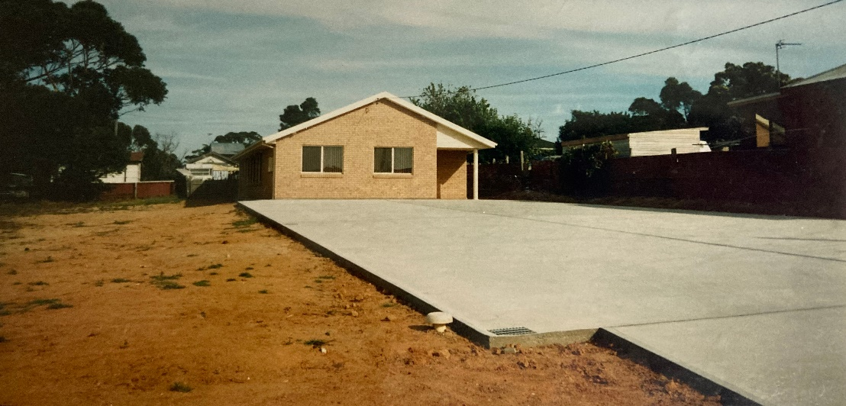
The bank loan was repaid within three years.
Then the air conditioner and instant hot water service was installed, a garden created, fences built, to say nothing of the equipment purchased, including new tables and chairs. The fridge, clock, notice board, sasanquas, TV and video, photos, pie oven, office desk and chair, the car park light and the Mollymook Bridge Club sign were all donated.
The labour of handypersons in the club is always free and much appreciated. The molymook Bridge Club Houose was opened on 12 December 1997.
Nance Tierney recalls
In the mid-1990s Dianne and Bill Samuel came to live at Mollymook and were responsible for fostering in the membership the ambition to own our own premises. Dianne in particular put in a lot of hard work to this end.
For their efforts in driving the vision through to actuality, for their formidable bridge capability (four times club champions), for Bill’s astute money management and for Dianne’s incredible tenures as president of the club (eleven times president), the Samuel Shield was established in their honour
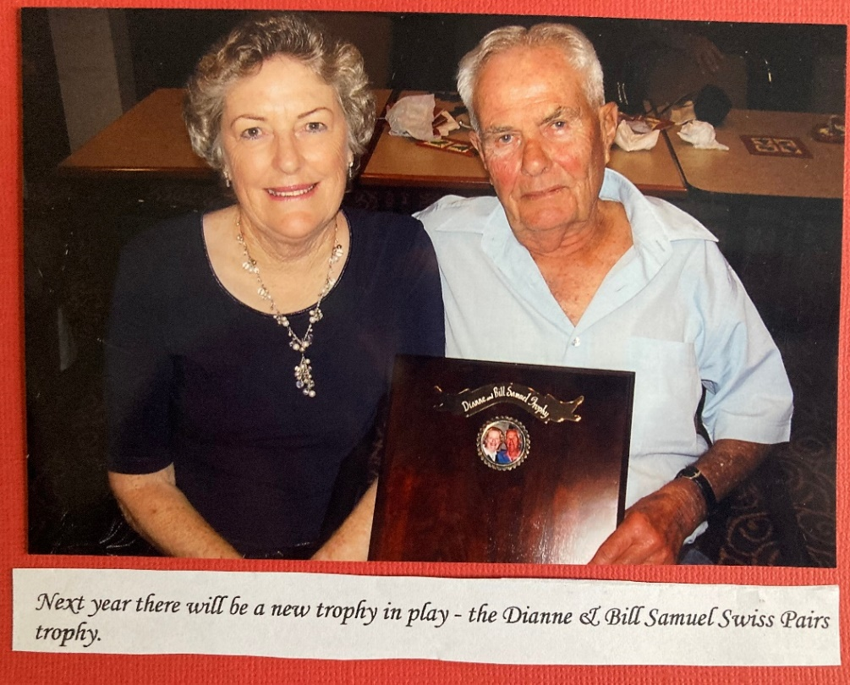

The Noughties and Beyond
In 2002 the first Mollymook Congress took place and the George Moorhouse Memorial Trophy for the highest placed Mollymook pair was established, won in that year by Mollie Gowing and Jo Smith
In 2009 the first Samuel shield was presented to Paul Daynes and Tony Rolfe
In 2016 Kevin Douglas built and presented the new championship board which adorns the ‘northern’ end of the club house. And in that year also new divisions for Intermediate and Novice players were created.
In 2022 new club championships for Rookie Pairs (each player with less than 5 MPs) and Classic Pairs (each player with less than 15 MPs) were established

Timeline
Date | Event | Source
Oct 1982 | Mollymook Bridge Club’s first game | Newspaper
June 1985 | Mollymook Bridge Club affiliated with ABF | Newspaper
Dec 1989 | Ruth and Eugene Lumbers fatal car crash | Nance
Jan 1990 | Decision to incorporate and first committee meeting | Club Records
Feb 1991 | First AGM held (see appendix for minutes) | Club Records
1991 | Dianne and Bill Samuel win the inaugural club championship | Honour Board
1991 | Inaugural Lumbers Shield Interclub event won by Mollymook | Honour Board
Dec 1992 | Molllymook Bridge Club incorporated. | Club Records
May 1995 | Inaugural Mollymook Congress | NSWBA Records
Apr 1997 | 127 St Vincent Street Ulladulla purchased | Club Records
Dec 1997 | Mollymook clubhouse opened | Club Records
2002 | George Moorhouse Memorial Shield established | Honour Board
2005 | President’s Trophy established | Honour Board
2009 | Samuel Shield established | Honour Board
2010 | Kevin Douglas built and presented the Mollymook Presidents Honour Board | Club Records
2013 | For the first time ever a Mollymook team won the teams event of the Mollymook Congress teams event. The winning team was Graham Evans - Tony Rolfe - Kevin Douglas and David Adamson | GE
2016 | Club Championship Honour Board built and presented by Kevin Douglas. Inclusion of Intermediate and Novice divisions | GE
2022 | Inaugural club championship event for Rookie Pairs and Classic Pairs | Honour Board
2023 | New scoring system (Compscore) effected together with a change to new web hosting | Committee Minutes
2023 | On the ten year anniversary of the first ever win, a Mollymook team again wins the Mollymook Congress teams event (just pipping another team which also included MBC members). The winning team was Kevin Tant - Graham Evans, Michael McTiernan and Ross Milbourne
2023 | Ros Simpson Trophy re-established | Committee Minutes

About this Document
This document compiled from a number of sources:
- Much of the early history is directly transcribed from Nance Tierney’s written history which focussed on the late 1980s and early 1990s, and supplemented with subsequent discussions with Nance.
- Monica Adamson’s club history book: Mollymook Bridge Club – the Early Years which can be found in the clubhouse.
- The history of the clubhouse was taken from the 2007 Ten Year Anniversary which can be found in the clubhouse.
- The photo of Ruth and Eugene was provided by their daughter Professor Eugenie Ruth Lumbers who also provided information about the early years of the club (as she and her husband Bill played at Mollymook bridge club when it was first started in 1982);
- Newspaper clippings from the Milton Ulladulla Express, mostly covering 1985-1989 but with some going back to 1982r, saved by Eugene or Ruth Lumber and discovered serendipitously by Ross Milbourne in 2022 when the new buyers of Eugenie and Bill’s many years previous residence found an old box labelled Mollymook Bridge Club containing 30+ year old documents and old newspaper clippings; which had really only been enjoyed by yours truly and an impressive collection of cockroaches and silverfish;
- The original unattributed (KT ?) history of the club which was on the web site;
- Many of the photos and extracts of club records were obtained from the photo albums stored at the clubhouse
- Honour Boards at the club house with names of Presidents and Club Champions and winners of trophies and shields
- https://www.janebadgerbooks-oldsite.co.uk/australia/lumbers.html for information about Eugene Lumbers writing.

Version
# | Who | When | What
0.1 | JR | Nov 2022 | Initial draft compiled from the sources listed above
0.2 | JR | Nov 2022 | Included memoirs from Genevieve Balzary
0.3 | JR | Feb 2023 | Updated honour board information and some of the noughties and beyond comments. Added Ruth Lumbers Shield winners from second shield
0.4 | JR | Apr 2023 | Updated Mollymook Congress information
TODO |  |  | Include the date of the second incorporation with ABF
 |  |  | Include info re eponymous awards

Memories from Past President Genevieve Balzary
July 9th 2010
I remember many happy times at the bridge club. I remember Di Samuel as the president prior to me. Di was extremely efficient and very knowledgeable. I remember her husband Bill who looked after our money as if it was our own. Darling Jo Smith was our gardener with Tony Simpson as her helper with many members donating plants and hours of help. Tony was also our masterpoints man while his lovely wife Ros was his constant help.
I remember Tony Howell who helped me become a director. He was all gruff but hidden kindness. Then there was George Moorhouse who wrote the committee a letter every month without fail. There were the two travellers Maureen and Maureen. Joy and Ron Irons were great members. Thanks Ron for helping me when I was a fledgeling director. Brian Tunney persuaded me to stick with bridge after a devastating start playing with Eileen Bathes. She shook her head in despair over me. I have improved Eileen but frankly you terrified me. You improved too I found ! Our Christmas parties were great fun. I did the “Ho Ho” basket, with little mars bars as prizes. One year I had one left and called for any man wearing red undies. I got a “Yes” and nearly a demonstration. I wont say who. There were lots of other people who played and worked for the club and helped me.
We held congresses at Mollymook Golf Club. We were told by Paul Marsden that it was the best congress outside of Sydney. We worked so hard. Some of our milestones were paying off our building. Having air conditioning. Getting a dealing machine. When I came to Queensland I went to the Redlands bridge club and found many old friends already there: Ruth and Gordon Peters, The Deckers – Sylvie and Ted, Ida Burke and Frank Hyde, Ron and Eileen Reu, Charlotte Krause.
Members have moved on since my time at Mollymook, but I remember fondly my time there.

Synopsis from Newspaper clippings of table numbers and locations
When | Tables | Where and when
May-83 |  | Mollmook Bowling Club Wed AM; Sarah Claydon Thu PM
Nov-84 |  | Mollmook Bowling Club Wed AM; Sarah Claydon Thu PM
Dec-84 |  | Mollmook Bowling Club Wed AM; Sarah Claydon Thu PM
Jun-85 | 5.5 and 2.5
Sep-85 | 7 and 3 | Mollmook Surf Club Wed AM; Sarah Claydon Thu PM
Jan-86 |  | Mollmook Surf Club Wed AM; Sarah Claydon Thu PM
Mar-86 | 5.5 and 2.5 | Mollmook Surf Club Wed AM; Sarah Claydon Thu PM
May-86 |  | Mollmook Surf Club Wed AM; Sarah Claydon Thu PM
Jul-86 |  | Mollmook Surf Club Wed AM; Sarah Claydon Thu PM
Oct-86 |  | Mollmook Surf Club Wed AM; Sarah Claydon Thu PM
Nov-86 | 7 and 4
Apr-87 | 7 and 3.5
Jun-87 | 7 and 4 | Mollmook Surf Club Wed AM; Sarah Claydon Thu PM
Jul-87 | 8.5 and 3.5 | Mollmook Surf Club Wed AM; Sarah Claydon Thu PM
Aug-87 | 7.5 and 3 | Mollmook Surf Club Wed AM; Sarah Claydon Thu PM
Sep-87 |  | Mollmook Surf Club Wed AM; Sarah Claydon Thu PM
Oct-87 | 7 and 4 | Mollmook Surf Club Wed AM; Sarah Claydon Thu PM
Nov-87 | 8.5 and 5 | Mollmook Surf Club Wed AM; Sarah Claydon Thu PM
Jan-88 |  | Sarah Claydon Mon PM; Royal Coastal Patrol HQ Wed AM
Mar-88 |  | Sarah Claydon Mon PM; Royal Coastal Patrol HQ Wed AM
Apr-88 |  | Sarah Claydon Mon PM; Mollmook Bowling Club Wed AM
May-88 |  | Sarah Claydon Mon PM; Mollmook Bowling Club Wed AM
Jun-88 |  | Sarah Claydon Mon PM; Mollmook Bowling Club Wed AM
Sep-88 |  | Sarah Claydon Mon PM; Mollmook Bowling Club Wed AM
Jun-89 |  | Sarah Claydon Mon PM; Mollmook Bowling Club Wed AM

Honour Boards
The honour boards were crafted and for almost all of their years, maintained by Kevin Douglas
President and Club Champions
Year | President | Club Champion Pair | Intermediate Pair | Novice Pair
1990 | Ron Irons
1991 | Les Hulbert | Bill Samuel - Dianne Samuel
1992 | Sylvia Decker | Sylvia Decker - Ted Decker
1993 | Antony Howell | George Moorhouse - Tony Simpson
1994 | Antony Howell | David Bird - John Schneider
1995 | Dianne Samuel | Jo Smith - Moira Sudlow
1996 | Dianne Samuel | Tony Howell - John Schneider
1997 | Dianne Samuel | Bill Samuel - Dianne Samuel
1998 | Nance Tierney | Jo Smith - Moira Sudlow
1999 | Dianne Samuel | Bill Samuel - Dianne Samuel
2000 | Dianne Samuel | George Moorhouse - Tony Simpson
2001 | Genevieve Balzary | George Moorhouse - Tony Simpson
2002 | Dianne Samuel | George Moorhouse - Tony Simpson
2003 | Dianne Samuel | Mike Covill - Tony Simpson
2004 | Dianne Samuel | Mike Covill - Tony Simpson
2005 | Dianne Samuel | Mike Covill - Tony Simpson
2006 | Dianne Samuel | Bill Samuel - Dianne Samuel
2007 | Dianne Samuel | Kevin Douglas - Graham Evans
2008 | Maureen Bromfield | Kevin Douglas - Graham Evans
2009 | Maureen Bromfield | Kevin Douglas - Graham Evans
2010 | Maureen Bromfield | Kevin Tant - Janet Turnell
2011 | Maureen Bromfield | Kevin Tant - Janet Turnell
2012 | Graham Evans | Kevin Douglas - Graham Evans
2013 | Graham Evans | Kevin Douglas - Graham Evans
2014 | Graham Evans | Kevin Tant - Janet Turnell
2015 | David Lardner | Kevin Tant - Janet Turnell
2016 | David Lardner | Kevin Douglas - Graham Evans | Michael McTiernan - Ross Milbourne | Moira Heath - Elisabeth Watt
2017 | Pam Date | Kevin Tant - Janet Turnell | Michael McTiernan - Ross Milbourne | Moira Heath - Laura Perino
2018 | Pam Date | Kevin Douglas - Graham Evans | Susanne Dillon - Susan Myers Bateman | Raewyn Duffy - Lauri Perino
2019 | Pam Date | Kevin Douglas - Graham Evans | Moira Heath - Laura Perino | Brad Dobson - Jacky Dobson
2020 | Moira Heath
2021 | Moira Heath | Peter Gill - Liz Sylvester | Susanne Dillon - Susan Myers Bateman | Jim McKenzie - John Reid
2022 | Ross Milbourne | Peter Gill - Liz Sylvester | Susanne Dillon - Susan Myers Bateman | Jim McKenzie - John Reid

Additional trophys and shields also adorn the clubhouse walls, the first Ruth Lumbers was constructed by Tony Howell, the remaining shields and trophies were crafted and maintained by Kevin Douglas:
Ruth Lumbers Trophy | Awarded to the winning team competing in the annual Ruth Lumbers Trophy Swiss Pairs event
George Moorhouse Memorial Shield | Awarded to the highest placed Mollymook pair competing in the Mollymook Congress
Presidents Trophy | Awarded to the pair winning the annual President’s Trophy event (for pairs winning a club match with the highest score greater than 65% in a year
Dianne and Bill Samuel Trophy | Awarded to the winning pair for that event
Ros Simpson Trophy | Awarded to the winning rookie + senior pair

 | Ruth Lumbers Trophy | George Moorhouse Memorial Shield | Presidents Trophy | Dianne and Bill Samuel Trophy | Ros Simpson Trophy
1991 | Mollymook
1992 | Nowra
1993 | Batemans Bay
1994 | Nowra
1995 | Batemans Bay
1996 | Nowra
1997 | Nowra
1998 | Nowra
1999 | Nowra
2000 | Nowra
2001 | Batemans Bay
2002 | Nowra | Mollie Gowing - Jo Smith
2003 | Batemans Bay | Dianne Samuel - Bill Samuel
2004 | Nowra | Mike Covill - Tony Simpson
2005 | Mollymook | Aileen Bathe - Graham Evans | Mike Covill - Tony Simpson
2006 | Batemans Bay | Tony Simpson - Mike Covill | Stephen Bird - David Bird
2007 | Batemans Bay |  | Tony Simpson - Paul Daynes
2008 | Nowra |  | Kevin Tant - Kevin Douglas
2009 | Mollymook | Pam Date - Kevin Tant | Graham Evans - Kevin Douglas | Paul Daynes - Tony Rolfe
2010 | Mollymook | David Adamson - Mike Covill | Paul Daynes - Tony Rolfe | David Adamson - Mike Covill
2011 | Batemans Bay | Kevin Douglas - Graham Evans | Monica Green - Ken Harrison | Graham Evans - Kevin Douglas
2012 | Mollymook | Margaret Hendriks - Lucy Robinson | Tony Rolfe - David Adamson | Graham Evans - Kevin Douglas
2013 | Nowra | Kevin Douglas - Graham Evans | Graham Evans - Kevin Douglas | Graham Evans - Kevin Douglas
2014 | Mollymook | Janet Turnell - Ron Turnell | Dianne Samuel - Bill Samuel | Tony Rolfe - Jim Tomas
2015 | Mollymook | Stepanie Badger - David Badger | Ross Milbourne - Jim Thomas | Nance Tierney - Ken Harrison
2016 | Mollymook | Vivienne Hodge - John Hodge | Pam Date - Kevin Tant | Graham Evans - Kevin Douglas
2017 | Batemans Bay | Louise Brassil - Michael Brassil | Michael McTiernan - Jim Thomas | Lucy Robinson - Tony Rolfe
2018 | Mollymook | Janet Turnell - Ron Turnell | Janet Turnell - Ron Turnell | Margaret Hendriks - May Powell  Henk Emans - Ian Barton
2019 | Mollymook | Graham Evans | Janet Turnell - Ron Turnell | Ross Milbourne - Kevin Douglas
2020 | Covid |  | Sue Tooth - Kevin Tant
2021 | Covid | Liz Sylvester - Peter Gill | Moira Heath - Kevin Tant | Graham Evans - Kevin Tant
2022 | Batemans Bay | Maureen Harrison - Ken Harrison |  | Lauri Perino - Kevin Tant
2023

In 2022 new club championships were introduced for Rookie Pairs (pairs each with less than 5 masterpoints) and Classic Pairs (pairs each with less than 15 masterpoints)
Year | Rookie Pair Champions | Classic Pair Champions
2022 | George Palavestra – Leigh Taylor | Ros Hughes – Chris Downs

Minutes of the first AGM (Feb 12 1991)
