Mollymook Bridge Club Directors Handbook - RealBridge

1. Overview 1
1.1 Components 1
1.1.1 RealBridge Admin Portal 1
1.1.2 RealBridge Event ‘server’ 1
1.1.3 Mollymook Website 1
1.2 Process Overview 1
1.3 Terminology 2
1.4 Version History 2
2. Process for RealBridge Session Management 3
2.1 Create Sessions 3
2.2 Create calendar event on MBC website 4
2.3 Configure Session Settings 4
2.4 Direct an Active Session 6
2.5 Export and Upload Results 6
2.6 Export Config for multi-session events 7
2.7 Update masterpoints 7

1. Overview

1.1 Components
There are three main components involved in providing a RealBridge session for MBC members:

1.1.1 RealBridge Admin Portal
This is where you create each session and the session’s login credentials (ie the links for players and directors).
URL: https://play.realbridge.online/club_admin.html
Access: to access the admin portal you will require the club Username and Accesskey.

1.1.2 RealBridge Event ‘server’
Each session has a unique URL, generated when you create the session in the RealBridge Admin Portal.
This is where users will login to play in a session, and (via a separate link) where the director will login to setup and manage the session and generate results for upload to the Mollymook website.
URL: will look something like https://oceania.realbridge.online/dw.html?p=250325225603&q=MFVD2146S1G6
Access: you can access via the link generated in the admin portal

1.1.3 Mollymook Website
The Mollymook website is used for two things, firstly to create calendar events for the sessions (which can include login links); and secondly to update the results upon completion of a session.
URL: Bridgewebs.com/mollymook
Access: you require website admin to update calendar and website director access to update results.

1.2 Process Overview
The next section will discuss these processes in detail.
Prior to the session:
- Create event in myABF (not documented)
- Create sessions in the admin portal
- Create calendar events on mollymook website
- Configure session settings
Session:
- Direct an active session
After the session:
- Export and Upload Results
- Export Config for multi-session events
- Update masterpoints

1.3 Terminology
Session | Refers to a single match or game
Event | A collection of sessions played as one multi-session event
Access Key | Really this is just a password

1.4 Version History
Ver | Date | Who | What
0.01 | 27/3/2025 | JR | Initial version
0.02 | 30/3/2025 | LS/JR | Changes per discussion Liz Sylvester and John Reid

2. Process for RealBridge Session Management

2.1 Create Sessions
NOTE: I would suggest having a standard naming convention for Session names and all access keys. For the purpose of this document, I will assume that there may be more than one division running in an event – and will be using:
Session description | MBCDiv[nnn]S[y] | Where nnn is the division name being either ONE or TWO and y is the session number. EG MBCDivOneS1
Player access key | MBCPKD[x]S[y] | Where x is the division number and y is the session number. Eg MBCPKD1S1
Dep. dir. access key | MBCDDKD[x]S[y] | Eg MBCDDKD1S1
Director access key | MBCDK2146D[x]S[y] | Eg MBCDK2146D1S1. Note that I have obfuscated the director key somewhat, as it could be otherwise deduced from the player key.
This makes it much easier to identify the session and access type which any link relates to.

This process is managed via the RealBridge Admin portal
From the RealBridge home page (https://realbridge.online/):
- click on the Club Admin link on the top right of the page
From the Club admin login page:
- enter the username and AccessKey for MBC and click Login
From the Club Admin page:
- Enter a session description (no spaces)
- Enter the player access key
- Enter the deputy director access key
- Enter the director access key
- Enter the session date
- Click Start session.

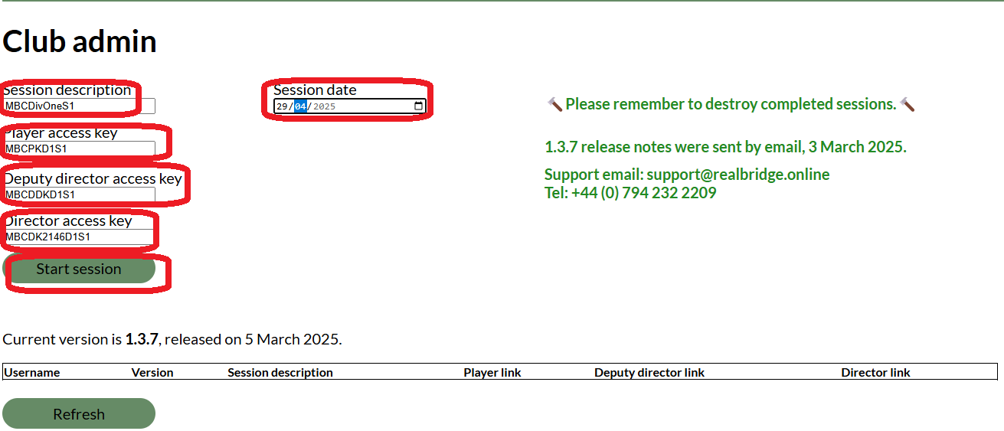

This will create the session and session links:

Don’t worry if you make a mistake, you can just click on the director link and destroy that session.

2.2 Create calendar event on MBC website
This can be done before or after creating the session in the admin portal. The only advantage for doing it after is that the player login link can be included at creation time. Note that this step will generally be managed by the MBC Event Coordinator – if that is not you; then you should provide her/him with the player links for each session.
Note to event coordinator:
- Fees = “Nil” (PS don’t set to 0 – use Nil)
- Online = RealBridge
- Online session # = Player link for session.

2.3 Configure Session Settings
Read
https://realbridge.online/main-director-guide.html. Sections
- Session Login Screen
- In the lobby: Director and Deputy Director view
- Session Settings Detail

2.3.1 Standalone Session or first session of multi-session event
NB: if this session is the second or subsequent session of a multi-session event refer to section 2.3.2

From the RealBridge home page:
- click on the Club Admin link on the top right of the page
From the Club admin login page:
- enter the username and AccessKey for MBC and click Login
From the Club Admin page
- Click on the Director Link for the session
- If necessary, identify this login as a director login (eg add (D) as a name suffix)
- Click login
From the landing page of the director session
- Enter the session name in the yellow banner – eg Molly Online Pairs Div 1 Game 1
- Enter the banner message – eg “Welcome to game one of the Molly Autumn Online Pairs”
- Click the + icon to create the expected number of tables
- Click on Session Settings button
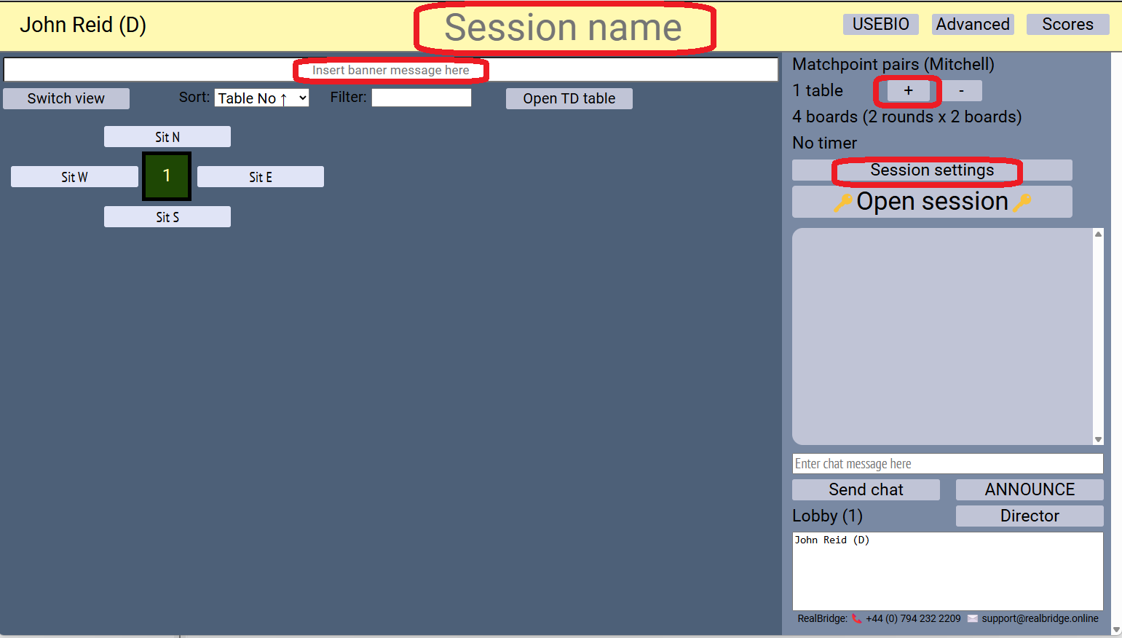

From the Session settings screen
- Scoring method = IMP Pairs
- Movement = Mitchell (2 winners)
- Boards per round = 12
- Number of rounds = 1
- Time = 90m
- Click OK
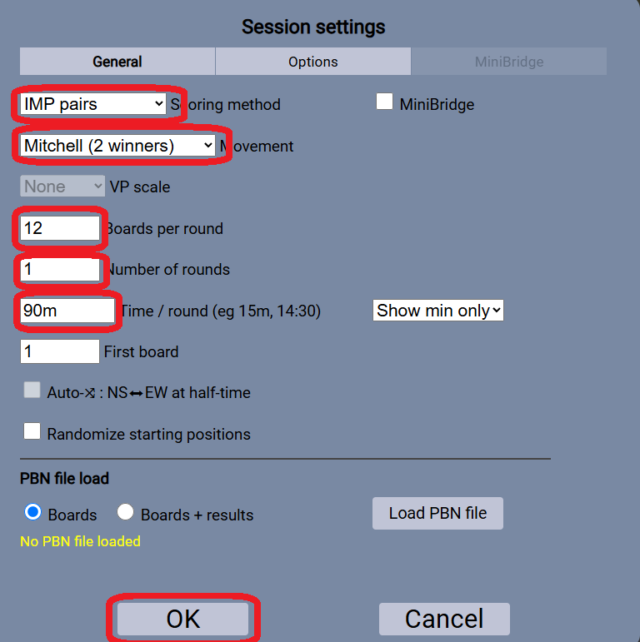

2.3.2 Subsequent session of multi-session event
From the RealBridge home page:
- click on the Club Admin link on the top right of the page
From the Club admin login page:
- enter the username and AccessKey for MBC and click Login
From the Club Admin page
- Click on the Director Link for the session
- If necessary, identify this login as a director login (eg add (D) as a name suffix)
- Click login
From the landing page of the director session
- Click Advanced at top right
From the Advanced director actions page
- Click Load & export
- Click Load Config file
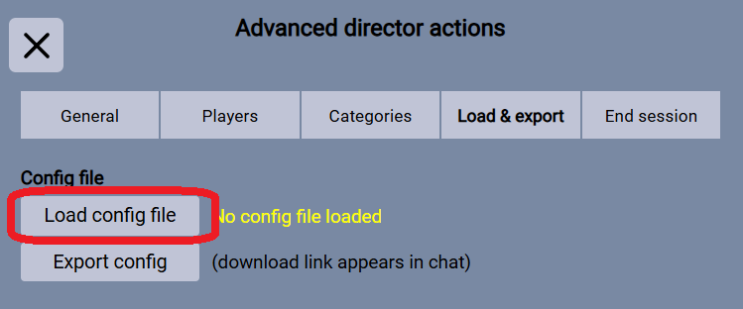
- In the file browser pop up find the config file produced in the last game, select it and click Open
- Close Advanced director actions window (X in top left)
From the landing page of the director session
- Edit the session name in the yellow banner – eg Molly Online Pairs Div 1 Game 2
- Edit the banner message – eg “Welcome to game two of the Molly Autumn Online Pairs”

If you need to adjust any of the reserved seatings (eg a substitute is playing this week):

From the landing page of the director session
- Click Advanced at top right
From the Advanced director actions page
- Click Players
- In the Remove player section find the reserved seating(s) which need to be deleted, and the click Kick player to lobby.
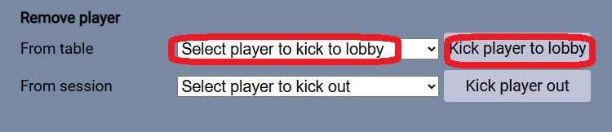

2.4 Direct an Active Session
Read:
https://realbridge.online/main-director-guide.html. Sections
- Advanced director actions
- Director settings
- Director calls
- Starting a game
- Game in progress
- Director utilities while sitting at a table
- Communication
- Commonly occurring requests for help

https://realbridge.online/advice.html
https://realbridge.online/broadcasts/

From the RealBridge home page:
- click on the Club Admin link on the top right of the page
From the Club admin login page:
- enter the username and AccessKey for MBC and click Login
From the Club Admin page
- Click on the Director Link for the session
- If necessary, identify this login as a director login (eg add (D) as a name suffix)
- Click login

The most common issue that you will encounter will be seating related. If reserved seating is incorrect (most commonly the player has logged in with a different name spelling); you can remove the reserved seating by going to Advanced -> Players -> Remove player from table (and selecting the reservation to remove)

2.5 Export and Upload Results
Read
https://realbridge.online/main-director-guide.html. Sections
- Exporting results, deals and bidding/play record

After all games are finished,
From the landing page of the director session:
- Click USEBIO
- (files available to download will be listed in the lobby chat window)
- Right click and save:
  - USEBIO file with play
  - PBN file
  - Player list
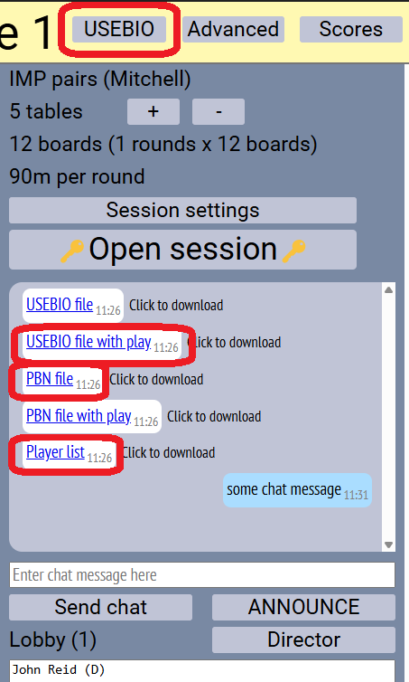

If you have director access to the website, upload the USEBIO file with play as a Results file and the PBN file as a Deal file. Otherwise provide these two files to someone with director access to website.

2.6 Export Config for multi-session events
Read
https://realbridge.online/how-to-run-multi-session-pairs.html

After all games are finished,
From the landing page of the director session
- Click Advanced at top right
From the Advanced director actions page
- Click Load & export
- Click Export config
- Click X to exit Advanced director actions
From the landing page of the director session
- Config file link will be listed in the lobby chat area. Right click and save. NOTE this is a critical file for the creation of the next session. If you are not responsible for creating the next session, make sure that other directors have a copy of this file.

While generally it would be recommended to now destroy this session; it is recommended for multi-session events that this session be retained until the next session is successfully up and running (just in case you need to re-generate the config file)

2.7 Update masterpoints
Masterpoints will be managed by the MBC Masterpoint secretary – Kevin Tant. Liaise with him as required.

