Mollymook Bridge Club Directors Handbook

1. Overview 5
1.1 Dealer 4 (D4) 5
1.2 CompScore (CS3) 5
1.3 Bridgemate Control Software (BCS) 5
1.4 Bridgemate Devices (BMs) 5
1.5 Dealmaster Pro (DMPro) 5
1.6 About this Document 5
1.7 Version History 5
2. Step by Step Instructions – Normal Session 7
2.1 Generate Random Hands and produce deal information (.pbn) for CS3 7
2.2 Deal Hands 7
2.3 Preparing Movement and Bridgemates 7
2.4 Launch and Monitor Session 8
2.5 Scoring and Shutting Down Session 10
2.6 Upload Hand Records to Web page 11
3. Common Issues 13
3.1 D4 13
3.1.1 Computer cannot communicate with Dealer4 13
3.1.2 Card Reading Error 13
3.1.3 Duplicate Card Error 13
3.1.4 Card Feeding Error 13
3.1.5 Redealing a Hand 13
3.2 CS3 13
3.2.1 Not using Bridgemates 13
3.2.2 CS3 is Accidentally closed down 14
3.2.3 Dealing with a Missing Pair 14
3.2.4 Correcting the Movement 14
3.2.5 Adding a New Player with an ABF number 14
3.2.6 Adding a New Player without an ABF number 14
3.2.7 Fixing Incorrect Scores after Session 15
3.2.8 Players failed to correct for Arrowswitch 16
3.2.9 Manually Entering Results from Travelers 16
3.2.10 BCS accidentally closed down during a normal session 18
3.2.11 BCS accidentally closed down during a Swiss Pairs session 19
3.2.12 Downloading the latest ABF Masterpoint file 19
3.3 BCS 20
3.3.1 Checking Suspicious Contracts 20
3.3.2 BCS Accidentally Shut Down 20
3.3.3 Not connected to Bridgemate Server 21
3.3.4 Battery Warning Light is On even when BCS is connected to Computer 21
3.4 Bridgemate Devices 21
3.4.1 Bridgemate Device stops working 21
3.4.2 Hand PASSED IN 22
3.4.3 Hand NOT Played 22
3.4.4 Bridgemate not showing right score 22
3.4.5 Entering Adjusted Score: Bridgemate Device 22
3.4.6 Invalid Lead Card or Declarer 22
3.4.7 How to change table number or Section on Bridgemate 23
3.4.8 TABLE NOT YET ACTIVATED 23
3.4.9 SYSTEM NOT YET ACTIVATED 23
3.4.10 TABLE STARTED BY ANOTHER BRIDGEMATE 24
4. Movements 25
4.1 Preferred Movements 25
4.1.1 Rover Mitchell Setup 25
4.2 Half Table Movements 25
5. Advanced Sessions 27
5.1 Multi Session Events 27
5.1.0 NBB 27
5.1.1 About 27
5.1.2 Run the individual Sessions 27
5.1.3 Identify and Tag any Substitutes 27
5.1.4 Create the Multi 28
5.2 Ruth Lumbers Trophy Swiss Pairs 31
5.2.1 Background 31
5.2.2 Event Details 31
5.2.3 Preparation 31
5.3 Interclub Swiss Pairs 31
5.3.1 Background 31
5.3.2 Event Details 31
5.3.3 Preparation 32
5.4 Dianne and Bill Samuel Trophy Swiss Pairs 32
5.4.1 Background 32
5.4.2 Event Details 32
5.4.3 Preparation 32
5.5 Swiss Pairs Event (Multiple Sessions) 33
5.5.0 NBB 33
5.5.1 Preparation 33
5.5.2 Setup Event Parameters 34
5.5.3 Create Blank Pairs 35
5.5.4 Start Session 1 Match 1 35
5.5.5. Run Session 1 Match 1 36
5.5.6. Finalise Match 1; Generate Draw for Match 2 37
5.5.7 Session 1 Match 2 37
5.5.8 Session 1 Match 3 38
5.5.9 MBC Half-Day Event Played over Multiple Days 39
5.5.10 Session 2 Match 1 (aka Match 4) 39
5.5.11 Session 2 Match 2 (aka Match 5) 41
5.5.12 Session 2 Match 3 (aka Match 6) 41
5.5.13 Calculate Masterpoints 41
5.5.14 Export Results to Website 42
5.5.15 Printing Results Manually 43
5.5.16 Loading Deal File for a Swiss Pairs Match 44
5.5.17 Amalgamating Swiss Pairs Results 45
5.5.18 Adding Substitutes 46
5.6 Single Session Swiss Pairs – Walk up Event 48
5.6.0 NBB 48
5.6.1 Setup Event Parameters 48
5.6.2 Setup Pairs 49
5.6.3 Prepare and Run Match 1 49
5.6.4 Run Match 2 50
5.6.5 Run Match 3 51
5.6.6 Run Match 4 51
5.6.7 Calculate Masterpoints 52
5.6.8 Export Results to Website 52
5.6.9 When Things go Wrong 53
5.7 Running Multiple Sections in One Session 54
5.7.0 NBB 54
5.7.1 Generate and deal hands 54
5.7.2 Setup Bridgemates for section B 54
5.7.3 Configure CS3 for Section A 54
5.7.4 Configure CS3 for Sections B onwards 54
5.7.5 Manage Sessions and Finalise 55
5.7.6 Reconfigure Bridgemates used for Section B 55
5.7.7 Using different Deals files for Sections 55
5.8 Supervised Play Sessions 55
5.9 Country Teams Club Qualifying Session – NO half table 56
5.9.1 Initial Setup 56
5.9.2 Match 1 58
5.9.3 Match 2 – Match 5 59
5.9.4 Finalising the Results 59
5.10 Country Teams Club Qualifying Session – with half table 61
5.10.1 Initial Setup 61
5.10.2 After each Match (aka Round) 62
5.10.3 After the Final Match 63
5.10.4 Calculating the Masterpoints 64
5.10.5 Half Table Movements 64
5.9.5 Calculating Masterpoints 70
5.11 Grand National Open Teams Club Qualifying Session 70
6. Business Continuity Plans 71
6.1 PC Failure 71
6.2 Dealer 4 hardware failure 71
6.3 Internet unavailable 71
6.4 Bridgemate Server Failure 71
6.5 Power outage 72
7. Data Files 73
7.1 PBN 73
7.2 BWS 73
7.3 XML 73
7.4 Log Files 73
7.5 BRI 73
7.6 DUP 73
7.7 TXT 73
8 Software Information 74
8.1 Dealer 4 74
8.3 Compscore 3 74
8.4 BCS 74
8.1 DMPro 75
9. Managing Masterpoints 76
9.0 Overview 76
9.1 Green Masterpoints 76
9.2 Red Grade B4c and B5i MasterPoints 77
9.3 State and National event Masterpoints 77
9.4 Creating a manual file 78
9.5 Uploading Masterpoints to ABF Masterpoint Centre 80
Appendix 1: Rover Mitchell instructions for moving pair 81
Appendix 2: Masterpoint Grades 82
Appendix 3: Masterpoint Calculations 82
Session Awards 82
Outright Awards 82
Swiss Pairs Winner Awards 82
Appendix 4: Boards to Use 82
Appendix 5: Events Synopsis 83
Appendix 6: Clubhouse Maintenance 87
Bridgemates 87
Dealer4 87

1. Overview

1.1 Dealer 4 (D4)
This software is used to produce randomise hands, produce the .PBN files used by Compscore to load hand records and is also used to control the Dealer 4 hardware to deal out the cards into the required hands. Note that you can also print out Traveller cards from Dealer 4.

1.2 CompScore (CS3)
Used to set up and manage the movement, invoke the bridgemate server software, score the event – taking results from the Bridgemate database. Produces .XML file which is used to load the results to the website.

1.3 Bridgemate Control Software (BCS)
BCS provides movement and player information to the BM devices and receives result information from same. Reads session info from the BWS file created by CS3 and updates the BWS file with results as they arrive from BM devices. NB: this software is started automatically by CS3 when the event is started. Previous BWS files can be loaded into BCS to restore a previous session.

1.4 Bridgemate Devices (BMs)
These are the handheld devices located on each table, used by the players to score each hand and confirm movements. Players enter their ABF numbers into the BMs, which in turn update BCS. Player names are then loaded into CS3 when the director loads names from devices (after play has started)

1.5 Dealmaster Pro (DMPro)
This software is no longer required. The functionality is managed by Dealer 4.

1.6 About this Document
This document compiled from a number of sources. Step by Step instructions were adapted from earlier instructions written for use with ASE9 by Graham Evans and Kevin Tant. Remaining chapters were in the main a collaboration between Kevin Tant and John Reid, with review and advice from other MBC directors including Ken, Lauri, Ross, Tony and Graham. This document prepared on behalf of the Mollymook Bridge Club [Club ID 2146]. Abbreviations used in this document:
- [<option>] means click this option on the screen
- D4 Dealer 4
- CS3 Compscore3
- BM Bridgemate Device
- BCS Bridgemate Control Software

NB: Each new section should start on an odd numbered page – to make it easy to rewrite and print any section in isolation.

1.7 Version History
Ver | Date | Who | What
0.01 | 1/11/2022 | KT/GE  JR | Based on the director’s handbook written by Kevin Tant and incorporates step by step instructions written by Graham Evans
0.02 – 1.08 | 3/11/2022 – 1/10/2023 | KT/JR | Added multi session events  Added Swiss Pairs  Added Swiss Pairs Ad Hoc event  Added Supervised Pairs session info  Added File format section  Added info on running Country Teams qualifying sessions and GNOT session  Added cleaning instructions for bridgemates and dealer4  Added synopsis of annual events and director instructions  Multiple updates for Swiss Pairs
1.09 | 11/10/2023 | JR | Updated instructions for manually creating a session from travelers
1.10 | 6/11/2023 | JR/KT | Removed Appendix 7 Screenshots to a separate document to reduce document size  Created new section for Ruth Lumbers Trophy Swiss Pairs; Interclub Swiss Pairs and Samuel Trophy with overviews to each of these events  Updated Swiss Pairs Event (Multiple Sessions) with notes from KT.
1.11 | 28/11/2023 | JR/KT | Added note about battery warning light on BCS
1.12 | 16/12/2023 | JR | Samuel Trophy: added notes about adding subs, editing dates on results and a possibly better way to capture sub names on second day.
1.13 | 21/3/2024 | JR/KT | Updated Country Teams Club Qualifying process for even numbers of tables (ie no half table). Need to confirm process used for half tables – though I think KT was suggesting that the same process could be used.
1.14 | 27/5/2024 | KT/JR | Changed pagination so that new sections all begin on a new page – to simplify updating any section (less printing). Updated the Country Teams/GNOT documentation per new process for even numbers of tables.  NOTE: generally we want each new section starting on an odd-numbered page, when adding to this document, check that each subsequent chapter is still starting on an odd numbered page
1.15 | 16/7/2024 | KT/JR | Added setup instructions for 7.5 table rover mitchell
1.16 | 30/7/2024 | KT/JR | Updated section 5.5 Swiss Pairs multi session info
1.17 | 6/8/2024 | JR/KT | Slight amendment to section 5.5 and 5.6 re swiss pairs:  Per advice from KT, clarified when to generate results files between sessions; and  corrected info re process for including the deal files.
1.18 | 8/8/2024 | JR | Updated 5.5 Swiss Pairs multi session following test run on 7th Aug.
1.19 | 22/2/2024 | KT/JR | Updated for changes to card dealing process (ie use Dealer4 to create .PBN files)  Removed most of the screen shots in section 2.  Removed references to .DUP files as these are no longer required
1.20 | 11/3/2025 | JR | Updates to section 5.9

2. Step by Step Instructions – Normal Session
Turn on Computer and login as Mollymook Bridge Club (2146)

2.1 Generate Random Hands and produce deal information (.pbn) for CS3
Where | Action Required | Defaults/Comments
Desktop | Open Dealer4 | Make sure that the Dealer4 device is connected to computer with USB connector and to power.  Note that there is no initial indication that the device is powered on
D4 Main Menu | File (top left) -> [New] | NB: for some of the more social club games (eg Pro-Ams) you *may* wish to check that there are not some really one-sided distributions – you can click Show Statistics to see the statistical analysis; and if one of the seats has a significant disadvantage, you may want to redeal. You should not consider this for any competitive events.
D4 Generate New Boards Set | Click Generate Boards using BigDeal (bottom middle). Then click Exit. | Leave other settings at default
D4 Main Menu | Click Analyze | This generates the makeable contracts information for each hand
D4 Main Menu | File (top left) -> [Save] | Save the hand information in portable bridge notation (PBN) format – to be later loaded into CS3. For filename, use dayofweek and date – eg Mon23.pbn  Directory is C:\Compscore3\Web\Deal Files

2.2 Deal Hands
Where | Action Required | Defaults/Comments
Desk | Set out boards for shuffling | Make sure that boards are in the correct order.
D4 Main Menu | [Deal] (2nd from left) | Green laser that reads cards should come on for a second  Make sure that two or three packs of alternating colours are in the hopper
Dealing Boards | Empty Board 1 cards and put in hopper  Push empty board into tray | Repeat process for all boards  Make sure that boards are firmly clicked shut (three spots)  Boards are loaded in trays with bumpy bits facing up
Dealing popup | Do you wish to move to the first board [No] | After all boards are dealt, dealing popup appears
Dealing Boards | [Exit]
D4 Main Menu | File -> Exit | Actually leave it running in background in case you need to redeal a hand.

2.3 Preparing Movement and Bridgemates
Where | Action Required | Defaults/Comments
Desk :p | Plug in Bridgemate Server | USB cable (confirm orientation) from the computer  Lights will come on.
Desktop | Click CS3 icon | Red Heart
CS3 Main Menu | Click +New (top left)
CS3 New Session/Event | Click New Session (top right)
CS3 Session Setup | Select the deal file (use drop down) and enter Director’s name or initials | 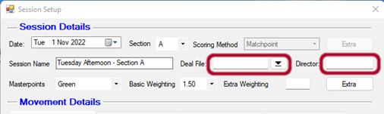
STOP | Be Patient :p | You can’t proceed until you know how many tables will be in this session. Check Section 4.1 Preferred Movements
CS3 Session Setup – Mitchell movement | Update:  - Number of Tables;  - Highest Board Number;  - Number of Rounds,  - Boards per Round;  - Half Table,  - Movement and then  - Apply. | For a Two winner Mitchell movement:  NB: if there is a half table, determine S/O direction and then enter pair number for the sitout (see SS 4b)  NBB: if you are not using the bridgemates, tick the Manual Scoring box at lower left.
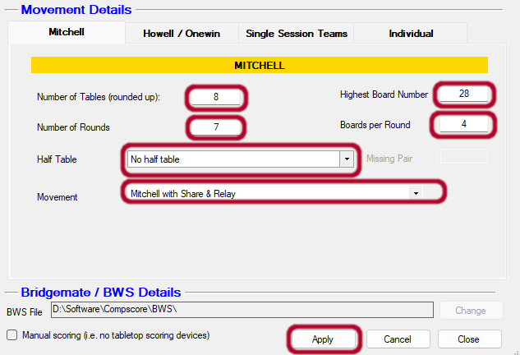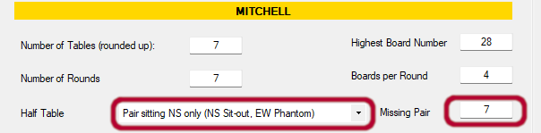
CS3 Session Setup – Howell movement | Update:  - Movement Template  - Boards per Round;  - Half Table and then  - Apply. | If this is going to be a Howell or a single winner movement  NB: if there is a half table, you need to provide the missing pair *number*. The easiest way to determine the missing pair number is to press Show and look at the movement.
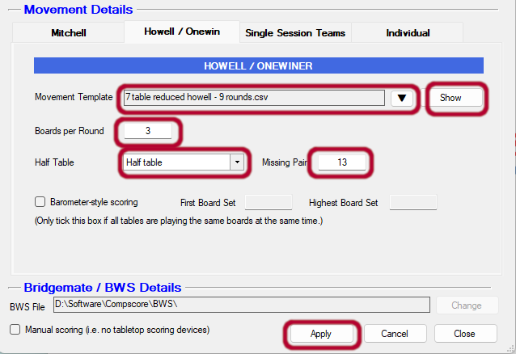
CS3 Confirm Movement requester | Review the movement information and if correct press Yes

2.4 Launch and Monitor Session
Where | Action Required | Defaults/Comments
CS3 Session Management | Launch | This will invoke BCS – though BCS will be minimised  NB: You will manage the entire session from this screen now  NBB: If at any time you close this screen, don’t panic. From the main screen select Open (second from left); then choose the session.
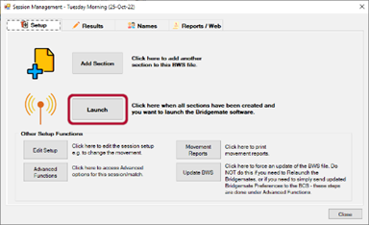
Desktop | Maximise BCS | Find the BCS icon in the taskbar at the bottom of screen and click it (or hold down the Alt key and press Tab until the BCS screen is highlighted)
BCS Main Menu |  | Confirm that number of tables is correct  Bridgemates are now active and users can enter ABF numbers
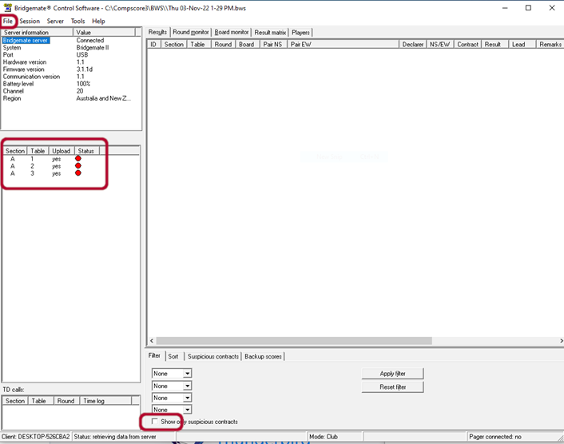
BCS Main Page | Tick [Show only suspicious contracts]  [Apply Filter]
WAIT |  | Wait for all bridgemates to be logged into and updated with ABF numbers
CS3 Session Management | Click on Names and then on Import Names. | If any names are incorrect or missing, you can edit them here and then update the Bridgemates by clicking on the Send Back button. I will write this up in a bit more detail later.
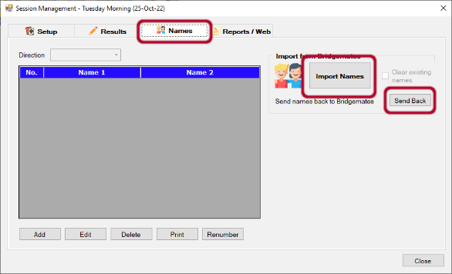
BCS Main Menu | Regularly check for Suspicious Contracts | See notes for BCS below

2.5 Scoring and Shutting Down Session
Where | Action Required | Defaults/Comments
BCS Main Menu | Make sure that all BMs show red dot beside them in BCS | When all boards/rounds are finished you get the message “End of Session” on the BM, press OK until screen is blank. If someone has forgotten to log off, do it for them
CS3 Session Management | Click on Reports/Web and then on Quick Finalise | This will import results from the bridgemates, print out the results page for the folder and generate an XML file with the results to be uploaded to the web site
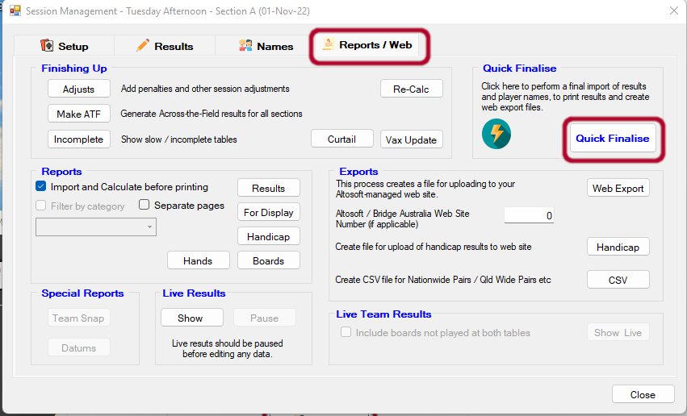
CS3 Session Management | Click Close and then File->Close to shutdown CS3
BCS Main Menu | Maximise BCS and Close it down  File -> Close  File -> Exit
Desk :p | Unplug BM server and power down | Press the black button until the light goes off.
Front Desk | Annotate day sheet with the day. Fold session sheet and take any table money and place both in a zip lock plastic bag. | Put in box inside cupboard in directors’ room
Front Desk | Put Results printout in the results folder
Room | Turn off:  - Hot water  - Lights in kitchen  - Air Conditioning  - Light+fan in men’s bathroom  - Room lights  - Check windows are closed

2.6 Upload Hand Records to Web page
Browse to bridgewebs.com/mollymook
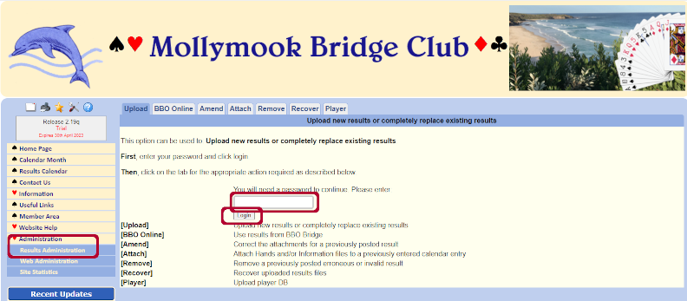 | On the left hand side panel, click on Administration -> Results Administration. Enter the MBC Directors password mbcdirector and click on Login
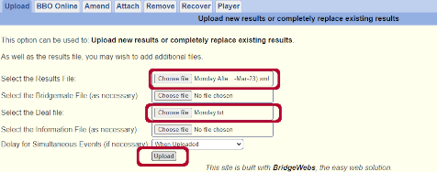  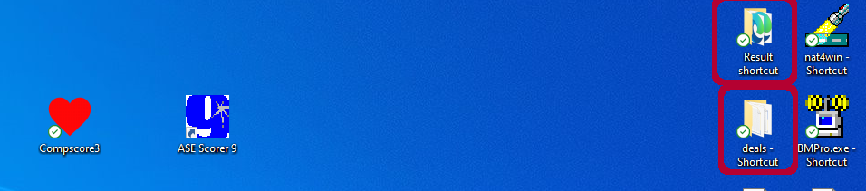 | You now need to select the Results file: Double click on the folder named Result shortcut on the right hand top of the desktop. This will present the available results files. Drag and drop the required result file into the results box. NOTE that you no longer need to upload the deal file, as this info is now contained in the results file.  Once selected, click Upload.
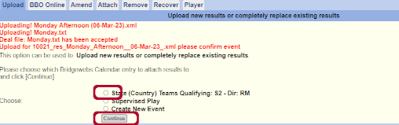 | If there is only one session in the calendar for that day, then you are finished. However if there are multiple events (eg on Monday there is also a Supervised Play session), you  will be prompted to nominate which session you wish to apply these results to. Select the session and click Continue.

This Page Intentionally Left Blank

3. Common Issues

3.1 D4

3.1.1 Computer cannot communicate with Dealer4
Very occasionally you get a message saying that the computer cannot communicate with Dealer4, [Cancel] and pull out the USB connector from the dealer or computer (easiest at the dealer), wait 30 seconds, replace and try again, it may take a couple of goes.

I did have one occasion when the Dealer4 machine lost power. Fiddling with the power connector resolved that issue.

3.1.2 Card Reading Error
You will get card reading errors, the machine reads the card BEFORE it leaves the hopper, so if there is a reading error, lift the cards out of the hopper and see if the card is upside down (most usual) or there is biro or crap on the card near the number or suit symbol. Replace the cards if there is a mark on the card turn it around or clean. [Continue].

3.1.3 Duplicate Card Error
If you get a “duplicate card” error message, look at the bottom card in the hopper and see if the colour of the back is the same as the ones being dealt, (1st card in next pack) if it is, there may be a card missing from the pack or it has misread a card. Look at the card on the bottom of the hopper and remove the dealt cards from the board and check that that card has not been dealt, if not place all the dealt cards back at the bottom of the hopper with the misread card first, press “Cancel” and then “deal”. If there is a card missing just get a new pack- “Cancel” – “Deal” If there is a card missing, look in front or on top of the computer, single found cards find their way there! If problem persists use another pack.

3.1.4 Card Feeding Error
Remove the cards from the hopper, usually the bottom two cards are stuck together, or the bottom card has a rough edge caused by the narrower pockets on some board sets, turn it around or give the bottom card a little tap. Or there may be crap on the button that the cards sit on, scrape it off (with a plastic card). . This error can also occur if there are not sufficient cards in the hopper to provide the traction required to feed the cards through. [Continue].

3.1.5 Redealing a Hand
Open up Dealer4
Note if you had closed down dealer4 previously you will need to re-load the dealing file; and then press Deal.
From Dealing Boards screen, press [Next] until required board is displayed.
Insert empty board into the tray

3.2 CS3

3.2.1 Not using Bridgemates
When setting up the session in CS3, make sure to select the option for manual scoring (bottom left corner of screen):
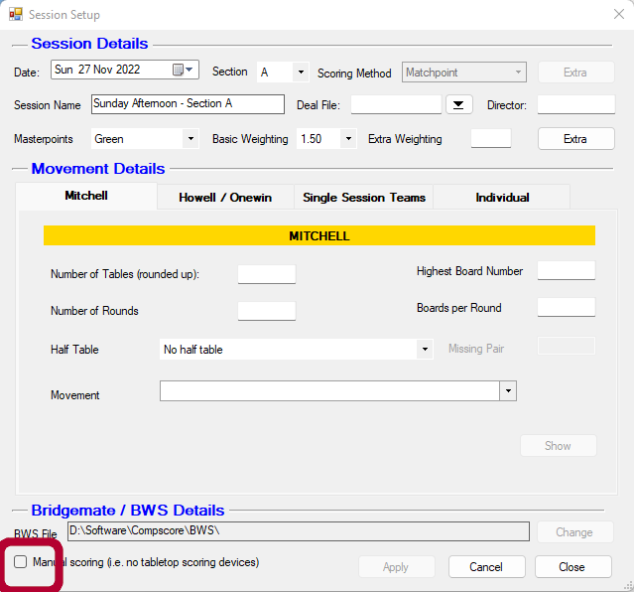

See Section 3.2.8 Manually Entering Results from Travelers for entering result info

3.2.2 CS3 is Accidentally closed down
Open from desktop and then open the event

3.2.3 Dealing with a Missing Pair
Note that in the course of any movement, the Bridgemates always skip any round that has no activity.
This means that at the initial sit-out table, it will skip straight to Round 2 after the player numbers
have been entered. Similarly, if the missing pair is scheduled to play at Table 3 in Round 4, the
Bridgemate at Table 3 will skip Round 4 completely. This confuses players, so as directors you should
be aware of this so you can allay any concerns. The turnaround table may also cause confusion as
the Bridgemate will skip two rounds when the missing pair are assigned to that table

3.2.4 Correcting the Movement
As with any other late change to a movement, make the change via Edit Setup. After applying the
change, a dialog will appear asking if the Bridgemates have been launched, and if so, from what
round should the update occur. Any change, including a change to the missing pair number, can be
made in this way. If no-one has logged any results yet, you can update from Round 1, otherwise
update from the first round that has not been started at any table. If you’ve changed the missing
pair number, in most cases the Bridgemate should ask for any additional player numbers, but in
other cases, the change may need to be made on CS3’s Names tab, and sent back to the
Bridgemates

3.2.5 Adding a New Player with an ABF number
When the Masterpoint file is downloaded, all current ABF members are downloaded, so no action should be required unless this is a new user (or a reactivated user) since the last download. Refer to 3.2.11 Download ABF Masterpoint File should that be the case

3.2.6 Adding a New Player without an ABF number
Wait until all players have entered their names in the bridgemates. From the Names tab on the Session Management screen, press Import Names. Click on the pair that needs updating, and then press Edit
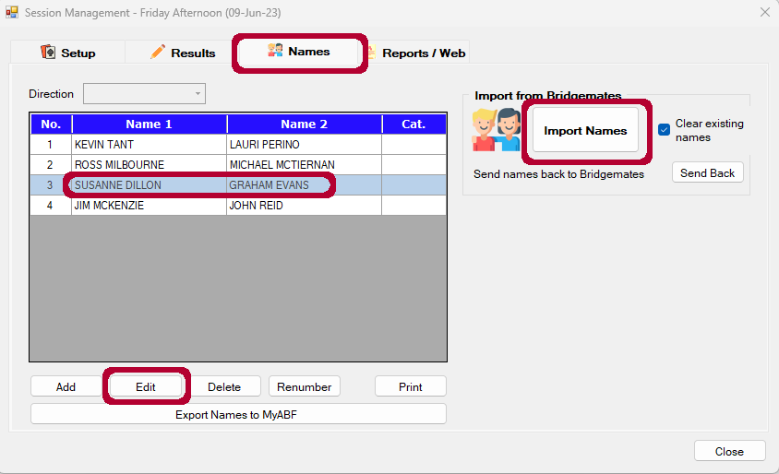

On the pop-up screen, for the unknown player, tick Player n is a new player and then enter her name in Player Name and click Apply
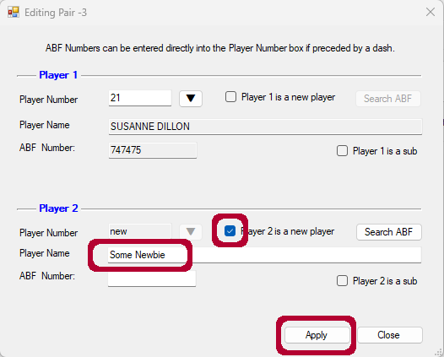

Now press the Send Back button on the Names screen to update the bridgemates.

3.2.7 Fixing Incorrect Scores after Session
- In the Session Management Screen Click on Results.
- Results are presented board by board. Click on the Board Drop down to select the required board or boards.
- You can sort the results information by a number of ways – the best option will be determined by the type of corrections required (correct one result only, correct all results for final round etc). Most recently, we had to correct all the results for the final round, as players omitted to effect an arrow swap for the final round.
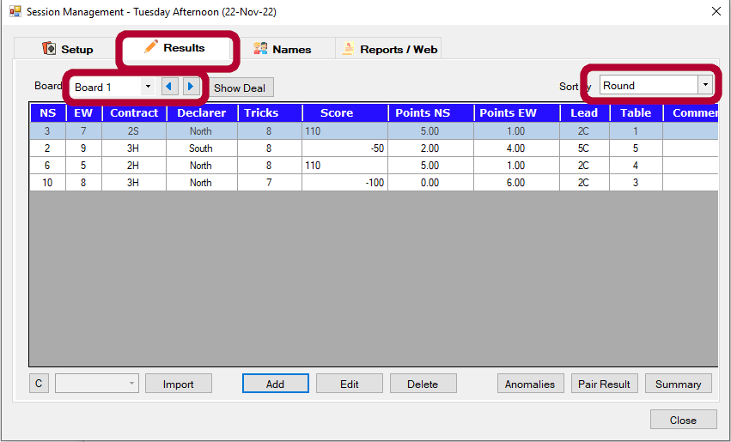

- Double click the hand to be corrected
- Apply the required change (in the case above, all that was required was to switch the NS and EW pair numbers) and then click Apply
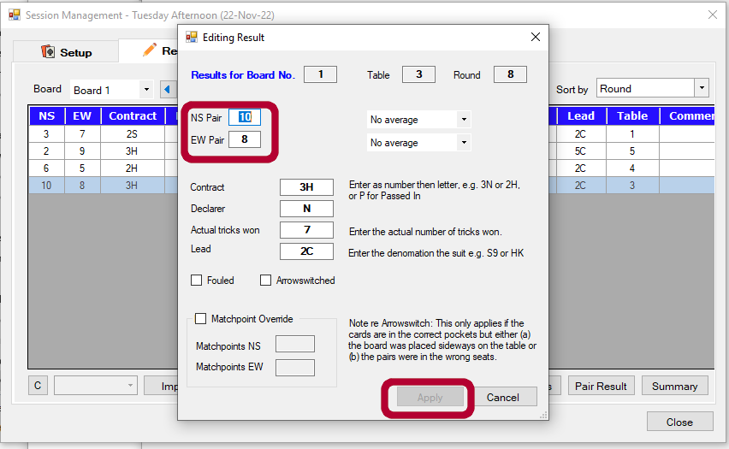

3.2.8 Players failed to correct for Arrowswitch
Follow process detailed in 3.2.7 above. NOTE: if the movement is a Mitchell you may not be able to correct by switching the pair numbers – instead, click on the Arrowswitched box (below and left of centre of Editing Result pop-up)

3.2.9 Manually Entering Results from Travelers
Create a new Session.
If you weren’t present for the session, you can deduce the movement from the information on the travelers: (# travelers = how many boards played; #player names on first board gives you the number of players (though there may have been a sitout); then working through the travelers, when the names first change indicates the number of boards per round). Check all travelers to see if there was a sitout. In the Session Setup Screen:
- Enter the Movement Details (make sure you put in the correct session date, name and deal file).
- Tick the manual scoring box at the bottom left of session detail screen
- Apply

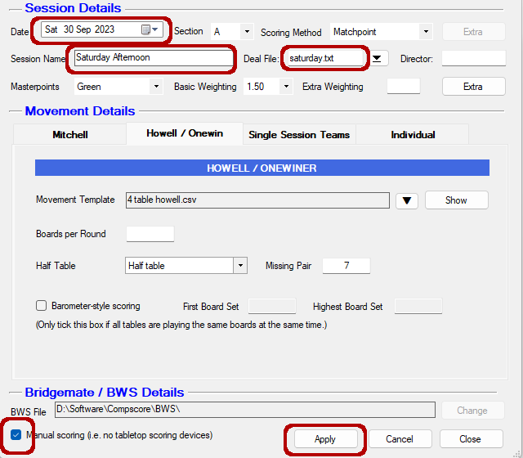

Add Player Names
- From the Session Management Screen, click on Names
- You now need to enter the names of each of the players – these should be written with pair numbers on the travelers. It is easiest if you enter them in pair number order, starting from 1. For each pair to be added, click on Add and then start typing the players’ last name in the Player Number field. Then Apply.
- You may need to change the numbering to allow for the sitout pair. To do this, start from the bottom selecting each pair in turn that needs to be renumbered, press Renumber; then enter the correct number for that pair in the Renumber Pair pop-up and press OK.
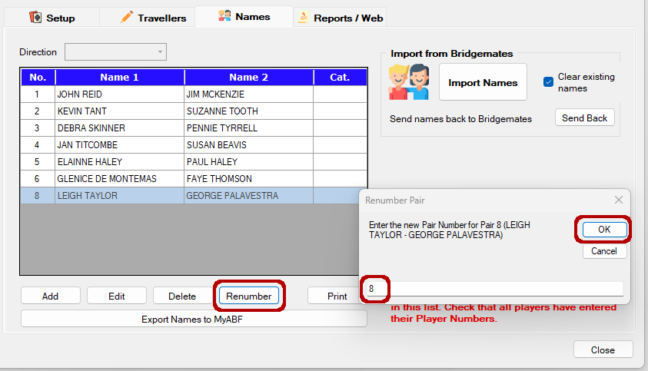

Enter the Scores

- Click on the Travellers tab
- Click the button labelled Load Blank Travellers. This will load a blank result line for each set of pairs
- Select Sort by Round.
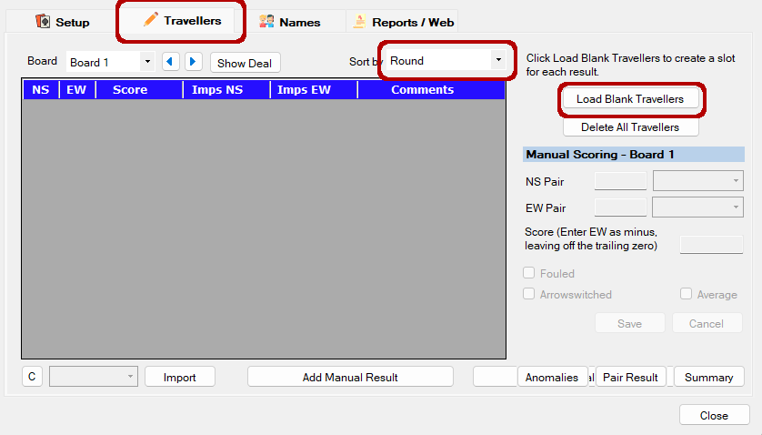

- Double check that the pair numbers match the details for round 1 on the travelers.
- To enter the result, simply click on the grid for the first pair and enter their score. Note that the trailing zero can be left off the score, and East-West scores are entered as negatives.
- Pressing the Enter key moves to the next line, and when the last line has been entered, a dialog displays asking if you want to move to the next board.
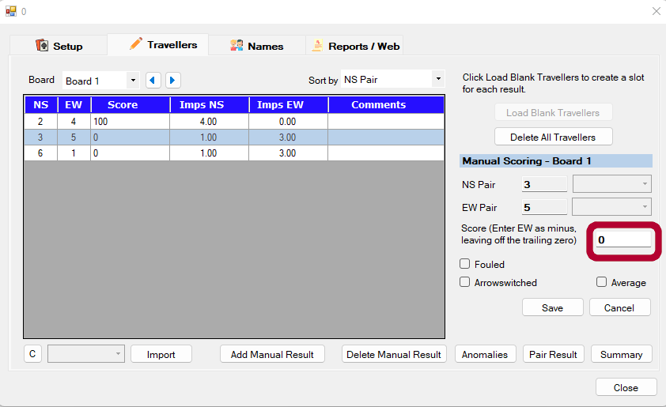
- The pair numbers should be correct but if there is a problem, you can delete pair lines and add additional lines as necessary.
- Note that you can alter the sequence of the tables in this display to suit the style of travellers you are using i.e. sort by Round or by NS Pair.
- Fouled boards, boards to be averaged and boards played arrowswitched can be designated by clicking the appropriate checkbox.
- The process for printing reports and creating the web export is identical as for a Bridgemate session.

3.2.10 BCS accidentally closed down during a normal session
- Re-open CS3 if necessary
- Open the Event
- Click on the Setup tab of the Session Management Screen
- Click on Advanced Functions
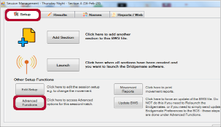
- Select the BWS Functions tab. Note that the file name at the top should show the current session – if not you have opened the wrong event
- Click Re-Launch.
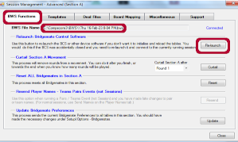

3.2.11 BCS accidentally closed down during a Swiss Pairs session
- Re-open CS3 if necessary
- Open the Event
- Select the Bridgemates tab of the Swiss Pairs Management Screen
- Open the match that is currently in progress
- Click on the Setup tab of the Session Management Screen
- Click on Advanced Functions (see above)
- Select the BWS Functions tab. Note that the file name at the top should show the current session – if not you have opened the wrong event
- Click Re-Launch (see above)

3.2.12 Downloading the latest ABF Masterpoint file
- From the CS3 main menu, chose File->Import->ABF Masterpoints Listing

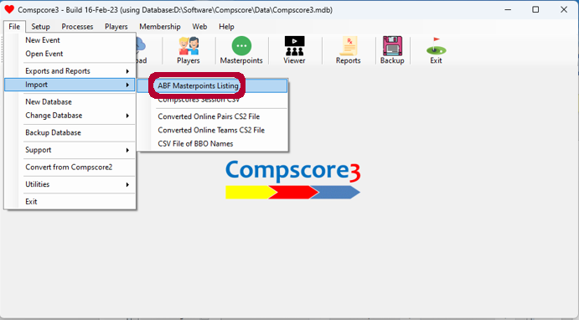
- On the pop-up screen select Exclude inactivate (sp) members then press Download. The process will take a few minutes
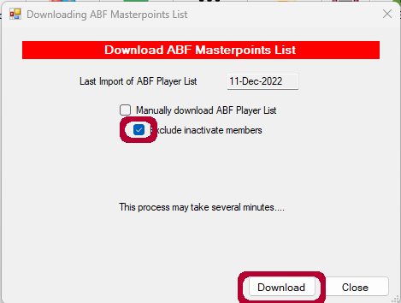

BCS

3.3.1 Checking Suspicious Contracts
2
To view the contract, right click on the problem result and select [Edit Score] Check Score with players – if score OK, click as shown, otherwise amend.

If you do get a "Suspicious contract" and the results don't seem to fit in with the hand, check the actual cards in the board. If it is a completely different deal, don't try and fix it - others will also come up as suspicious. just let all the boards be played as they are. (Possibly caused by boards being out of order when cards were dealt)

If however the cards have been rotated, leave the board as it is and at the end after recovering the scores, in CS3 go to the board that has been fouled and mark the results that have been fouled as fouled.

3.3.2 BCS Accidentally Shut Down
Only relevant if BCS has already been launched from CS3
From CS3
- Open the Event
- Click on the Setup tab of the Session Management Screen
- Click on Advanced Functions
- Select the BWS Functions tab
- Click Re-Launch.
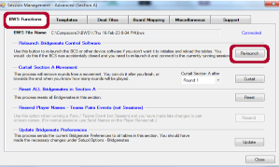

3.3.3 Not connected to Bridgemate Server
Make sure that the cable is connected and Bridgemate server hardware turned on
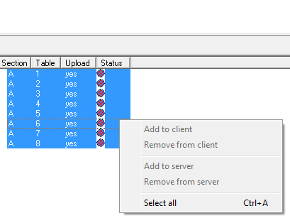
On the Bridgemate Control Page Put the Curser on one of the table numbers and left click it and you get the popup box, right click [Select all] and then [Add to server]
You then have to wait a few seconds and you get a pop up on the page saying that tables xyz have been added to the Server. YOU MUST CLOSE THIS POPUP. All should now be good.

3.3.4 Battery Warning Light is On even when BCS is connected to Computer
There are two likely causes:
- One or more batteries are lose or not properly connected. Check this by opening the back of the bridgemate control server and repositioning the batteries. Replace back. If this does not resolve the issue it may be that one or more batteries need replacing
- Batteries need replacing. Check the BCS main screen which shows the battery level:
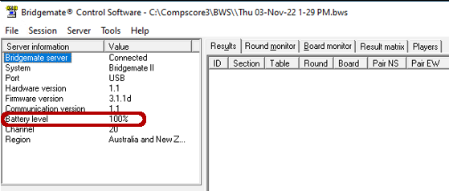
If battery level shown on BCS is showing low even after readjusting batteries, try changing one or more of the batteries.

3.4 Bridgemate Devices

3.4.1 Bridgemate Device stops working
If a table top device stops working it can be replaced by one not in use, preferably 13 or 14, First, maximise the Bridgemate Control, open [Server] (top left) – [Show Tables], select the relevant table, click [Log Off table(s)]. Take a new BM press [OK] to start and [SETUP] (bottom left of screen is highlighted, press OK, arrow down to Table Number and press cancel to remove the current number then enter the number of the table you wish to replace. Then press “Back” Activate the new one (pressing OK)

3.4.2 Hand PASSED IN
If a hand is PASSED IN, they press the PASS button for the contract and then OK

3.4.3 Hand NOT Played
If a hand is NOT PLAYED – usually no time press the 0 button and ‘NOT PLAYED” is displayed. Accept as normal. NB: use the right one, they produce different results.

3.4.4 Bridgemate not showing right score
A common call is that the Bridgemate is not showing the right score?? USUALLY caused by the person entering the score not pressing [OK] then the checker presses the button where the [Accept] should be but until [ok] has been pressed it is still on [Scores] and shows all of the scores entered for that round, press [back] and [ok] then [accept] If a score needs to be changed, it can be done through [SCORES] on the Bridgemates rather than the TD menu if the round has not been finished. If the round has ended, you can change the score at the table where the error occurred. Open Tour. Dir – code 0000. erase score (3), enter the board No and OK, then re-enter the board number and the correct contract/result.

3.4.5 Entering Adjusted Score: Bridgemate Device
If you need to give an adjusted score 60% – 40% or 50 – 50 at the contract entry point press the TD button (code is 0000) press 1 to enter the assigned percentages.

3.4.6 Invalid Lead Card or Declarer
This option is controlled from within CS3. From the CS3 main menu select Setup -> Options and then click on Bridgemate Options:
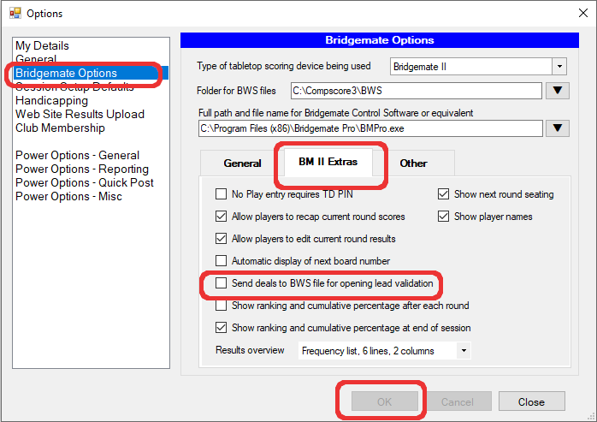
Click on the BM II Extras tab and then select (to enable) or deselect (to disable) Send deals to BWS for opening lead validation. [OK]
NOTE: if BCS has been launched you will need to close BCS and relaunch it in order for this config change to take effect. (You may need to actually close and restart CS3, I am not certain. [JR to check])

The most common causes of this error are:
- incorrect lead card :p;
- incorrect declarer; or
- incorrect board number; or
- incorrect board orientation (ie south pointing to north);

There is a less common cause of this error, which will require some form of intervention by the director:
- the hands in the boards may not match what is expected by CS3

1.Actual hands not matching expected:
One less than common cause might be where the hands in the board don’t actually match the hands expected by CS3 (ie hand information provided in the file(s) produced by D4). There are a few ways that this could happen :

- though D4 generated 32 decks; not all of the 32 had been dealt out and put into the - and this is one of the higher number boards;
- when dealing the cards, the boards were out of order and some hands were dealt to different boards; or
- the boards in use are not the ones which were dealt out

To determine if one of these is the cause of the problem, compare one of the problem boards with the actual hands in CS3 (Reports/Web and click on Hands).
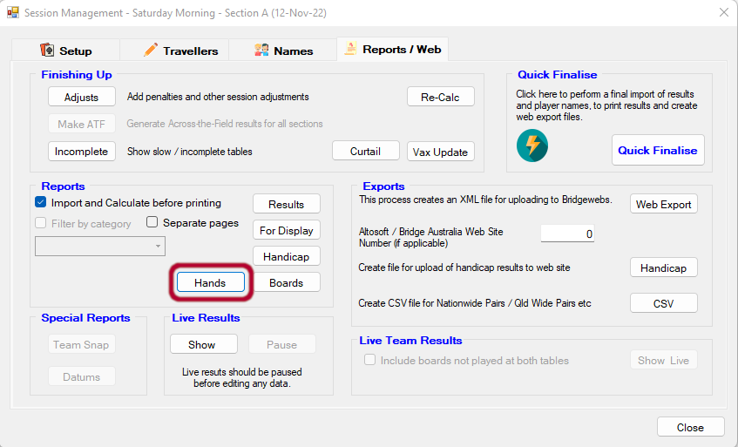
If it is only one or two boards which are in error, then just look at the hand which CS3 believes is correct, and find a valid lead card and tell the user to use that.

3.4.7 How to change table number or Section on Bridgemate
On each of the bridgemates which need to be reconfigured:
- Press Setup soft key
- Press + key to change the Section to B;
- Press down arrow soft key;
- Press - key to change the table number to desired number.
- Remember to reset when done :p

3.4.8 TABLE NOT YET ACTIVATED
Possible causes:
- The Bridgemate II scoring system has not been started yet by the scoring program.
- The corresponding table has not been added to the server.
- The server and the Bridgemate are not communicating over the same channel.
- The region setting in BCS does not match the region setting of the Bridgemates.
- The server is outside the range of the Bridgemate and cannot communicate with the Bridgemate

3.4.9 SYSTEM NOT YET ACTIVATED
- The Bridgemate has been set to scan for existing sections in the setup menu but the Bridgemate II
scoring system has not been started yet

3.4.10 TABLE STARTED BY ANOTHER BRIDGEMATE
- Another Bridgemate with the same section/table number setting has already logged in to the server

4. Movements

4.1 Preferred Movements
Est minutes per board is calculated based on an inter round movement time of 2.5 minutes for a Mitchell movement and 3.5 minutes for a Howell movement. See the missing pair and last Sitout table for information relating to movements with half tables
No of Tables | Movement | #Tbls | Max Board # | Rnds | Brds/Rnd | Mins/Brd | CS3 template
3 | 3T Howell | 3 | 30 | 5 | 6 | 6.5 | 3tbl Howell
3.5 - 4 | 4T Howell | 4 | 28 | 7 | 4 | 6.8 | 4tbl Howell
4.5 - 5 | 5T Howell | 5 | 27 | 9 | 3 | 6.7 | 5tbl Howell
5.5 | 6T ¾ Howell | 6 | 27 | 9 | 3 | 6.7 | 6tbl reduced Howell – 9 rounds
6 | 6T Mitchell | 6 | 30 | 6 | 5 | 6.6 | Mitchell with Share & Relay
6.5 | 7T ¾ Howell | 7 | 27 | 9 | 3 | 6.7 | 7 tab rdcd hwll molly
6.5 | 7T Mitchell | 7 | 28 | 7 | 4 | 7.0 | Straight Mitchell with s/o
7 | 7T Mitchell | 7 | 28 | 7 | 4 | 7.0 | Straight Mitchell
7.5 | Rover Mitchell | 8 | 28 | 14 | 2 x 2 | 6.3 | 7.5 table switch rover – last 4 boards arrowswitched
8 | Skip Mitchell | 8 | 28 | 7 | 4 | 7.0 | Skip Mitchell
8.5 - 9 | 9T Mitchell | 9 | 27 | 9 | 3 | 7.0 | Straight Mitchell
9.5 - 10 | 10T Skip Mitchell | 10 | 27 | 9 | 3 | 7.0 | Skip Mitchell
10.5 | Appendix Mitchell | 11 | 27 | 9 | 3 | 7.0 | Appendix Mitchell 11 tables 9 rounds (created by JR – needs review)
11 | 11 Mitchell | 11 | 33 | 11 | 3 | 5.6 | Straight Mitchell
11.5 - 12 | 12T Skip Mitchell | 12 | 36 | 9 | 3 | 7.0
11.5 - 12 | 12T Skip Mitchell | 12 | 36 | 10 | 3 | 6.3

4.1.1 Rover Mitchell Setup
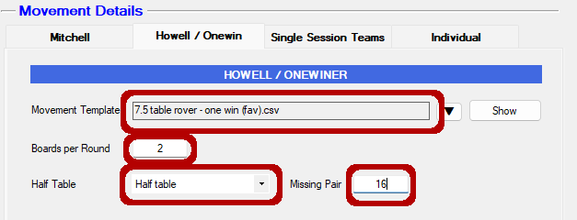
ie this movement uses 14 * 2 board rounds. There are movement cards for the rover pair at appendix 1.

4.2 Half Table Movements
(Determining the Missing Pair and the Last Sit Out)
In the table below, I have tried to always make the sitout table the stationary table in the movement. This makes the sitout much more obvious; but has the disadvantage of not accommodating movement challenged players. If you need to accommodate for a movement challenged person, the comments section provides the alternate of using the EW pair in the last table in round 1 for the sitout pair. NOTE: Where a movement has one or more semi-stationary pairs; these are shown in square brackets in italics in the Stationary column.

No of Tables | Movement | Stationary | Missing  Pair | Last Sit Out # | Start | Comments
2.5 | 3T Howell | T1 NS | 6 | 5 | T3 NS | (missing T3EW = #2. T2 NS gets final sitout)
3.5 | 4T Howell | T1 NS | 8 | 7 | T4 NS | (missing T4EW = #3. T1 EW gets final sitout)
4.5 | 5T Howell | T3 NS | 10 | 9 | T4 NS | (missing T5EW = #4 T3 EW gets final sitout)
5.5 | 6T ¾ Howell | T1 NS [T2-NS; T3-NS] | 12 | 9 | T5 NS | (missing T6EW = #3 T2 NS gets final sitout)
5.5 | 6T Howell | T1 | 12 | 11 | T3 NS | (missing T6EW = #8 T5 MS gets final sitout)
6.5 | 7T ¾ Howell | T6 [T1-NS; T3-NS; T4-EW; T7-NS] | 14 | 9 | T4 NS | Almost certainly wrong – check at clubhouse
6.5 | 7T Mitchell | Any NS | 7 EW | 6 NS | T6 NS
7.5 | Rover Mitchell | Any NS | 16 | 14 | T7 EW
8.5 | 9T Mitchell | Any NS | 9 EW | 8 NS | T8 NS
9.5 | 10T Skip Mitchell | Any NS | 10 EW | 9 NS | T9 NS
10.5 | Appendix Mitchell | Any NS | 11 NS | 3 EW | T3 EW
11.5 | 12T Skip Mitchell | Any NS | 12 EW | 11 NS | T11 NS

5. Advanced Sessions

5.1 Multi Session Events

5.1.0 NBB
- All sessions must be single winner sessions
- You can flag substitutes when you create the multi
- To track the overall results on the webpage it is necessary to define a competition. For the time being, discuss with the current web admin

5.1.1 About
Multi session events are events where the players can earn masterpoints not just for the individual sessions, but also for the overall results in the multi. The club plays a number of multi session events throughout the year (eg Spring Pairs).

5.1.2 Run the individual Sessions
Run each of the sessions for the multi as you would a normal session (you may wish to name these differently – eg Spring Pairs Session 1; Spring Pairs Session 2 etc.
NB: each session of a multi MUST be a single winner event
NBB: Most multi sessions will NOT be Green MP events, so you will need to change the Masterpoint colour and the Basic Weighting value (for most of our multis these will be Red and 2.50 respectively).
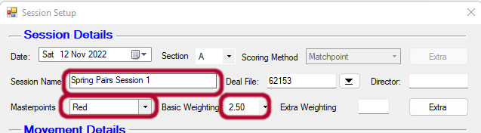

5.1.3 Identify and Tag any Substitutes
A pair must have played in both sessions to be eligible to be included in the multi event results. A pair is allowed one substitute.

To flag a person as a substitute, bring up the relevant session (CS3 -> Open and select) and then on the Session Management screen click on Names:
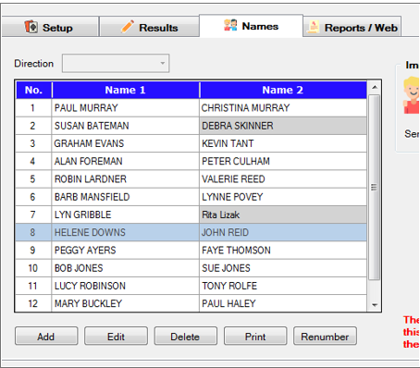

Then double click the pair which you want to update as a sub; in the screen above, we want to flag Helene as a substitute for Rae. Tick the box Player n is a sub; and then click the drop down arrow to select the player for whom she is a sub.
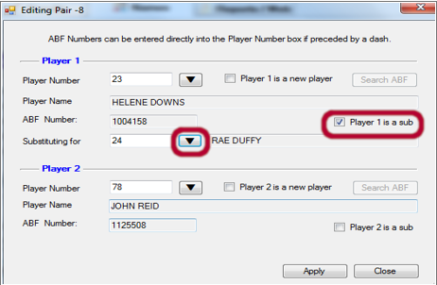

NB it can be hard to identify all the subs from the session management screens, but you get another chance later when you are setting up the multi to identify pairs who have not played all sessions and if necessary, you can close down the multi, go back to the session and update the subs and then restart the multi.

5.1.4 Create the Multi
Create a new Traditional Multi:
CS3 -> New -> New Multi
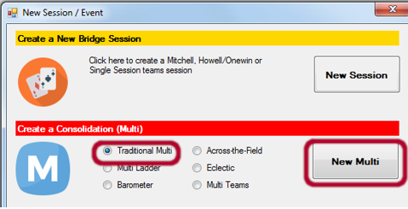

- Give the Multi a name, eg Sping Pairs
- No. of winners = 1
- Number of Sessions = 2
- Masterpoints Colour = Red (weight 2.5)
- Press Add to select and add the relevant Sessions
- Then Next
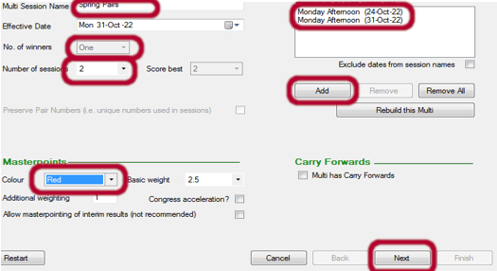

You will now be presented with a screen showing all the pairs who have played in the sessions and the number of sessions which that pair have played
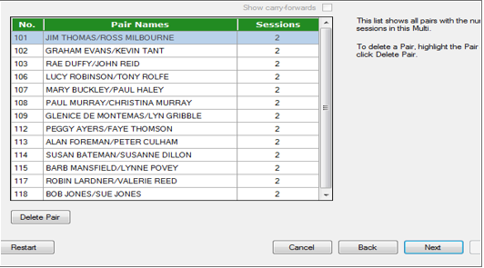
If some of the pairs have not played all sessions you will get a pop up:
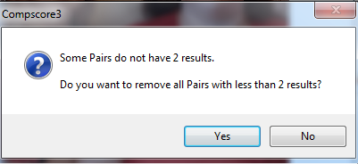
Check the pairs who haven’t played all sessions, and make sure that some of these pairs do not contain subs (if they do, close out the multi, go to the relevant session and update the player(s) as a substitute). Now double check the list of pairs against what you expected from when you compared the two sessions, if there is a different number you have missed something, like a pair with the same name :-)

Pairs who have not played in both sessions are NOT eligible to be included in the multi, and as such should be removed. Once you have confirmed that you have the correct names playing in all sessions, you must remove any pairs who have not played all sessions: press Yes to the deletion request and Yes again to the confirmation pop up.

Defaults should be correct on the next screen. Press Next.
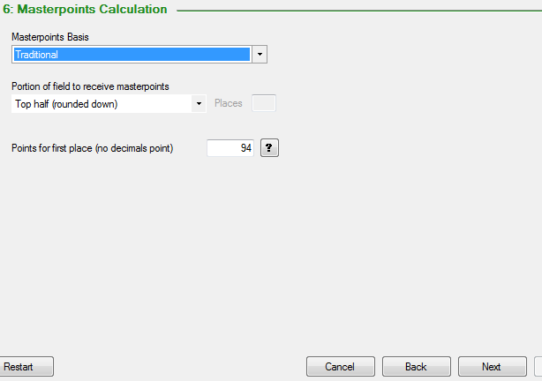

And then Quick Finalise and Finish.
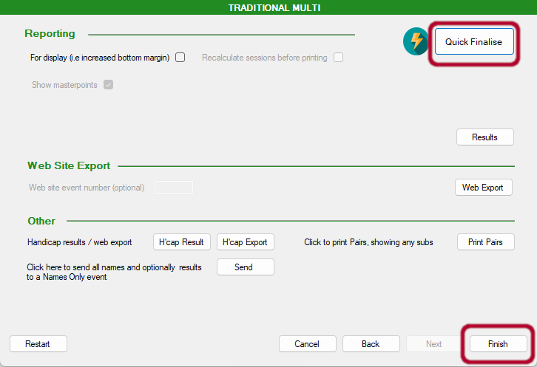

Results for the multi will be sent to the Multi Session Results page on the website, while each individual session will be presented on the website on the Single Session Results page.

5.2 Ruth Lumbers Trophy Swiss Pairs

5.2.1 Background
The Mollymook Bridge Club has its beginnings in October 1982, when Ruth and Eugene Lumbers started a private bridge club. They played two times a week, with around six tables being played weekly. During those years many of our members also played at Nowra and Batemans Bay and Ruth was a well-respected player at all three clubs. Ruth and Eugene both died due to a car crash in December of 1989. To memorialize Ruth and Eugene’s critical influence on the establishment of duplicate bridge in the region, it was proposed to establish an annual competition between Nowra, Bateman’s Bay, Moruya and Mollymook. The first Lumbers Trophy event was held in 1991, and was won by Mollymook. Hosting for the event used to rotate between Batemans Bay and Mollymook with players from Moruya and Nowra invited; but from 2023 onwards, it was decided to host the event only at Mollymook.
NOTE that Moruya was invited to the first Ruth Lumbers but declined as they could not field four teams. Over time all clubs found it problematic to field multiple teams, and the event was changed to a pairs event. At or around that time, Nowra elected to pull out of the competition22 (I don’t have the year). In 2023 Nowra returned to the competition and Moruya competed in their own right (had previously competed as a joint team with Batemans Bay), restoring the event to a four club competition.

5.2.2 Event Details
- Played as a single day Swiss Pairs event of six matches of nine boards commencing at 09:30;
- Players provide their own lunch;
- Morning and afternoon tea provided by the host;
- Cost of $10 per player (Mollymook players play for free)
- B5i Masterpoint event – ie red masterpoints with a weighting of 2.0
- Scoring is IMPs 2 VP
- Winning club is determined by the aggregate VPs of the club’s top three placed pairs

5.2.3 Preparation
- The four clubs need to be contacted and asked to provide the names and ABF numbers of their competing pairs. We need this info no later than the Wed of the week preceding the event
- Prior to the event you will need to prepare multiple board sets. You will need separate board sets for the morning and the afternoon sessions. This means that you will need to create two deal files; one for session 1 and the second for session 2. You need a minimum of two boards per table. So the #boardsets * boards_per_round must be greater than 2 * #tables (So for each session you will require: One board set for up to four tables; two board sets for up to eight tables; three board sets for nine or more). That is to say, if you have nine tables, you will need to deal out six sets of boards, three to be used in the morning session, and three in the afternoon session.
- Prior to the event prepare a new event in compscore (make sure that the date is correct for the actual event) and enter the names of all the pairs and seed the pairs. Then print two copies of the draw for round 1. NB: compscore doesn’t seem to give a masterpoint option for a weighting of 2.0 for this event, so you need to add a factor of 0.8
Refer to section 5.5 Swiss Pairs Event (Multiple Sessions)

5.3 Interclub Swiss Pairs

5.3.1 Background
There are two Interclub Swiss pairs events run annually. These are all day events, commencing at 09:30. Host club provides lunch. The events are open to players from Moruya, Batemans Bay, Milton and Mollymook. The host rotates between Batemans Bay and Mollymook, generally with Batemans Bay hosting the first session.

5.3.2 Event Details
- Played as a single day Swiss Pairs event of six matches of nine boards;
- Host club provides lunch, morning and afternoon tea
- Cost of $10 per player
- B5i Masterpoint event – ie red masterpoints with a weighting of 2.0
- Scoring is IMPs 2 VP
- Winning club is not currently determined – but if we wanted to, we could do the same way as Lumbers: aggregate VPs of the club’s top three placed pairs

5.3.3 Preparation
- The four clubs need to be contacted and asked to provide the names and ABF numbers of their competing pairs. We need this info no later than the Wed of the week preceding the event
- Prior to the event you will need to prepare multiple board sets. You will need separate board sets for the morning and the afternoon sessions. This means that you will need to create two deal files; one for session 1 and the second for session 2. You need a minimum of two boards per table. So the #boardsets * boards_per_round must be greater than 2 * #tables (So for each session you will require: One board set for up to four tables; two board sets for up to eight tables; three board sets for nine or more). That is to say, if you have nine tables, you will need to deal out six sets of boards, three to be used in the morning session, and three in the afternoon session.
- The event will be captured on the website as two separate sessions – morning and arvo. As such there will need to be two calendar events – morning and arvo, with the morning one costing $10 and the afternoon free.
- Previously we would pre-seed the event, but per advice from KT, latest process is to not bother with pre-seeding and just let the event play out. This means seating is not pre-allocated, people sit where they want for the first round.
Refer to section 5.5 Swiss Pairs Event (Multiple Sessions)

5.4 Dianne and Bill Samuel Trophy Swiss Pairs

5.4.1 Background
In December 1991 the club began exploring the possibility of owning its own clubhouse, but it was Dianne and Bill Samuel's arrival in the mid 1990s which really provided the impetus to make this happen. For their efforts in driving the vision through to actuality, for their formidable bridge capability (four times club champions), for Bill’s astute money management and for Dianne’s incredible tenures as president of the club (eleven times president), the Samuel Trophy was established in their honour.

5.4.2 Event Details
- Played over two consecutive weekdays - Swiss Pairs event of three matches of nine boards each day;
- B4c Masterpoint event – ie red masterpoints with a weighting of 2.5
- Scoring is IMPs 2 VP

5.4.3 Preparation
- Players need to register. We require a standby pair
- Prior to each session of the event you may need to prepare multiple board sets. You need a minimum of two boards per table. For each session you will require: One board set for up to four tables; two board sets for up to eight tables; three board sets for nine or more.
- Prior to the event prepare a new event in compscore (make sure that the date is correct for the actual event) and enter the names of all the pairs and seed the pairs. Print a copy of the draw for round 1.
- Prior to running the second session you will likely need to add substitutes – process detailed at the end of section 5.5. I also think for the second session you are better off asking players to enter their ABF numbers at the start (note that you should have printed out the seating for round 4 before that)
Refer to section 5.5 Swiss Pairs Event (Multiple Sessions)

5.5 Swiss Pairs Event (Multiple Sessions)

5.5.0 NBB
- This section is for a Swiss Pairs event played over two or more sessions (eg over separate days, or with a morning and afternoon session). See section 5.6 for a single session played in an afternoon.
- Will require multiple board sets – you need a minimum of two boards per table. So the #boardsets * boards per round must be greater than 2 * #tables (assuming 9 boards per round, two board sets will suffice for 9 tables, 3 boardsets for up to 13 tables).
- And you will need another set of boards for the second session.
- You can setup a stationary table for a pair if required. Ask people at the start.
- You have to manually enter the starting board # each time you are starting a new match.
- You don’t need to print out the draw after each match – the bridgemates will tell people where to go (but it helps to have it).
- You can save paper by just printing the results manually rather than doing a quick post-match. Refer section 5.5.16 Printing Results Manually
- Hand Records: it is probably simplest if you just print out the full set and hand out at the end of each session.
- In these notes I am assuming that we are playing six matches over two sessions; each match being of nine boards. This is the standard session, match and board configuration for the Interclub Swiss Pairs and for the Ruth Lumbers Trophy

5.5.1 Preparation
Note that prior to July 2024 we used to seed the field for round one – we don’t do this any more. Players can sit where they wish (may finesse this a bit for the interclub).
Prepare Boards
- for InterClub you will need to deal a minimum of six sets of boards (three for session 1, three for session 2;
- For Samuel Trophy you will need to deal out three sets of boards for the first session
- Arrange space for used boards to be collected
- Arrange space for food
Set up Event in Compscore
InterClub - Additional Help required:
- Someone to put out the boards and collect boards from previous session;
- Someone to organise food (sandwich delivery, putting out morning and afternoon tea, ensuring enough milk etc);
- Someone to cut up the personals and distribute
- Someone to organise drinks when match is finished and while waiting the results
Announcements (Interclub)
- Welcome
- If you require a stationary table – please advise the director
- The temperature has been set at 22 degrees. If you are finding it too hot or too cold, please advise the director and we will adjust by democratic process;
- We will be playing two sessions with each session being three rounds of nine boards. At the end of each round, once the scores have been updated, the bridgemates will advise you what table you are moving to next. A printed draw will also be available at this table, after each round. You will need to enter your ABF numbers at the start of round one – but the bridgemates should automatically update after that;
- Results and all hand records will be available on our website after the game, but if you want printed hand records, I can provide these on request at the end of each session;
- Money collection – someone will come around
- Break for lunch at 12:30 and resume at 13:00 – will try to finish up close to 16:30, at which time the winners will be announced and we would love it if you had the time to stay around for a drink or two afterwards

5.5.2 Setup Event Parameters
CS3 -> New -> New Pairs Event
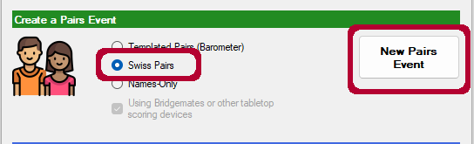

This will bring up the Swiss Pairs management screen (screenshot below).
On the Setup tab of Swiss Pairs management screen enter:
- Event name – (do NOT include session #). This name will be used for all sessions
- Number of matches – this is the total number of matches to be played over all sessions (usu 6)
- Boards per match (usu 9).
- Number of sessions – usually 2 (e.g. morning and afternoon for interclub and Samuel; or two separate days)
- Tick the Import pair names from Bridgemates option
- Scoring Method – Imps (Butler)
- Enter the names of the deal files to use for this event (after testing in July 2024, this proved to be the only method to work correctly for loading deal files)
- Use WBF VP Scale - Deselect
- Trad. VP Scale – Select ABF Scale for Pairs – n Board (where n is the number of boards per match)
- Butler Extremes to remove (usu 1 - would need 12 or more pairs before changing this to 2.)
- For B5i interclub events which have a weighting of 2.0, you may need to select Red (2.5) and then apply an additional weighting of 0.8. Not required for B4c class events
- Session/Matches pattern – this is how many matches to play over each session. For example, if playing 3 matches in two sessions (split into morning and afternoon sessions), the pattern would be 3-3 showing three matches on 1st session and three matches on 2nd session (usu 3-3)
- Apply

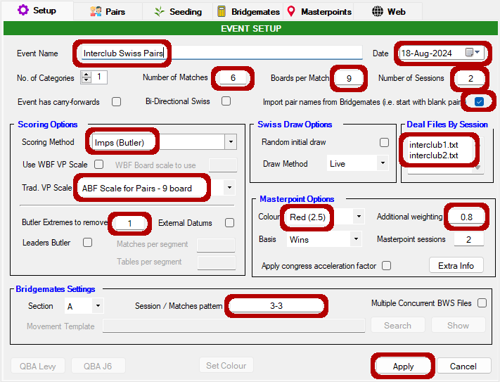

Select the Pairs tab

5.5.3 Create Blank Pairs
From the Pairs tab of Swiss Pairs management screen:
As of July 2024, we are no longer pre-seeding the players – so players can just sit wherever they like for round one (may need some finessing for the interclub). So, on this page:
- Tick NS Pair No equals starting table number;
- Click Blank Pairs
- On the Adding Blank Pairs pop up enter the number of pairs playing (ie 2 * #tables) then OK and OK.
- Note that if one or more people require a stationary table, this is managed via this screen. Arrange for the stationary pairs to be sitting N-S at one of the tables (start with table 3 and then every second or so tables as required). After the start of round 1, once players have entered their names, return to this screen, find the pair(s) who are stationary, click on Edit Pair then click the Pair requires stationary seating, and enter the table number (see purple highlights in the s/s)
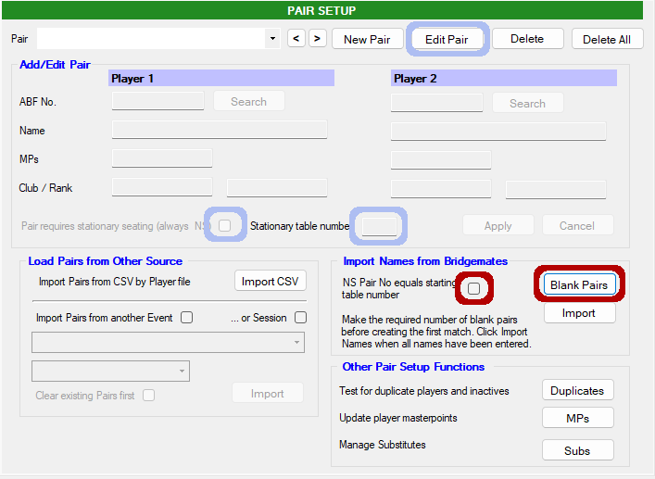

Once the blank pairs have been created – select the Bridgemates tab

5.5.4 Start Session 1 Match 1
From the bridgemate tab of Swiss Pairs management screen:
- Select Create new BWS File
- If the first board doesn’t start at #1 for some reason, then change first board number
- Click Create Match 1
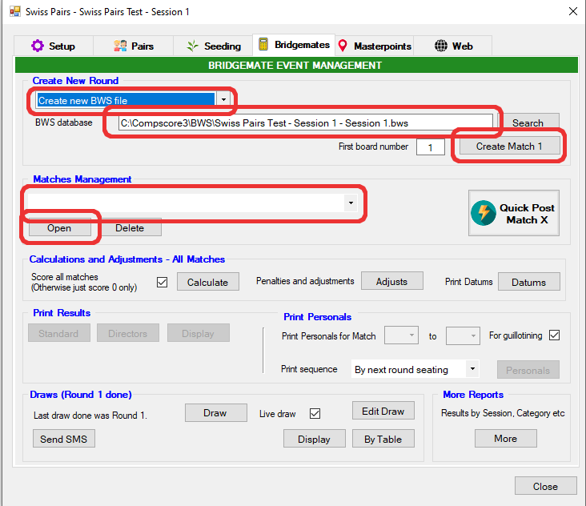
- After a brief pause to cogitate, the screen will refresh with the matches management section being updated with the new Session 1 – Match 1 name.
- Click on Open which will bring up the Session Management Screen

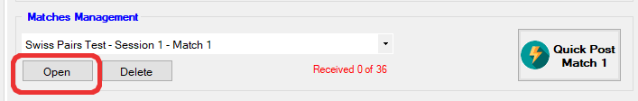

5.5.5. Run Session 1 Match 1
From the Setup tab of Session Management screen
- Make sure that the Bridgemate Server is plugged in
- Press Launch
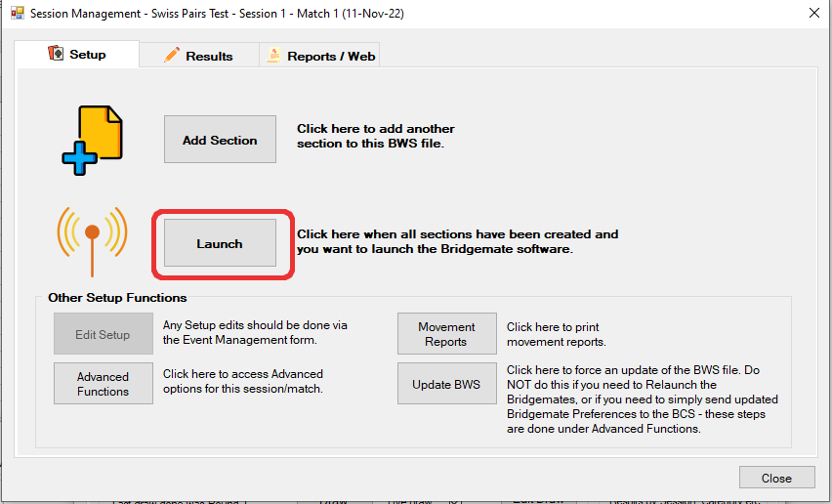
BCS will be launched and Bridgemates will now be activated

From the Main Menu of the BCS
- File->Import; select this session’s dup file and click Import.

Players should now enter their ABF numbers on the bridgemates at each table
Review the Pairs tab – and ensure that all names have been correctly updated
Players can now play boards for match 1.
Once all pairs have finished the match 1 boards (you can monitor this via BCS Monitor tab) – select the results tab on Session management screen

From the Results tab of Session Management screen:
- Click Import
- Once all results are imported – click Close
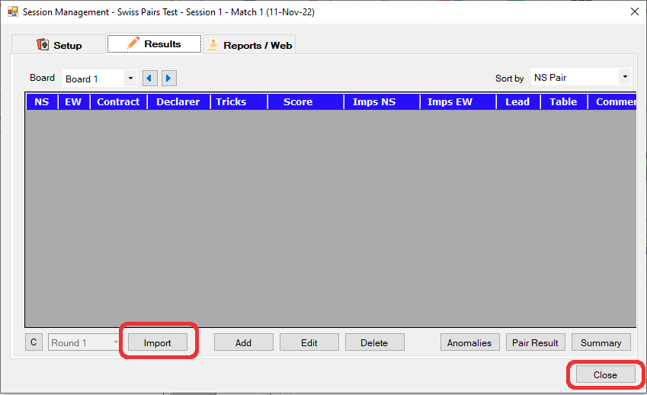

5.5.6. Finalise Match 1; Generate Draw for Match 2
From the bridgemate tab of Swiss Pairs management screen
- check that you have received all the results. (the match management counter should be in blue and say something like “All 72 results received”
- NB Rather than using the Quick Post Match option below, you can just print out the results manually. To do so, refer 5.2.13 Manually Printing Results
- Click Quick Post Match 1. This will calculate results for match 1 and generate the draw for match 2 and print out results.
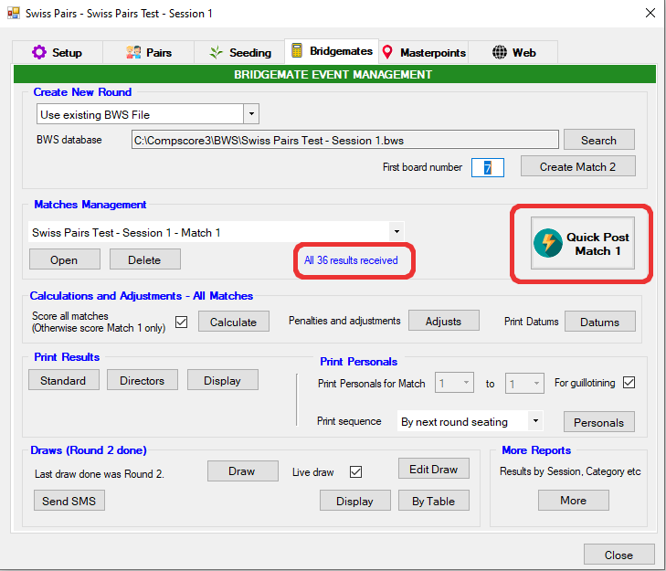
For the Interclub Swiss Pairs, print out the personals, cut and distribute (this is done from the Bridgemates tab):
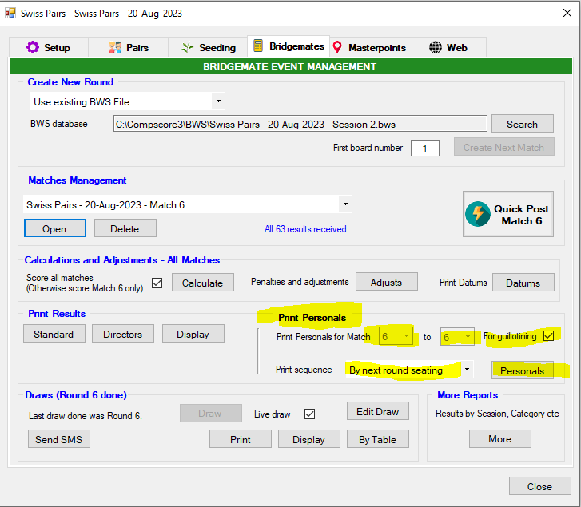

5.5.7 Session 1 Match 2
From the bridgemate tab of Swiss Pairs management screen:
- use the existing BWS file;
- Specify the new starting board number (usu 10).
- Click Create Match 2.
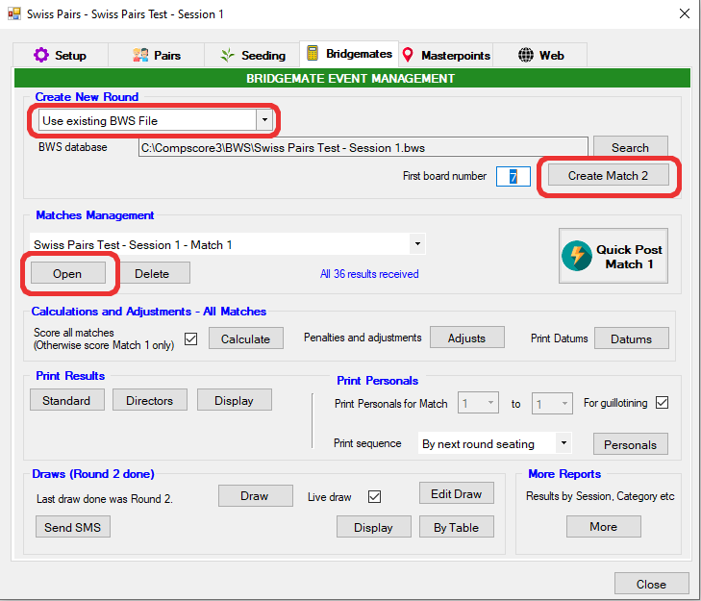

Matches Management section should now be showing Match 2
- Select Match 2 from the dropdown
- Click on Open which will bring up the Session Management Screen.
- Bridgemates will now be updated with the new table positions. Refer players to bridgemates for their new tables.

Players can now move and then play boards for match 2.
Once all pairs have finished the match 2 boards – select the results tab on Session management screen

From the Results tab of Session Management screen:
- Click Import
- Once all results are imported – click Close

From the bridgemate tab of Swiss Pairs management screen
- check that you have received all the results. (the match management counter should be in blue and say something like “All 72 results received”
- Either print results manually or Click Quick Post Match 2. This will calculate results for match 2 and generate the draw for match 3 and print out results.
- For Interclub event, print out personals and distribute

5.5.8 Session 1 Match 3
From the bridgemate tab of Swiss Pairs management screen:
- use the existing BWS file;
- Specify the new starting board number (usu 19).
- Click Create Match 3.

Matches Management section should now be showing Match 3
- Select Match 3 from the dropdown
- Click on Open which will bring up the Session Management Screen.
- Bridgemates will now be updated with the new table positions. Refer players to bridgemates for their new tables.

Players can now play boards for match 3.
Once all pairs have finished the match 3 boards – select the results tab on Session management screen

From the Results tab of Session Management screen:
- Click Import
- Once all results are imported – click Close

From the bridgemate tab of Swiss Pairs management screen
- check that you have received all the results. (the match management counter should be in blue and say something like “All 72 results received”
- Either print results manually or Click Quick Post Match 3. This will calculate results for match 3 and generate the draw for the next session: Session 2 Match 1 and print out results.
- For Interclub event, print out personals and distribute
Maximise BCS and close and then exit the bridgemate server.
For InterClub Swiss Pairs - print out Hand Records – probably easiest done from dealer4 (analyze first).

5.5.9 MBC Half-Day Event Played over Multiple Days
If this is an MBC Swiss Pairs event played over multiple days, then you will need to produce a results file (which means you will also need to calculate the interim masterpoints). Refer sections:
- 5.5.13 Calculate Masterpoints; and
- 5.5.14 Export Results to Website

5.5.10 Session 2 Match 1 (aka Match 4)
If this is an event played over multiple days, you may need to update the pair names with substitutes, see section 5.5.18 Adding Substitutes
From the Bridgemates tab of the Swiss Pairs management screen
- Create a new BWS file
- Make sure that the name of the BWS file says Session 2;
- Assuming these are new boards, first board number should be 1
- NBB: if you need to print out the draw again (ie Samuel Trophy second session), then do so BEFORE creating the match (click on Draw at bottom of page)
- The click Create Match 4
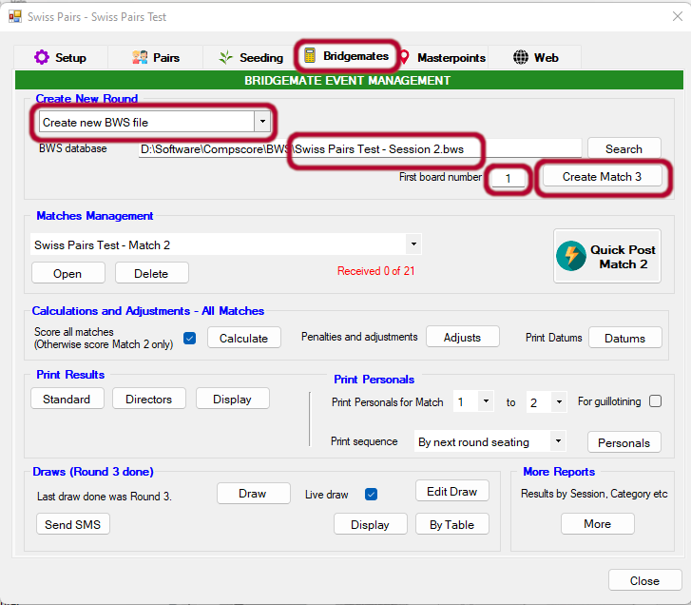
Matches Management section should now be showing Match 4
- Select Match 4 from the dropdown
- Click on Open which will bring up the Session Management Screen

In our testing of July 2024 we noted that the usernames were not showing on the bridgemates at the start of the second session. To correct this:
From the Setup tab of the Session Management screen
- click on Advanced Functions (lower left)
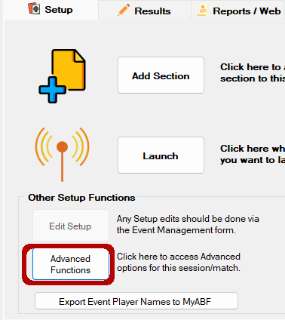

From the BWS Functions tab of the Session Management – Advanced screen
- Click on the Resend button to Resend Player Names – Teams Pairs Events
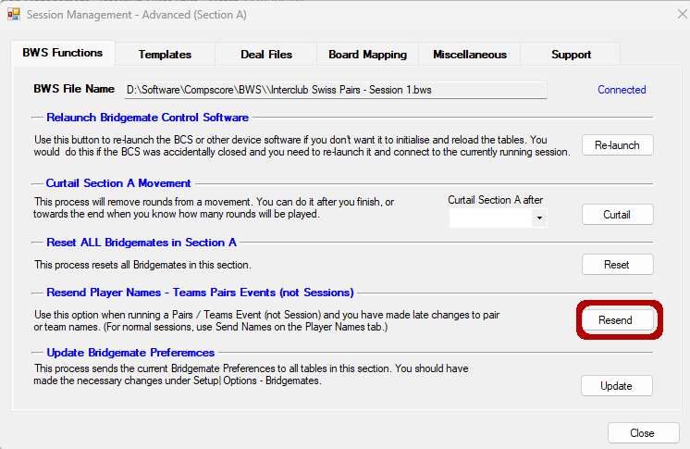

From the Setup tab of Session Management screen
- If you need to print out the seating card, click Movement Reports -> Print Initial Seating -> Print
- Make sure that the bridgemate server is plugged in
- Press Launch
BCS will be launched and Bridgemates will now be activated
- Check on one of the bridgemates that names have been correctly updated

From the Main Menu of the BCS
- File->Import; select the session’s dup file and click Import.

User names will show on the screen at each table
Players can now play boards for match 4
Once all pairs have finished the match 4 boards – select the results tab on Session management screen

From the Results tab of Session Management screen:
- Click Import
- Once all results are imported – click Close
From the bridgemate tab of Swiss Pairs management screen
- check that you have received all the results. (the match management counter should be in blue and say something like “All 72 results received”
- Either print results manually or Click Quick Post Match 4. This will calculate results for match 4 and generate the draw for match 4 and print out reports
- For Interclub event, print out personals and distribute

5.5.11 Session 2 Match 2 (aka Match 5)
From the bridgemate tab of Swiss Pairs management screen:
- use the existing BWS file;
- Specify the new starting board number (usu 10)
- Click Create Match 5.

Matches Management section should now be showing Match 5
- Select Match 5 from the dropdown
- Click on Open which will bring up the Session Management Screen.
- Bridgemates will now be updated with the new table positions. Refer players to bridgemates for their new tables.

Players can now play boards for match 5
Once all pairs have finished the match 5 boards – select the results tab on Session management screen

From the Results tab of Session Management screen:
- Click Import
- Once all results are imported – click Close

From the bridgemate tab of Swiss Pairs management screen
- check that you have received all the results. (the match management counter should be in blue and say something like “All 72 results received”
- Click Quick Post Match 5. This will calculate results for match 5 and print out reports.
- For Interclub event, print out personals and distribute

5.5.12 Session 2 Match 3 (aka Match 6)
From the bridgemate tab of Swiss Pairs management screen:
- use the existing BWS file;
- Specify the new starting board number (usu 19);
- Click Create Match 6.

Matches Management section should now be showing Match 6
- Select Match 6 from the dropdown
- Click on Open which will bring up the Session Management Screen.
- Bridgemates will now be updated with the new table positions. Refer players to bridgemates for their new tables.

Players can now play boards for match 6
Once all pairs have finished the match 6 boards – select the results tab on Session management screen

From the Results tab of Session Management screen:
- Click Import
- Once all results are imported – click Close

From the bridgemate tab of Swiss Pairs management screen
- check that you have received all the results. (the match management counter should be in blue and say something like “All 72 results received”
- Click Quick Post Match 6. This will calculate results for match 6 and generate the overall results

5.5.13 Calculate Masterpoints
- Click on the Masterpoints tab of Swiss Pairs management screen
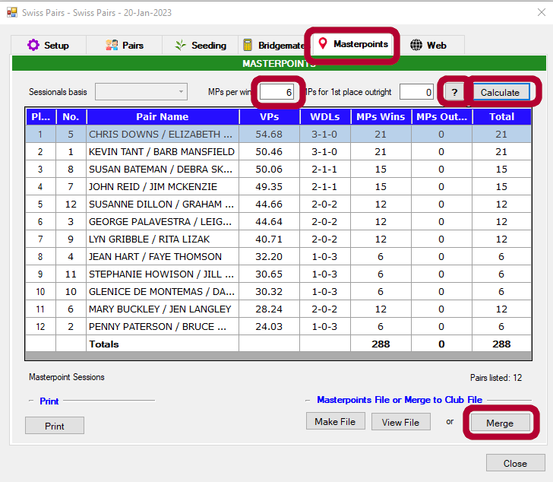
- Click on the [?] it will then show the relevant masterpoint awards. For reasons known best to its creator CS3 displays MPs without the decimal. So for example 14.4 is actually .144 and 67 is .67.
- For Interclub Swiss Pairs, leave the MPs for 1st place outright as calculated, but for MBC swiss pairs events, make sure that MPs for 1st place outright = 0
- Press Calculate
- NB: the best place to print out the final results is from this page. Press Print.
- For now do NOT make a masterpoint file nor Merge it. Leave this for KT to finalise masterpoints
- Print out two copies of masterpoints (one for KT, one for people to review)

5.5.14 Export Results to Website
- Click on Web tab of Swiss Pairs management screen
- In the top section (the section to create a USEBIO XML web page);
- Click Show masterpoint;
- Click Deals and then Make Files
- Click Close
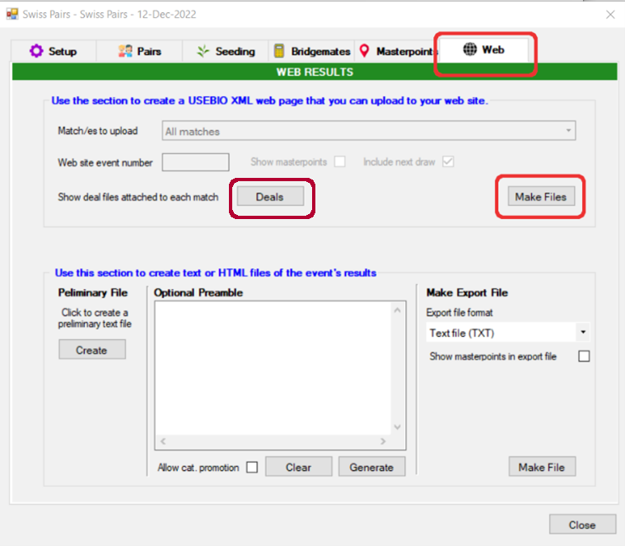
- This should generate two XML files for uploading – one titled Session 1.xml and the other Session 2.xml. The calendar should have both sessions for the results to be uploaded to; but if not then give Web Admin (currently JR) a call to create so that you can upload results correctly.
- NB: It is possible to amalgamate the two result files into one for uploading. This is very manual and requires a lot of editing of the text files. For my (JR’s) benefit, I have appended some basic notes on this at 5.5.17 Amalgamating Swiss Pairs Results
- Use standard process to now load the results file and the deal file to the website. Refer 2.7 Upload Hand Records to Web page
- NB: if you are creating a results file for a multi-day event (eg Samuel Trophy) the date in the Session 2 results file will possibly be wrong (ie have the date for the first event). You can fix this by editing the results file and look for the <DATE>dd/mm/yyyy</DATE> line and change the date to todays date.

5.5.15 Printing Results Manually
From the Bridgemates tab of the Swiss Pairs session management screen:
- Click on Calculate
- Click on Draw
- NB: you may want to just print the personal results – which can be done from the Print Personals area on the right towards the bottom (click on Personals and follow prompts)
- Click on More
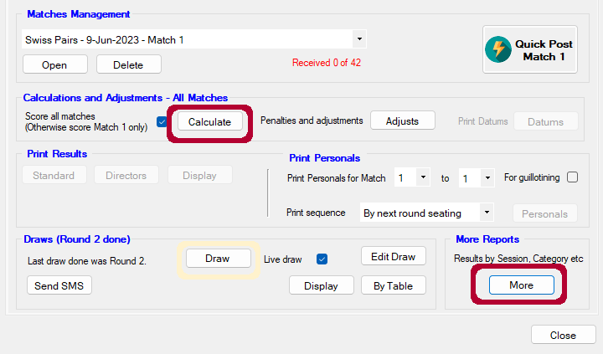

On the pop-up screen click on Print
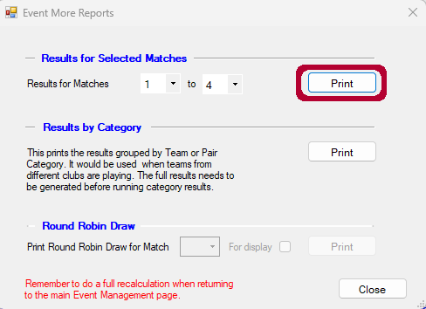

On the Report Preview screen click on the printer icon
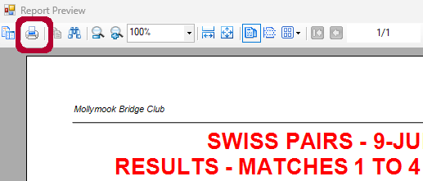

Then click on Advanced
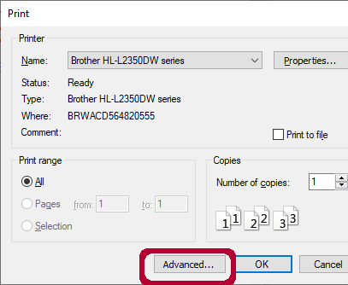

Then click on the drop down box next to Page Scaling and select Fit to Printable
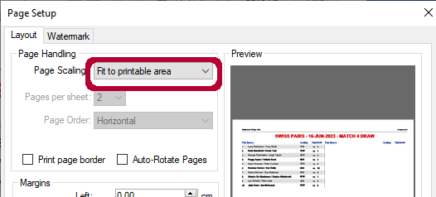

Then [OK] [OK] to print.

NOTE; you can print the draw out if required by following a similar process after clicking Draw on the Bridgemates tab.

5.5.16 Loading Deal File for a Swiss Pairs Match
From the Setup tab of Session Management screen:
NB: as of July 2024 this process has been deprecated and replaced with entering deal files in the initial setup screen.
- Press Advanced Functions
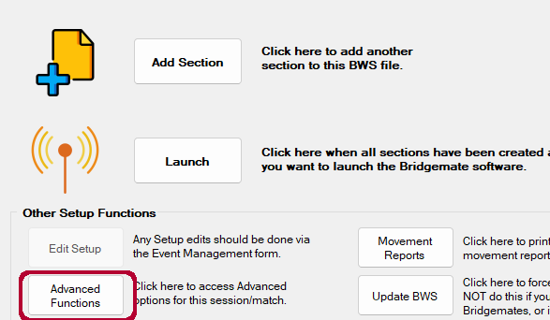

From the Session Management – Advanced screen:
- Select the Deal Files tab,
- Click on the down arrow next to the Deal file name input box and locate the deal file for this session.
- Make sure that the board numbers are correct and then
- Click Import; and
- Close the window
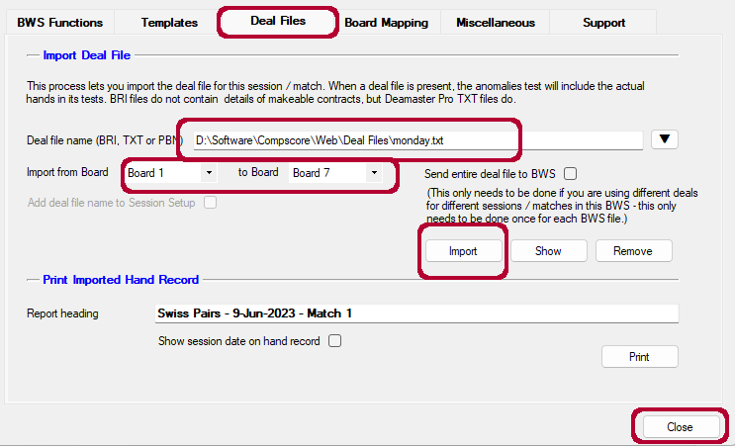

#If you want to hand out hand records after each match, the alternate is to print them from this page. As nine boards fit onto a half page, you can ask how many players want a copy, print half, return the paper to the printer with the printed side down and to the back of the tray and print the other half, it is then just a matter to have someone who is finished first cut them in half, this is easier than changing to A5 paper.

5.5.17 Amalgamating Swiss Pairs Results
Overview
- We will append the session two hand records to session 1, renumbering the boards in session 2 to be from brd 28 – 54 (will need to delete the extra hand records at end of both files)
- We will update the board numbers in the session 2 XML file – ie updating board # 1 to board # 28; brd 2 -> brd 29 etc.
- Append the updated board events from session 2 XML to the session 1 XML
- Update session 1 XML with the overall MPs (taken from masterpoint extract file)

Detailed process
- Update the Makeable Contracts/hand record info
  - Copy the two session 1 and session 2 .XML files and the two hand record files (.TXT) to a separate directory – eg we wont make any changes to the original files
  - Using vi, edit the session 2 .TXT file. Search for BD: and update the board number by adding 27 (eg 1 -> 28 etc). Delete boards after board # 54. Note. Format appears to be BD:nnn (ie don’t type after the current number so BD: 1 should become BD: 28 not BD: 28)
1 | 28 |  | 10 | 37 |  | 19 | 46
2 | 29 |  | 11 | 38 |  | 20 | 47
3 | 30 |  | 12 | 39 |  | 21 | 48
4 | 31 |  | 13 | 40 |  | 22 | 49
5 | 32 |  | 14 | 41 |  | 23 | 50
6 | 33 |  | 15 | 42 |  | 24 | 51
7 | 34 |  | 16 | 43 |  | 25 | 52
8 | 35 |  | 17 | 44 |  | 26 | 53
9 | 36 |  | 18 | 45 |  | 27 | 54
  - Edit the session 1 .TXT file to remove board records after BD: 27; and then append the new session 2 .TXT. Remove the two header lines from the session 2 data. Create new TXT file _both

- Update the XML
Looking at the XML, it is composed of a number of sections. The two we are interested in:
Participants: which details each pair; their total score and MPs awarded.
Match->Board: which shows the results table by table for each round and for each board therein; thus each board number is referenced nine times (assuming that we have nine tables).
  - Open up the session 2 XML in vi. For each board number 1 – 27; increment the board number by 27 (see table above). /<BOARD_NUMBER>1< etc. (use cw to edit; then nwww.) This is a tad time consuming – going to take fifteen minutes or so. Double check your work as there is quite a bit of editing.
  - Get an extract from the session 1 file of the first three rounds board results and insert these into the session 2 file at the top of the <MATCH> section. (:.;$wjj.xml – then delete the last two lines of jj.xml (/EVENT and /USEBIO)
  - Double check that you have the right <MATCH> and </MATCH> tags at top and bottom of inserted section
  - Finally, remove the <CARRY FORWARD> lines for each pair (check with KT – this may relate to the IMPs rather than the VPs)
  - Save a new file with _both

5.5.18 Adding Substitutes

From the Pairs tab - click on Subs
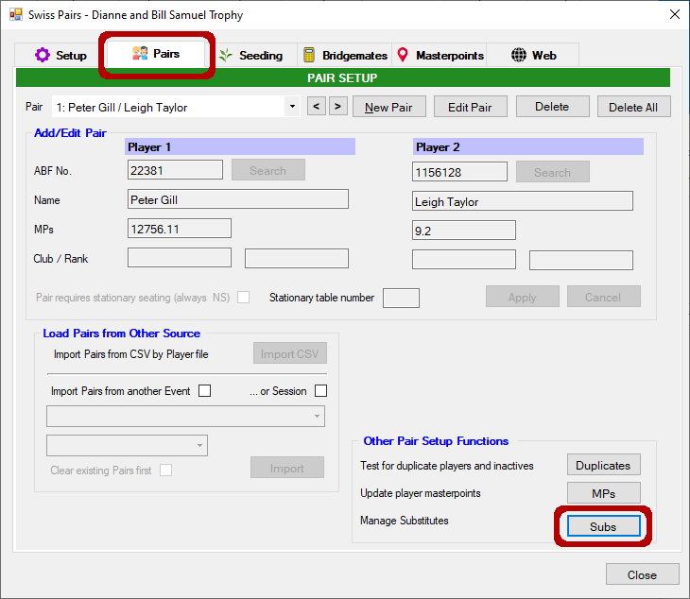
From the Substitutes screen:
- From the dropdown, select the pair for whom you are adding a substitute;
- Click Add Sub;
- type player name into ABF Number field until it is found;
- Select the person to be replaced and then update the matches which the sub is playing
- Click Apply and then Yes to the pop-up requester.
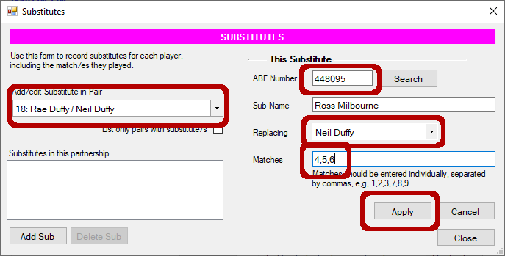

5.6 Single Session Swiss Pairs – Walk up Event
If you want to run an ad hoc Swiss Pairs event with players not seeded and just entering their names on bridgemates to start off. Please note; you may be able to define a stationary table after names have been imported (ie for someone who is movement restricted) – check on the Pairs tab

5.6.0 NBB
- Will require multiple board sets – you need a minimum of two boards per table. So the #boardsets * boards per round must be greater than 2 * #tables (assuming 7 boards per round, two board sets will suffice unless you have eight or more tables)
- You can setup a stationary table for a pair if required.
- You have to manually enter the starting board # each time you are starting a new match.
- You don’t need to print out the draw after each match – the bridgemates will tell people where to go.
- You can save paper by just printing the results manually rather than doing a quick post-match. Refer section 5.5.16 Printing Results Manually

5.6.1 Setup Event Parameters
CS3 -> New -> New Pairs Event
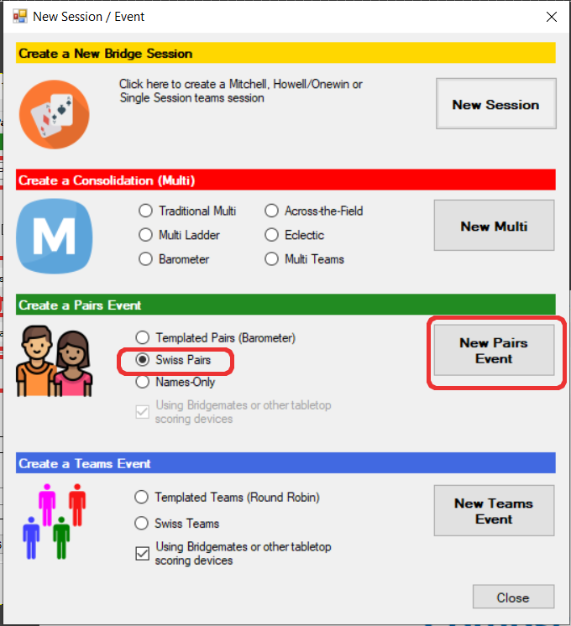

This will bring up the Swiss Pairs management screen
On the Setup tab of Swiss Pairs management screen enter:
- Event name – (do NOT include session #).
- Number of matches – 4
- Boards per match - 7
- Number of sessions – 1
- Tick option to import names from bridgemates
- Scoring Method – X-Imping
- Enter the name of the deal file to use for this event (after testing in July 2024, this proved to be the only method to work correctly for loading deal files)
- De-select Use WBF VP Scale, and choose ABF Scale for Pairs – 7 board
- Masterpoints Colour – Change to required (Green (1.0) or Red (2.5) )
- Session/Matches pattern – 4
- Apply
Note for more than six tables, it is probably better to use Imps (Butler) as a scoring method. Use the appropriate ABF Scale for Trad. VP Scale and remove 1 Butler extremes (if 12+ tables can remove 2 extremes).
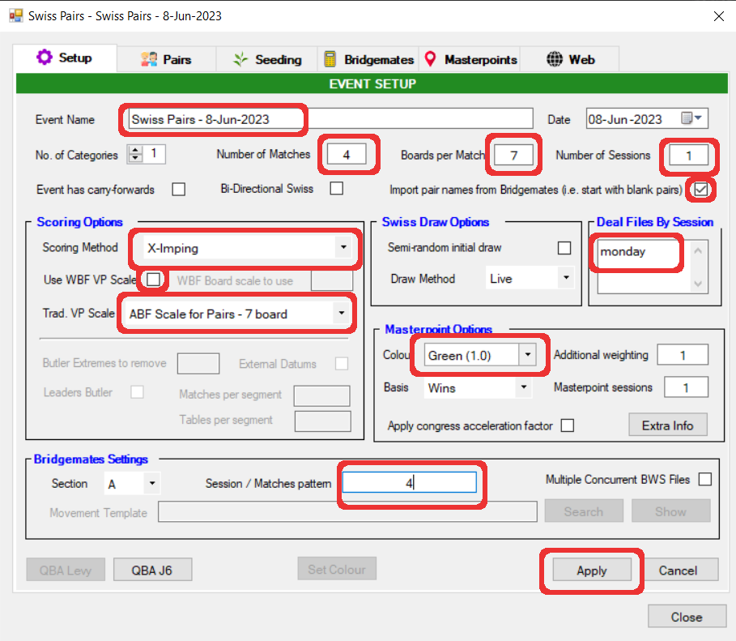

Move to the Pairs tab

5.6.2 Setup Pairs
From the Pairs tab of the Swiss Pairs management screen
- Tick NS Pair No equals starting table number
- Click on Blank Pairs and then on the Adding Blank Pairs pop-up specify the number of pairs playing (#tables * 2) [OK] and then OK to the next Pop-up.
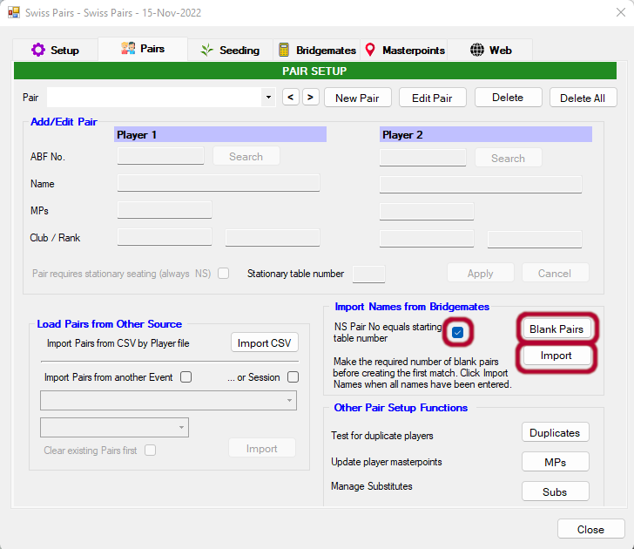

5.6.3 Prepare and Run Match 1
Select the Bridgemate tab
From the bridgemate tab of Swiss Pairs management screen:
- Select Create new BWS File
- If the first board doesn’t start at #1 for some reason, then change first board number
- Click Create Match 1 and then Yes to the pop-up
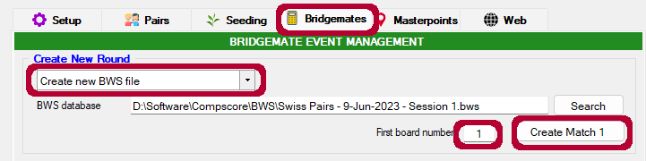

In the matches management section:
- Select Match 1 from the dropdown
- Click on Open which will bring up the Session Management Screen
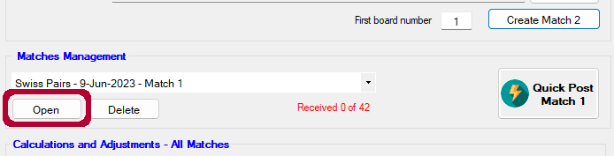

From the Setup tab of Session Management screen
- Make sure that the bridgemate server is plugged in
- Press Launch - BCS will be launched and Bridgemates will now be activated

From the Main Menu of the BCS
- File->Import; select today’s dup file and click Import.
- Wait for the BCS pop-up and close that window

- Ask users to enter their ABF numbers into the bridgemates
- Once all names have been entered successfully, return to the Pairs tab of the Swiss Pairs management screen and press Import.
- All pairs should now be showing in the Pairs screen
- Click on the Duplicates button (bottom right) to ensure there are no duplicates.
- Players may now commence playing match 1 boards. Once all boards have been completed for match 1– select the results tab on Session management screen
From the Results tab of Session Management screen:
- Click Import
- Once all results are imported – click Close
From the bridgemate tab of Swiss Pairs management screen
- check that you have received all the results. (the match management counter should be in blue and say something like “All 36 results received”
- Either print results manually (see 5.2.14) or Click Quick Post Match 1. This will calculate results for match 1and generate the draw for match 2 and print out reports

5.6.4 Run Match 2
From the bridgemate tab of Swiss Pairs management screen:
- use the existing BWS file;
- Specify the new starting board number (usu 8).
- Click Create Match 2.

Matches Management section should now be showing Match 2
- Select Match 2 from the dropdown
- Click on Open which will bring up the Session Management Screen
- This will update the movement on the bridgemates and send the seating for this match to the bridgemates. BCS will do some calculations and then present a pop-up which must be closed

Players may now play boards for match 2
Once all pairs have finished the match 2 boards – select the results tab on Session management screen

From the Results tab of Session Management screen:
- Click Import
- Once all results are imported – click Close

From the bridgemate tab of Swiss Pairs management screen
- check that you have received all the results. (the match management counter should be in blue and say something like “All 36 results received”
- Either print results manually or Click Quick Post Match 2. This will calculate results for match 2 and generate the draw for match 3 and print out reports

5.6.5 Run Match 3
From the bridgemate tab of Swiss Pairs management screen:
- use the existing BWS file;
- Specify the new starting board number (usu 15)
- Click Create Match 3.

Matches Management section should now be showing Match 3
- Select Match 3 from the dropdown
- Click on Open which will bring up the Session Management Screen
- This will update the movement on the bridgemates and send the seating for this match to the bridgemates. BCS will do some calculations and then present a pop-up which must be closed

Players may now play boards for match 3
Once all pairs have finished the match 3 boards – select the results tab on Session management screen

From the Results tab of Session Management screen:
- Click Import
- Once all results are imported – click Close

From the bridgemate tab of Swiss Pairs management screen
- check that you have received all the results. (the match management counter should be in blue and say something like “All 36 results received”
- Either print results manually or Click Quick Post Match 3. This will calculate results for match 3 and generate the draw for match 4 and print out reports

5.6.6 Run Match 4
From the bridgemate tab of Swiss Pairs management screen:
- use the existing BWS file;
- Specify the new starting board number (usu 22)
- Click Create Match 4.

Matches Management section should now be showing Match 4
- Select Match 4 from the dropdown
- Click on Open which will bring up the Session Management Screen
- This will update the movement on the bridgemates and send the seating for this match to the bridgemates. BCS will do some calculations and then present a pop-up which must be closed

Players may now play boards for match 4
Once all pairs have finished the match 4 boards – select the results tab on Session management screen

From the Results tab of Session Management screen:
- Click Import
- Once all results are imported – click Close

From the bridgemate tab of Swiss Pairs management screen
- check that you have received all the results. (the match management counter should be in blue and say something like “All 36 results received”
- NB the best place to print out the final results is via the Masterpoints page – see next section.

5.6.7 Calculate Masterpoints
- Click on the Masterpoints tab of Swiss Pairs management screen
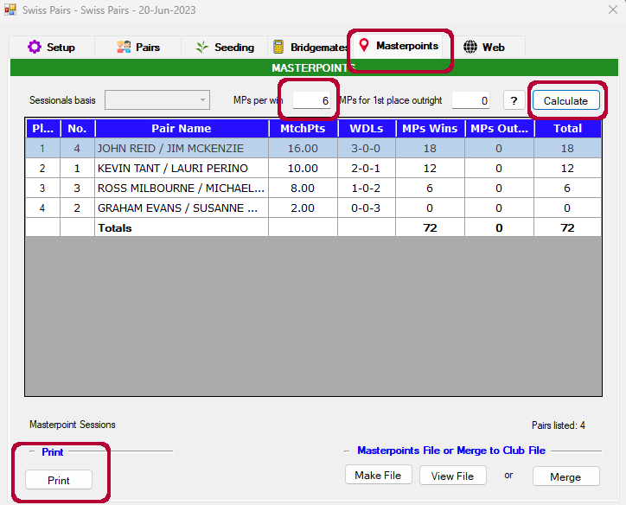

- Enter the MPs per win (this can be calculated by multiplying the number of boards per round * 0.8 and rounding – ie 6 for 8 board rounds). Not confirmed, but you should be able to press the ? button and CS3 will correctly update the values.
- Make sure that MPs for 1st place outright = 0
- Press Calculate
- NB: the best place to print out the final results is from this page. Press Print.
- For now do NOT make a masterpoint file nor Merge it. Leave this for KT to finalise masterpoints.

5.6.8 Export Results to Website
- Click on Web tab of Swiss Pairs management screen
- In the top section (the section to create a USEBIO XML web page); click on Deals
- Click Make Files
- Click Close
- The results file will be created in the standard Results directory and can be uploaded to the website via the usual means. Refer Upload Hand Records to Web page

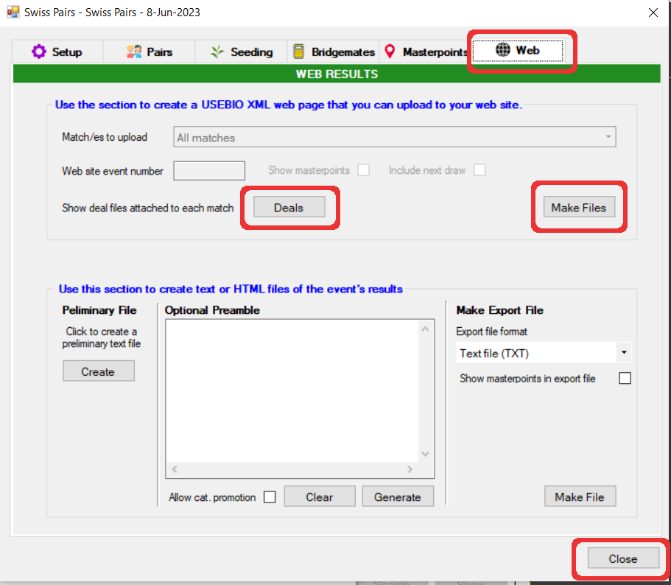

5.6.9 When Things go Wrong

Note that if you run out of time to play one or more of the final sessions, just return to Setup and change the number of matches at the top and then the Session / Matches pattern to the reduced matches played. Apply and then proceed per usual process.

5.7 Running Multiple Sections in One Session

5.7.0 NBB
- Make sure that you use a different name for each section – otherwise results files will overwrite each other
- Also note that you will need to have two events on the website, so that you can load the each result to its own session

5.7.1 Generate and deal hands
The simplest thing is to deal out the same hands for each section. If for some reason you need to use different hands there are some things you will need to ensure that things work properly: see section 5.7.7. Using Different Deal Files for Sections

5.7.2 Setup Bridgemates for section B
On each of the bridgemates which need to be reconfigured:
- Press Setup soft key
- Press + key to change the Section to B;
- Press down arrow soft key;
- Press - key to change the table number to desired number.
- Remember to reset when done :p

5.7.3 Configure CS3 for Section A
Once the number of tables for each section is known
- CS3 -> New Session
- Enter section A session information (change the Session name to something more descriptive if not a standard session)
- Press Apply and Confirm Details. This will present the Session Management screen for Section A.
- Click Add Section.
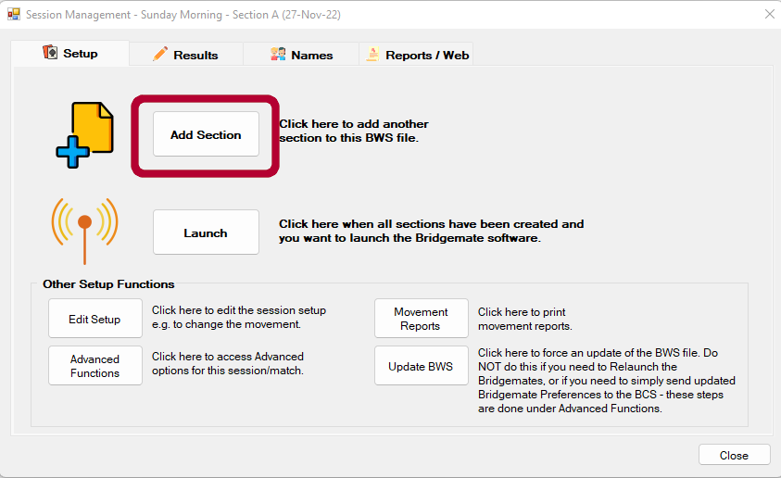

5.7.4 Configure CS3 for Sections B onwards
- Enter section B session information (NB Session name MUST be different )
- Press Apply and Confirm Details (This will bring up a separate Session Management screen for Section B
- If you are running more than two Sections (good luck!) then press Add Section again, otherwise Click Launch to bring up BCS. Note: there will be just one instance of BCS which will present information for each section each deal line will be prefaced by the section name

5.7.5 Manage Sessions and Finalise
Now manage each section in its own Session Management screen as per normal. You can manage and finalise each independently of the other.

5.7.6 Reconfigure Bridgemates used for Section B

5.7.7 Using different Deals files for Sections
- If you plan on using different deal files, firstly make sure the naming convention for each is obvious.
- Because only one instance of BCS will be running; you WILL NEED TO TURN OFF LEAD CARD VALIDATION – otherwise leads in one section will be flagged as invalid. Refer instructions in Section 3.4.6 Invalid Lead Card or Declarer

5.8 Supervised Play Sessions
Supervised Play sessions attract master points per schedule F. When setting up the session, choose Green Masterpoints with a Basic Weighting of 0.75

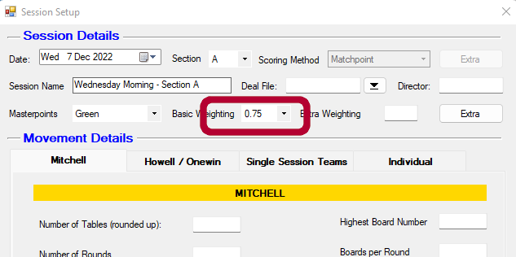

5.9 Country Teams Club Qualifying Session – NO half table

5.9.1 Initial Setup
The Country Teams qualifying sessions are run as IMP scored Pairs single-winner events with Barometer-style scoring (results produced after each round). Seating is allocated randomly (use the buttons), and you will need to deal out three sets of (thirty) boards (you may need four sets if you are likely to get more than nine tables). There are no outright awards for these events. You might find it useful to ask someone else to manage the distribution and subsequent collection of all the boards as you will have lots to do between each match. The movement is effectively a Mitchell – albeit with a single winner. Boards will be shared between tables; players should move the boards in the usual clockwise direction (looking down on the room).
Open a new Templated Pairs event
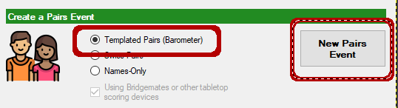
This will bring up the Templated Pairs management screen
On the Setup tab of Templated Pairs screen enter:
Event Name | Country Teams Qualifying - Sx
No. of Categories | 1
Number of Matches | 5
Boards per Match | 6
Number of Sessions | 1
Import pair names from Bridgemates | Tick box
Scoring Method | X-Imping
Deal Files by Session | Enter the name of the deal file eg GNOT_S1.pbn (include the extension)
Trad. VP Scale | Imps = VPs
MasterPoint Colour | Red (2.5) NB: Gold for GNOT
MasterPoint Additional Weighting | 2 NB: 1 for GNOT
Session/Match Pattern | 5
Movement Template | GNOT n tables (Fav).csv
(x = current event session number; n = number of tables)
Click Apply.
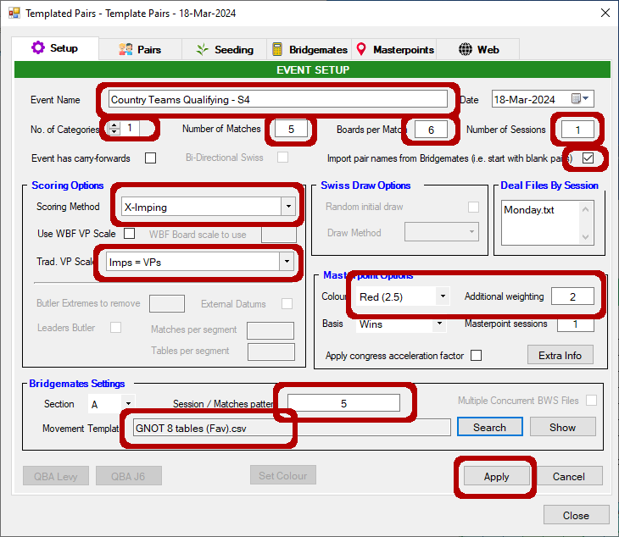

Click on the Pairs tab of Templated Pairs
In the Import Names from Bridgemates section (lower middle right of screen) enter:
NS Pair No equals starting table # | Tick box
Click Blank Pairs.
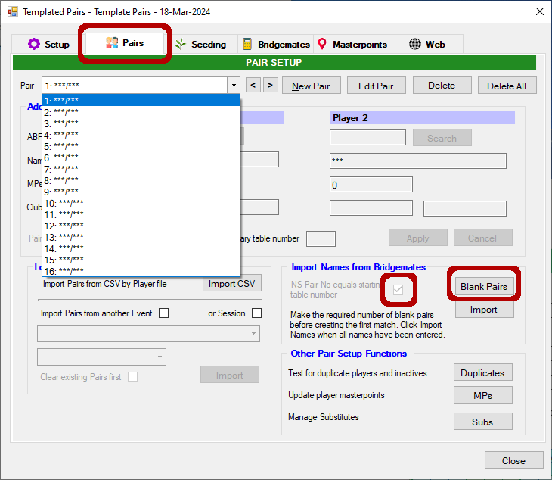

On the Adding Blank Pairs pop-up screen
- Enter the number of pairs (ie 2 * # tables) and click OK

NOTE: Be sure to tick [NS pair # = table #] *before* clicking [Blank Pairs]. New event if not.

Click on the Bridgemates tab of Templated Pairs screen

5.9.2 Match 1
From the Bridgemates tab of Templated Pairs screen:
- Select Create New BWS file and then
- Click on Create Next Match
- Click Open to open Match 1

From the Setup tab of Session Management screen
- Make sure that the bridgemate server is plugged in
- Press Launch - BCS will be launched and Bridgemates will now be activated
- For some reason, it appears that you need to import the .pbn file for suspicious contract error checking by BCS, so maximise BCS, file-> Import and import the .PBN file.

- Ask users to enter their ABF numbers into the bridgemates
- Once all names have been entered successfully, return to the Pairs tab of the Templated Pairs management screen and press Import.
- All pairs should now be showing in the Pairs screen
- Click on the Duplicates button (bottom right) to ensure there are no duplicates.
- Players may now commence playing match 1 boards. Once all boards have been completed (check in the BCS Round monitor) for match 1– select the Results tab on Session management screen
From the Results tab of Session Management screen:
- Click Import
- If any results need to be adjusted that can now be done in this screen (select the required board and then click on the hand which needs to be adjusted)
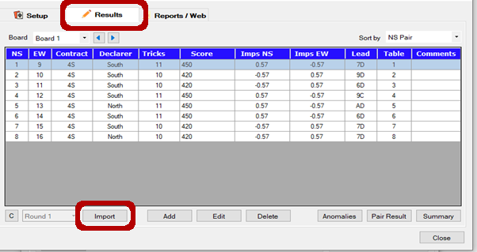
- Once all results are imported – select the Reports/Web tab on Session Management screen and Re-Calc if required.
- Click Close.
From the bridgemate tab of Templated Pairs management screen
- check that you have received all the results. (the match management counter should be in blue and say something like “All 48 results received”)
- Click on Quick Post Match 1. This will generate the results page for match 1.

5.9.3 Match 2 – Match 5
From the bridgemate tab of Templated Pairs management screen
- Click on Create Next Match (NB use existing BWS file)
- From the Matches management section click on Open.
Ask (EW) users to move for the next round
Once all matches are complete and any anomalous results addressed:
From the Results tab of Session Management screen:
- Click Import (close the screen once results are imported)
From the bridgemate tab of Templated Pairs management screen
- check that you have received all the results. (the match management counter should be in blue and say something like “All 48 results received”)
Click on Quick Post Match n. This will generate the results page for match n.

Repeat this process until all five matches have been played

5.9.4 Finalising the Results
Click on the Masterpoints tab of the Templated Pairs management screen. From that screen:
- click on the question mark to get the MPs per Win value
- click on Calculate and answer YES to the Calculate Masterpoints pop-up screen

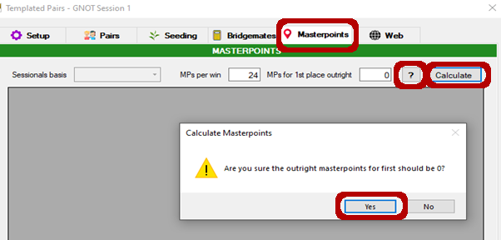

When the results are displayed – click on Print
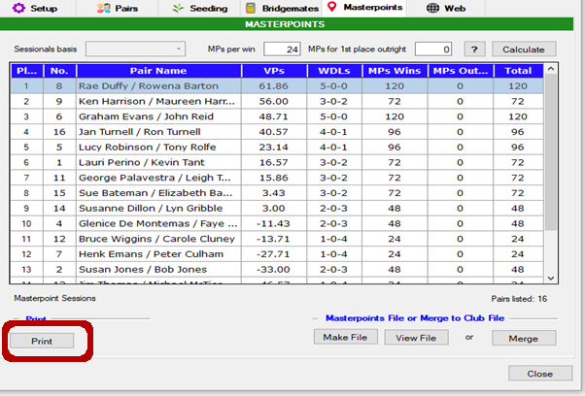

Send a copy to the printer, and while the print screen is open, select save as and save a copy as PDF. A copy of each sessions results is needed by whoever is responsible for the overall running, to send to the regional organiser or in the case of the GNOT, whoever authorises the masterpoints.

Click on the Web tab of the Templated Pairs management screen
- Tick Show masterpoints
- Then click Make Files to generate the results file.
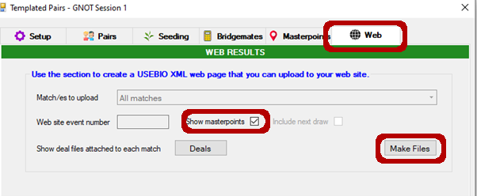
Upload results file and deal file to website.

5.10 Country Teams Club Qualifying Session – with half table

5.10.1 Initial Setup
The Country Teams qualifying sessions are run as IMP scored Pairs single-winner events with Barometer-style scoring (results produced after each round). Seating is allocated randomly (use the buttons), and you will need to deal out three sets of (thirty) boards (you may need four sets if you are likely to get more than nine tables). EXCEPT for a 4.5 table movement which has only four matches – and for which you have to make either two sets of either 4 * 8 boards (32 to be played) or 4 * 6 boards (24 to be played).
There are no outright awards for these events. You might find it useful to ask someone else to manage the distribution and subsequent collection of all the boards as you will have lots to do between each match. The movement is effectively a Mitchell – albeit with a single winner. Boards will be shared between tables, players should move the boards in the usual clockwise direction (looking down on the room).

The process for managing half tables requires a lot of manual intervention. The movement templates which will be used do not exactly match the actual movement (the bump pairs are not included); so you will need to carefully manage the bump ins and outs. The bump ins and outs are described in detail for each of the half table scenarios, in the following sections – but in overview, what will be happening is that each round, the EW pair at the sitout table, sits out the first three boards of the round and then bumps the designated N/S pair to the sitout table. That EW pair then returns to the normal EW movement starting at table 1 (the sitout table is the last table). I would recommend that you copy/paste the movement information for the actual number of tables (see sections 5.10.5 onwards below) so that you can have that available while following these instructions.

NB: with the half table movement it is most important to start putting the boards out for each match on the table where the bump is going to take place (the first 3 boards in the set). If you don’t, you must know which three boards were played by each pair in order to update the bump-in/out players after the match.

- Open a new standard session in CS3
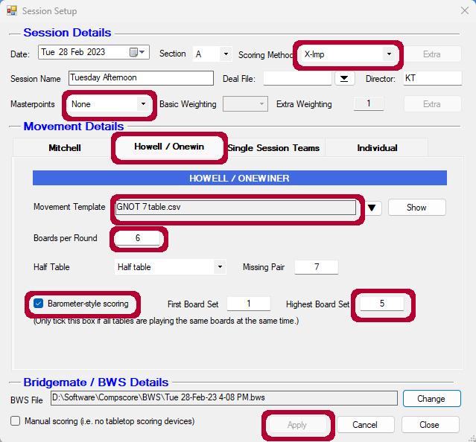

Scoring Method | X-Imp (Note: Scoring method can be either X-Imp or Butler - you might chose Butler if there is a lot of variability in the field in terms of capability).
Session Name | Country Teams Qualifying - Sx
Deal File | (as usual)
Masterpoints | None (MPs will be calculated using the KTEmulator.xlsx)
Movement Details | Select Howell/Onewin tab
Movement Template | GNOT n tables (Fav).csv
Boards per Round | 6
Half Table | Half Table
Missing Pair | #tables (make NS pair at highest numbered table missing)
Barometer-style scoring | Tick
First Board Set | 1
Highest Board Set | 5
Click Apply

NOTE: when placing the boards, put down the first three boards at the table which will be bumped this round. This is detailed in the section specific to the number of tables.

From the Setup tab of the Session Management window
- Launch BCS

From the Bridgemate Control Software window
- Setup and apply any required filter

Once all players have entered their ABF numbers, from the Names tab of the Session Management window:
- Import Names

Play first match

5.10.2 After each Match (aka Round)
- Check in the BCS Round monitor that all tables have completed all boards
- In the CS3 Session Management window:
- Click on Results tab
- At the bottom left of the screen, select the Round number which was just completed and
- Click on Import
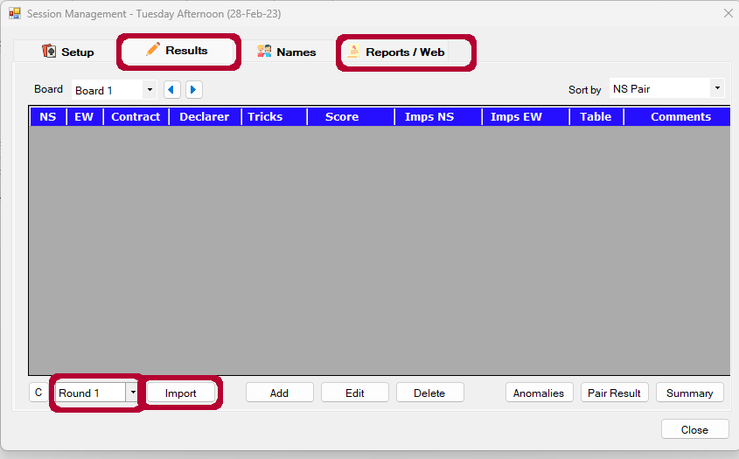

You now need to correct for the bumpout pair. From the Results tab, select each of the boards (usually three) which need to be adjusted – all going well this will be the fourth, fifth and sixth boards of the match – find the N/S pair which was bumped and double click that row – in the pop-up replace the N/S pair number with the bumping pair number and Apply
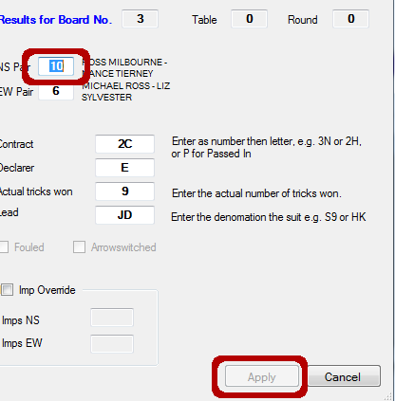

Select the Report/Web tab of the Session Management screen

- Click on Re-Calc to apply the bump-out/in pair changes
- Click on Results in the Reports section to print out the current standings
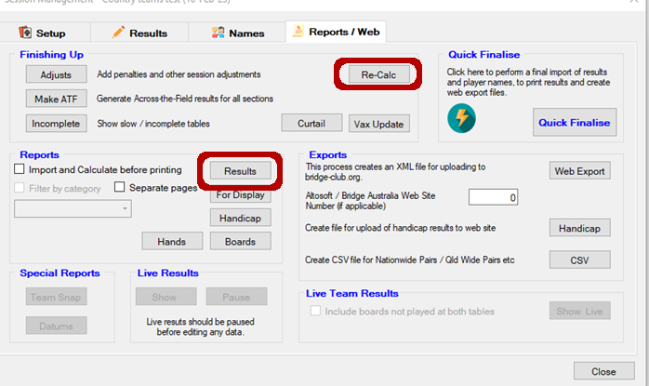

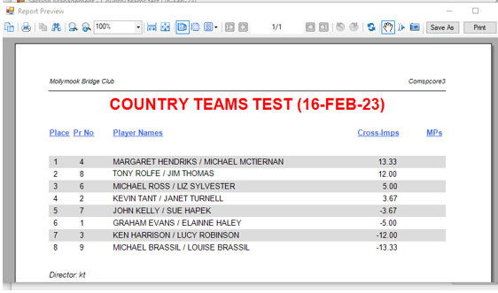

Ask East-West to move for the next round and distribute the boards for the next round NOTING the boards should be placed with the first three boards at the bumpout table

5.10.3 After the Final Match
- Import and update results per process in 5.10.2
- On the Reports/Web tab of the Session Management screen – click Recalc and then Quick Finalise
- While you are on the Reports/Web page, click the CSV option in the Exports section to generate a CSV formatted results output – this is used in the next section to calculate masterpoints.
- You can now upload the results to the web page – noting that no masterpoints will be included.

5.10.4 Calculating the Masterpoints
I provide below KT’s overview of the process to determine masterpoints. This is mostly for information as the process has now been semi-automated with the excel workbook KTEmulator.xlsx. At some future date I will aspire to document that or better automate the process.

Having done all of this you now have to (later) work out who won which round, a win at Imps is an Imp Score GREATER than .02 per board per Round. So for 6 boards which we play it has to be an Imp score GREATER THAN 1.2 - + or -1.2 IS A DRAW.! You need to create an Excel sheet to do this. It can be done at home at your leisure on you own copy of Compscore3. By making a CSV file of the event and importing to your own computer.
Allocate .24 mpts for each win and .12 for a draw #The half rounds (make it +.06 for a win) gets .12, and .06 for a draw! It is possible that the pair at the bumping table can have a half win and a loss on that round.
To get the wins go to the results table and start at round 1

5.10.5 Half Table Movements
Movements vary according to the number of tables. The sections below provide details of the movement for different table numbers. The synopsis in each section has the following columns:
Rnd : The round/match number
Brds : Board numbers in play for this round
1st Brds : Start putting out boards at the nominated table (to ensure N/S plays first half of boards)
S/O Pair : E/W pair sitting out at the start of the round
N/S Bump : N/S pair that E/W pair will bump after half the boards are played
Boards by S/O : Boards this round which the E/W pair will play (useful later on when you are adjusting the scores)

5.10.6 Movement for 4.5 Tables
NOTE: for this movement only, use two boardsets. Session will be 4 Rounds of 8 Boards
Sit out pair: 5 NS
Rnd | Brds | 1st Brds | S/O Pair | N/S Bump | Boards by S/O
1 | 1-8 | T1 | 10 | 1 | 5-8
2 | 9-16 | T3 | 9 | 3 | 13-16
3 | 17-24 | T2 | 8 | 2 | 21-24
4 | 25-32 | T4 | 7 | 4 | 29-32

R1 (b# 01-04): Sitout Pair 10 at sitout table #5
R1.5 (b# 05-08): Pair 10 bump NS (pair 1) at table 1.

R2 (b# 09-12): Pair 10 move to table 1 EW; Pair 1 return to table 1 NS; Pair 9 at sitout table #5
R2.5 (b# 13-16): Pair 9 bump NS (pair 3) at table 3.

R3 (b# 17-20): Pair 9 move to table 1 EW; Pair 3 return to table 3 NS; Pair 8 at sitout table #5
R3.5 (b# 21-24): Pair 8 bump NS (pair 2) at table 2.

R4 (b# 25-28): Pair 8 move to table 1 EW; Pair 2 return to table 2 NS; Pair 7 at sitout table #5
R4.5 (b# 29-32): Pair 7 bump NS (pair 4) at table 4.

Score adjustments required:
- For each round in the table above, Adjust each of the “Boards by S/O” by changing the N/S Bump pair to the S/O Pair.

5.10.7 Movement for 5.5 Tables
Session will be 5 rounds of 6 Boards
Sit out pair: 6 N/S
Rnd | Brds | 1st Brds | S/O Pair | N/S Bump | Boards by S/O
1 | 1-6 | T1 | 12 | 1 | 4-6
2 | 7-12 | T3 | 11 | 3 | 10-12
3 | 13-18 | T5 | 10 | 5 | 16-18
4 | 19-24 | T2 | 9 | 2 | 22-24
5 | 25-30 | T4 | 8 | 4 | 28-30

R1 (b# 01-03): Sitout Pair 12 at sitout table
R1.5 (b# 04-06): Pair 12 bump NS (pair 1) at table 1.

R2 (b# 07-09): Pair 12 move to table 1 EW; Pair 1 return to table 1 NS; Pair 11 at sitout table
R2.5 (b# 10-12): Pair 11 bump NS (pair 3) at table 3.

R3 (b# 13-15): Pair 11 move to table 1 EW; Pair 3 return to table 3 NS; Pair 10 at sitout table
R3.5 (b# 16-18): Pair 10 bump NS (pair 5) at table 5.

R4 (b# 19-21): Pair 10 move to table 1 EW; Pair 5 return to table 5 NS; Pair 9 at sitout table
R4.5 (b# 22-24): Pair 9 bump NS (pair 2) at table 2.

R5 (b# 25-27): Pair 9 move to table 1 EW; Pair 2 return to table 2 NS; Pair 8 at sitout table
R5.5 (b# 28-30): Pair 8 bump NS (pair 4) at table 4.

Score adjustments required:
- For each round in the table above, Adjust each of the “Boards by S/O” by changing the N/S Bump pair to the S/O Pair.

5.10.8 Movement for 6.5 Tables
Session will be 5 rounds of 6 Boards
Sit out pair: 7 N/S
Rnd | Brds | 1st Brds | S/O Pair | N/S Bump | Boards by S/O
1 | 1-6 | T1 | 14 | 1 | 4-6
2 | 7-12 | T3 | 13 | 3 | 10-12
3 | 13-18 | T5 | 12 | 5 | 16-18
4 | 19-24 | T2 | 11 | 2 | 22-24
5 | 25-30 | T4 | 10 | 4 | 28-30

R1 (b# 01-03): Sitout Pair 14 at sitout table
R1.5 (b# 04-06): Pair 14 bump NS (pair 1) at table 1.

R2 (b# 07-09): Pair 14 move to table 1 EW; Pair 1 return to table 1 NS; Pair 13 at sitout table
R2.5 (b# 10-12): Pair 13 bump NS (pair 3) at table 3.

R3 (b# 13-15): Pair 13 move to table 1 EW; Pair 3 return to table 3 NS; Pair 12 at sitout table
R3.5 (b# 16-18): Pair 12 bump NS (pair 5) at table 5.

R4 (b# 19-21): Pair 12 move to table 1 EW; Pair 5 return to table 5 NS; Pair 11 at sitout table
R4.5 (b# 22-24): Pair 11 bump NS (pair 2) at table 2.

R5 (b# 25-27): Pair 11 move to table 1 EW; Pair 2 return to table 2 NS; Pair 10 at sitout table
R5.5 (b# 28-30): Pair 10 bump NS (pair 4) at table 4.

Score adjustments required:
- For each round in the table above, Adjust each of the “Boards by S/O” by changing the N/S Bump pair to the S/O Pair.

5.10.9 Movement for 7.5 Tables
Session will be 5 rounds of 6 Boards
Sit out pair: 8 N/S
Rnd | Brds | 1st Brds | S/O Pair | N/S Bump | Boards by S/O
1 | 1-6 | T1 | 16 | 1 | 4-6
2 | 7-12 | T3 | 15 | 3 | 10-12
3 | 13-18 | T5 | 14 | 5 | 16-18
4 | 19-24 | T7 | 13 | 7 | 22-24
5 | 25-30 | T2 | 12 | 2 | 28-30

R1 (b# 01-03): Sitout Pair 16 at sitout table
R1.5 (b# 04-06): Pair 16 bump NS (pair 1) at table 1.

R2 (b# 07-09): Pair 16 move to table 1 EW; Pair 1 return to table 1 NS; Pair 15 at sitout table
R2.5 (b# 10-12): Pair 15 bump NS (pair 3) at table 3.

R3 (b# 13-15): Pair 15 move to table 1 EW; Pair 3 return to table 3 NS; Pair 14 at sitout table
R3.5 (b# 16-18): Pair 14 bump NS (pair 5) at table 5.

R4 (b# 19-21): Pair 14 move to table 1 EW; Pair 5 return to table 5 NS; Pair 13 at sitout table
R4.5 (b# 22-24): Pair 13 bump NS (pair 7) at table 7.

R5 (b# 25-27): Pair 13 move to table 1 EW; Pair 7 return to table 7 NS; Pair 12 at sitout table
R5.5 (b# 28-30): Pair 12 bump NS (pair 2) at table 2.

Score adjustments required:
- For each round in the table above, Adjust each of the “Boards by S/O” by changing the N/S Bump pair to the S/O Pair.

5.10.10 Movement for 8.5 Tables
Session will be 5 rounds of 6 Boards
Sit out pair: 9 N/S
Rnd | Brds | 1st Brds | S/O Pair | N/S Bump | Boards by S/O
1 | 1-6 | T1 | 18 | 1 | 4-6
2 | 7-12 | T3 | 17 | 3 | 10-12
3 | 13-18 | T5 | 16 | 5 | 16-18
4 | 19-24 | T7 | 15 | 7 | 22-24
5 | 25-30 | T2 | 14 | 2 | 28-30

R1 (b# 01-03): Sitout Pair 18 at sitout table
R1.5 (b# 04-06): Pair 18 bump NS (pair 1) at table 1.

R2 (b# 07-09): Pair 18 move to table 1 EW; Pair 1 return to table 1 NS; Pair 17 at sitout table
R2.5 (b# 10-12): Pair 17 bump NS (pair 3) at table 3.

R3 (b# 13-15): Pair 17 move to table 1 EW; Pair 3 return to table 3 NS; Pair 16 at sitout table
R3.5 (b# 16-18): Pair 16 bump NS (pair 5) at table 5.

R4 (b# 19-21): Pair 16 move to table 1 EW; Pair 5 return to table 5 NS; Pair 15 at sitout table
R4.5 (b# 22-24): Pair 15 bump NS (pair 7) at table 7.

R5 (b# 25-27): Pair 15 move to table 1 EW; Pair 7 return to table 7 NS; Pair 14 at sitout table
R5.5 (b# 28-30): Pair 14 bump NS (pair 2) at table 2.

Score adjustments required:
- For each round in the table above, Adjust each of the “Boards by S/O” by changing the N/S Bump pair to the S/O Pair.

5.10.11 Movement for 9.5 Tables
Session will be 5 rounds of 6 Boards
Sit out pair: 9 N/S
Rnd | Brds | 1st Brds | S/O Pair | N/S Bump | Boards by S/O
1 | 1-6 | T1 | 20 | 1 | 4-6
2 | 7-12 | T3 | 19 | 3 | 10-12
3 | 13-18 | T5 | 18 | 5 | 16-18
4 | 19-24 | T7 | 17 | 7 | 22-24
5 | 25-30 | T9 | 16 | 9 | 28-30

R1 (b# 01-03): Sitout Pair 20 at sitout table
R1.5 (b# 04-06): Pair 20 bump NS (pair 1) at table 1.

R2 (b# 07-09): Pair 20 move to table 1 EW; Pair 1 return to table 1 NS; Pair 19 at sitout table
R2.5 (b# 10-12): Pair 19 bump NS (pair 3) at table 3.

R3 (b# 13-15): Pair 19 move to table 1 EW; Pair 3 return to table 3 NS; Pair 18 at sitout table
R3.5 (b# 16-18): Pair 18 bump NS (pair 5) at table 5.

R4 (b# 19-21): Pair 18 move to table 1 EW; Pair 5 return to table 5 NS; Pair 17 at sitout table
R4.5 (b# 22-24): Pair 17 bump NS (pair 7) at table 7.

R5 (b# 25-27): Pair 17 move to table 1 EW; Pair 7 return to table 7 NS; Pair 16 at sitout table
R5.5 (b# 28-30): Pair 16 bump NS (pair 9) at table 9.

Score adjustments required:
- For each round in the table above, Adjust each of the “Boards by S/O” by changing the N/S Bump pair to the S/O Pair.

5.10.12 Movement for 10.5 Tables
Session will be 5 rounds of 6 Boards
Sit out pair: 10 N/S
Rnd | Brds | 1st Brds | S/O Pair | N/S Bump | Boards by S/O
1 | 1-6 | T1 | 22 | 1 | 4-6
2 | 7-12 | T3 | 21 | 3 | 10-12
3 | 13-18 | T5 | 20 | 5 | 16-18
4 | 19-24 | T7 | 19 | 7 | 22-24
5 | 25-30 | T9 | 18 | 9 | 28-30

R1 (b# 01-03): Sitout Pair 22 at sitout table
R1.5 (b# 04-06): Pair 22 bump NS (pair 1) at table 1.

R2 (b# 07-09): Pair 22 move to table 1 EW; Pair 1 return to table 1 NS; Pair 21 at sitout table
R2.5 (b# 10-12): Pair 21 bump NS (pair 3) at table 3.

R3 (b# 13-15): Pair 21 move to table 1 EW; Pair 3 return to table 3 NS; Pair 20 at sitout table
R3.5 (b# 16-18): Pair 20 bump NS (pair 5) at table 5.

R4 (b# 19-21): Pair 20 move to table 1 EW; Pair 5 return to table 5 NS; Pair 19 at sitout table
R4.5 (b# 22-24): Pair 19 bump NS (pair 7) at table 7.

R5 (b# 25-27): Pair 19 move to table 1 EW; Pair 7 return to table 7 NS; Pair 18 at sitout table
R5.5 (b# 28-30): Pair 18 bump NS (pair 9) at table 9.

Score adjustments required:
- For each round in the table above, Adjust each of the “Boards by S/O” by changing the N/S Bump pair to the S/O Pair.

5.10.13 Movement for 11.5 Tables
Session will be 5 rounds of 6 Boards
Sit out pair: 11 N/S
Rnd | Brds | 1st Brds | S/O Pair | N/S Bump | Boards by S/O
1 | 1-6 | T1 | 24 | 1 | 4-6
2 | 7-12 | T3 | 23 | 3 | 10-12
3 | 13-18 | T5 | 22 | 5 | 16-18
4 | 19-24 | T7 | 21 | 7 | 22-24
5 | 25-30 | T9 | 20 | 9 | 28-30

R1 (b# 01-03): Sitout Pair 24 at sitout table
R1.5 (b# 04-06): Pair 24 bump NS (pair 1) at table 1.

R2 (b# 07-09): Pair 24 move to table 1 EW; Pair 1 return to table 1 NS; Pair 23 at sitout table
R2.5 (b# 10-12): Pair 23 bump NS (pair 3) at table 3.

R3 (b# 13-15): Pair 23 move to table 1 EW; Pair 3 return to table 3 NS; Pair 22 at sitout table
R3.5 (b# 16-18): Pair 22 bump NS (pair 5) at table 5.

R4 (b# 19-21): Pair 22 move to table 1 EW; Pair 5 return to table 5 NS; Pair 21 at sitout table
R4.5 (b# 22-24): Pair 21 bump NS (pair 7) at table 7.

R5 (b# 25-27): Pair 21 move to table 1 EW; Pair 7 return to table 7 NS; Pair 20 at sitout table
R5.5 (b# 28-30): Pair 20 bump NS (pair 9) at table 9.

Score adjustments required:
- For each round in the table above, Adjust each of the “Boards by S/O” by changing the N/S Bump pair to the S/O Pair.

5.9.5 Calculating Masterpoints
There is a spreadsheet which has been written to assist in calculating the masterpoints for this event. Refer to c:\manuals\KTEmulator.xlsx. At the time of writing the latest version is 1.07. Refer to the Instructions tab of that workbook for details on how to use. (latest version is also available on google drive: https://drive.google.com/drive/folders/1wILoaCz1HLkJkmBbbim5DRqbnVz2orIJ?usp=share_link)

Having done all of this you now have to (later) work out who won which round, a win at Imps is an Imp Score GREATER than 0.2 per board per Round. So, for 6 boards which we play it has to be an Imp score GREATER THAN 1.2 ie.1.2 IS A DRAW. You need to create an Excel sheet to do this. It can be done at home at your leisure on you own copy of CS3. By making a CSV file of the event and importing to your own computer. Allocate .24 mpts for each win and .12 for a draw

#The half rounds (make it +.06 for a win) gets .12, and .06 for a draw! It is possible that the pair at the bumping table can have a half win and a loss on that round.
To get the wins go to the results table and start at round 1

5.11 Grand National Open Teams Club Qualifying Session
The process used to run the GNOT qualifying sessions is identical (apart from session names and the master points colour) to the process used for the country teams qualifying sessions. With no half table, refer to section 5.9 Country Teams Club Qualifying Session – NO half table. If you have a half table, refer to section 5.10 Country Teams Club Qualifying Session – with half table

6. Business Continuity Plans

6.1 PC Failure

Implications
D4, CS3, BCS software unavailable. MBC website effectively unavailable. Data files unavailable.
Setup is per Swiss Pairs Setup instructions

Service Restoration Actions
Manually randomise some boards. Keep a record of who is playing and their starting positions. Keep a record of the movement used. Use travellers to record results. Keep travellers and other notes for later manual updates to CS3.

Recovery Actions
Once main computer is restored see 3.2.9 Manually Entering Results from Travelers

6.2 Dealer 4 hardware failure

Implications
Hands will need to be manually shuffled and dealt

Service Restoration Actions
- Hand will need to be shuffled and dealt manually to boards.
- Lead card validation should be disabled. See section 3.4.6.
- CS3, BMC and BM devices can be used as per normal; though no dubious contract checking available.
- No deals can be loaded to website.

Recovery Actions
Nil

6.3 Internet unavailable

Implications
Results (and makeable contracts) will be able to be sent to the website.
I believe that BCS and BM devices will still communicate with each other.

Service Restoration Actions
Ring service provider (hmm who is that )

Recovery Actions
- Once service is restored, Start up CS3 and Open the session.
- If you have not yet finalised the event, then finalise per normal

6.4 Bridgemate Server Failure

Implications
BM Devices will be unusable. Results will need to be captured manually and subsequently manually updated in CS3. No dubious contract checking.

Service Restoration Actions
Use Travellers to manually capture hand results. Manually update results in CS3 after the session. (see 3.2.9 Manually Entering Results from Travelers).

Recovery Actions
Nil

6.5 Power outage

Implications
Very much timing dependent. Have the boards been dealt, is it during play or after play before results are finalised. In most cases it will be during play.

Service Restoration Actions
Wait

Recovery Actions
If prior to boards being dealt:
- Manually shuffle and deal cards into card holders. Use travellers to record results.

If during play:
- Continue playing as per normal. Remember that the Bridgemates run on battery and the Server has battery backup so keep entering the information on the Bridgemates, it will still go to the server. KT thinks the batteries in the server will power it for at least 24 hours
- Restart the computer and open CS3 as normal and open the current session.
- Open the Event
- Click on the Setup tab of the Session Management Screen
- Click on Advanced Functions
- Select the BWS Functions tab. Note that the file name at the top should show the current session – if not you have opened the wrong event
- Click Re-Launch.
- You can confirm that results during blackout have been correctly loaded by clicking on the Board Monitor or Round Monitor tabs of BCS.

7. Data Files

7.1 PBN
Directory : C:\Compscore3\Web\Deal files
Produced by : Dealer 4
Data : Deals and makeable contract information.
Used by : CS3 (read only).
More Info : Portable Bridge Notation. Standard deal file and card play information. Data is text and human readable by opening with any text editor.

7.2 BWS
Directory : C:\Compscore3\BWS
Produced by : CS3
Data : Stores session information for current session – updated by bridgemates.
Used by : BCS; CS3. The BWS file is the communication channel between Bridgemates, BCS and CS3.
More Info : bws files are actually Microsoft access database files. You can view the contents by changing the suffix (.bws) to .mdb; and then clicking to open with Microsoft access (assuming access is installled on the PC).

7.3 XML
Directory : C:\ Compscore3\Web\XML Files
Produced by : CS3
Data : Results file for uploading
Used by : Manual upload to website process
More Info : You can view and/or edit this file in any text editor or with most browsers. The file contains event info within the EVENT tag; Participant info including player names and ABF numbers, total score, %, place masterpoints and type within the PARTICIPANTS tag; Results for each board showing within the BOARD tag; and hand records showing dealer and cards within the HANDSET tag;

7.4 Log Files
Directory : C:\ Compscore3\Logs
Produced by : CS3
Data : Quite detailed activity log created by CS3 each time it is opened
Used by : Humans for debugging only.
More Info : This file can be viewed and or edited with any text editor (eg Notepad or WordPad). NOTE that BCS also produces log files – details to be included [JR].

7.5 BRI
More Info : Use of BRI files has been deprecated and replaced with PBN format files.

7.6 DUP
More Info : Use of DUP files has been deprecated

7.7 TXT
More Info : Use of TXT files has been deprecated. Functionality for makeable contracts now provided by PBN format files.

8 Software Information

8.1 Dealer 4

Files
INPUT
- nil
OUTPUT
- PBN

Connectivity
Dealer 4 Hardware is connected to USB port on computer

Software Version

Hardware Version

Installation Instructions
Installation directory
Software keys/Activation Code

Website
http://www.dealer4.com/Manuals.htm

8.3 Compscore 3

Files
INPUT
- PBN (deal and makeable contract information
OUTPUT
- BWS (for BCS)
- XML (results information for database)
- Log files

Connectivity : Nil

Software version
Version 1.0.0

Installation Instructions
Installation directory
Software keys/Activation Code

Website
http://www.altosoft.com.au

8.4 BCS

Files
INPUT
- BWS (to load an earlier Bridgemate session)
OUTPUT
- BWS (BCS will update the BWS file created by CS3)
- Log files

Connectivity
Connected to CS3 via the COM port on the computer
Connected to Bridgemate devices via wireless radio frequency (using the 868MHz ISM band)

Software version

Installation Instructions
Installed in C:\Program files\Bridgemate Pro
Log file created here.

Website
https://www.bridgemate.com/resources/documents/BM2manual.pdf

8.1 DMPro

NOTE this software is no longer used.

Files
INPUT
- Nil
OUTPUT
- BRI
- DUP
- TXT

Connectivity
Nil

Software Version

Installation Instructions
Installation directory
Software keys/Activation Code

Website
http://dealmaster.com

9. Managing Masterpoints

9.0 Overview
Club Masterpoint Secretaries may submit green points and Grade B4c and B5i red points directly to the ABF Masterpoint Centre (abfmasterpoints.com.au). Points earned in higher grade events need to be uploaded by NSWBA appointed organisers or the State Masterpoint Secretary (process detailed below). For more info, refer to the NSWBA guide (Club_Masterpoint_Secretary_Handbook.pdf) and the ABF Masterpoint manual

9.1 Green Masterpoints
In almost all cases these will be Grade E sessions with a factor of 1.5. The more important events such as Club Championships should be run at Grade D. Clubs can play up to six Grade D events each year.

To ensure that club members MPs are processed by the ABF in their monthly run, green MPs should be uploaded on or just before the last day of the month

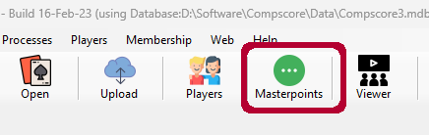 | Open CS3 and click on the Masterpoints tab
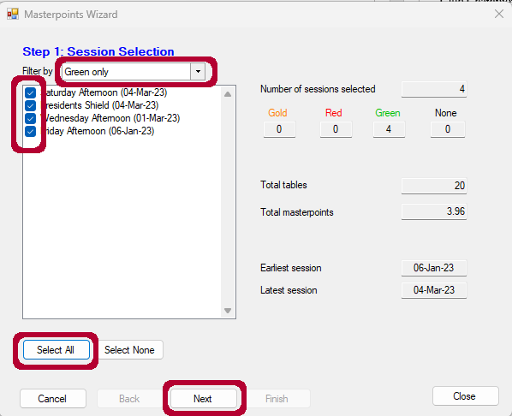 | You will be presented with a list of all open sessions (any sessions for which masterpoints had previously been uploaded should have been closed and will not be listed).  Filter by Green only.  Review the list and make sure that there are no duplicates and no test sessions (if there are, delete them first). Also make sure that no sessions are missing – if any are there are probably two reasons – either the session has already been closed (go back and check in CS3), or the session has been inadvertently deleted or overwritten – in which case you will need to create a manual file for that session (see section 9.4) if you can find the winners details by some means (printed result sheet in the folder or results online).  Select All and click Next
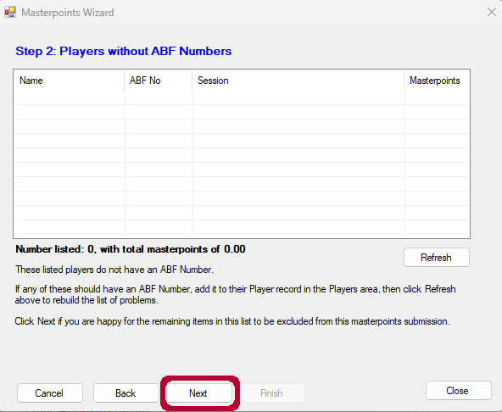 | If there were any players without ABF numbers in the included sessions, you will now have the opportunity to update each player’s info.  Click Next after any updates
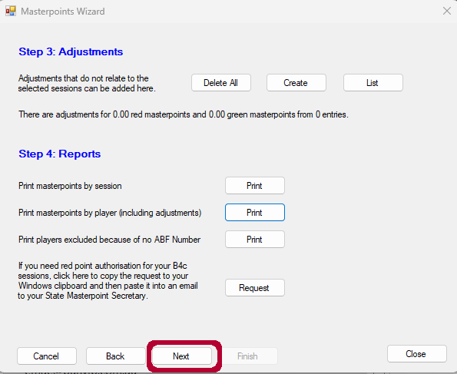 | I have no idea what adjustments might be required. Cross your fingers and hastily press Next
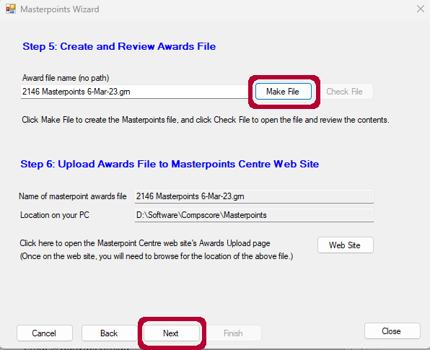 | You can now create the masterpoints file for upload to the ABF Masterpoints Centre. Though you could upload it directly now, I will add those steps subsequently.  Click Make File and then click on OK to the pop up confirming file creation.  Click Next.
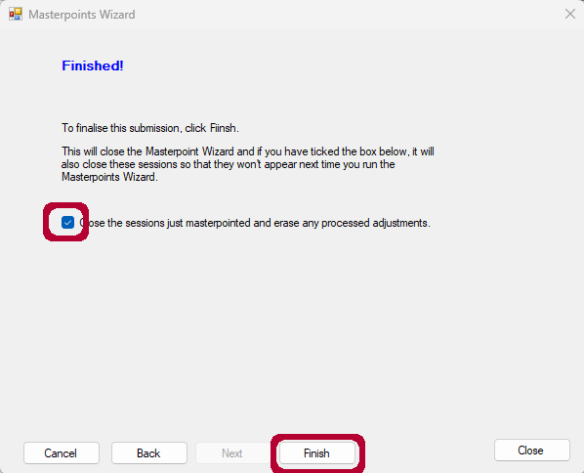 | You can now close all the sessions for which you have exported masterpoints. This will ensure that these sessions are not presented again the next time that you generate the masterpoint file.  Make sure that the Close sessions tick box is ticked and Press Finish and then click Yes to the confirmation requestor box.  To upload the file, see 9.5 Uploading Masterpoints to ABF Masterpoint Centre

9.2 Red Grade B4c and B5i MasterPoints
Same process as for 9.1 Green Masterpoints except that at the second step select Red only.

9.3 State and National event Masterpoints
These files will need to be approved by the relevant state or national masterpoint secretary. NB generally these masterpoints will not be awarded to the players until after the finals for that specific event have been played later in the year. NBB these must be lodged within 30 days of the completion of the event (a fine will otherwise be applied)
Create the masterpoint file per the process outlined at 9.1 Green Masterpoints – selecting the appropriate MP colour filter.
State events to be sent to the state coordinator: masterpoints@nswba.com.au
National events to be sent to the national coordinator: masterpoints@abf.com.au
Questions for KT
- what else apart from the .red or whatever file needs to be sent ? .pdf ? evidence of the session itself ?
- I assume that only you are authorised to send these emails ?
- Do the qualifying rounds for all state and national events need to be sent this way ?

9.4 Creating a manual file
It is very rare that you might need to do this. Recently a session was inadvertently overwritten by a later session, such that the details in CS3 were lost for the earlier session. In order to ensure that the masterpoints for the earlier session were captured correctly it was necessary to create a manual file for that session.
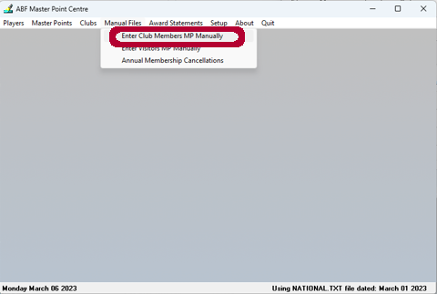 | Open nat4win_program.exe (The icon is on the RHS of the monitor screen) and select Manual Files -> Enter Club Members MP Manually.  NOTE: Nat4Win should be updated at the start of each month AFTER the ABFMPC updates it. The version date is at the bottom of the page
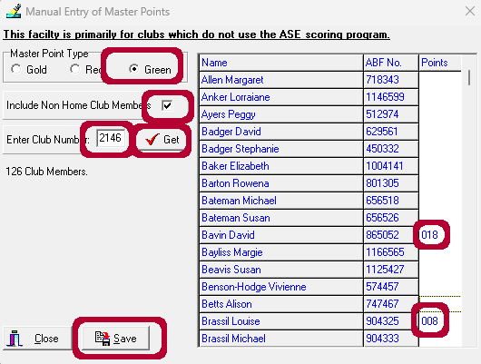 | Click on the MP Type  Tick Include Non Home Club Members  Enter Club Number and then click on the Get tick box.  You will now be presented with an alphabetic list of all club members and other regular players from other clubs. Find the member(s) who need masterpoints added. Enter the masterpoints as three integers with leading zeros, for example 0.18 MPs should be entered as 018; and 1.20 MPs should be entered as 120.  Once all members have been entered, click on Save.
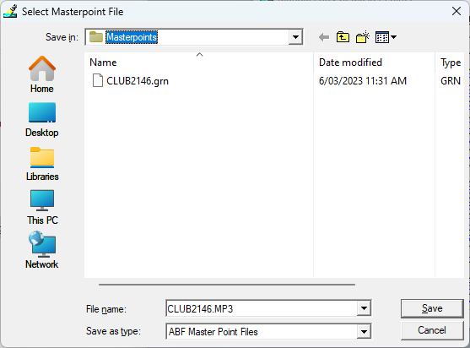 | You will be presented with a file requester asking you to specify the file name and where to save the file. The default location is C:/National Files  The default file suffix is .mp3 – this can be a bit confusing, so change the suffix to .grn (or .red; .gld as required) and save.  You can now upload the masterpoint file see 9.5 Uploading Masterpoints to ABF Masterpoint Centre.
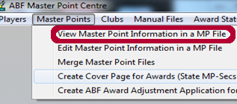  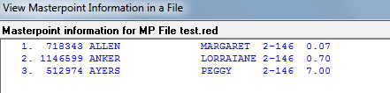 | To check the contents of a MP file using nat4win, select Master Points -> View Master Point Information in a MP file and then select the required file
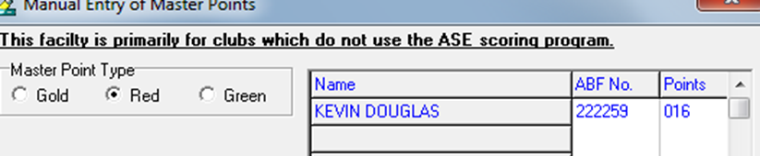 | If you need to update a player whose name does not come up on the list  Go to Manual Files -> Enter visitors manually Type in their ABF No and [enter] Their name will come up.  Enter their awards and save as above. But give the file a different name eg -8 march visitors
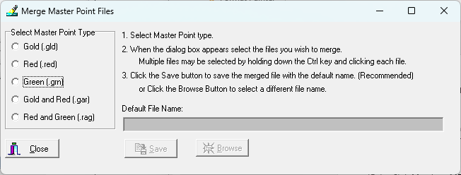  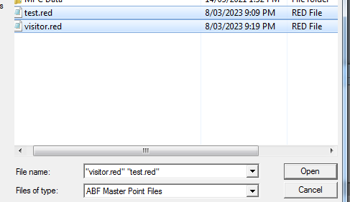 | If necessary you can merge multiple files. Go to Master Points -> Merge Master Point Files. Select the file colour(s) to merge and then find and click on all files to be merged and click Open. You should view the contents of the merged file

9.5 Uploading Masterpoints to ABF Masterpoint Centre
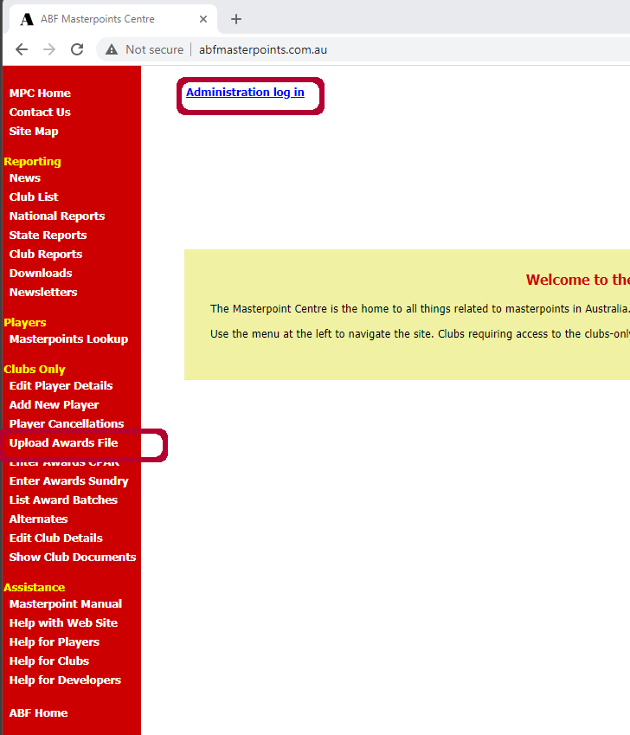 | Open up a web browser and go to the ABF masterpoints centre (abfmasterpoints.com.au).  Click on the Administration log in link at the top towards the left.  Username is mollymook2146.  Password is  And then click on the Upload Awards File link in the left hand panel (under Clubs Only heading)
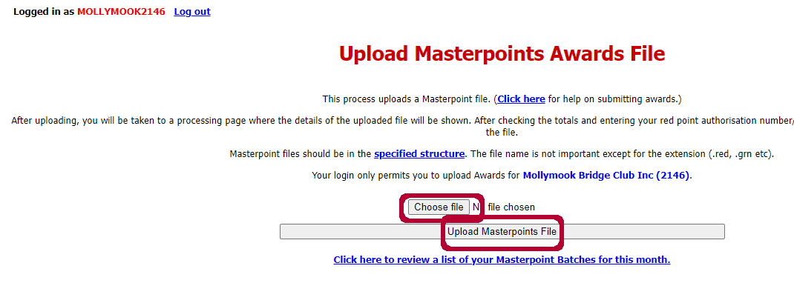 | Click on Choose file and browse to the .grn masterpoint file just created (C:\Compscore3\Masterpoints). NB: make sure that you pick the .grn file NOT the .pdf file)  Click Upload Masterpoints File and Log Off

Appendix 1: Rover Mitchell instructions for moving pair
N/S ROVER PAIR 15 N/S ROVER PAIR 15 N/S ROVER PAIR 15
ROUND TABLE SIT ROUND TABLE SIT ROUND TABLE SIT
1 | 8 | OUT |  | 1 | 8 | OUT |  | 1 | 8 | OUT
2 | 2 | N/S |  | 2 | 2 | N/S |  | 2 | 2 | N/S
3 | 4 | N/S |  | 3 | 4 | N/S |  | 3 | 4 | N/S
4 | 4 | E/W |  | 4 | 4 | E/W |  | 4 | 4 | E/W
5 | 6 | N/S |  | 5 | 6 | N/S |  | 5 | 6 | N/S
6 | 6 | E/W |  | 6 | 6 | E/W |  | 6 | 6 | E/W
7 | 1 | N/S |  | 7 | 1 | N/S |  | 7 | 1 | N/S
8 | 1 | E/W |  | 8 | 1 | E/W |  | 8 | 1 | E/W
9 | 3 | N/S |  | 9 | 3 | N/S |  | 9 | 3 | N/S
10 | 3 | E/W |  | 10 | 3 | E/W |  | 10 | 3 | E/W
11 | 5 | N/S |  | 11 | 5 | N/S |  | 11 | 5 | N/S
12 | 5 | E/W |  | 12 | 5 | E/W |  | 12 | 5 | E/W
13 | 7 | N/S |  | 13 | 7 | N/S |  | 13 | 7 | N/S
14 | 7 | E/W |  | 14 | 7 | E/W |  | 14 | 7 | E/W

N/S ROVER PAIR 15 N/S ROVER PAIR 15 N/S ROVER PAIR 15
ROUND TABLE SIT ROUND TABLE SIT ROUND TABLE SIT
1 | 8 | OUT |  | 1 | 8 | OUT |  | 1 | 8 | OUT
2 | 2 | N/S |  | 2 | 2 | N/S |  | 2 | 2 | N/S
3 | 4 | N/S |  | 3 | 4 | N/S |  | 3 | 4 | N/S
4 | 4 | E/W |  | 4 | 4 | E/W |  | 4 | 4 | E/W
5 | 6 | N/S |  | 5 | 6 | N/S |  | 5 | 6 | N/S
6 | 6 | E/W |  | 6 | 6 | E/W |  | 6 | 6 | E/W
7 | 1 | N/S |  | 7 | 1 | N/S |  | 7 | 1 | N/S
8 | 1 | E/W |  | 8 | 1 | E/W |  | 8 | 1 | E/W
9 | 3 | N/S |  | 9 | 3 | N/S |  | 9 | 3 | N/S
10 | 3 | E/W |  | 10 | 3 | E/W |  | 10 | 3 | E/W
11 | 5 | N/S |  | 11 | 5 | N/S |  | 11 | 5 | N/S
12 | 5 | E/W |  | 12 | 5 | E/W |  | 12 | 5 | E/W
13 | 7 | N/S |  | 13 | 7 | N/S |  | 13 | 7 | N/S
14 | 7 | E/W |  | 14 | 7 | E/W |  | 14 | 7 | E/W

N/S ROVER PAIR 15 N/S ROVER PAIR 15 N/S ROVER PAIR 15
ROUND TABLE SIT ROUND TABLE SIT ROUND TABLE SIT
1 | 8 | OUT |  | 1 | 8 | OUT |  | 1 | 8 | OUT
2 | 2 | N/S |  | 2 | 2 | N/S |  | 2 | 2 | N/S
3 | 4 | N/S |  | 3 | 4 | N/S |  | 3 | 4 | N/S
4 | 4 | E/W |  | 4 | 4 | E/W |  | 4 | 4 | E/W
5 | 6 | N/S |  | 5 | 6 | N/S |  | 5 | 6 | N/S
6 | 6 | E/W |  | 6 | 6 | E/W |  | 6 | 6 | E/W
7 | 1 | N/S |  | 7 | 1 | N/S |  | 7 | 1 | N/S
8 | 1 | E/W |  | 8 | 1 | E/W |  | 8 | 1 | E/W
9 | 3 | N/S |  | 9 | 3 | N/S |  | 9 | 3 | N/S
10 | 3 | E/W |  | 10 | 3 | E/W |  | 10 | 3 | E/W
11 | 5 | N/S |  | 11 | 5 | N/S |  | 11 | 5 | N/S
12 | 5 | E/W |  | 12 | 5 | E/W |  | 12 | 5 | E/W
13 | 7 | N/S |  | 13 | 7 | N/S |  | 13 | 7 | N/S
14 | 7 | E/W |  | 14 | 7 | E/W |  | 14 | 7 | E/W

Appendix 2: Masterpoint Grades

Grade |  | Type | Grade Weighting Factor |  | Description
 |  |  | Pairs | Teams
F |  | Green | 0.75 | 0.5 | Supervised play
E |  | Green | 1.5 | 1.0 | Club events
D |  | Green | 2.0 | 1.5 | Club Championships
C |  | Green | 2.5 | 2.0 | Regional Championships
B4c |  | Red | 2.5 | 2.5 | Special Club events
B5i |  | Red | 2.0 | 2.0 | Interclub Tournaments
B4s |  | Red | 2.5 | 2.5 | Special State events
B5 |  | Red | 2.0 | 2.0 | Congress minor events
B4 |  | Red | 2.5 | 2.5 | Congress Championships
B3 |  | Red | 3.75 | 3.75 | Super Congress Championships
B |  | Red | 5.0 | 5.0 | State Championships
A2 |  | Gold | 5.0 | 5.0 | ABF Super Congresses
A2 |  | Gold | 5.0 | 5.0 | National minor Championships
A |  | Gold | 10.0 | 10.0 | National Championships

Appendix 3: Masterpoint Calculations

Session Awards
(valid for up to 15 tables)
Session awards are determined by the number of tables (T) and the grade weight factor of the session (W).
- For a two winner movement (eg Mitchell) the formula is 0.02WT (for up to 30 tables).
- For a single winner movement (eg Howell) the formula is 0.04WT (for up to 15 tables)

Outright Awards

Swiss Pairs Winner Awards

No. of boards | Winner’s Award | Imp margin for a win | No. of boards | Winner’s Award | Imp margin for a win
5 | 0.040 | 1 | 15 | 0.12 | 4
6 | 0.048 | 2 | 16 | 0.128 | 4
7 | 0.056 | 2 | 20 | 0.16 | 5
8 | 0.064 | 2 | 24 | 0.192 | 5
10 | 0.08 | 3 | 28 | 0.224 | 6
12 | 0.096 | 3 | 30 | 0.24 | 7
14 | 0.112 | 3 | 32 | 0.256 | 7

Appendix 4: Boards to Use
Monday | Dark Green
Wednesday | Beige
Thursday | Light Blue
Friday | Dark Blue
Saturday | Light Green

Appendix 5: Events Synopsis
Event | Mon | # S | Multi | Swiss | MP Class | Wght | Scored | Directors Info
Summer Pairs | Jan  Feb | 2 | Y | N | Red (Grade B4c) | 2.5 | MP | Single winner sessions. Preferred to play with the same partner each session
State (Country) Teams Qualifying | Feb  Mar | 4 | N | N | Red (Grade B) | 5 | IMP | Played as an IMP scored Pairs event of 5 x 6 board events, allowing for half tables. Special barometer movement used - and as such you will need to deal out three sets of boards. Run as one event of four sessions. Seating needs to be randomly assigned using the buttons. No outright awards. If half table, the sit out pair (E/W) sits out for 3 boards and then 'bumps' a designated N/S pair giving 2 half matches.
President’s Trophy | Mar | 1 | N | N | Green (Grade E) | 1.5 | MP | Run as a multi-section event, in parallel with regular Saturday bridge session.  Has to be run as a single winner event - typically five table Howell.
State (Country) Mixed Pairs Qualifying | Apr | 4 | N | N | Red (Grade B) | 3.75 | MP | Single winner movement required. No Outright winner masterpoints awarded.
Grand National Open Teams Qualifying | Apr | 5 | N | N | Gold (Grade A2) | 5 | IMP | Run the same way that the Country Teams events are played. Played as an IMP scored Pairs event of 5 x 6 board events, allowing for half tables. Special barometer movement used - and as such you will need to deal out three sets of boards. Run as one event of five sessions. Seating needs to be randomly assigned using the buttons. No outright awards. If half table, the sit out pair (E/W) sits out for 3 boards and then 'bumps' a designated N/S pair giving 2 half matches.
Interclub Swiss Pairs | May  Aug | 2 | Y | Y | Red (Grade B5i) | 2 | IMP 2 VP | Registration required  Probably 6 matches (three each morning and afternoon) each of 9 boards.  You will need to deal out more than one set of boards:  With four or less tables, one set will suffice;  With between five and eight tables, two sets will suffice;  with between nine and twelve tables, you will need to deal out three sets; and  with thirteen or more four sets.
Autumn Pairs | May | 2 | Y | N | Red (Grade B4c) | 2.5 | MP | Single winner sessions. Preferred to play with the same partner each session
Australia-Wide Novice Pairs | May | 1 | N | N | Green (Grade E) | 1.5 | MP | If possible run two sections, with the second section assigned to those competing in the event  Deal file will be provided by Australian Bridge; otherwise run as a standard event.  In addition to website, XML results file should be uploaded to http://www.australianbridge.com/AWP/upload.php. CSV file to be mailed to mail@australianbridge.com
State (Country) Pairs Qualifying | Jun | 4 | N | N | Red (Grade B) | 5 | MP | Single winner movement required. No Outright winner masterpoints awarded.
State (Country) Teams Regional | Jul | 1 | N | N | Red (Grade B) | 5 | IMP | In 2023 this will be played online - so no Directors activity required.
Club Swiss Pairs | Jul | 2 | Y | Y | Red (Grade B4c) | 2.5 | IMP 2 VP | Registration required  Probably 4 matches each of 7 boards.  You will need to deal out more than one set of boards:  With three or less tables, one set will suffice;  With four to seven tables, two will suffice;  With eight to ten tables, three will suffice; and  With eleven to thirteen tables, four will suffice.
Southern NSW Bridge Championship | Jul | 1 | N | Y | Red (Grade B4s) | 2.5 | IMP 2 VP | The format will be Swiss Teams, played over two sessions, each of 3-rounds, 9-boards per round. No yellow systems are permitted. Teams from the same club may play one another in the morning session (3 matches) but not in the afternoon session (3 matches).
Winter Pairs | Jul  Aug | 2 | Y | N | Red (Grade B4c) | 2.5 | MP | Single winner sessions. Preferred to play with the same partner each session
State (Country) Teams Zonal | Jul  Aug | 1 | N | N | Red (Grade B5i) | 2 | IMP | n/a. In 2023 this event may be played online - TBC.
State Wide Pairs | Aug | 1 | N | N | Green (Grade E) | 1.5 | MP | Deal File will be provided by NSWBA  Results to be provided to NSWBA SWP Organiser
Grand National Open Teams Regional | Aug | 5 | N | N | Gold (Grade A2) | 5 | IMP | Masterpoints are paid at the rate of .04 per board (ie .24 per six board win)
Ros Simpson Trophy Pairs | Sep | 1 | N | N | Green (Grade E) | 1.5 | MP | Registration required. Process for splitting to be confirmed
Club Pairs Championship | Oct | 4 | Y | N | Green (Grade D) | 2 | MP | Single winner sessions. Preferable to play with same partner each session. Pairs may have one (or is it two) substitute  Grades – Open = all; Intermediate Under 300MPs; Restricted Under 50 MPs. As at 30 June update.
Australia-Wide Restricted Pairs | Oct | 1 | N | N | Green (Grade E) | 1.5 | MP | Run as a standard event. Results need to be uploaded to http://www.australianbridge.com/AWP/upload.php
Ruth Lumbers Trophy Swiss Pairs | Oct | 1 | N | Y | Red (Grade B5i) | 2 | IMP 2 VP | Registration required  Probably 6 matches (three each morning and afternoon) each of 9 boards.  You will need to deal out more than one set of boards:  With four or less tables, one set will suffice;  With between five and eight tables, two sets will suffice;  with between nine and twelve tables, you will need to deal out three sets; and  with thirteen or more four sets.
Spring Pairs | Oct | 2 | Y | N | Red (Grade B4c) | 2.5 | MP | Single winner sessions. Preferred to play with the same partner each session
Dianne and Bill Samuel Trophy Swiss Pairs | Nov | 2 | Y | Y | Red (Grade B4c) | 2.5 | IMP 2 VP | Registration required.  3x9 board matches each session.  NOTE: you may need to deal out more than one set of boards:  With four or less tables, one set will suffice;  With between five and eight tables, two sets will suffice; and  with more than eight tables, you will need to deal out three sets.
Club Classic and Rookie Pairs Championship | Nov | 1 | N | N | Green (Grade D) | 2 | MP | Run as a second section on the Saturday. Should probably be run as a single winner session.
Christmas Pairs | Dec | 1 | N | N | Red (Grade B4c) | 2.5 | MP | Merry Christmas

Appendix 6: Clubhouse Maintenance

Bridgemates
Remove one of the batteries from the back
To remove the cover, find the two lugs on the back towards the bottom. Using the blade of a screwdriver, carefully pressure the lugs sideways and then out – this should allow the cover to open slightly. Once lugs are disengaged fully, slip cover forwards over the top. Remove the rubber keypad
Using methylated spirits and a cleaning rag:
- Clean each of the concentric contact plates
- Clean each of the connectors on the back of the rubber keypad
- If required, clean the actual face of the rubber keypad buttons and/or the plastic case of the bridgemate.
- Replace rubber keypad; replace plastic cover and replace battery. Confirm device working correctly.

Dealer4
Remove cards from the hopper
Remove the plastic cover (it slides off) and put aside. NOTE: cover is NOT symmetrical, so it needs to be replaced in the same direction/orientation.

With a brush (there is a small pastry brush in the pen container):
- clean the camera lens and around the camera (it is just under the card hopper)
- Clean the illumination LEDs (these are opposite and facing the camera
- clean around the inside of the tray area
- clean the little black counters behind the each set of green rollers – only the bottom element of the photointerruptor needs to be cleaned. NOTE: there are five photointerruptors, one on each side of the first drive roller and then one after each of the other drive rollers. There MAY also be a photointerruptor where the card tray goes in
Check the pressure pad (card support mushroom) at the bottom of the card hopper. This sometimes gets a coating of grime. Easiest way to clean is to use a spare card and scrape it off

With methylated spirits and a cleaning cloth:
- clean the yellow feeder roller below the card hopper (usually required every 500 boards dealt – once a month should do)
- clean the green drive rollers (clean the lower ones from underneath, turning the upper ones to force the lower ones to rotate – clean the upper ones from above (usually required every 2000 boards dealt – every three months should do). Note that the first driver roller may not be reachable from below and will need to be cleaned from the side. When doing side be careful not to bend the wire gate which directs cards into the South pocket.

With methylated spirits and a cotton bud:
- clean the little black counters (photointerruptors) just behind each set of green rollers

