Notice of Motion

That table money, paid by members, for ordinary club games, held at the Mollymook Bridge Club be increased from $3 to $4 per game. This increase to be postponed until full kitchen facilities are available to members (when permitted under Covid 19 regulations).

Signed:
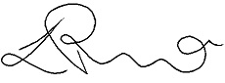
Lauri Perino, Treasurer. Date:

Seconded:

Rae Duffy, Secretary. Date :

Notes to Motion
The Mollymook Bridge Club is run largely as a community service and profit is not a priority. However, we still require some income and profit, to ensure the upkeep of the buildings, associated infrastructure and to provide services to our members.
Last year the Mollymook Bridge Club made a small loss of $1,555.86 and the previous year, the club returned a very small profit of $543.70. With the additional costs of meeting COVID requirements, table money is unlikely to cover our costs if kitchen services are resumed.

