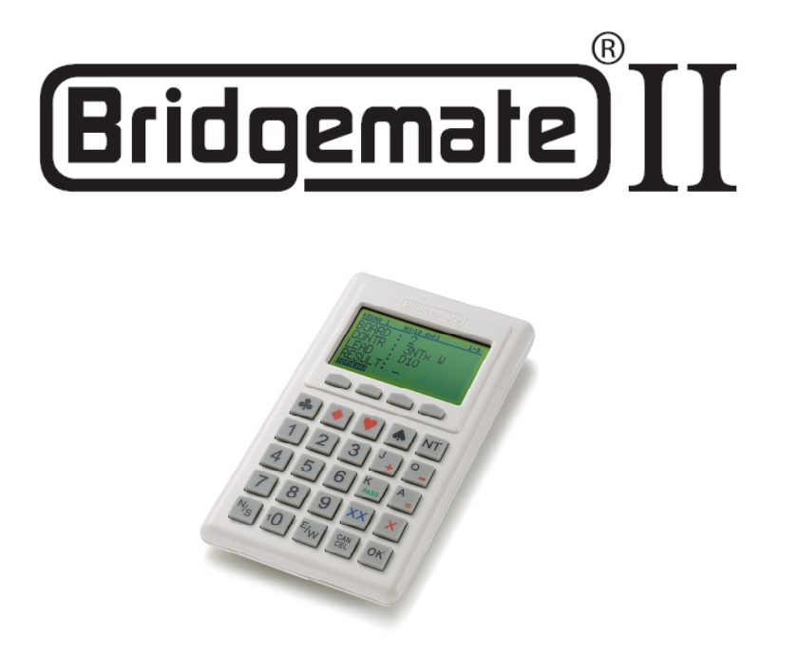

- Replacing a Bridgemate during a game
- Configuring (setting up) a Bridgemate

Bridgemate Presentation 16th November 2023
Replacing a Bridgemate – option 1
If for any reason you need to replace a Bridgemate proceed as follows:
This procedure is known as the “take over table” feature of the Bridgemate. This makes it extremely simple to replace a Bridgemate with a new one. Proceed as follows:
- Remove the Bridgemate to be replaced out of the game.
- Take another Bridgemate and set this Bridgemate to the correct section and table number. Also make sure to set the correct channel.
- Activate this Bridgemate.
It will inform you that the table has been started by another Bridgemate. Press OK to proceed, enter TD PIN code and press OK again. When it asks you to erase or retain previously entered data, press CONTIN to retain the data and continue where the old Bridgemate has left the game. This Bridgemate has now replaced the old Bridgemate.

If the above procedure does not work proceed as follows:
Replacing Bridgemate - option 2
If for whatever reason you need to replace a Bridgemate during a session, proceed as follows:
- In BCS, go to menu Server à Show tables.
- Select the relevant table and press “Log off table(s)”.
- The Bridgemate will now be logged off from the server.
- Take another Bridgemate and set this Bridgemate to the correct section and table number. Also make sure to set the correct channel.
- Activate this Bridgemate.
The Bridgemate will take over the position of the old Bridgemate.

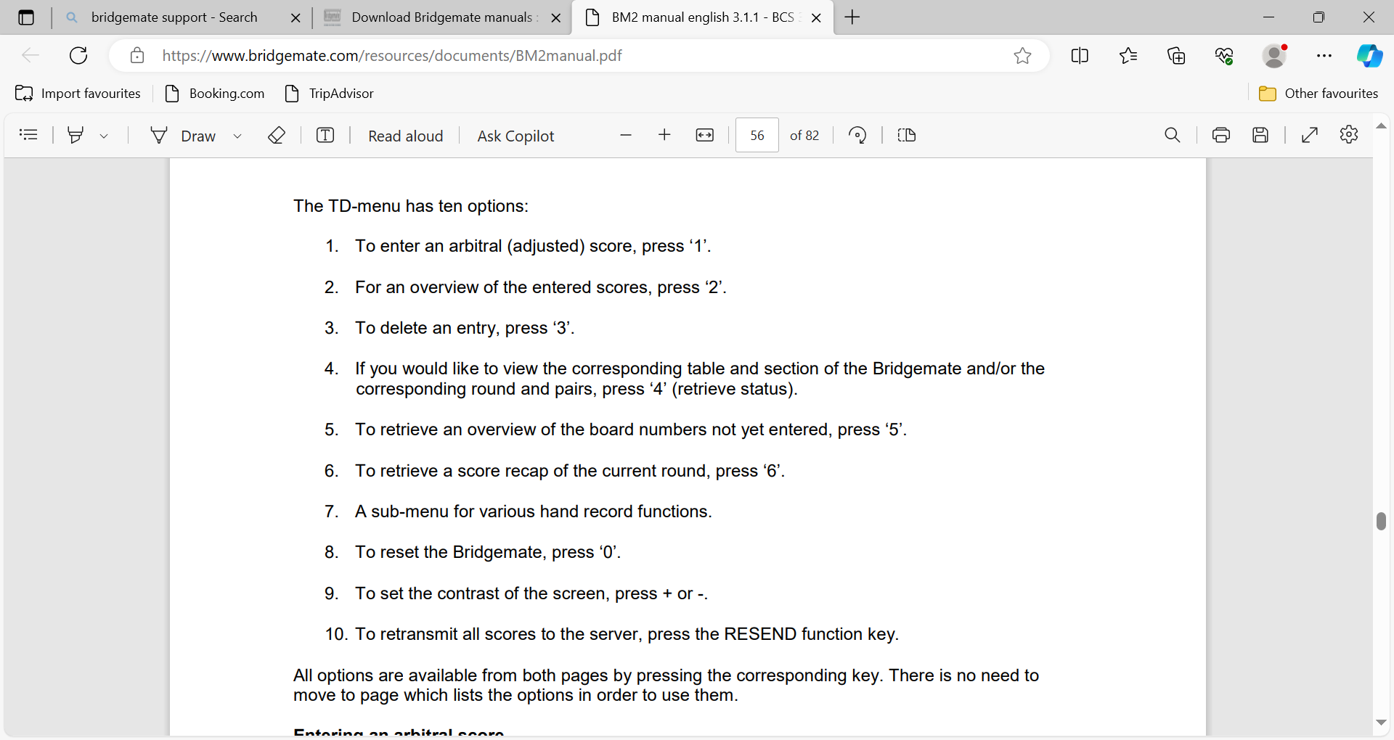

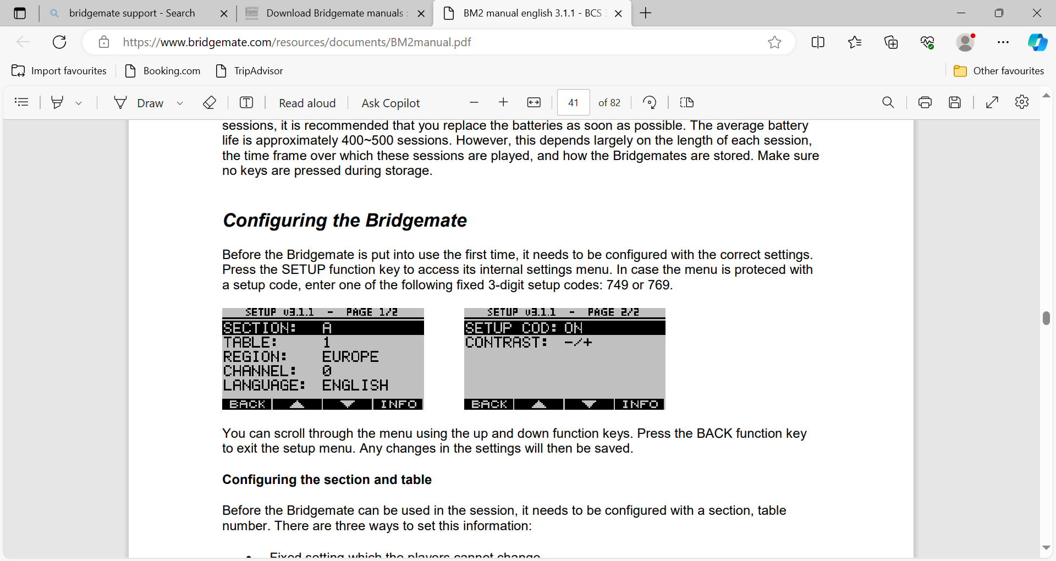

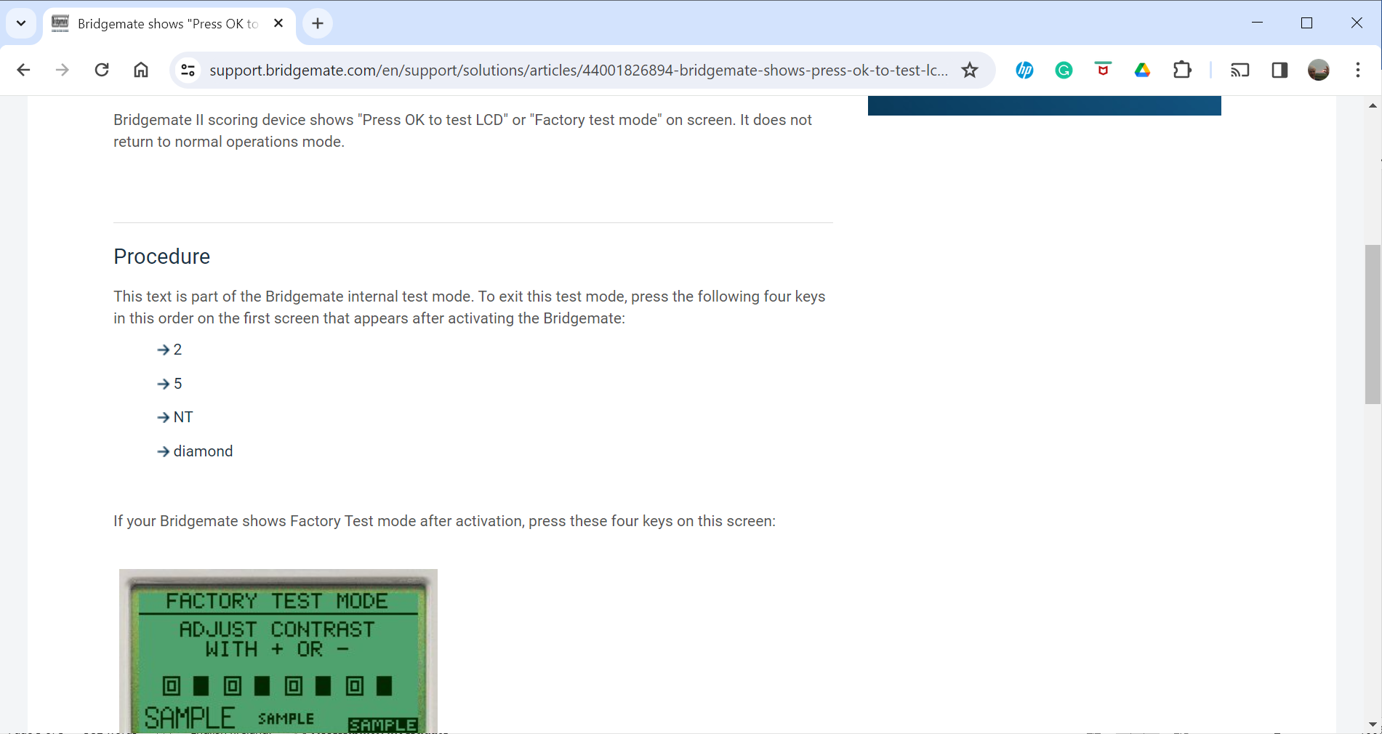

Using Scorebridge without the Bridgemates
Just untick Bridgemates on “create an event screen” and proceed to input the results and then the names of the players. The input of the result of the contract is sufficient. There is no need to input the actual contract unless you really want to.
Other features
Last 0 is omitted e.g., input 5 for 50 and 10 for 100
If you have a series of same results just press enter each time and it saves you the bother of inputting each individual result
Always check that the results are correct.
Reminder
The A Bridgemates are for the first game created.
The B Bridgemates are for the second game created
The C Bridgemates for the 3rd game and the D Brid

