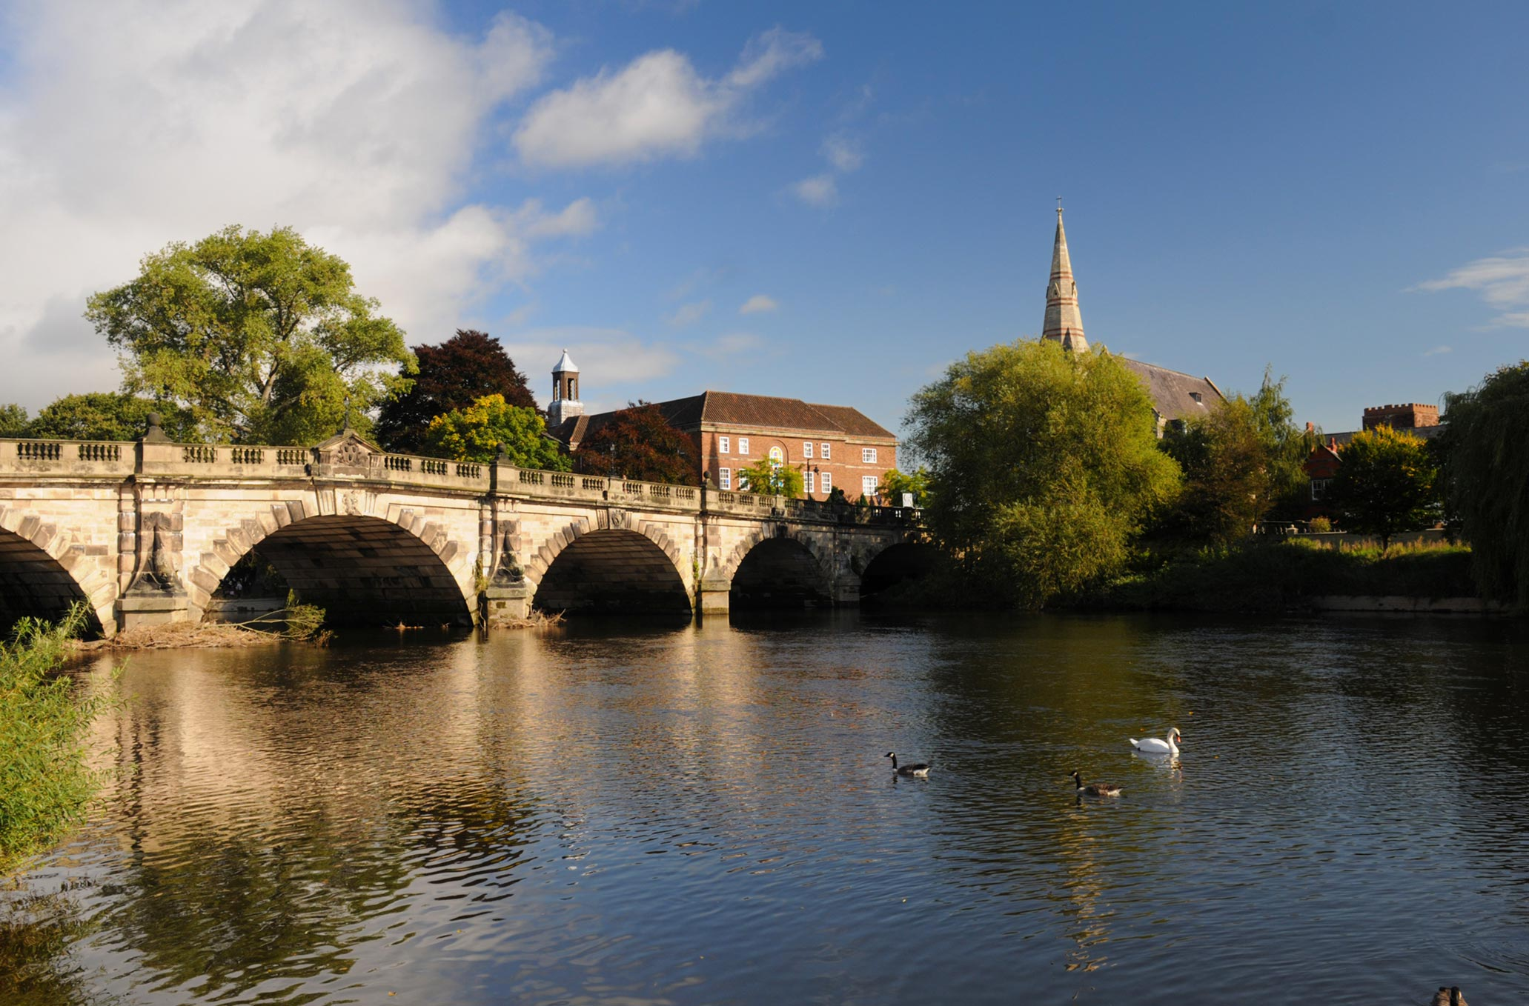

Steve & Julia are delighted to announce their latest bridge holiday in the charming medieval town of Shrewsbury.
What a fascinating town this is!
Modern shopping centres nestle alongside cobbled alleyways and Tudor buildings, all encircled by the beautiful River Severn.

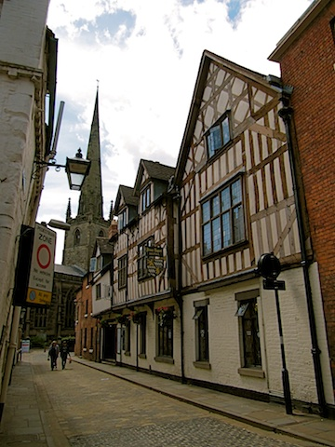
The hotel we’ve chosen is the delightful Prince Rupert in the heart of the town. This is a listed building which has been renovated lovingly by its present owner to provide all modern amenities without sacrificing its innate historic charm. It very recently has had a major refurbishment.

Parts of the hotel date back to the 11th century and the ‘new’ part was added in the 17 hundreds!

For the shopaholics there’s plenty of choice on hand. If that isn’t to your taste, then how about taking a stroll by the river? Overlooked by Shrewsbury School in the park known as the Quarry, is the Dingle - the famous garden, designed by Percy Thrower. You also could visit the castle with its regimental museum.

Other attractions include the cathedral and the prison (thankfully no longer occupied by convicts). The Sabrina boat company operate 45-minute cruises around the picturesque River Severn loop. More details are at www.sabrinaboat.co.uk It sounds like fun.

The owners of the hotel pride themselves on the quality of their food and will do their best to cater for all tastes.

For those fancying a snack, a coffee, or a drink there is an abundance of nearby pubs and cafes.
Car Parking and Travel

There is a car park about 5 minutes’ walk away. Drop off your bags at the hotel and go and park your car. Steve will send directions with the acknowledgement of the receipt of your deposit. There is a charge of £10.00 per night per car.

If there is enough interest, we will provide a coach leaving from Bramhall Village Club on
the Monday and returning on Thursday morning. Please tick the box on the booking form
if you’d like to avail yourself of that option. The cost of this will depend on the numbers
but, as an example, a fully occupied 53-seater coach works out at £20.00 per head.

We recommend that you travel by coach because it’s cheaper, less hassle and more
sociable. With all the attractions very conveniently located, there really isn’t any need for
a car. Failing that, the railway station isn’t far from the hotel, so the train may be an
option.
PROGRAMME and INFORMATION

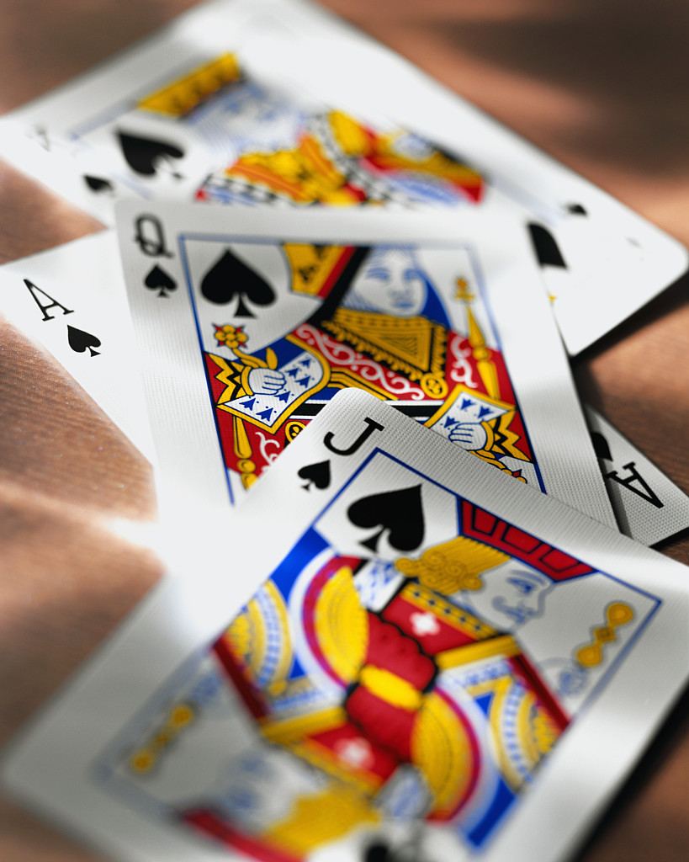
- Welcome drinks reception on the first evening.
- Three evenings’ duplicate bridge with prizes.
- Two mornings’ duplicate bridge, one of which may be a teams’ event, with prizes.
- Pre-dealt boards with hand records and analysis.
- Our own dedicated bridge room for the whole holiday.
- Partners will be provided for anybody who needs one.
- Experienced director and speedy scoring using bridgemates.
- There will be a seminar with comprehensive lecture notes and practice hands.
- Accommodation is on a half board basis – i.e., Dinner, Bed and Breakfast.

COSTS

Double/Twin £350 per person
Single rooms (Only 6 singles – early booking is advised) £385
Single occupancy of petite double or twin £405

There is a discount of £15.00 for non-players.

The Dingle
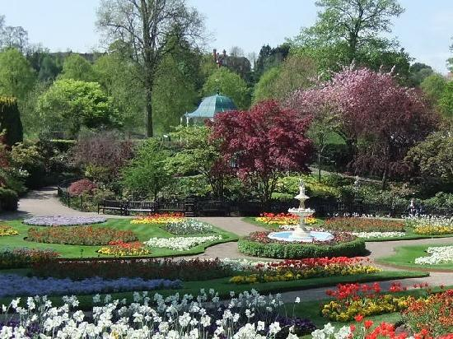
WHY NOT VISIT OUR WEBSITE?

Our website address is www.bridgewebs.com/justbridge/

There is up-to-date information on other holidays, classes, results, past holiday pictures and lots more. Drop by and say ‘Hello!

The Prince Rupert Hotel,
Butcher Row, Shrewsbury,
Shropshire, SY1 1UQ.
01743 499955.
www.prince-rupert-hotel.co.uk

BRIDGE IN SHREWSBURY

9th – 12th MAY 2022

Please book ______ Double / Twin / Single / Double or Twin for Single Occupancy Room(s)
Delete as appropriate
NAME(S)
Mr/Mrs/Mr & Mrs/Ms/Miss__________________________________________________
Delete as appropriate
ADDRESS(ES)____________________________________________________________
________________________________________________________________________

POST CODE(S)_____________TEL(S)________________________________________

EMAIL(S)________________________________________________________________

Please tick if you, or a member of your group, is a non-bridge player □
Please tick if you are interested in travelling by coach. □

DEPOSIT ENCLOSED AS SOON AS POSSIBLE £100.00 per person £____________

(BALANCE TO JULIA BANNISTER IS DUE BY 7TH MARCH – NON-PAYMENT BY THE DUE DATE WILL BE DEEMED A CANCELLED BOOKING)

BACS payments to 16-15-31 11196673 or cash or cheques payable to Julia Bannister.

Please return this form to Steve Mattinson, 22 Grange Road, Bramhall, Stockport SK7 3BD 0161 439 4844 07788 577535 smattinson@btinternet.com

CONTACT DETAILS

Steve Mattinson and Julia Bannister will be co-hosting this holiday and can be contacted by email on smattinson@btinternet.com and julia.bannister@outlook.com or by ‘phone on 07788 577535 (Steve) and 07941 685331 (Julia).

Prince Rupert Dining Room

