Harlow Knights Bridge Club

Annual General Meeting
6.45pm on Friday 26th June 2026
Online meeting on MS Teams before bridge session at 7.30pm
You may vote by proxy if unable to attend

The AGM agenda is set out below. If you wish to raise any other business to be discussed at the meeting please notify the Chairman, e.g. via the club email, preferably prior to the meeting.

Harlow Knights Bridge Club

Agenda for Annual General Meeting for 2025-26

To be held on 26th June 2026
6.45pm online via MS Teams – joining instructions below

- Apologies for Absence

- Minutes of the AGM 27th June 2025 & Matters Arising from the Minutes

- Chairman’s Report and Prize Winners

- Treasurer’s Report and Accounts

- Annual Subscription and Table Money

- Election of the Committee and Custodian

- Any Other Business

Joining Instructions for Microsoft Teams Meeting
Harlow Knights AGM

Microsoft Teams meeting
Join: https://teams.microsoft.com/meet/35945872507660?p=r8JGT2cZui82uRVFPD
The link should take you directly to the meeting when your system has loaded MS Teams.
If the meeting page is not found, you can access it manually as follows:
Meeting ID: 359 458 725 076 60
Passcode: uY7su3b5

Need help? | System reference
Dial in by phone
Number: +44 20 3855 4234 / 020 38 55 4234
Phone conference ID: 336 618 772#
Overall code: +44 20 3855 4234,,336618772# United Kingdom, City of London

Minutes of Harlow Knights Bridge Club Annual General Meeting
27th June 2025, 6.45 pm by MS Teams

Present
Ian Kemp (chair), George Lock, Sara Barnett, Hazel Fricker, Gill Little, Jules Little, Fiona Langridge, David Langridge, Hazel Miles, Tim Potter, Alan Deeley, Sheila Cooper.

1. Apologies
Christine Edwards and Michael Shine
The quorum of 10 members, or 20% of membership if less, was satisfied.
The meeting opened at 18.45.

2. Minutes of last AGM, 22 June 2024
There were no comments/objections to the minutes, and they were unanimously accepted.

3. Introduction and Chairman’s report
Ian gave the Chairman’s report which was shown on the Club website as part of the AGM material.
In contrast to previous two years this year has been relatively settled. We have continued the pattern of joint pairs session with Watford and monthly teams’ sessions. These have been well received, with pairs typically having 7-11 tables (including Watford players) and 5-8 teams on second Fridays (with the parallel BBO pairs sessions having 3-6 tables). Our continued thanks to Watford for organising the joint sessions, which have been of benefit to both clubs. Likewise, we are pleased that some Watford players have also joined us to play teams.
Table numbers saw a slight fall on the previous year, and this is consistent across Hertfordshire for online bridge. Some face-to-face clubs are growing slightly, but others are in decline. The question has been raised occasionally whether we should try to restart face-to-face bridge. However, based on previous and current feedback, Ian believes that it is better for us to be supporting our other local face-to-face clubs, and be available as an extra outlet for people who want a convenient extra session on Fridays on prefer online bridge.
Our abolition last year of the annual membership fee makes it easier for players to attend multiple clubs. We are fortunate in having several healthy clubs in the area, such as Broxbourne, Herts & Essex and Hatfield Heath. Members were asked to encourage players from other clubs to consider trying out a Harlow online session. The average standard of opposition (by NGS) is a bit higher at Harlow than at local f2f clubs, so we can provide an interesting challenge for players wishing to stretch their game and hopefully progress further to HBA (Hertfordshire Bridge Association) competitions.
Membership Update: Membership numbers have been largely maintained, with 56 current members, compared to 61 last year, as a small number of inactive members have been removed.
A moment’s silence was held to remember two past members who passed away this year: Martyn West and Mark Westley.
There are 2 committee member vacancies. One unfilled from last year and a new vacancy as Mary Wilkinson has resigned. Ian thanked Mary for her support of the Club both as a committee member and as a player over many years. Members are invited to inquire about potentially filling the vacancies if interested.
Competitions –
A list of prize-winners for our 2024-5 competition was shared and is available on our website. As before, this includes a wide range of members, with 19 winning various competitions and a further 12 being runners-up. Ian thanked Fred Ross who, though not playing online with the club, has kindly continued to score the Open and Handicap Teams competitions.
Our competitions have retained the same pattern as last year; multi-round Winter and Summer pairs (Open and Handicap), an Individual Championship run over the full year, monthly teams (Open and Handicap sections), the one-off Parkinson and Seaman Trophies, and the two-round Club Championship (Open and Restricted). Last year all the pairs competitions took place during the shared sessions with Watford, but only Harlow players were eligible for the competitions. This worked well for most competitions, but for the Club Championship it was noted that many members played less than half their boards against other Harlow players and the strength of the field was variable. Therefore, this year, we are trialling a separate two-round Club Championship for members only.
No players were eligible for the Restricted section last year, so we have relaxed the upper limit from NGS 9 to NGS 10. It has also been suggested that the eligibility criteria for our pairs competitions should be relaxed from the current level of two-thirds of rounds to 60% or half the rounds, and that instead of taking the best qualifying scores (eliminating some bad results), that a simple average score should be used. The Committee did not reach consensus on this, and members’ views were invited. The Teams competition will continue with its current arrangement of two-thirds of rounds and taking the best 8 scores.
Various club members have enjoyed success in HBA and national competitions. Ian Kemp is on the HBA Committee and can act as a route for queries or suggestions on the HBA. Most HBA competitions are online on Realbridge, but there are now 2 face-to-face Swiss Pairs events, in March and July.

4. Treasurer’s report
Sara presented the audited accounts and thanked Martin Wybrew for his services in auditing them. Martin has agreed to continue to audit our accounts in the future.
The club made an insignificant loss of £4.28 for the year, including our share of the profits from the joint sessions with Watford. We have comfortable reserves of over £5500, although nearly £900 of this is advance payments in members’ accounts which are decreasing slowly over time.
The Club made covered all the charitable donation for the Marjorie Lukyn competition at the HBA. This year their nominated charity was Mudlarks which is a Hertford based charity supporting adults and young people with learning disabilities and mental health concerns.
The acceptance of the accounts was proposed by George Lock and seconded by Tim Potter and they were adopted unanimously.

5. Annual Subscription and Table Money
Members will be aware that the Committee is committed to keeping table money as low as possible, to minimise costs to players. The Committee has reviewed the income and costs from sessions and conclude that the current levels of table money will enable us to approximately break-even over the year. Watford also wish to keep the BBO charge at its current level of $3. We are therefore recommending that we maintain table money for members at $3 for BBO pairs and £3 for Realbridge teams.
For Teams games, we propose continuing the offer of 3 free visitor sessions before requiring payment, especially as this allows substitutes and enables us to choose convenient movements. For pairs, BBO does not offer this option and charges a flat rate for all players. We would encourage visitors to join the club as members, but if they do not, the fee for Teams games then increases to £4 per session. Teams regularly fielding non-members also become ineligible for prizes.
At the AGMs in 2022-4 members authorised the Committee to keep the table money under review and to make amendments as circumstances change, and the Committee seeks the same authorisation this year.
This was voted on and accepted unanimously.

6. Election of the Committee and Custodian
No new members were nominated. Members are asked to approve the election of the Committee members (Sara Barnett, Christine Edwards, Hazel Fricker, Ian Kemp, Fiona Langridge and George Lock) and the appointment of Jeff Green as the Custodian of the Club. This was proposed by Jules Little and seconded by Alan Deeley and agreed unanimously.
The committee will appoint the club officers at their next meeting.

7. Any Other Business
Hazel Miles suggested encouraging other people to join the Club as being online we have no geographical restrictions to participation, and as far as she is aware a Friday evening doesn’t clash with other clubs. We have a strong Teams competition which may be of interest to other players as there are fewer opportunities to play Teams. It was agreed that the Committee would take this forward.
The meeting closed at 19.12.

Agenda item 3 - Chairman’s Report for 2024-2025

This has again been a relatively settled year as we have continued the pattern of joint pairs sessions with Watford on BBO and monthly teams sessions on Realbridge. Numbers have largely held steady, with pairs typically having 7-9 tables (including Watford players) and 6-8 tables for teams on second Fridays (although the parallel BBO pairs sessions have declined to 3-4 tables and have sometimes been cancelled, so Watford are now checking in advance whether people plan to play). Our continued thanks to Watford for organising the joint sessions, which have been vital to keep table numbers at a viable level, and to Richard Banbury and Gary Conrad, our regular directors. This can also be seen against a background of decline in BBO sessions in the UK in general and including Hertfordshire; the only other regular BBO session in east or central Herts is that at Broxbourne on Wednesday evenings.

Although we no longer play face-to-face bridge, we are happy to encourage players to also join face-to-face sessions at other clubs in the area, such as Broxbourne, Herts & Essex, Hatfield Heath and New Hertford. Our abolition 2 years ago of the annual membership fee makes it easier for players to attend multiple clubs. Likewise, please do encourage players from other clubs to consider trying out a Harlow online session as an extra. The average standard of opposition (by NGS) continues to be higher at Harlow than at local f2f clubs, so we can provide an interesting challenge for players wishing to stretch their game, and hopefully progress further to HBA (Hertfordshire Bridge Association) competitions. One interesting challenge is that many people learnt online bridge by necessity during the Covid pandemic, but since that is now 6 years behind us (astonishingly) there is now a new generation of players who have no experience of the online platforms, which may act as a barrier to them joining either Harlow or HBA sessions. It’s worth noting that Realbridge run regular sessions explaining how to use their platform.

At last year’s AGM it was pointed out that as we play online, we no longer have geographical restrictions and therefore can invite players from further afield if they are free on Friday nights, when there are very few other sessions nationally as well as locally. As well as Watford players, we have regular attendees from Dorset, York and Scotland, as well as other occasional visitors. An attempt was made to encourage players from other Herts clubs to join us for Teams but this did not bring in any further teams, though it increased the list of potential reserves. Sadly, Teams as a whole is in decline, and also many players do this through the HBA Leagues.

Membership numbers have been largely maintained, with 55 current members, compared to 56 last year, although some of these have not played for some time. A couple of players have left but a couple more have joined or rejoined, or are dipping their toes in the water as visitors.

We have 8 places for committee members but only 6 of our current committee are standing for re-election. Members are invited to apply for the vacancy, preferably in advance of the AGM. It is not an onerous task, with normally just 2-3 online meetings per year, as little work is required to keep the online sessions organised. As usual, the officers (Chair, Vice-Chair, Secretary and Treasurer) are elected by the committee in their first meeting after the AGM. Jeff Green is again happy to continue as our Custodian under the constitution. He is a club member but is not on the committee and so remains an independent voice with no conflict of interest.

We remember Sheila Cooper, previously Sheila Evans, a long-standing member who passed away this year. She made a great impact on Hertfordshire bridge for many years, particularly through arranging partners at Broxbourne and thus allowing players new to the game or the area to get involved; many other clubs including Harlow benefited from this.

The Treasurer will present the accounts shortly but the Club continues to be fully solvent, with table money approximately balancing costs (directors fees, EBU fees and club prizes). The Committee therefore proposes retaining table money at BBO $3 for the joint sessions with Watford and £3 for the Realbridge teams sessions (see Item 5). The Club continues to have substantial reserves and the Committee are happy to consider any ideas for making good use of these. We continue to run an annual heat of the Marjorie Lukyn Cup, from which part of the table money goes towards a local Hertfordshire charity selected each year; for 2025-6 this was the local charity GRIT (Growing Resilience in Teens) which is based in North Herts and does excellent work.

Our competitions have retained the same pattern as last year; multi-round Winter and Summer pairs (Open and Handicap), an Individual Championship run over the full year, monthly teams (Open and Handicap sections), the one-off Parkinson and Seaman Trophies, and the two-round Club Championship (Open and Restricted). Last year nearly all the pairs competitions took place during the shared sessions with Watford, but only Harlow players were eligible for the competitions. Last year we trialled a separate Club Championship with 2 sessions in May and June, to ensure that the results were from playing only against other club members. This worked reasonably well but the number of tables fell to 5, and there was no guarantee that this would be achieved this year. Hence, the Committee agreed to return to the previous format of a two-round Club Championship in the normal joint sessions in late September, between the Summer and Winter Pairs. No players were eligible for the Restricted section in 2024-5 so we relaxed the upper limit from NGS 9 to NGS 10 (average for the pair, with neither player being higher than J) and two pairs were eligible this year.

It was also suggested last year that the eligibility criteria for our pairs competitions should be relaxed from the current level of two-thirds of rounds to half the rounds, but there was no consensus among the Committee or members. However, the number of players fulfilling the eligibility criteria has dropped, so we can reconsider lowering the qualifying level for the Winter Pairs and Individual Championship. Regular players will still have an advantage as the best qualifying scores are taken, so the more times you play, the more bad results you eliminate. The teams competition will continue with its current basis of two-thirds of rounds, taking the best 8 scores from the maximum of 12. One change this year is to return to Victory Point scoring for the Open Teams competition, reducing the effect of freak results from individual boards and matches.

Various club members have also enjoyed success in HBA and national competitions. Ian Kemp is on the HBA Committee and can act as a route for queries or suggestions on the HBA. Most HBA competitions are online on Realbridge, but there are now 2 face-to-face Swiss Pairs events, in March and July.

A list of prizewinners for our 2025-6 competitions follows. As before, this includes a wide range of members, with 14 winning various competitions and a further 12 being runners-up. As always, we thank Fred Ross who has kindly continued to score both the Open and Handicap Teams competitions. The latter would be impossible on Bridgewebs, while Fred’s support enables us to change team lineups or combine teams together when pairs are missing, in both competitions.

We look forward to another successful year and hope that you will continue to join us regularly and enjoy your Friday night bridge.

Ian Kemp, HKBC Chair
Harlow Knights Bridge Club - Competition prize-winners for 2025-6:
Note: winners of open competitions are not eligible to also win the Handicap competition

Summer Open Pairs | Winners – John & Marion Birch  Runners up - Alan Deeley & Eddie Cirket
Summer Handicap Pairs | Winners – Ian Greig & Tim Potter  Runners up - Adrienne Tinn & Michael Shine
Winter Open Pairs | Winners – John & Marion Birch  Runners up - Amanda Barnes & John Hirons
Winter Handicap Pairs | Winners – Ian Greig & Tim Potter  Runners up - Adrienne Tinn & Michael Shine
Club Championship Pairs Open | Winners – Alan Deeley & Eddie Cirket  Runners up - Gill & Jules Little
Club Championship Pairs Restricted | Winners – Ian Greig & Tim Potter  Runners up - David & Fiona Langridge
Club Individual Championship | Winner – Ian Kemp  Runner up - Hazel Miles
Parkinson Trophy | Winners - Naomi Gibbs & David Owen
Seaman Trophy | Winners – Hazel Miles & Ian Kemp
Open Teams | Winners - Rawlins Mike Rawlins, Naomi Gibbs, David Owen, Nigel Rawlins & Ivan Leung  Runners up - Mumford Jill Mumford, Arni Anidjar-Romain, Tim Nash & Jeff Green
Handicap Teams | Winners - Cirket Eddie Cirket, Alan Deeley, Hazel Miles & Roy Young  Runners up - Langridge David & Fiona Langridge, Amanda Barnes & John Hirons

Total number of different winners: 14
Total number of different winners/runners-up: 26

Seaman Trophy 2026-7 | Winners – Adrienne Tinn & Michael Shine

Agenda item 4 – Accounts for year ending 31 March 2026

The audited accounts for the year are set out below. The club made a loss of £293.16 for the year, including our share of the profits from the joint sessions with Watford. The director’s fees were higher than for last year, partly because there were two extra sessions for the separate Club Championship, though these will not continue this year. However, we have comfortable reserves of nearly £5000, and the amount as advance payments in members’ accounts has fallen from £900 to just over £600, which is more realistic. Many thanks to Martyn Whybrew for auditing our accounts.

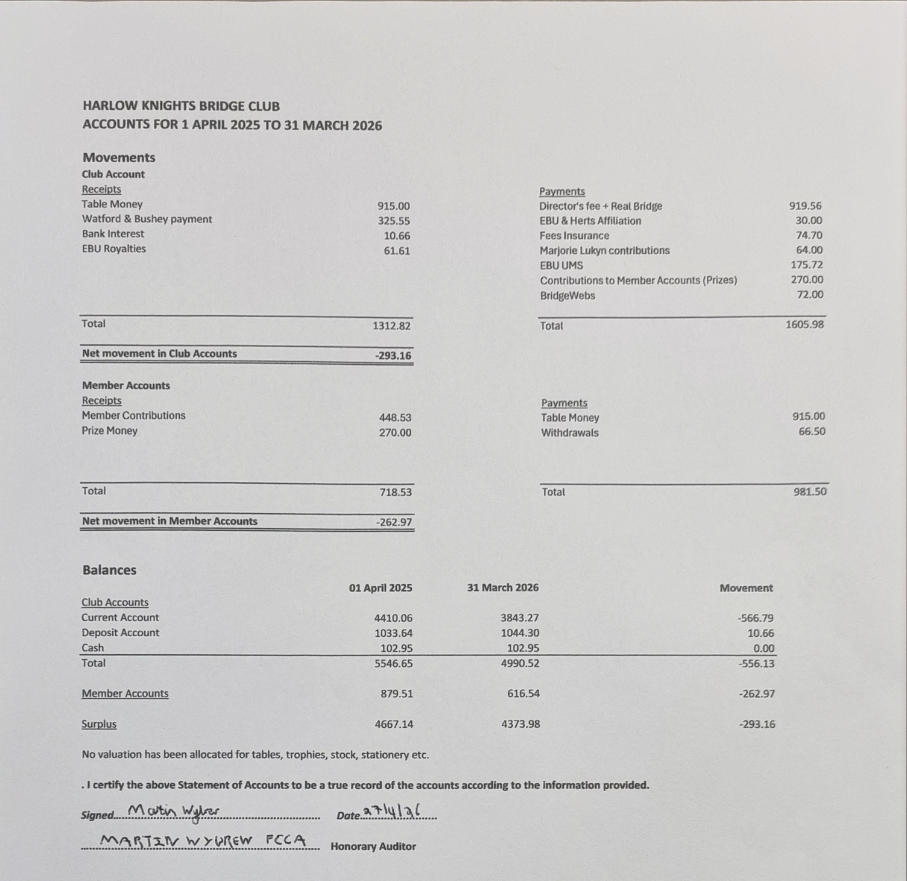

Members are asked to approve the accounts for 2025-26.

Agenda item 5 – Table money and annual subscription

Table money

Members will be aware that the Committee is committed to keeping table money as low as possible, to minimise costs to players. The Committee has reviewed the income and costs from sessions and conclude that the current levels of table money will enable us to approximately break even over the year or make a small sustainable loss, allowing for club expenses. We are therefore recommending that we maintain table money for members at $3 for BBO pairs and £3 for Realbridge teams.

For teams games, we propose continuing the offer of 3 free visitor sessions before requiring payment, especially as this allows substitutes and enables us to choose convenient movements. For pairs, BBO does not offer this option and charges a flat rate for all players. We would encourage visitors to join the club as members, but if they do not, the fee for teams games then increases to £4 per session. Teams regularly fielding non-members also become ineligible for prizes.

At the AGMs in 2022-5 members authorised the Committee to keep the table money under review and to make amendments as circumstances change, and the Committee seeks the same authorisation this year.

Annual Subscription

The proceeds from table money are broadly sufficient to cover club operating costs including prizes, insurance etc. Also, since many members only play in the joint pairs sessions with Watford, they no longer use their club accounts. Watford does not charge an annual subscription. Harlow Knights abolished the annual subscription in 2024 and the club remains fully solvent. Therefore, the Committee recommends a zero annual subscription for the forthcoming year (which begins in September 2026).

Members are asked to:

- ratify the continuation of the zero annual subscription.
- ratify the continuation of table money for BBO pairs games as $3 BBO
- ratify the continuation of table money for Realbridge teams games as £3 (members) and £4 (visitors) but with the visitors fee waived for up to 3 games
- authorise the committee to review and amend table money if required

Agenda item 6 – Election of Committee and Custodian

The following Committee members are willing to stand again and have been nominated for the Committee:

- Sara Barnett
- Christine Edwards
- Hazel Fricker
- Ian Kemp
- Fiona Langridge
- George Lock

There have been no other nominations to the Committee at the time of posting the AGM meeting notice. Further nominations can be made by contacting the Club, preferably before the AGM, but additional nominations could be taken at the AGM.

The committee has 8 places (4 officers plus 4 ordinary members) and there are 6 current nominations, leaving two vacancies. If the number of nominations does not exceed the number of vacancies, those nominated can be approved without requiring the election of individuals.

Under our Constitution, the officers of the Club are not elected at the AGM, but are selected by the Committee from among their members at the first Committee meeting following the AGM, normally in July. Current officers are: Chair – Ian Kemp, Vice Chair – Fiona Langridge, Membership Secretary – Christine Edwards, Treasurer – Sara Barnett.

Jeff Green has once again agreed to be nominated as the Club’s Custodian, which has a role in relation to disciplinary matters. He has fulfilled this role successfully since it was set up in 2021. Jeff is Chairman of Welwyn Garden City Bridge Club. He is a member of Harlow Knights, but is not on the Committee and thus fully independent of the Club’s organisers. Members are asked to approve his election.

Members are asked to approve the election of the Committee members as listed above, and the appointment of Jeff Green as the Custodian of the Club.

Agenda Item 7 – Any Other Business

If you wish to raise any other business to be discussed at the meeting please notify the Chairman via the club email address or by other means, preferably prior to the meeting.

