Harlow Knights Bridge Club

Annual General Meeting
6.45pm on Friday 27th June 2025
Online meeting on MS Teams before bridge session
You may vote by proxy if unable to attend

The AGM agenda is set out below. If you wish to raise any other business to be discussed at the meeting please notify the Chairman, preferably prior to the meeting.

Harlow Knights Bridge Club

Agenda for Annual General Meeting for 2024-25

To be held on 27th June 2025
6.45pm online via MS Teams – joining instructions in email

- Apologies for Absence

- Minutes of the AGM 21st June 2024 & Matters Arising from the Minutes

- Chairman’s Report and Prize Winners

- Treasurer’s Report and Accounts

- Annual Subscription and Table Money

- Election of the Committee and Custodian

- Any Other Business

Minutes of Harlow Knights AGM
21st June 2024 6.45 pm by MS Teams

Present
Ian Kemp (chair), George Lock, Sara Barnett, Hazel Fricker, Christine Edwards, Terry Edwards, Fiona Langridge, David Langridge, Fred Ross, Hazel Miles, Tim Potter, John Birch, Marion Birch, Alan Deeley, Sheila Evans.
1. Apologies
Amanda Barnes, John Hirons, Jill Mumford, Kay Vowles – All with proxy
Jeff Green, Stephen Page, Adrienne Tinn – without proxy.
The quorum of 10 members or 20% of membership if less was satisfied.
Meeting opened at 1845.
2. Minutes of last meeting
There were no comments/objections to the minutes. Hazel F proposed and Chris Edwards seconded acceptance of these.
3. Introduction and Chairman’s report
Ian summarised the Chairman’s report which appears (and will remain on for the coming weeks) on the Club website. There is 1 committee member vacancy as Fred has resigned and Ian asked if anyone would like to put themselves forward. There were no nominations so the committee will continue with one vacancy. However, members are invited to inquire about potentially filling the vacancy if interested. Ian thanked Fred for his faithful service to the club over many years.
There have been important changes in the club this year, notably the change of most sessions to being joint sessions with Watford and Bushey Bridge Club on BBO. As hoped, this has given a marked increase in the number of tables, from 4-6 to 8-12 typically, and many favourable comments have been received. The monthly teams competitions attract 6-8 teams and will also continue.
Membership update - Chris reported on the membership numbers which have remained largely stable since last year, with a small fall from 64 to 62 members, partly from the sad passing of Pat Flavell. A moment’s silence was held to reflect on the members that have passed away in recent times.
Competitions – Ian displayed the list of competition winners and runners-up, noting that we had again had no less than 23 different winners of competitions this year and 11 additional runners-up, showing that we have a good variety of competitions giving everyone opportunities as well as enjoying competing.
Questions - John Birch asked about the club balance and Ian advised it was about £3,000. He asked if any members were willing to propose and organise a social event that this balance could fund. No immediate responses were received. John asked if there were any plans for the club to go back face to face. Ian advised there weren’t, but this could not be ruled out in the future. He noted that much of the club’s equipment had been lent/donated to other clubs including Hatfield Heath and a U3A bridge club in Ware.
John commented on the aging demographics of bridge players and asked if the club might consider an afternoon face to face club as these appear more popular. Ian advised that this was not currently under consideration, especially as there are other local clubs already doing this, but would not be ruled out in the future.
4. Treasurer’s report
Sara presented the audited accounts thanking Martin Wybrew for his services in auditing them. These were later proposed by Hazel F and seconded by George Lock.
We have since received an additional payment of £203 from Watford which is our share of the profit from table money for the first 8 months of the joint BBO sessions.
Most table money is now collected through BBO and therefore members’ club accounts are used less, and not at all if they are not playing in teams. Members who do not expect to use their account balances are invited to apply for refunds, preferably in the month following the AGM. Prize money will be paid into club accounts.
5. Annual Subscription and Table Money
Ian reported that the club was breaking even on the current table money and membership. He proposed that there be no change to the table money of $3 on BBO and £3 per night for teams. This should generate a very small surplus that covers running costs inc. director’s fees and prize money. The committee proposes to abolish annual subscriptions but we would still like players to join the club as members rather than visitors, giving eligibility for all our competitions.
This was voted on and accepted unanimously.
6. Election of the Committee and Custodian
No new members were nominated. A vote unanimously ratified the committee and custodian (Jeff Green). The committee will appoint the club officers at their next meeting.
7. Any Other Business
There was only 1 item. Ian proposed to run a heat for the HBA Marjorie Lukyn competition and, as in previous years, the club will fund the charitable contribution. The club will also consider entering the Desmond Flockhart (teams of 8) competition.
John thanked Ian and the committee for their hard work.
The meeting was closed at 1915.

Agenda item 3 - Chairman’s Report for 2024-2025
In contrast to the last 2 years, this has been a relatively settled year as we have continued the pattern of joint pairs session with Watford and monthly teams sessions. Both seem to have been well received, with pairs typically having 7-11 tables (including Watford players) and 5-8 teams on second Fridays (with the parallel BBO pairs sessions having 3-6 tables). Our continued thanks to Watford for organising the joint sessions, which have been of benefit to both clubs. Likewise we are pleased that some Watford players have also joined us to play teams.
Table numbers are a slight fall on the previous year and this is indeed consistent across Hertfordshire for online bridge, while some face-to-face clubs are growing slightly, but others are in decline. The question has been raised occasionally whether we should try to restart face-to-face bridge. However, based on previous and current feedback, I believe that it is better for us to be supporting our other local face-to-face clubs, and be available as an extra outlet for people who want a convenient extra session on Fridays on prefer online bridge. Our abolition last year of the annual membership fee makes it easier for players to attend multiple clubs. We are fortunate in having several healthy clubs in the area, such as Broxbourne, Herts & Essex and Hatfield Heath. Please do encourage players from other clubs to consider trying out a Harlow online session as an extra. The average standard of opposition (by NGS) is a bit higher at Harlow than at local f2f clubs, so we can provide an interesting challenge for players wishing to stretch their game, and hopefully progress further to HBA (Hertfordshire Bridge Association) competitions.
Membership numbers have been largely maintained, with 56 current members, compared to 61 last year, as a small number of inactive members have been removed. We have 8 places for committee members but only 6 of our current committee are standing for re-election, so applications for the 2 vacancies are most welcome, preferably in advance of the AGM. It is not an onerous task, with normally just 2-3 online meetings per year. As usual, the officers (Chair, Vice-Chair, Secretary and Treasurer) are elected by the committee in their first meeting after the AGM. Jeff Green is again happy to continue as our Custodian under the constitution. He is a club member but is not on the committee and so remains an independent voice with no conflict of interest.
We remember two past members who passed away this year; Martyn West and Mark Westley.
Despite the abolition of the membership fee, the Club made a small profit during the year, and table money approximately balances costs (directors fees, EBU fees and club prizes). The Committee therefore proposes retaining table money at BBO $3 for the joint sessions with Watford and £3 for the Realbridge teams sessions. The Club has substantial reserves and the Committee are happy to consider any ideas for making good use of these. We continue to run an annual heat of the Marjorie Lukyn Cup, from which part of the table money goes towards a local Hertfordshire charity selected each year; for 2024-5 this was the excellent Hertford-based charity Mudlarks which helps and stimulates adults with learning disabilities, including work on allotments.
Our competitions have retained the same pattern as last year; multi-round Winter and Summer pairs (Open and Handicap), an Individual Championship run over the full year, monthly teams (Open and Handicap sections), the one-off Parkinson and Seaman Trophies, and the two-round Club Championship (Open and Restricted). Last year all the pairs competitions took place during the shared sessions with Watford, but only Harlow players were eligible for the competitions. This worked well for most competitions, but for the Club Championship it was noted that many members played less than half their boards against other Harlow players and the strength of the field was variable. Therefore, this year, we are trialling a separate two-round Club Championship for members only; the first round attracted 10 pairs enabling an all-play-all format, and we encourage all members to play in the second round following tonight’s AGM. No players were eligible for the Restricted section last year so we have relaxed the upper limit from NGS 9 to NGS 10. It has also been suggested that the eligibility criteria for our pairs competitions should be relaxed from the current level of two-thirds of rounds to 60% or half the rounds, and also that instead of taking the best qualifying scores (eliminating some bad results), that a simple average score should be used. The Committee did not reach consensus on this and members’ views are invited. The teams competition will continue with its current arrangement of two-thirds of rounds and taking the best 8 scores from the maximum of 12.
Various club members have also enjoyed success in HBA and national competitions. Ian Kemp is on the HBA Committee and can act as a route for queries or suggestions on the HBA. Most HBA competitions are online on Realbridge, but there are now 2 face-to-face Swiss Pairs events, in March and July.
A list of prizewinners for our 2024-5 competitions follows. As before, this includes a wide range of members, with 19 winning various competitions and a further 12 being runners-up. We particularly thank Fred Ross who, though not playing online with the club, has kindly continued to score the Open and Handicap Teams competitions.
We look forward to another successful year and hope that you will continue to join us regularly and enjoy your Friday night bridge.
Ian Kemp, HKBC Chair

Harlow Knights Bridge Club - Competition prize-winners for 2024-5:
Note: winners of open competitions are not eligible to also win the Handicap competition

Summer Open Pairs | Winners – Adrienne Tinn & Michael Shine  Runners up - Roy Young & Sheila Cooper
Summer Handicap Pairs | Winners – John & Marion Birch  Runners up - Ian Greig & Tim Potter
Winter Open Pairs | Winners – John & Marion Birch  Runners up - Roy Young & Sheila Cooper
Winter Handicap Pairs | Winners – Alan Deeley & Eddie Cirket  Runners up - Ian Greig & Tim Potter
Club Championship Pairs Open | Winners – Denver Gorman & Luigi Wiechula  Runners up - Alan Deeley & Eddie Cirket
Club Championship Pairs Restricted | No eligible pairs
Club Individual Championship | Winner – Ian Kemp  Runner up - Hazel Miles
Parkinson Trophy | Winners - John & Marion Birch
Seaman Trophy | Winners – Naomi Gibbs & David Owen
Open Teams | Winners - Rawlins Mike Rawlins, Naomi Gibbs, David Owen, Ivan Leung & Nigel Rawlins  Runners up - Mumford Jill Mumford, Arni Anidjar-Romain, Tim Nash, Jeff Green & Sara Barnett
Handicap Teams | Winners - Mumford Jill Mumford, Arni Anidjar-Romain, Tim Nash, Jeff Green & Sara Barnett  Runners up - Langridge David Langridge, Fiona Langridge, Sheila  Fitzpatrick, Joe Carreira, Shirley Bull, Amanda Barnes & John Hirons

Agenda item 4 – Accounts for year ending 31 March 2025

The audited accounts for the year are set out below. The club made an insignificant loss of £4.28 for the year, including our share of the profits from the joint sessions with Watford. We have comfortable reserves of over £5500, although nearly £900 of this is advance payments in members’ accounts. Many thanks to Martyn Whybrew for auditing our accounts.

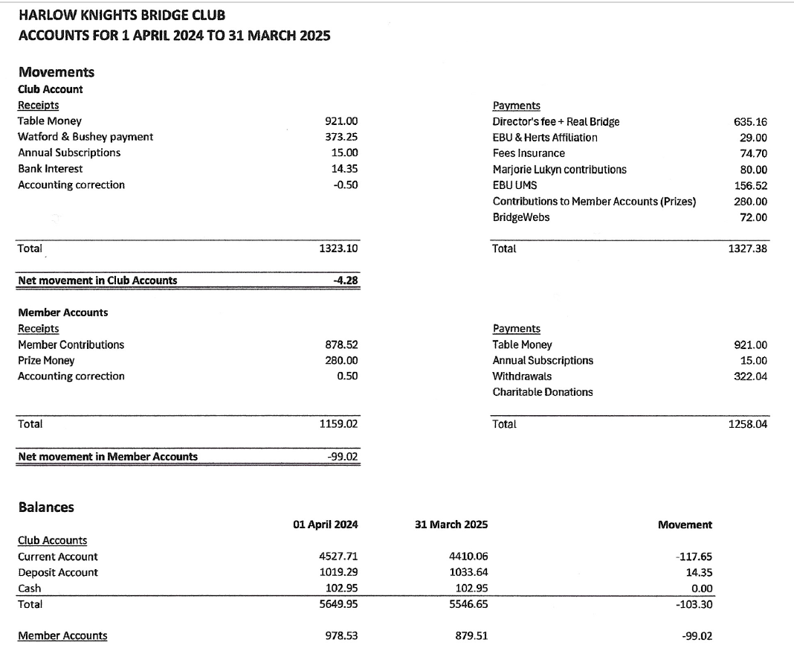
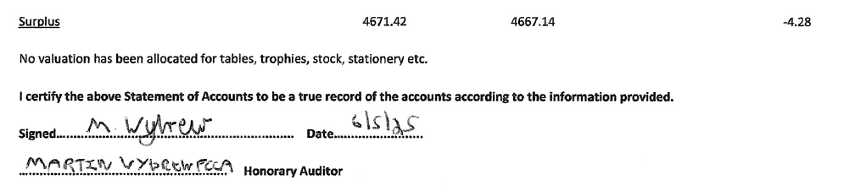

Members are asked to approve the accounts for 2024-25.

Agenda item 5 – Table money and annual subscription

Table money

Members will be aware that the Committee is committed to keeping table money as low as possible, to minimise costs to players. The Committee has reviewed the income and costs from sessions and conclude that the current levels of table money will enable us to approximately break even over the year allowing for club expenses. We are therefore recommending that we maintain table money for members at $3 for BBO pairs and £3 for Realbridge teams.

For teams games, we propose continuing the offer of 3 free visitor sessions before requiring payment, especially as this allows substitutes and enables us to choose convenient movements. For pairs, BBO does not offer this option and charges a flat rate for all players. We would encourage visitors to join the club as members, but if they do not, the fee for teams games then increases to £4 per session. Teams regularly fielding non-members also become ineligible for prizes.

At the AGMs in 2022-4 members authorised the Committee to keep the table money under review and to make amendments as circumstances change, and the Committee seeks the same authorisation this year.

Annual Subscription

The proceeds from table money are broadly sufficient to cover club operating costs including prizes, insurance etc. Also, since many members only play in the joint pairs sessions with Watford, they no longer use their club accounts. Watford does not charge an annual subscription. Harlow Knights abolished the annual subscription in 2024 and the club remains fully solvent. Therefore, the Committee recommends a zero annual subscription for the forthcoming year (which begins in September 2025).

Members are asked to:

- ratify the continuation of the zero annual subscription.
- ratify the continuation of table money for BBO pairs games as $3 BBO
- ratify the continuation of table money for Realbridge teams games as £3 (members) and £4 (visitors) but with the visitors fee waived for up to 3 games
- authorise the committee to review and amend table money if required

Agenda item 6 – Election of Committee and Custodian

The following Committee members are willing to stand again and have been nominated for the Committee:

- Sara Barnett
- Christine Edwards
- Hazel Fricker
- Ian Kemp
- Fiona Langridge
- George Lock

Mary Wilkinson is stepping down from the Committee at the 2025 AGM and we thank her for her help and support over the years.

There have been no other nominations to the Committee at the time of posting the AGM meeting notice. Further nominations can be made by contacting the Club, preferably before the AGM, but additional nominations could be taken at the AGM.

The committee has 8 places (4 officers plus 4 ordinary members) and there are 6 current nominations, leaving two vacancies. If the number of nominations does not exceed the number of vacancies, those nominated can be approved without requiring the election of individuals.

Under our Constitution, the officers of the Club are not elected at the AGM, but are selected by the Committee from among their members at the first Committee meeting following the AGM, normally in July. Current officers are: Chair – Ian Kemp, Vice Chair – Fiona Langridge, Membership Secretary – Christine Edwards, Treasurer – Sara Barnett.

Jeff Green has once again agreed to be nominated as the Club’s Custodian, which has a role in relation to disciplinary matters. He has fulfilled this role successfully since it was set up in 2021. Jeff is Chairman of Welwyn Garden City Bridge Club. He is a member of Harlow Knights, but is not on the Committee and thus fully independent of the Club’s organisers. Members are asked to approve his election.

Members are asked to approve the election of the Committee members as listed above, and the appointment of Jeff Green as the Custodian of the Club.

Agenda Item 7 – Any Other Business

If you wish to raise any other business to be discussed at the meeting please notify the Chairman via the club email address or by other means, preferably prior to the meeting.

