Tricky decision with a lot at stake

At the weekend playing in the Garden Cities Teams tournament representing Mid Essex Bridge Club, I picked up this exciting hand:
Sitting West, with North as the dealer, I hear a PASS on my left and a PASS from my partner.
Just as I was contemplating what I would open in fourth position, South opens 2 No Trumps, which is alerted as showing about 6 to 10 points and 5-5 in the Majors.
What do you bid?

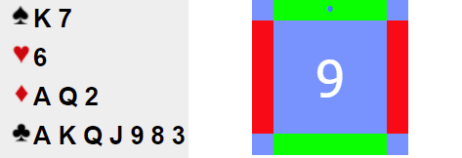
Anyone who is familiar with ‘Leaping Michaels’ is aware that if South opens a weak 2, say 2 Hearts, an immediate bid of 3 Hearts would be asking our partner to bid 3NT with a Heart stop.
The big question is, does this strategy also apply to a 2NT opening bid that shows BOTH majors?
Not wanting to confuse my partner, rightly or wrongly, I chose to bid 3NT.
North now DOUBLED in a ‘Voice of Thunder’, (Actually we were playing on RealBridge, but it sounded as if he had clicked on his DOUBLE card very loudly).
After two more passes, it is back to our decision.
What do we do? (There is a lot at stake).
If we decide to leave 3 No Trumps DOUBLED in, then things get very exciting.

Here are all four hands:
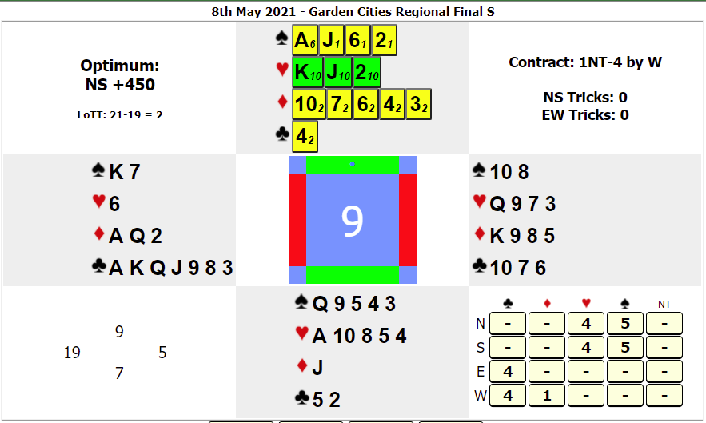
North is on lead to 3NT doubled.
If North leads a small Spade, then declarer will wrap up the first TWELVE tricks, by way of a Spade, 7 Clubs and 4 Diamond tricks for the delightful score of:
3NT Doubled Plus 3 vulnerable, scoring +1350
However, if North leads a Heart, then the defence wrap up the first TEN tricks, by way of 5 Spade tricks and 5 Heart tricks which means we go 6 off doubled in our 3NT contract, which scores us -1700.
So, it is either +1350 or -1700 depending on what North leads.
Of course, we could always REDOUBLE and if we get to play in 3NT REDOUBLED
Then depending on the lead, the score we will be writing in is either:
+2200 or -3400.
Now that IS exciting bridge……

