ANNUAL GENERAL MEETING REPORTS & ACCOUNTS 2018/19

Minutes of the 72nd Annual General meeting of the ECBA
held on Sunday 12 May 2019 at Barleylands

Present Paul Mollison (Chairman), Petra Bromfield (Webmaster),
Bernie Hunt (League Secretary), Pat Johnson (Publicity Officer),
Val Mollison (Tournament Secretary) and 27 others (a list is available if required)

- Chairman’s opening remarks

Paul welcomed those present and said he was pleased to see so many attendees. He had received a number of apologies (see Appendix F for a full list).

See Appendix A for the text of Paul’s remarks.

- Minutes of the last meeting

The minutes had been previously circulated and are available on the website. They were agreed as a true record.
Proposed Paul Spencer; seconded Marcia Levan-Harris. A copy was signed by the Chairman.

- Matters arising

There were no matters arising.

- Secretary’s report

I continue to provide support to the committee and have acted as a conduit for communication between the committee and the EBU on a small number of topics.

See Appendix B for full report.

- Treasurer’s report

As you can see from the accounts, we have a surplus of £645 (£1,981- 2018). The difference has mainly been due to the drop in revenue from the Essex and Herts Green Point events in July and September last year - this year £1,700 was received compared to £2,000 last year. The competition fees received are similar (£10,352 this year compared to £10,323 last year). No seminars were run this year

See Appendix C for the report and accounts.
The report was accepted. Proposed Marcia Levan-Harris, seconded Mike Harbour.

- Appointment of Examiner for 2019/2020

Petra Bromfield was unanimously appointed as Examiner. .

- Tournament Secretary’s report

First of all, thanks to all of the players who have supported our events by taking part over the last year. Also, thanks to Alan Rodger for being the director of most of our events, and assisting Richard Banbury on some of our larger events.

See Appendix D for the full report.
The report was accepted without questions. .

- League Secretary’s report

Bernie summarised the league results.
.
See Appendix E for the full results.

- Proposal to cease to provide food at the Seniors events and to adjust the entry fees accordingly

Proposal accepted 21 voting for; 8 against. Proposed Graham Beeton; seconded Alan Rodger

- Proposal to rename the Seniors Competition the Essex Daytime Pairs and remove the age qualification

Proposal accepted with 1 against. Proposed Tanya Genthe; seconded Mary Perkin

- Election of officers

No nominations were received for the vacancies and the committee was re-elected as a whole.

Position | Nominee
Chairman | Paul Mollison
Secretary | Sue Thorburn
Treasurer | Linda Fleet
Tournament Secretary | Val Mollison
League Secretary | Bernie Hunt
Education Secretary
Webmaster | Petra Bromfield
Committee Member | Pat Johnson
Committee Member | Dennis Valtisiaris
Committee Member

- Any Other Business

No matters raised.

- Presentation of trophies

Trophies were presented to the competition winners.

Paul then declared the meeting closed.

Appendix A Chairman’s Opening Remarks

Overall, we have not had to change very much this year.

Thank you to all players who have supported our events. We have maintained the overall numbers of players at events which has allowed us to maintain our existing levels of cash reserves.

My thanks to all the committee members, who each have their own speciality. I would like to make particular mention of Alan Rodger who has helped us enormously as Director or Assistant Director for almost all of our events. We really appreciate the time that he devotes to this.

Continued progress has been made with the Warboys (thanks to Rob Elliot and Jon Ward) which now runs as a two-section event eight times during the year.

Finally, we have now added pictures to the certificates given out with the trophies. We anticipate that most players will not wish to take their trophy home with them. We are quite happy to retain them and use them purely for the photographs.

Appendix B Secretary’s report

My role providing support to the committee and acting as a conduit for communication between the committee and the EBU is unchanged.

General Data Protection Regulations After protracted discussions it was decided that there was no requirement for a contract between the EBU and Clubs in order to comply with the regulations which came into force on May 25 2018. No further action is anticipated on this subject.

Bridge in schools The initiative to introduce bridge in schools has expanded and, currently, there are plans to set up a teaching club. The ECBA has provided financial support from the education fund.

Val Poter deserves praise for his work on this initiative.

Essex Clubs Witham has closed and Ann Owen and Brentwood are now unaffiliated; there is one new club - Upminster and Cranham.

Appendix C Treasurer’s report and financial statements

Bank Balance at year end

£10,002- Barclays and Lloyds
£15,995 – Skipton

Competitions Overall the competitions during the year made a surplus of £993 compared to a surplus last year of £554 During the year we subsidised the hotel expenses for the Corwen & Pachabo players and the Tollemache team.

P2P Total for the year £2,590 £2,748- 2018). The EBU portion has increased from 38p to 39p from 1st April 2019. The amount of the Essex portion has remained the same as last year. I would like to thank Tony for his help in compiling the list of clubs and the amount of P2P collected.

Essex & Herts GP We are starting to get the entries in for this July’s event – Alan Woof has done a very good job as Herts organiser This year we are continuing the free coffee and tea and biscuits. The venue at Ware has been booked for July 20th & 21st and September 21st & 22nd 2019

Independent Examiner I would like to thank Petra Bromfield for her examination of the accounts.

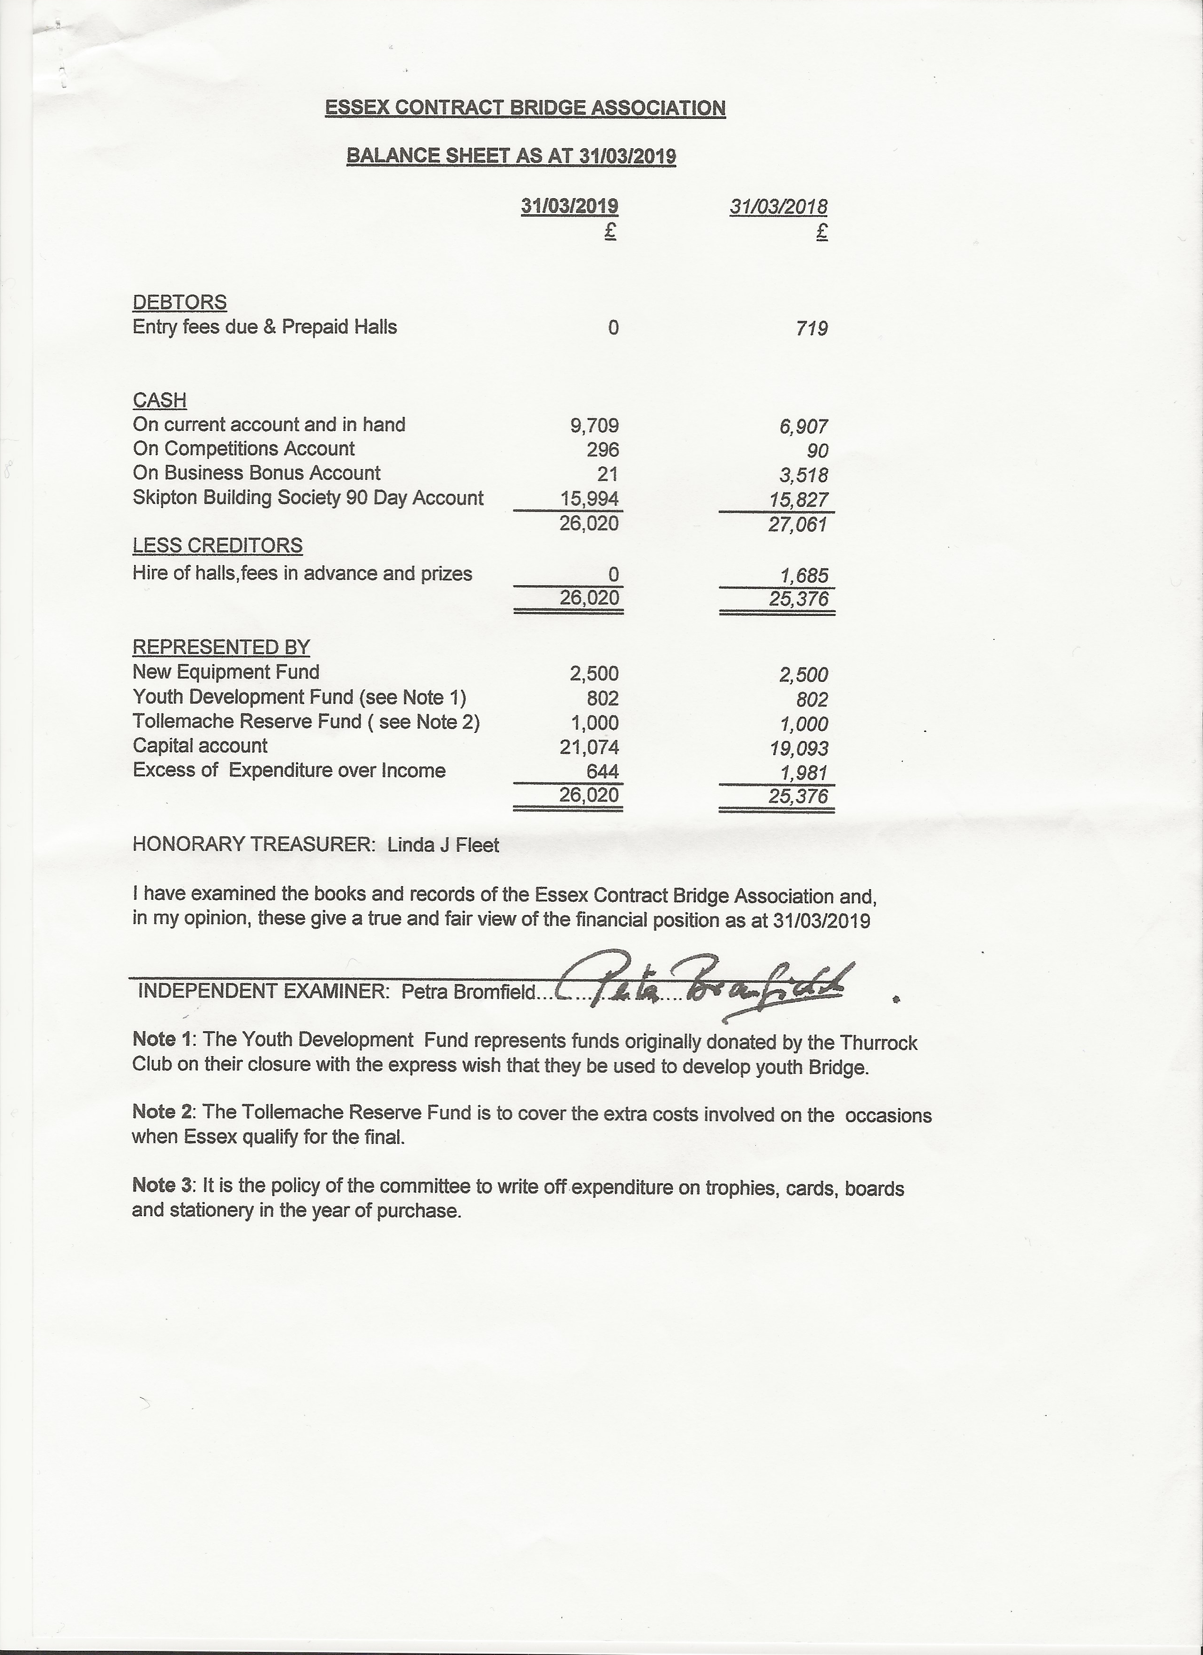
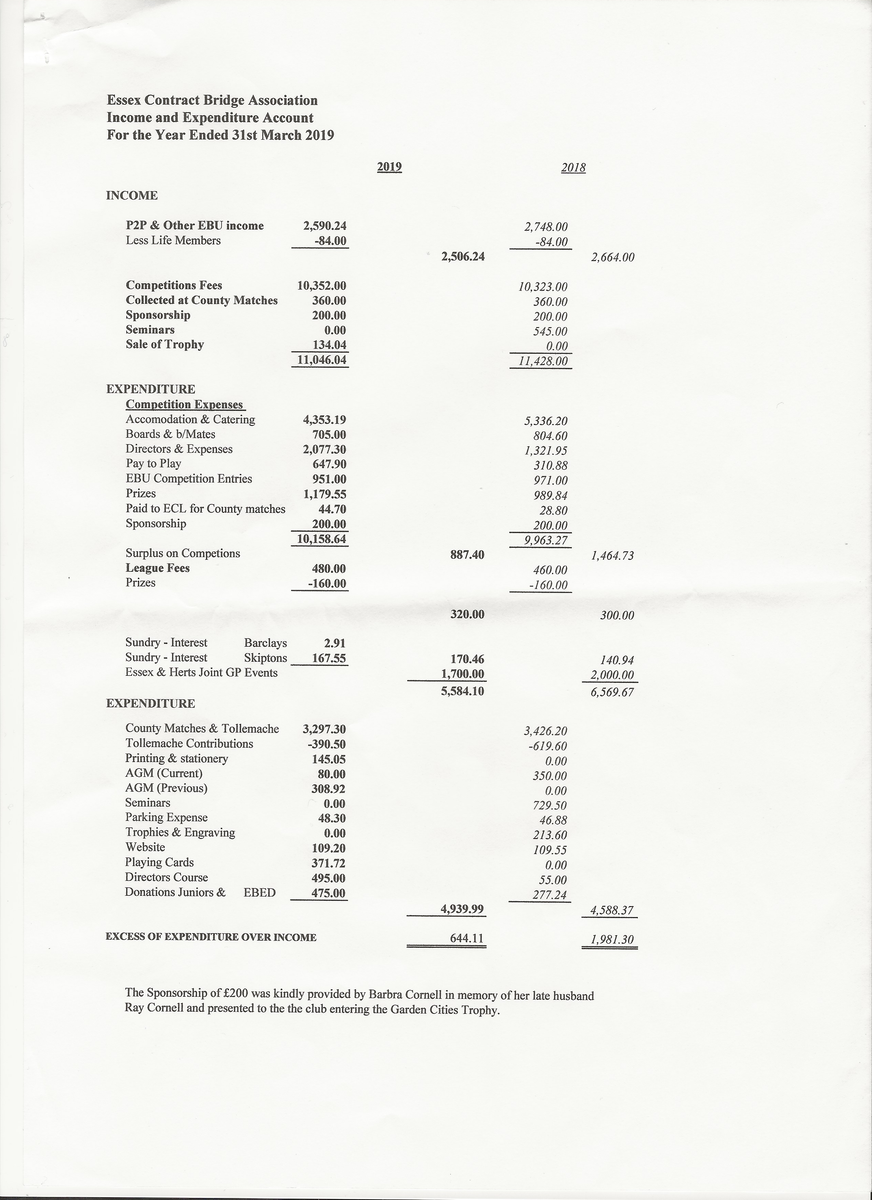
Appendix D Tournament Secretary’s Report

Attendance at events has been slightly up on the previous year, with just one event being less well attended than the previous season. There was a net increase of 74 player attendances over the year. Unfortunately, we had no entries for the B flight pairs this year which had to be cancelled for the second year running. This seems to be following the same pattern as the EBU’s events for less experienced players, with plenty of interest initially, but quickly dropping away to nothing.

The knockout competitions are holding reasonably steady. We had 3 extra teams in the Teams of 4, including an entry at the plate competition stage. However, there was one less team in the Switch Cup. Hopefully those who took part this year will continue to do so and I hope more teams will be encouraged to join. Entries for the switch and Teams of 4 main event are due by the end of this month although I can usually accommodate entries up to a week or so late. Direct entry into the teams of 4 plate competition which starts in December is an option for any team who would like to have a go. Please think about forming a team in one or other of the events if you don’t already play, or spread the word to other potential participants if you do.

Most of you are now more familiar with the 2017 changes to the laws and alerting and announcing rules. Please remember that the intention of the laws is not necessarily to penalise someone who makes a mistake. but simply to make sure that the non-offending side is not damaged. The rule changes are designed to decrease the number of situations which cause an abnormal result. Abnormal results affect not just those players at the table, but all the players at other tables

We are now using computer scoring of most of our home County matches as are a few, but not all, of the other counties. This means that for more than half the matches we can post the results on the website and make use of the Bridgewebs play-it-again feature.

Congratulations to our newest qualified County Director, Graham Beeton.

Finally, Congratulation to all those Essex players who go further afield to play in various EBU events and congresses. Petra reports the successes she knows about on the website so I won't go into detail here. If you, or any Essex player you know, does well in any such event, be sure to let Petra know.
Appendix E League Secretary’s Report

All matches played in main leagues

Premier League
Winners Ultra Llama
Runners Up Loughton Collier

West Division
Winners New Foresters
Runners Up Shad

South East Divisions
Division 1
Winners Crowstone
Runners Up May & Baker

Division 2
Winners Weakenders
Runners Up Aurora

League tables are available to view on the EBU website with a link from the ECBA website

Appendix F Apologies for absence

Cath Fox
Chris Martin
Chris Megahey
Chris Taylor
Linda Fleet
Pascaline Mower
Sue Thorburn
Tanya Genthe

