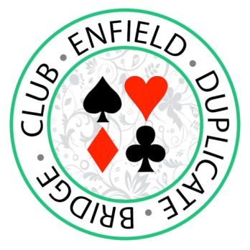
ENFIELD DUPLICATE BRIDGE CLUB
FREE REAL BRIDGE THURSDAY EVENING ON-LINE CLUB SESSIONS Until end of APRIL 2021

MEMBERSHIP APPLICATION

First Name: Click here to enter text. Last Name: Click here to enter text.
Phone: Click here to enter text. Mobile: Click here to enter text.
Please provide at least one contact phone number
Email Address: Click here to enter text.
EBU Number (if known): Click here to enter text. BBO id (if known): Click here.

Please tick to receive club communications via email.
Please tick to consent to your phone number(s) being visible to other members.
Please tick to consent to other members being able to email you from the website. (Your email address will not be visible).

Choose one of the below
I am emailing form to secretary@edbridge.org.uk and transferring £15 to: Enfield Duplicate Bridge Club, Sort Code: 20-58-51, Account 93714470.
Please include full name(s) of person(s) being paid for in your bank transfer system’s reference field.
I am posting completed form and cheque for £15 to:
Secretary, Enfield Duplicate Bridge Club, 15, Haslemere Road, London N21 3AB

