Minutes of the DBA Annual General Meeting
Held at 11 a.m. on Sunday 13 July 2025 via Zoom conferencing
Draft minutes awaiting approval at the 2026 DBA AGM

1. Attendance: (17 people attended, plus 13 proxies, total of 30)
Officers: Chair, Jacqui Munns (JM), Vice Chair, Jeremy Child (JC), Treasurer, Neil Marsden (NM)
Committee members: Bill Luscombe (BL), Sheila Ferguson (SF)
Members: Alison Pollok (AP), Barbara Rennie (BR), Brent Wormald (BW), Carol Ritzen (CR), Colin Found (CF), Ian Dalrymple (ID), Linda Rafferty (LR), Roger Gowland (RG), Ruth Edmondson (RE), Sharon Found (SF), Stephen Rafferty (SR), Steve Munns (SM),
Proxies: Andrew Craddock (SM), Brenda Martin (BR), Brigid McElroy (RE), David Meek (SF), Eamon Rogers (CF), Karen Rogers (AP), Kate Ross (BW), Liz Timbrell (SF), Mike Hamon (JC), Mike Dixon (CR), Norman Botton (BL), Richard Watkins (NM), Terence Treeby (JM).
Apologies: Alex Maddocks
The chair announced that the meeting was quorate with 30 members represented, and the meeting opened at 11:10am.
2. Minutes of the 2024 AGM
The minutes of the 2024 AGM have been on the website for a month.
Barbara Rennie proposed that the minutes were accepted, this was seconded by Stephen Rafferty, and agreed by a show of hands.
There were no matters arising.
3. Chair’s Report
Jacqui Munns presented her report.
I am coming to the end of my third year as chair and as I said last year, while we have made progress, there is still much to do. As was the case last year, the make-up of the executive committee is taken from a small pool of hard-working people – Jeremy Child, Neil Marsden, Bill Luscombe, Liz Timbrell, Mike Hamon, and Sheila Ferguson, and I would like to thank all of them for their contribution. As I said last year, to make the kind of progress that is needed going forward we will need some more help.
Education & Teaching
Teaching is key to increasing the number of Bridge players in Devon and there has been progress in this area since last year. As well as the regular teaching being offered via clubs in Exeter, Torquay, and Plymouth, we have now started teaching in North Devon. The DBA has also run two successful No Fear Bridge events to give new players an opportunity to experience duplicate Bridge in a friendly, supportive environment as part of their transition from class to club.
So, while there has been progress on the teaching front, we need to find more people to come to our classes. This isn’t just about advertising, but is also about promoting the game we all love and encouraging others to try it.
Examples of this in the past year include; Alex Maddocks gave a talk on Bridge as part of the ‘Cards on the Table’ event at the annual Agatha Christie Festival in Torquay in September. This raised the profile of the game and encouraged at least a couple of people to start lessons; Jeremy Child and members of the Exeter Club were featured on Spotlight on the BBC in February.
We can all play our part in promoting Bridge and there are many ways to do it. Taster sessions are fairly easy to organise, either in Bridge clubs or other venues such as libraries. I have done quite a few now and am quite happy to help others who would like to try.
We have also made contact with the EBU’s new County & Membership Development Officer Mary Cousins, who has lots of ideas for developing the membership. She has helped us with online advertising for our next set of classes in the North and is happy to do so for others.
New Website
First of all, this is a good time to thank Ruth Edmondson for all her hard work setting up the DBA website and keeping it going. It has always been one of the best-looking county sites, and I know as I have looked at all of them!
For the last year or so, Devon has had a Bridgewebs site in addition to the main DBA website. This was originally set up to allow for real-time posting of competition results, but we are now in the process of moving all content over to the new site, and it is anticipated that this will be our only site by 2026. Basically, all new content going forward will be on the new site www.bridgewebs.com/devon although there will be links between the two sites for the time being to get you where you want to be.

One of the main drivers for this is that the Bridgewebs site is easy to use and this means that many people can contribute. This is a good time to thank Nigel Richardson for transferring the Devon Leagues (previously the Eastern Leagues) content to the new site and for his help going forward.
Congresses
Both the North Devon Congress in February and the Devon County Congress in April were successful events, attracting similar numbers to the previous year, and both made a surplus. Of note, there were many new faces at both events, which hopefully bodes well for the future.
I would like to thank Carolyn Page for her contribution to the North Devon Congress as treasurer and co-organiser, as she has now stepped down from this role, and would like to welcome Sharon Found, who will take over from her. I would also like to thank Sheila Ferguson and the DCC subcommittee members for running a successful County Congress in Torquay this year and for securing the Grand Hotel in Torquay for next year, an exciting development. Entries are now open on the new website, btw. Thanks also to our TDs, Jeremy Child for the North, and Colin Simcox for the County Congress in Torquay, with Jeremy as host for that event.
Competitions
The competitions subcommittee organised all of Devon’s competitions this year, and once again, entry fees were kept low to encourage participation and ensure that Devon would be well represented in the National competitions. Unfortunately, and once again, entry numbers were not as high as we had hoped and overall, the Devon competitions made a loss. However, this was offset by the surplus from the congresses so that overall, competitions as a whole stayed in the black.
I would like to take this opportunity to thank our selection subcommittee, headed by Warner Solomon and including Stefan Lindfors, Alex Maddocks and Stephen Rafferty.
We will try to improve participation in competitions this year, with Liz Timbrell, our club liaison officer working hard to encourage new players.
Sections Update
The North Section, the only one of the original four sections of the DBA to be in operation at the last AGM has now had its final AGM and has closed. However, the work of the North Section will continue as the North Devon Bridge Group, and will be a subcommittee of the DBA, reporting to the executive committee in the same way as the other subcommittees. Now that the final Section has closed, the references to the sections in the DBA constitution need to be removed. This has given us an opportunity to update the constitution, and a proposal to accept the new draft constitution will be considered in this meeting.
At the end of the chair’s report, Alison Pollok, Jeremy Child and Barbara Rennie thanked the chair for her hard work during the past year.
4. Financial Report
The annual accounts were presented by Neil Marsden, treasurer, and are available at the end of this document.
The summary balance sheet (table 6) shows a continued healthy overall balance of c.£44,200, up by c.£1,400 on the previous year. The West and East Section accounts have both closed and the funds transferred to the reserve account. The final East Section transactions, shown on table 5, were included with the Central accounts for convenience of reconciliation and scrutiny. Thanks to Tim Barnes for managing these funds and organising their transfer.
During the year, the main sources of income were c.£1,150 from the Universal Membership Subscription (UMS, previously Pay to Play), the North Devon Congress surplus of c.£1,900, and interest on the reserve account of c.£900.
The largest items of expenditure were £1,500 towards the cost of a dealing machine, which was paid out by the Eastern Section prior to closure, c.£850 in entry fees for regional and national competitions, and £840 in prizes for the Devon County Congress.
The two new ‘No Fear Bridge Pairs’ sessions generated c.£500 of income, which matched the costs of these events.
Thanks to our scrutineers, Roger Gowland for the DBA central accounts, and Marjorie Higgins for the North Section account and the North Devon Congress account.
At the end of the presentation, questions were invited.
(i) the large expenditure by the Eastern Section towards the cost of a dealing machine for a non-affiliated club was raised by one of the members. In response, it was confirmed that this had been a Section decision. However, it is the objective of the DBA to promote Bridge in Devon and that should include the non-affiliated clubs. It is also our understanding that the machine is being used by more than one club, at least one of which is an EBU-affiliated club.
(ii) NM added that the scrutineer had asked that we have a receipt for the congress prizes, given that this represented a large sum of money taken out of the bank as cash. It was agreed that all recipients could sign to confirm their receipt of prizes at the presentation.

7. Presentations
Congratulations and thanks were given to successful Devon members in the following competitions
The Devon Pairs for the Julia Chadwick Trophy 2025
Unfortunately, although eight pairs started this competition, due to technical issues, only seven finished. The joint winners were Doug Dunn & Nigel Wain with Stefan Lindfors & Jim Grant. They were joined by Jesper Rundin & Alex Maddocks as the three pairs eligible to represent Devon in the EBU Corwen Trophy competition. Stefan Lindfors & Jim Grant were again the highest placed Devon pair in the competition finishing an impressive 3rd out 82 pairs.
Devon Teams of Four for the Western Morning News Trophy 2024 - 2025
There were no entries for this knockout competition, which consequently did not go ahead and Devon was therefore not represented in the Pachabo this year. The competitions subcommittee is considering a different format for the coming season.
Devon Club Teams-of-Eight 2025
Once again, Torquay was the only club to enter this competition this year so they represented Devon in the EBU Garden Cities competition by default. The team of Alex Maddocks & Jacek Pietrzycki, Pete Van Praag & Michael Anderson, George Triantafyllidis & Billy Lambert, and Stefan Lindfors & Jesper Rundin therefore took part in the regional final in Bristol, missing out on qualification for the final.
Western League 2024-2025
Devon’s A, B & C teams finished 2nd, 2nd, and tie 3rd, respectively.
The chair reminded everyone that there is no NGS requirement to play in the Western League and any player wishing to represent Devon in this competition should complete the form on the new Bridgewebs DBA website.
Thanks to our selectors Warner Solomon and Stephen Rafferty.
The Spring League 2025 (previously the Eastern League)
The winners of Division A were the Paradocs - Willie, Ali, & Ian Hamilton, Peter Wood & Howard Kent-Webster and the B Division winners were the Hopefuls - Lin Waddington, Elizabeth Timbrell, Harriet Bailey & Paul Guppy.
Please sign up for the Winter League asap on the new Bridgewebs site, see the competitions tab in the Menu on the LHS.
John Woolcott 2025
Sheila & Eva Ferguson won the pairs with Richard Lingham & Viv Mably in second place. The teams’ event winners were Stephen Rafferty & Roger Gowland with Carmen Ruiz-Castell & David Southcombe.
Many thanks to Nigel Richardson and his team for organising these two events and for contributing to the new website.
North Devon Congress 2025
The Swiss Pairs winners were Simon & Debbie Richards, and the Swiss Teams winners were Sally & Terry Stuttard with Chris Thomas & John Dick.
Devon County Congress 2025
The Swiss Pairs winners were Cathy & Andrew Smith, and in the Swiss Teams there was a tie for first place between Richard Lingham & Ann Slee with Ruth Edmondson & Brigid McElroy and the newcomers Mike Huggins & Irene Robinson
With John Dakin & Tony Olech.
Tollemache 2024/25
The Devon team of Jim Grant (captain), Sam, Sally & Venetia Anoyrkatis, Willie Hamilton, Pete Wood, Jacek Pietrzycki, Jesper Rundin, Ian Walsh, Doug Dunn & David Strawbridge competed in the Tollemache qualifier along with 28 other counties over a weekend in November but did not go through to the final.
Lady Milne 2025
Congratulations to Sally and Venetia Anoyrkatis, who were part of the victorious EBU Team this year.
5. Election of Chair, Vice-Chair, Hon. Treasurer and Hon. Secretary
Officer nominations
Chair: Jacqui Munns, proposed by Carol Ritzen, seconded by Brenda Martin
Vice-Chair: Jeremy Child, proposed by Jacqui Munns, seconded by Neil Marsden
Hon. Treasurer Neil Marsden, proposed by Steve Munns, seconded by Roger Gowland
Hon. Secretary no nominations received yet…
All officer nominations were accepted by a show of hands.

Committee members
Returning Members:
Bill Luscombe, proposed by Neil Marsden, seconded by Jeremy Child
Liz Timbrell, proposed by Jeremy Child, seconded by Jacqui Munns
Mike Hamon, proposed by Jacqui Munns, seconded by Neil Marsden
Sheila Ferguson, proposed by Neil Marsden, seconded by Jeremy Child
All committee member nominations were accepted by a show of hands.

8. Proposals
(i) The committee agreed to propose to the AGM that from April 2026, the amount the county receives from the Universal Membership Subscription (UMS, previously Pay to Play) will remain unchanged at 4p; the club subscription will remain at zero and the Devon part of direct membership remains at £3.
This proposal was accepted by a show of hands.
(ii) The Executive Committee propose that an updated version of the Association Constitution be accepted. The new draft brings the constitution more in line with the EBU model constitution, has a simplified version of the Association’s objectives, has removed references to the sections, and has been updated to reflect the use of email and online notices.
This was accepted by a show of hands.
8. AOB
The chair suggested that we provisionally set the date of future DBA AGM’s to take place on Wimbledon Men’s Finals Day, which in 2026 will be Sunday, July 12, 2026.
As there was no other business, the Chair thanked everyone for attending and closed the meeting at 11.35am.
The next DBA Executive Committee Meeting will be at 10am on August 12, 2025 via Zoom.

SEE BELOW FOR THE DBA ACCOUNTS FOR THE YEAR TO APRIL 30, 2025
Devon Bridge Association Accounts Summary

1. DBA Central Accounts for the year ending 30th April 2025

2. Northern Section Accounts for the year to 30th April 2025
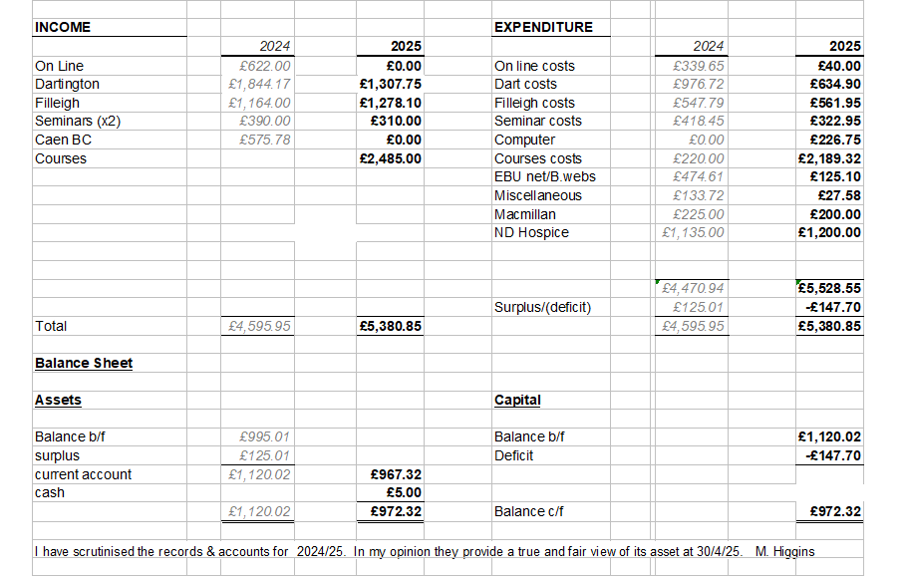

3. Northern Devon Congress Accounts for 2025

4. Western Section Accounts
This account had a balance of £3,638.67 on the 30th April 24, and this was transferred to the DBA reserve account on 14th October 2024.

5. Eastern Section Account
This account had a balance of £3,435.75 on the 30th April 24. Final transactions for this account are shown below, and the closing balance of £1,880.47 was transferred to the DBA reserve account on 3rd June 2024. These transactions have been incorporated into the main accounts of the DBA.
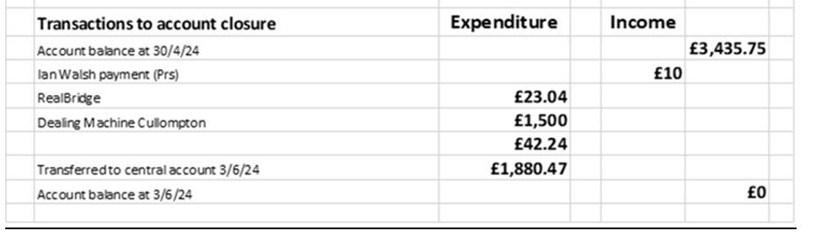

6. Overall County Accounts Summary

