Minutes of the DBA Annual General Meeting
Held at 11 a.m. on Sunday 14 July 2024 via Zoom conferencing
Draft minutes awaiting approval at the 2025 DBA AGM

1. Attendance: (21 people attended, plus 12 proxys, total of 33)
Officers: Chair, Jacqui Munns (JM), Vice Chair, Jeremy Child (JC), Treasurer, Neil Marsden (NM)
Committee members: Bill Luscombe (BL), Doug Dunn (DD), John Wintle (JW), Mike Hamon (MH), Sheila Ferguson (SF)
Members: Alex Maddocks, Barbara Rennie (BR), Brenda Martin (BM), Carol Ritzen (CR), Carole Bewes, Caroline Palmer, Clare Hamon, Linda Rafferty, Liz Timbrell, Peter Taylor, Roger Gowland (RG), Stephen Rafferty, Steve Munns (SM),
Proxys: Bill Oke (DD), Chris Smith (BR), Eamon Rogers (SM), Enid Hamon (MH), Karen Rogers (JM), Kate Ross (JW), Paul Hide (NM), Richard Watkins (CR), Rosemary Caddy (BL), Ruth Edmondson (JC), Sue Hunt (BM), Tony Allsworth (SF).
Apologies: Hilary Adams

The chair announced that the meeting was quorate with 33 members represented, and the meeting opened at 11:02am.
2. Minutes of the 2023 AGM (non-quorate and reconvened)
The minutes of both the non-quorate and the reconvened AGM meetings have been on the website for a month. The non-quorate minutes included the chair’s report, and the minutes of the reconvened meeting included the financial report, the presentations, the elections of officers, and the Pay to Play proposal, which was accepted.
Stephen Rafferty proposed that the non-quorate minutes were accepted, this was seconded by Linda Rafferty and agreed by a show of hands. Steve Munns proposed that the reconvened minutes were accepted, this was seconded by Clare Hamon and agreed by a show of hands. There were no matters arising.
3. Chair’s Report
I am coming to the end of my second year as chair and feel that while we have made progress, there is still much to do. As was the case last year, the make-up of the central committee and all our subcommittees is taken from a small pool of hard-working people – Jeremy Child, Neil Marsden, Bill Luscombe, Doug Dunn, Mike Hamon, and Sheila Ferguson, and I would like to thank all of them for their contribution. As I said last year, to make the kind of progress that is needed going forward we will need some more help, so please don’t be shy.
On that note, I am delighted to announce that Liz Timbrell has agreed to join us in a club liaison role. I would also like to take this opportunity to thank Doug for all his hard work over the last few years as he is standing down at this meeting. As well as his contribution to the central committee, he has led the Devon County Congress committee, which has delivered two successful Face-to-Face County Congresses as we recovered from the Covid era. I am also grateful to Sheila Ferguson for agreeing to take over his role and I know that with her expertise in running previous excellent events, we are in good hands.
Education & Teaching
In last year’s chair’s report I mentioned the decline in both the number of Bridge players and the number of affiliated clubs in Devon and the challenges we all face to reverse this trend. The view of the DBA is that to fully support new players in their journey from novice, through supported play and No Fear Bridge to being ready to play in a club environment, it is the clubs that are best placed to deliver the teaching, either individually, or in collaboration with other nearby clubs. So what have we done? Since the last AGM, we have co-organised two ‘Teach the Teacher’ courses, both run by our own Sally Anoyrkatis. We are happy to organise more, so please get in touch if we can be of assistance. And don’t forget, every affiliated club can have a free place on the course every two years.
So, there is now more teaching going on regularly in Devon with Alex Maddocks teaching at Torquay, Jeremy teaching in Exeter, Doug teaching in Teignmouth in collaboration with the U3A, and in the North, there is a beginner’s course planned for October. Please let me know if I have missed anyone out.
Teaching the basics is just the start of a long Bridge journey for new players and it is important that we continue to support them as they make progress. With this is mind, and now that there is a growing number of students who have graduated from beginners classes in Devon, we are organising a ‘No Fear Congress’ in Exeter in October to give our new players a taste of friendly but competitive duplicate Bridge, and hopefully get them hooked. There will be more information soon on the DBA website but if you have suitable students who might be interested, do get in touch.
And talking of the website, the ‘Learn to Play Bridge’ page has been revamped and there is now a prominent ‘Learn Bridge’ banner on the Home Page. Please help us to keep this page accurate and up-to-date, and in particular, let us know if you are running any supported, No Fear-type sessions for new learners to join, either F2F or online.
So, while there has been progress on the teaching front, we also need to find people to come to our classes. This year, we have had stalls at Rosemoor’s Hobby weekend, and in both the Exeter and Barnstaple Library foyers. At these events we talked to passers-by about Bridge and encouraged them to have a go at MiniBridge. There are plans for more events and of course, the EBU’s Bridge Festival in September should help to raise the profile of the game. Another event to note is the ‘Cards on the Table’ Bridge event, taking place in September as part of the annual Agatha Christie Festival in Torquay. Alex Maddocks is involved in that and will be giving a talk at the event. We will post something on the website nearer the time.
Competitions and Congresses
Both the North Devon Congress and the Devon County Congress were successful events, attracting similar numbers to last year in the case of the North, and slightly increased numbers in the case of the Torquay event, and both events made a surplus. Thanks to everyone involved in the relevant subcommittees, and also to Carolyn Page, treasurer and co-organiser of the North Devon Congress and the TDs, Jeremy for the North, and Colin Simcox for the County Congress in Torquay.
The competitions subcommittee organised all of Devon’s competitions this year, and once again, entry fees were kept low to encourage participation and ensure that Devon would be well represented in the National competitions. Unfortunately, entry numbers were not as high as we had hoped and overall, the Devon competitions made a loss. However, this was offset by the surplus from the congresses so that overall, competitions as a whole stayed in the black.
I would like to take this opportunity to thank our selectors, Warner Solomon, Stefan Lindfors, Alex Maddocks and Stephen Rafferty.
We are aware that the vast majority of our membership don’t go to congresses and haven’t entered any of the Devon competitions. Going forward, we know that we need to find ways of representing and supporting all of our members and clubs, and with Liz’s help we aim to make progress in the coming year. In the meantime, don’t be shy in telling us what you want.
Sections
As I mentioned in my report last year, Devon is the only county to have its association split into sections, but many of the reasons behind this are no longer relevant in the modern world. The South Section folded a few years back and this year the East Section has closed, returning its account balance to the central account. However, I am delighted to say that Nigel Richardson and his team will continue to run the John Woolcott weekend and the Eastern League and I would like to take this opportunity to thank them for the hard work they have put into these events this year.
The West Section has not been active for a number of years and this will also fold in the coming months. That will leave the North Section, responsible for running a number of charity events, the North Devon Congress, and the upcoming beginner’s course. Discussions are ongoing as to how Bridge should be organised in the North, and once decided, the aim will be to update the relevant parts of the DBA constitution in time for approval at next year’s AGM.
Last year, I finished my report by saying that our focus this year would be on promoting Bridge and supporting clubs to develop teaching, and to find new players to teach. We have clearly made progress in this area although there remains much to do. In the coming year, we aim to improve communication and engagement with the clubs in Devon, both affiliated and non-affiliated. We are also planning a financial review to decide on a strategy for using the significant funds of the DBA to benefit all members of the DBA equitably, and your views are key to this, so please get in touch.
Finally, one more ‘thank you’ – to Ruth Edmondson, for her help and support generally and more specifically in her role as Webmaster, keeping the DBA website up to date and eye-catching.
4. Financial Report
The overall accounts for the year to 30th April 2024, including summaries for the three sections, have been available on the website the last four weeks and are reproduced below. The summary (Table 5) shows a surplus of £614.46 for the year and a total holding of £42,776.67, both amounts being a little higher as compared to the previous year.
The DBA has three main sources of income, (1) universal membership fees (Pay to Play), which brought in £1,125.64 this year, (2) the Devon County Congress, which made a surplus of over £900 in April, and (3) the North Devon Congress, which made a surplus of just under £500 in February.
Expenditure has followed a similar pattern to recent years comprising mostly of expenses related to the congresses and other county competitions.
The Eastern Section has closed its bank account and in future, income and expenditure for events previously organised by the section will be processed through the central account. Thanks to Tim Barnes for running the Eastern Section accounts and for its smooth closure.
Thanks also to John Wintle for scrutinising the central accounts and to Marjorie Higgins for scrutinising the accounts of the Northern Section and the North Devon Congress.
Following the financial report, Alex Maddocks asked if the committee had considered whether paying a small honorarium might help to secure help in certain areas and this will be considered when drawing up the financial plan.
5. Election of Chair, Vice-Chair, Hon. Treasurer and Hon. Secretary
Officer nominations
Chair: Jacqui Munns, proposed by Carol Ritzen, seconded by Richard Watkins
Vice-Chair: Jeremy Child, proposed by Jacqui Munns, seconded by Neil Marsden
Hon. Treasurer Neil Marsden, proposed by Linda Rafferty, seconded by Roger Gowland
Hon. Secretary no nominations received yet…
All officer nominations were accepted by a show of hands.
Committee members
Returning Members:
Bill Luscombe, proposed by Neil Marsden, seconded by Jeremy Child
John Wintle, proposed by Brenda Martin, seconded by Steve Munns
Mike Hamon, proposed by Jacqui Munns, seconded by Neil Marsden
Sheila Ferguson, proposed by Neil Marsden, seconded by Jeremy Child
New appointment:
Liz Timbrell, proposed by Jeremy Child, seconded by Jacqui Munns
All committee member nominations were accepted by a show of hands.
6. P2P payment in 2025
The committee agreed to propose to the AGM that P2P from April 2025 will remain unchanged at 4p; the club subscription will remain at zero and the Devon part of direct membership remains at £3.
This proposal was accepted by a show of hands.
7. Presentations
Congratulations and thanks were given to the following Devon members:
The Devon Pairs for the Julia Chadwick Trophy 2024
Eleven pairs took part in this competition, congratulations to the winners Stefan Lindfors & Jim Grant. We were allowed to enter three pairs from the Julia Chadwick into the EBU Corwen Trophy competition and so Stefan & Jim were joined by Alex Maddocks & Jacek Pietrzycki and Douglas Dunn & Bill Luscombe. Stefan Lindfors & Jim Grant were the highest placed Devon pair in the competition finishing an impressive 5th out 75 pairs.
Devon Teams of Four for the Western Morning News Trophy 2023 - 2024
There were six entries for this knockout competition. Congratulations to the winning team of Warner Solomon & Alex Maddocks, with Jim Grant and Stefan Lindfors. Unfortunately, Warner’s teams were not able to field a team for the EBU Pachabo Cup so the runners up team of Richard Lingham & Ann Slee with Brigid McElroy & Ruth Edmondson represented Devon, coming 24th out of a strong field of 29 teams. There was no Devon Plate competition this year.
Devon Club Teams-of-Eight 2024
Torquay was the only club to enter this competition this year so they represented Devon in the EBU Garden Cities competition by default. The team of Alex Maddocks & Jacek Pietrzycki, Michael Orriel & Michael Anderson, Margaret & Ian Mundy, Ian Walsh & Mike Walsh therefore took part in the regional final in Bristol and came tie third, just missing out on qualification for the final. Western League 2023-2024
Devon’s A, B & C teams finished 2nd, 3rd, and 2nd, respectively.
The chair reminded everyone that there is no NGS requirement to play in the Western League and any player wishing to represent Devon in this competition should complete the form on the DBA website.
Thanks to our selectors Warner Solomon and Stephen Rafferty.
East Section League (Spring 2024)
A Division winners were Alex Maddocks (captain), Ian Walsh, Jacek Pietrzycki, Jim Grant, Stefan Lindfors & Warner Solomon, and B Division winners were Stephen Rafferty (captain), Neil Marsden, Paul Hide & Sam McKibbin.
John Woolcott 2023-2024
Alex Maddocks & Jacek Pietrzycki won the pairs with Ian Walsh & Rob Lawy in second place. The teams’ event did not go ahead due to too few entries.
Many thanks to Nigel Richardson and his team for organising these two events
North Devon Congress 2024
The winners of the Swiss Pairs were Graham Horscroft & Mike Bull, and the winners of the Swiss Teams were Dave Smith & Chris Wormleighton with Sue Ingham & Gwynn Davis, attending for the first time.
Devon County Congress 2024
The Swiss Pairs winners were Alan Wearmouth & Tony Hill, and the Swiss Teams winners were Tim Rees & Ceri Pierce with Ian Hamilton & Paul Denning.
Tollemache
The Devon team of Stefan Lindfors (captain), Jim Grant, Alex Maddocks, Jacek Pietrzycki, Joe & Gillian Fawcett, Sally, Venetia & Sam Anoyrkatis competed in the Tollemache qualifier along with 30 other counties over a weekend in November but did not go through to the final.
Lady Milne 2024
Congratulations to Sally and Venetia Anoyrkatis who were part of the victorious England Team for the second year running.
EBU Silver Award 2023
Congratulations to Gillian Fawcett who received the EBU Silver Award in recognition of her significant contribution to the EBU, including shaping their response to the Covid pandemic.
EBU Dimmie Fleming Award 2023
Ruth Edmondson received the Dimmie Fleming Award this year in recognition of more than 30 years of service to Bridge in Devon, including but not limited to providing IT support and running the DBA website.
8. AOB
Carol Bewes said that as a new EBU member she wanted to express her thanks for the support she had received thus far.
As there was no other business, the Chair thanked everyone for attending and closed the meeting at 11.32am.

The next DBA Committee Meeting is online 10am, August 20, 2024.

SEE BELOW FOR THE DBA ACCOUNTS FOR THE YEAR TO APRIL 30, 2024
Devon Bridge Association Accounts Summary

1. DBA Central Accounts for the year ending 30th April 2024

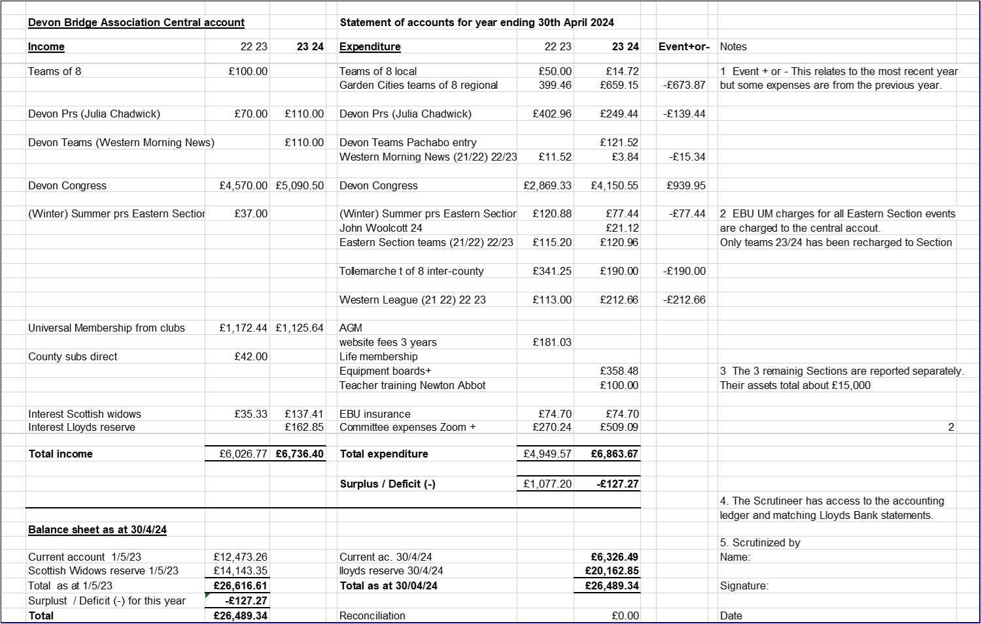
2. Eastern Section Accounts from 1st May 2023 to close of account on 3rd June 2024

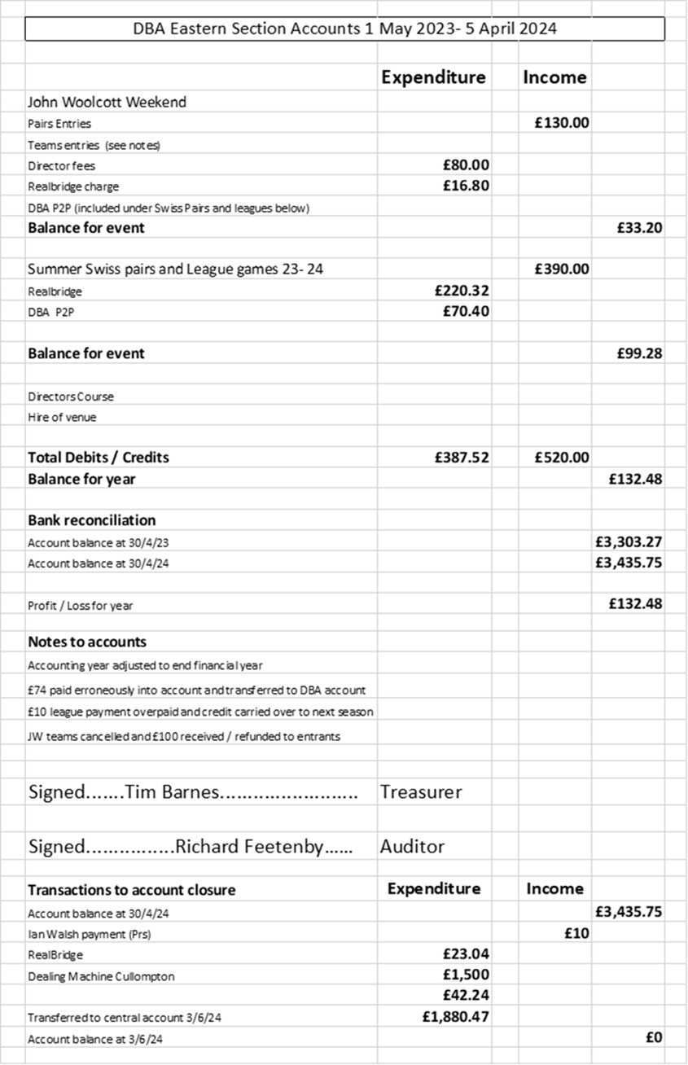

3. Northern Section Accounts for the year to 30th April 2024
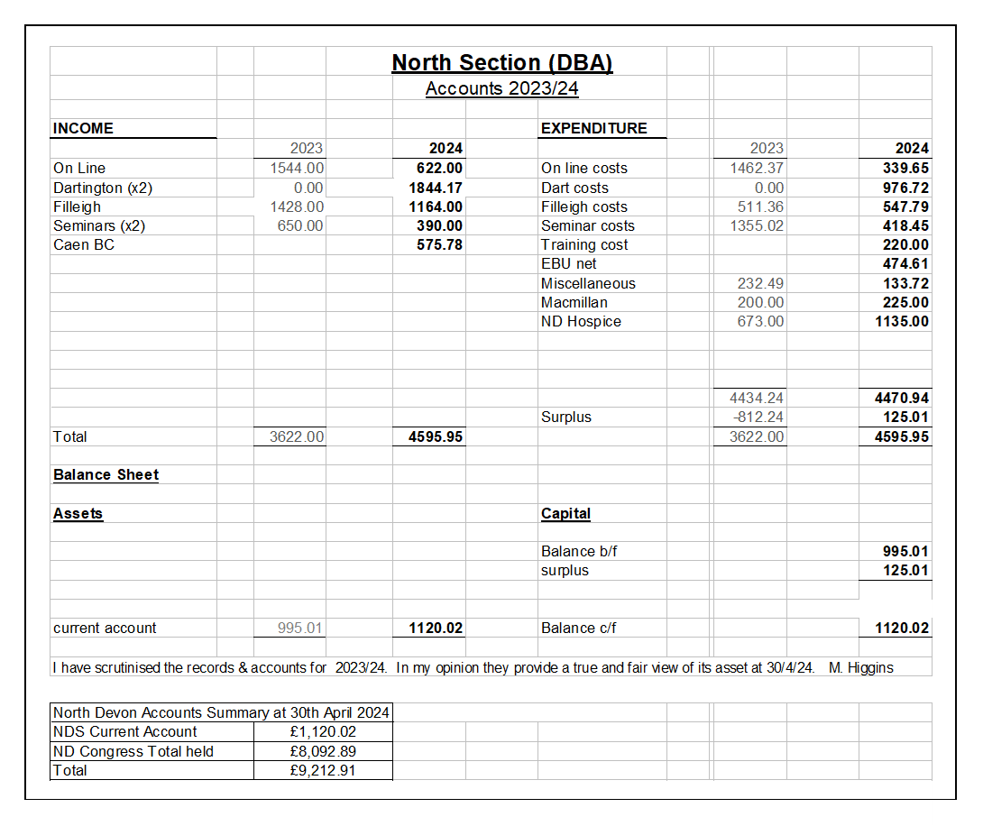

4. Western Section Accounts from 5th June 2023 to 3rd June 2024
Opening & closing balances = £3,638.67, with no transactions in this period.

5. Overall County Accounts Summary

