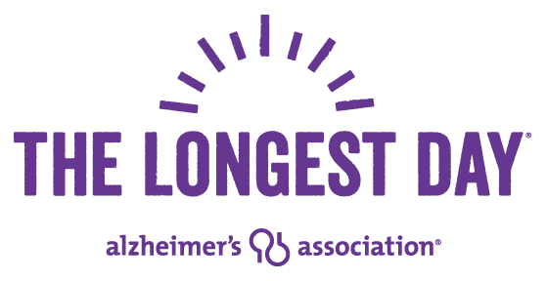

Dear
I am participating in “The Longest Day”, a fund raiser for the Alzheimer’s Association to support research to eventually end this disease. Alzheimer’s is a disease which robs our loved ones of their most precious gifts, their memories of their life, their memories of their loved ones, their memories of their family and eventually all memories of their entire life is erased or forgotten over the course of the disease. Heartbreaking.
I will be playing in as many as 6 on-line bridge games on Saturday, June 20th and Sunday, June 21std. All the fees for these on-line games, paid by the participants, go directly to the Alzheimer’s Association.
Would you please sponsor my play at $5.00 or $10.00 or $25.00 or more per game played? This is a tax deductible event and your check should be made payable to the Alzheimer’s Association.
Thank you for your support of my efforts and the Alzheimer’s Association in fighting this disease, which affects 16 million American’s today.
Thank you,

