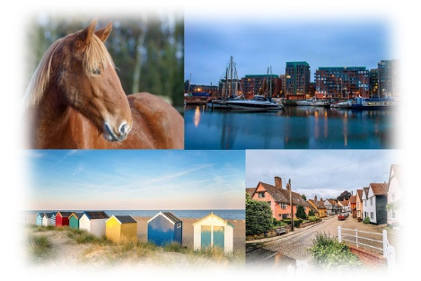

THE SUFFOLK CONGRESS

Elmswell - Sunday 2 October
Swiss Pairs - 11am start
The Suffolk Congress will be a one day Swiss Pairs event played Face to Face at Elmswell on Sunday 2 October, starting at 11am (please be seated by 10.45am).
The Blackbourne Centre at Elmswell, near Bury St Edmunds, is a spacious venue, ideal for playing Bridge. Postcode is IP30 9UH.
The day's bridge will comprise seven 7-board rounds, with Rob Sassoon directing. The cost, including a quality snack lunch, is £25 per person.
For those who don’t know, in Swiss Pairs events players are matched after each round to play against others at a similar level in the standings.
You’ll find the entry form on the Club website, www.bridgewebs.com/stratfordstmary

