Dear Xxxxx 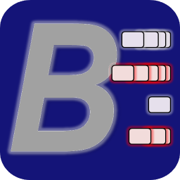
NOTTINGHAM CAFÉ BRIDGE
24th April 2019
BriAn Scorers
Can we thank you for agreeing to use your mobile phone to score the playing results on the “BriAn” app at our upcoming Café Bridge event. We are very grateful for your assistance, as this enables us to raise more money for our charity. It will help us enormously to organise registration if you can come either before, or with, your partner.
When you go through initial registration we will check with you (or your playing partner) that you do have your phone with you, in which case a “N/S” card will be handed to the first 24 people with phones. You will need to hand this in when you go to the “Café Registration” section where you will choose the Café at which you wish to have your lunch (this is on a first come, first served basis). We are fortunate on this occasion that more people have agreed to bring their phones; we can only allocate the first 24 to score as N/S, others will be allocated to E/W. However, it is essential that we do have 24 people scoring so please bring your phone and do not leave it just to others.
After registering for your lunch and collecting your “Movement Cards”, if there are any particular questions you have regarding the BriAn scoring system, you can get any help and assistance you need from Keith Spencer. Please do not go to see Keith before you have registered for your lunchtime Café and been given your “Route Cards”. If you have no special queries and all you need is the access codes for the day’s event, Keith will be announcing these before you leave for your first Café venue.
Don’t forget you also need to order your lunch choices as part of registering – details are included in “Final Instructions”
Our “Café Directors” who will be looking after each group, will take you through the game set up procedures when you arrive at your first event.
If you have any problems scoring at any time through the day, please tell your “Café Director” immediately; they will then try and solve your problem or call in someone who can help. In the meantime carry on playing and score on the paper travellers which are on each board; it is important to keep playing – we can always solve any problem that arises if the travellers have been completed.
From past experience we have found that it is better to use 3G/4G mobile data rather than to rely on Wi-Fi at the different venues, which can be variable. BriAn will use very little of your data during the day, but please ensure that you have at least 20MB of data available on your phone. Also, please ensure that your phone is fully charged.
Thank you once again for your help in this important area and have a great day.
www.bridgewebs.com/cbn

