
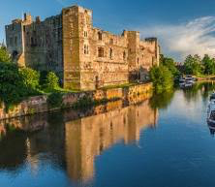 Newark Café Bridge
Tuesday 10th November 2026

Duplicate Bridge for charity, moving between Café venues.
£35 (per player) includes welcome tea/coffee, 2-course lunch, wine or soft drink at the end. Entry deadline 13th October with full payment. There will be limited places this year, so please register as soon as possible. When all places are full a waiting list will be started.

Venues will be: Swan & Salmon, Gannets, The Ram, Castle Barge & La Vita Mia
Registration and refreshments 9.30-10.10am at Swan & Salmon.
Choose your lunch venue (first come first served) and make your way to the first venue.

At each venue you will play several boards and then proceed to the next venue.
Your 2-course lunch will be served at one of the venues.
After the last hands have been played, make your way to the final gathering at Swan & Salmon for drinks, raffle, and prizes, finishing at about 5.15pm.
Extra refreshments may be purchased at each venue.
Some venues have steps and stairs.
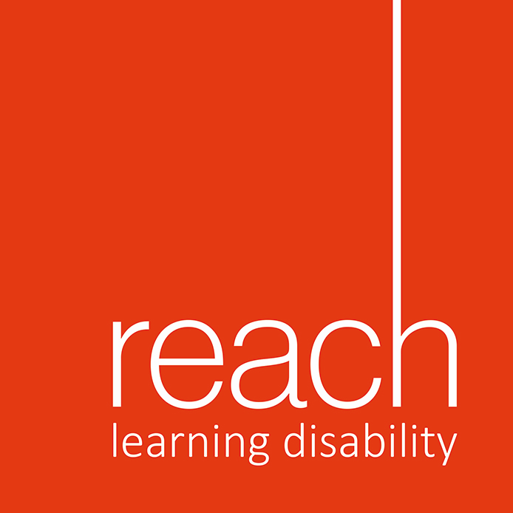

This year we are supporting Reach, a registered charity dedicated to supporting people with learning disabilities in Nottinghamshire as our chosen charity. (Registered Charity No – 1076318)

Please note that when registering to play in one of the CBN events, you are agreeing to the privacy statement on the CBN website, particularly with regards to the use of photographs.

Entry method one (preferred)
Email nottinghamcafebridge@gmail.com with the names, telephone numbers (mobile),
and email addresses of both players.
Transfer £35pp to our Lloyds Bank account Nottingham Café Bridge, 30-98-97; 67002462 using surnames as reference.

Entry method two
Write to Steve Crawford, Prize Farm, 12 College Street, East Bridgford, Notts, NG13 8LE, with a cheque for £35pp payable to Nottingham Café Bridge. Include the names, telephone numbers (mobile if possible), and email addresses of both players.

Please tell us if you can use your mobile phone or tablet with the BriAn scoring app

YOU CAN ACCESS OUR PRIVACY STATEMENT AND CHECK REGULARLY FOR UPDATES AT WWW.BRIDGEWEBS.COM/CBN

