Chairman Secretary Hon Treasurer
Steve Jarvis Peter Milewski Bob Alderdice
steve08@hotmail.co.uk wwba.sec.pjm@gmail.com bobalderdice@btinternet.com
Tournament Organiser Webmaster
David Nicklin Christine Smith
wwba.ato.dn@gmail.com chris.smith1@ymail.com

Annual General Meeting Minutes: Sunday 12th May 2024 at approx. 2.0 p.m.

Held at Tumble Hall

- Present:
Steve Jarvis (Chairman), Bob Alderdice (Treasurer), Christine Smith (Webmaster), David Nicklin (ATO), Peter Milewski (Secretary), Tony Haworth (Porthcawl rep), Perry Crickmere (Pembroke rep), Nicky Hancock (Tenby rep) and the following WWBA members: Eleanor Price, Irene Delahunty, Julie Milewski, Cindy Middleton, Gareth Jones, Kay John, Frances Williams, Glyn Williams, Vida Halford, Tim Dean, Keith Davison, Lavinia Thomas, Martin Sheppard, Mike Baker, Emer Disley, John Coghlin, Dave Lea, Debbie Lea, , Robert Burge, Graham Norris, Sue Norris.

- Previous Minutes and Matters Arising:
The minutes of the meeting held via Zoom on 14th May 2023 were circulated by email prior to the meeting. They were proposed as a true record by Glyn Williams and seconded by Keith Davison, passed nem con.

- Matters Arising:
none.

- Secretary’s Report
The WWBA successfully held its annual events face to face as last year, with the exception as before, of the Celtic and Porthcawl Congresses (a foreshortened version of the latter was held online). The numbers while quite good still hadn’t picked up to pre-pandemic levels, the most tables having been twelve at the Swiss Pairs. We continue to plan our events well into 2025 as Tumble Hall is heavily booked already, and would like members to note the dates from the website, and to encourage their colleagues to bring in new players, and to participate.

- Treasurer’s Report
The full Report and Accounts (with thanks to Ted Hylton who audited them) are in Appendix 1. In brief, Bob Alderdice highlighted our current assets totalling well over £23,000 with an increase in fixed assets to over £1400 due to the recent purchase of equipment (see ATO report). The Treasurer acknowledged a gift of £629 from Letterston Bridge Club that has now closed down, that money having accrued from running a West Wales bridge event on Bridgebase Online during the pandemic. However, our face to face events have been running at a slight loss, and this year we will be taking a hit from running two major events (see Chairman’s Report). The Treasurer is stepping down shortly and we have an urgent need for a new Treasurer and Auditor. The report and accounts were agreed by members nem con.

- ATO Report
We have held 5 events since (and inc) the last AGM and big congratulations to all the winners as follows:
John Issac – Tony Haworth and Emer Disley, Swiss Pairs – Tony again with Kevin Maddox, Vince Bevan Pairs – Lee Collier and Gareth Jones , Mixed Pairs – Adrian Tricky and Mrunalini Dewan, Laidlaw Murray teams of 4 – Viking Yuen, Fu Cheung, John Salisbury and Joy Secular .
All of these events were well attended which showed the f2f game was still healthy in the area. However, todays attendance is a cause for worry as this trend has slowed down. Whether this has anything to do with the current feelings by many about the relevance of the WBU is a matter for debate.
As ATO I have arranged the above events at our venues here in Tumble and Llanarthne and a big thanks goes to them for the support they have given me. Looking forward for the rest of the year and beyond it seems Tumble has become a very popular building and we have been unable to secure any dates in 2024 so the next 2 events will be in Llanarthne. Although this presents a few logistical problems with tables etc we will manage for sure. I have offered dates to Tumble for 2025 for 5 events including the next AGM and JI but have yet to hear back from them (due to circumstances beyond my/their control). Once dates are agreed they will be published in the area calendar.
I have also negotiated the purchase of the following assets for use by me or others as Director at our events: Laptop, Printer, 4 card sets of approx 30 boards each, Duplimater obtained from the Rest Bay Club, 15 Bridgemates .
We should now have all we need to run events in the future without having to beg/steal/borrow from elsewhere, but Tony Haworth is a good source of extra items should we need them. I would also personally like to give a big thank you to Tony for all the help and guidance given to me in setting up movements and controlling the scoring at our events. This is an area which needs much improvement by me so I will be relying on him a lot more in the future.
Dave Nicklin 12/05/2024

- Webmaster’s report:
No issues identified, but Christine Smith would like details of the recent history of Porthcawl Congress for the website. It was suggested that we might ask Jenny Vaughan to approach her sister Irene Thomas for this.

- Chairman’s report:
The full report is in Appendix 2.
In summary, Steve Jarvis pointed out that we now have only seven WBU-affiliated clubs in the Western Area, with only Swansea and Carmarthen holding events in the evening, our members being mainly retired and no longer economically active. He pointed out the importance of affiliation as the WWBA is inextricably tied to the WBU, if one fails so does the other. The income from our subscriptions is now only about £340 and we are making no profits from events. We also have heavy commitments this year to the Perry Spickett and President’s Cups, and the resurrection of the face to face Porthcawl Congress, with the need for forty-five two night stays at the Seabank Hotel, Porthcawl. He encouraged members to enter as the hotel has offered very reasonable terms. The only possibility for further income is perhaps to develop an online event. He put out a further plea for a new Treasurer, to take over from Bob later this year.
- Election of Officers:
Apart from the Treasurer, all the Officers have agreed to stay on, and in the absence of further volunteers, this was agreed nem con.
- AOB:
none.

Appendix 1. Treaurer’s report and Accounts.

Commentary of WWBA Accounts for 2023/24
Firstly I would like to thank Ted Hylton for standing in at the last minute to audit the accounts in the absence of the WWBA having appointed an auditor for the year.
- Our Total Assets remain similar to last year at £23604976 though £1418,22 is Fixed assets with us having purchased a second hand duplimator, a computer, printer and additional boards. £22186.54 is cash assets in the bank. Similar to last year the officers did not take the £750/annum they traditionally received prior to Covid but this may not be appropriate going forward. WWBA wish to thank them for their voluntary work during the year.
All creditors and debtors carried forward from last year’s accounts have been cleared
- We have been fortunate to have received a gift of £629 from Letterson Bridge Club’s surplus funds on closure.
- Tournament’s have run at a £702.69 loss however £238 of this was for the buffet at the AGM. 95% transactions were paid through the BACS system electronically.
- Prior to Covid we typically received £1-1.5K/annum form the Porthcawl and Celtic Congresses and this has now reduced to £224 this year so we have a major challenge re. fund raising for the future. We are reinstituting Porthcawl Congress on 1st-3rd Nov 2024 to celebrate the 75th Anniversary of the first Congress but this brings a major risk and challenge and is dependent on recovering face-to-face playing numbers and the majority of players choosing to stay in the Seabank Hotel. Recognising that we received >£2.3K surplus from the former Porthcawl account closure last year the Committee feel we need to try to encourage Congress participation for our future
- A word of caution, obviously we are taking a major financial risk restarting Porthcawl Congress, however this summer WWBA will be hosting the Perry, Spicket and President’s Cup and traditionally this costs approx. £2.-2.5K additional expenditure every 4 years and together with the number of Area playing members dropping dramatically we need to be prudent recognising the significant expenditure over the next 6 months. The challenge is to recover interest in Area Congresses and tournaments.
We need to appoint a new Treasurer and Auditor for next year at this AGM
I would like to encourage you to accept these accounts

Bob Alderdice

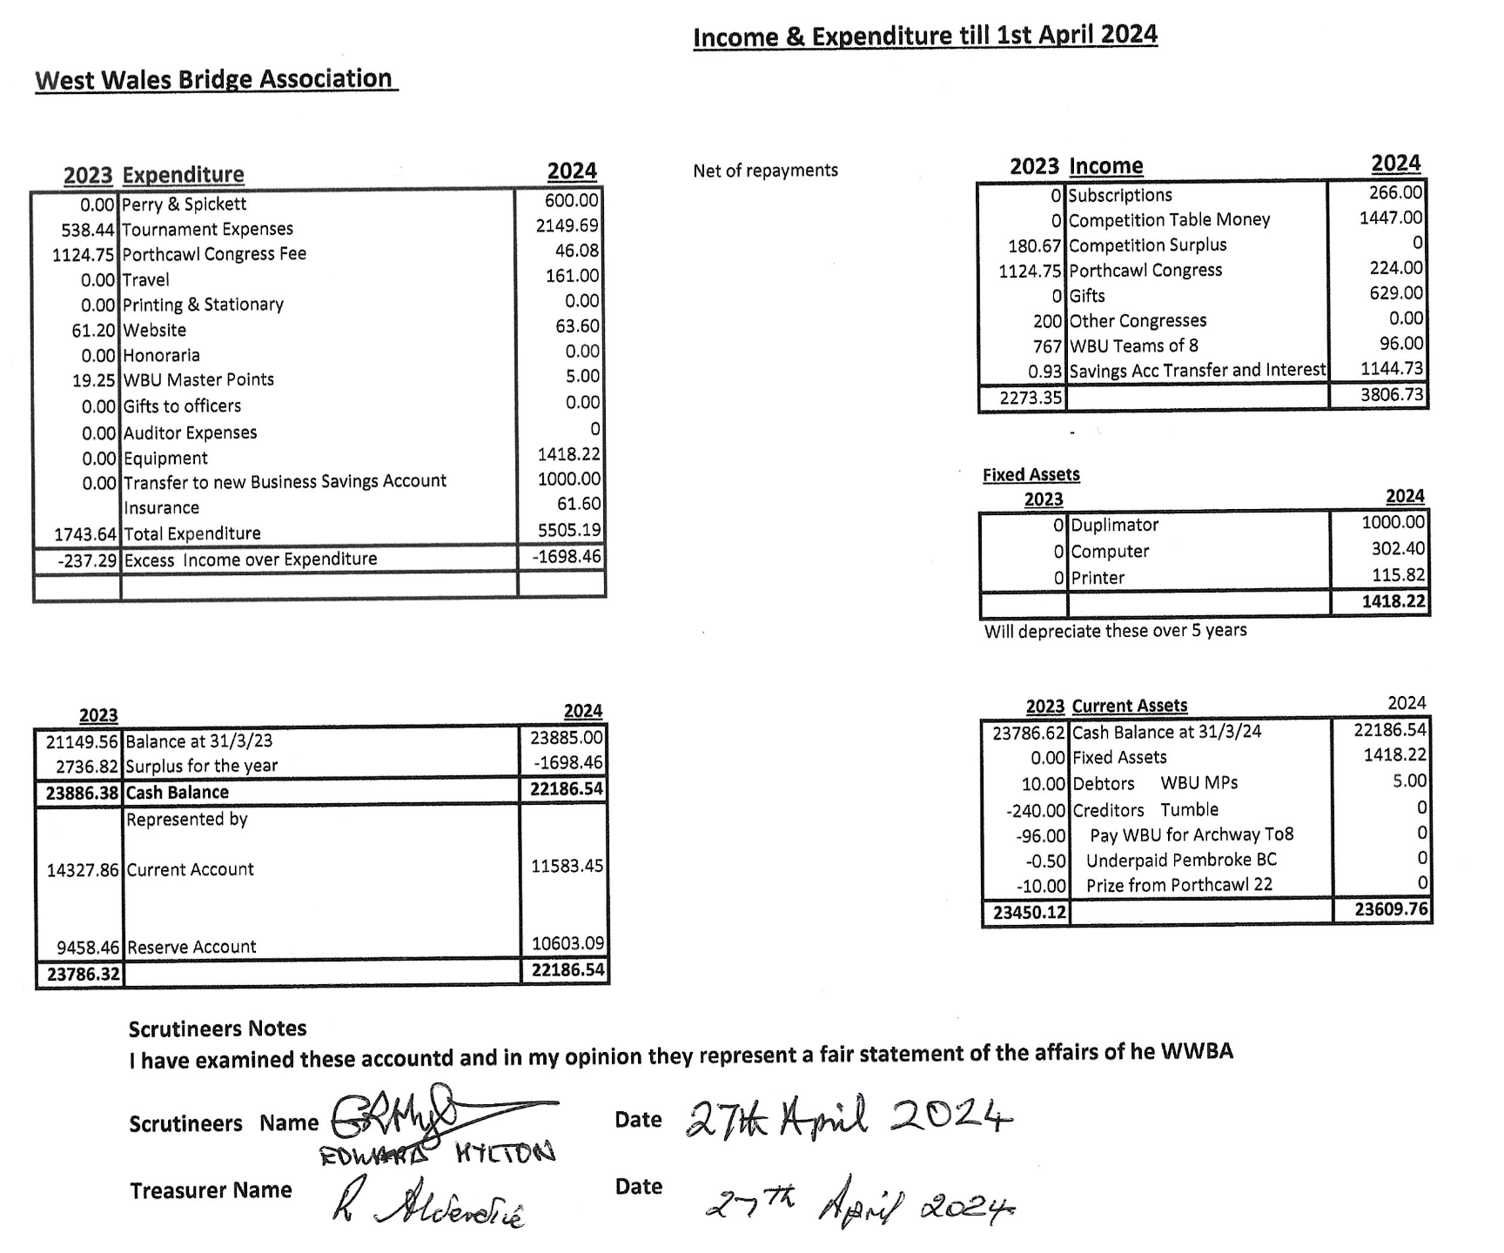

Appendix 2. Chairman’s report.

Chairman's Report for the WWBA AGM May 12th 2024

Can I start by thanking the officers on your behalf for their efforts over the year. Dave for running and directing events so well, Peter and Chris for their work and particularly Bob Alderdice . Bob resigned this role last year, again, but he is still here. He will not be continuing so it is vital that we find a replacement now, to keep control of the accounts and attend our occasional Zoom meetings.

Last year I highlighted the difficulties we faced and our priorities for the future, that has not changed but we have lost Porthcawl and Pembroke Club has disaffiliated from the WBU and so is lost to us also. We now have 7 affiliated clubs and 170 members. Only Swansea and Carmarthen offer Bridge in the evenings! So we have become an offering for the retired and economically inactive. That means our income is oly £340 this year, clearly not enough when we have events to organise (most at a loss) and, every 4 years, the Perry and Spicket to run at a cost of £1500+.

I believe we performed quite well last year, thanks to Dave, today and others events like today have been largely successful. But of course we are dealing with a new reality of online Bridge. I don't think we can ever compete with BBO, Real Bridge, StepBridge and I believe we must incorporate them into our offerings.

As you will know, there has been some recent criticism of the WBU, and I suppose that they have been too slow in adjusting to the new reality as their numbers have plummeted. Of course we are only here as part of the WBU, the Western Area of the WBU. I have attended the monthly Management Committee meetings and I can testify to the amount of work the Officers, volunteers, do. The WBU has many responsibilities including representing us on the UK, European and World stage. In 3 out of 4 years the WBU has to host a Home International event at a cost of a few thousand. International players were supported to some extent financially, but that has now stopped completely (except for Juniors). We do need a National Organisation, or perhaps we need to become an Area of the English Bridge Union. Whatever happens we will be part of the problem and the solution. I expect that at the Welsh AGM (online 2nd June, links and information on the WBU website) Andrea Knox will become President and will be setting new priorities rapidly. As a final point I can tell you that the EBU Membership fee is £34 and that the EBU has 20 full time employees. Can I encourage you to look at the WBU website, review the information and attend the AGM if you are able

Back to the West, we are hosting the Perry, Spickett and Presidents Cup events in Carmarthen on July 13/14. This will be at the Halliwell Centre. After that a huge commitment for us as the Porthcawl Congress returns and to the refurbished Seabank Hotel. Information and links are all on our website and can I encourage you to take part and to stay at the Seabank (which is priced very reasonably) for a great weekend in early November, either for the Green Pointed Events or the Holiday Bridge Events. Sarah Amos is directing both these, and thanks especially to Lee Collier who is helping to organise the Carmarthen and Porthcawl events.

Thank you for your support today, I look forward to seeing some of you at the Halliwell Centre in July and all of you at the Seabank in November

