In our last lesson we looked at agreeing with our partner that some two-level suit openings tell our partner that we have a weak, preemptive, hand with six cards in our opening suit.
Now we must agree how we bid to show strong hands.
We can choose from three variations on the Acol bidding system.

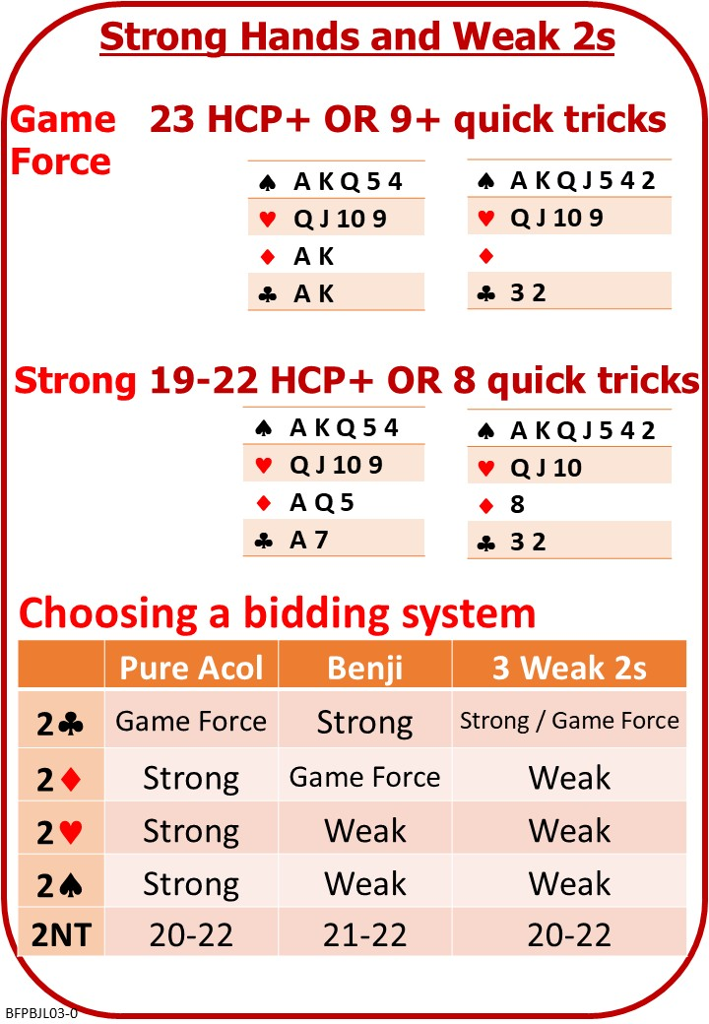

Please find attached:
BFP BJ L03 NOTES Strong Hands Playing Weak 2s

On No Fear Bridge:
This topic isn’t covered on No Fear Bridge.

Cardiff Bridge Tutors:
These kind people have put some free quizzes on the Internet that do cover it:
https://www.bridgequiz.co.uk/index.html

Scroll down to “Our Quizzes – Free” and try:

Benji
(I have made a donation on your behalf).

