In our lesson we looked at hands with few HCPs, but a suit with 6 cards. If the honour cards are in the suit, the suit should be capable of taking five or six tricks as a trump suit.
With such a low HCP count, we can assume the opponents have most of the power, and probably a game contract.
We open our suit at the two level.
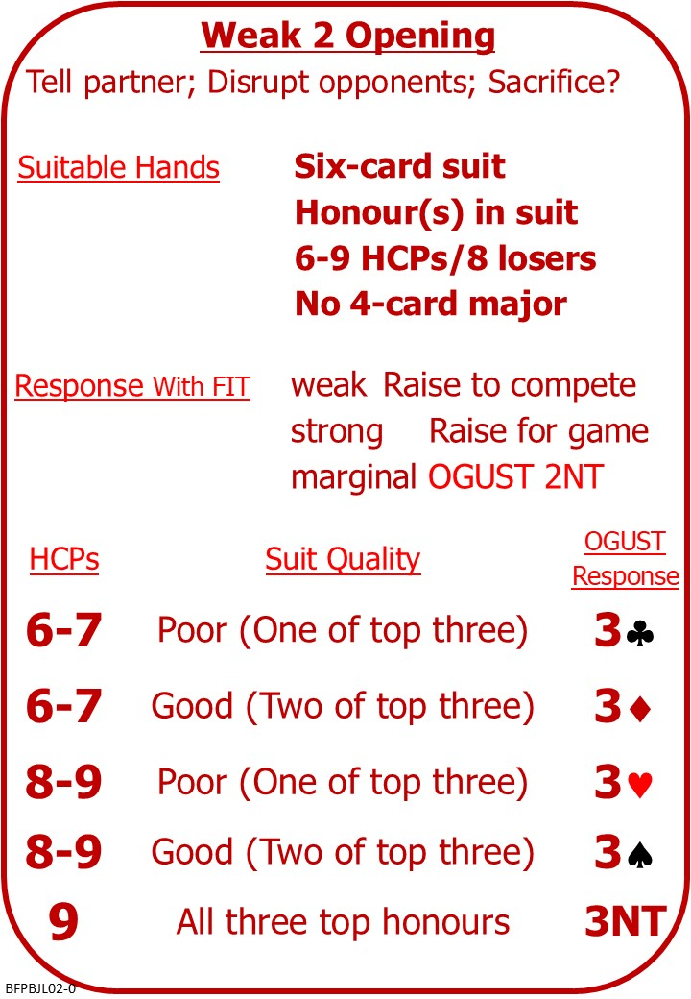

Please find attached:
BFP BJ L02 NOTES Opening Weak 2s

On No Fear Bridge:
Left Menu, “Topic Index”
“Bidding Topics Alphbetically”
“Weak Twos”
Instant Feedback Quizzes
Opening Weak 2 &
Responding to Weak 2
NOTE: No Fear Bridge doesn’t have the OGUST convention, but they do use 2NT replies to ask for more info, so the Responding to Weak 2 questions do reflect what we learned, BUT “Continuing the auction” might not.

