In our lesson we looked at hands with few HCPs, but a suit with at least 7 cards. If the honour cards are in the suit, the suit should be capable of taking five or six tricks as a trump suit.
With such a low HCP count, we can assume the opponents have most of the power, and probably a game contract.
We open, or overcall, our suit at the three level.
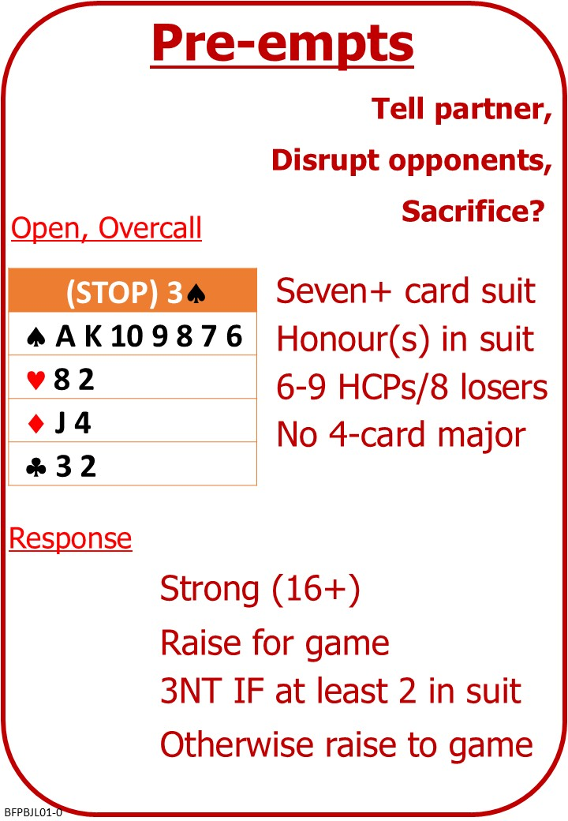
There’s a special case when we have all four honours in a seven-card minor.
An opening 3NT is often agreed to mean the “Gambling 3NT”. It tells partner that opener has a solid (A K Q J x x x) suit in either Clubs or Diamonds and therefore that partner can rely on you for seven tricks in that minor, but nothing else. This means nothing higher than a Queen in any of the other three suits.

Please find attached:
BFP BJ L01 NOTES Preempts
BFP BJ L01 NOTES Gambling 3NT

On No Fear Bridge:
Left Menu, “Topic Index”
“Bidding Topics Alphbetically”
“Preempts”
Instant Feeback Quizzes

A Lttle bit more On No Fear Bridge:
Left Menu, “Topic Index”
“Bidding Topics Alphbetically”
“Preempts More”
The Rule of 2,3, and 4
Instant Feeback Quizzes

