In our lesson we looked at responding to partners opening bid when opponents have overcalled.

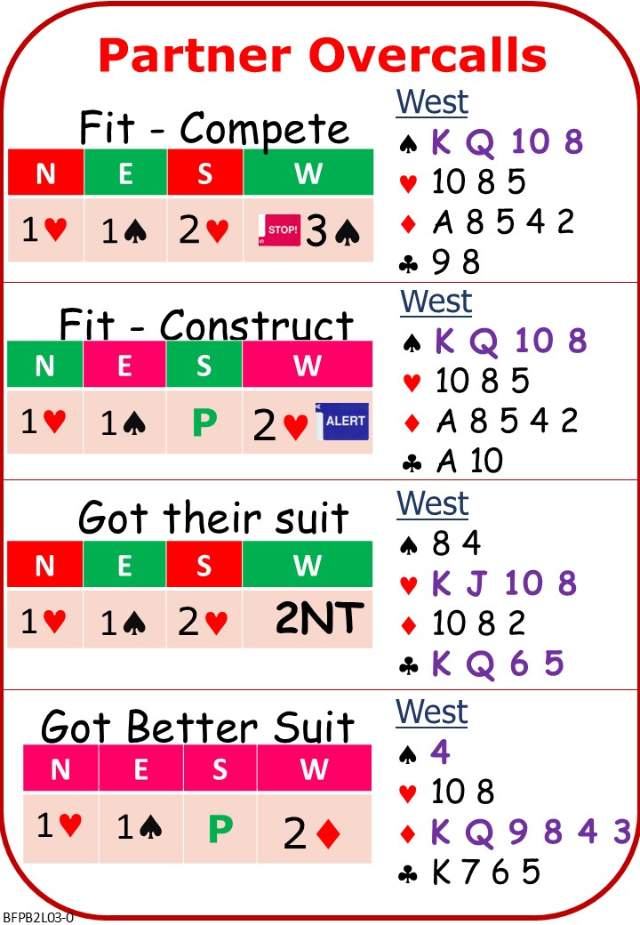

Please find attached:
BFP BC L03 NOTES BFP BC L03 NOTES Advancing Overcalls-UCB-Stretch Bids
On No Fear Bridge:
Left Column Menu: “Topic Index”
“Bidding Topics Alphabetically”
“Overcalls”
Play as many as you like

Next Lesson

