In our lesson we looked at responding to partners opening bid when opponents have overcalled.

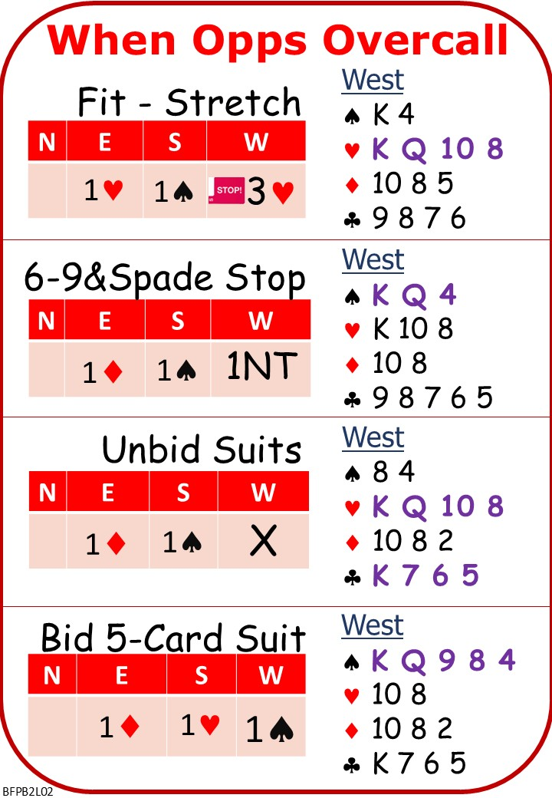

Please find attached:
BFP BC L02 NOTES When Opponents Overcall
On No Fear Bridge:
Left Column Menu: “Topic Index”
“Bidding Topics Alphabetically”
“Negative Doubles”
Play as many as you like

Next Lesson

