Last lesson we talked about using transfers when partner opens 1NT and we have enough high card points or a long suit for game.
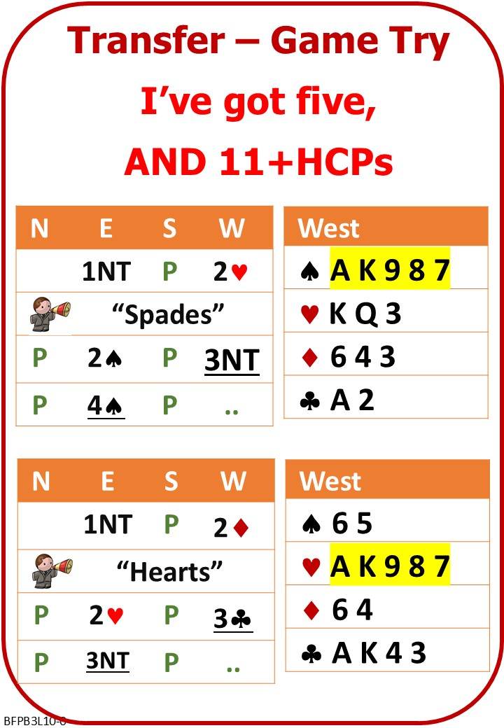

Attached Documents:
- L10 Transfers for Game Tries NOTES
- L10 Transfers for Game Tries QUIZ

No Fear Bridge
You might like to practice on No Fear Bridge
On the Home Page, From the horizontal menu across the top, select: Practice Hands and Quizzes
Then: "Bidding Practice"
- Level 2 – Improvers
  - Transfers

Invite to Next Lesson
If online send link/joining instructions
If face to face remind venue, day and start time.

