Last lesson we talked about bidding very strong unbalanced hands. These hands would have either 23+ HCPs OR they would have distributional strength, able to take at least 8 tricks in a particular trump contract.

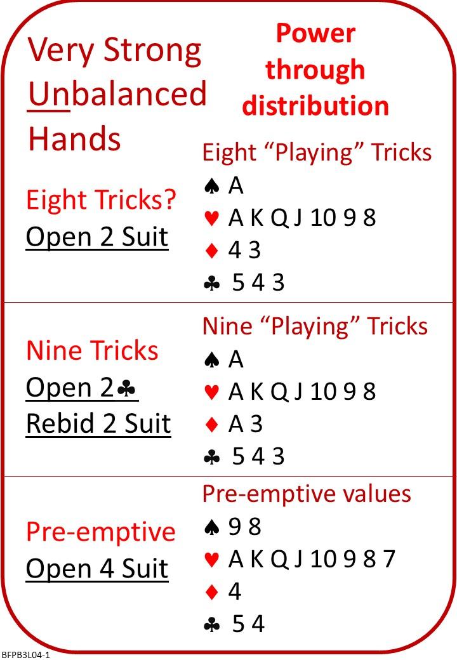
Attached Documents:
- BFP B3 L03 QUIZ ANSWERS Very Strong Balanced Hands
- BFP B3 L04 NOTES Very Strong Unbalanced Hands
- BFP B3 L04 COMMENTARY Very Strong Unbalanced Hands
- BFP B3 L04 QUIZ Very Strong Unbalanced Hands

No Fear Bridge
You might like to practice on No Fear Bridge. Because there’s such a wide variety of ways of bidding strong unbalanced hands, there’s a not a huge amount of directly relevant material, but it’s worth looking at:
- On the Home Page, From the horizontal menu across the top, select "Practice Hands and Quizzes" and then “Bidding Practice”
  - From the list, under Level 2 - Improvers
  - Two club opening (with 2D negative response)
AND/OR

- On the Home Page, From the horizontal menu across the top, "Practice Hands and Quizzes " and then “Millionaire Quiz"
  - From the list, under Level 3 - Intermediate
2C Bids. What do you know? Note, all sorts of 2C situations!
AND/OR
- On the Home Page, From the horizontal menu across the top, " Practice Hands and Quizzes " and then “Bidding Quizzes"
  - From the list, under Level 2 – Improvers:
  - Strong Twos (Note that NFB treats Strong 2 Opening’s as forcing for one round, with 0-7HCPs, bid 2NT)

Results (If you capture the play and load it to a web site)
We played some hands and recorded the results on a tablet at the table. These results were aggregated and loaded to our web site. If you click the link below, you will be directed to those results.
There's a wealth of information about how the final contracts and the results of the card play.

Invite to Next Lesson
If online send link/joining instructions
If face to face remind venue, day and start time.

