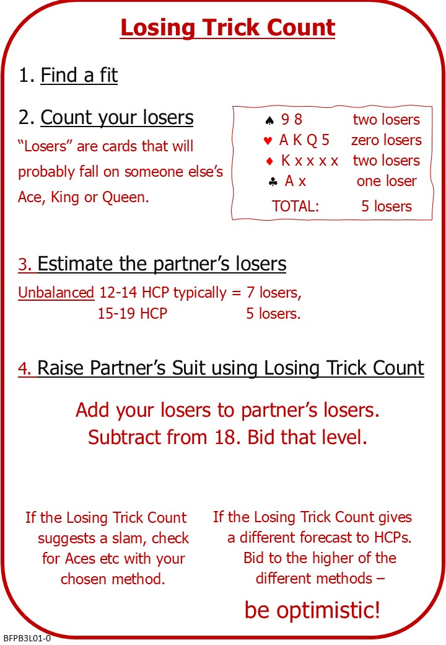

The Losing Trick Count is a method that helps work out how many tricks you and your partner can make with a given, agreed, fit in a trump suit.
It’s particularly good at finding “thin” game contracts that depend on distribution.
At other times the joint High Card Point count still works.

Attached Documents:
- B2 L10 Quiz with Answers
- B3 L01 NOTES
- B3 L01 QUIZ

No Fear Bridge
You might like to practice on No Fear Bridge
- On the Home Page, From the left-hand vertical menu, select "Topic Index”
  - Bidding Topics Alphabetically
    - Losing Trick Count
      - Try some hands
      - Read the Handout

Invite to Next Lesson
If online send link/joining instructions
If face to face remind venue, day and start time.

