Players defend 50% of the hands they play.
Defence card play is a challenging and subtle part of the game.
Work with your partner. Remember you are one of a team of two!
Here are some basic principles.
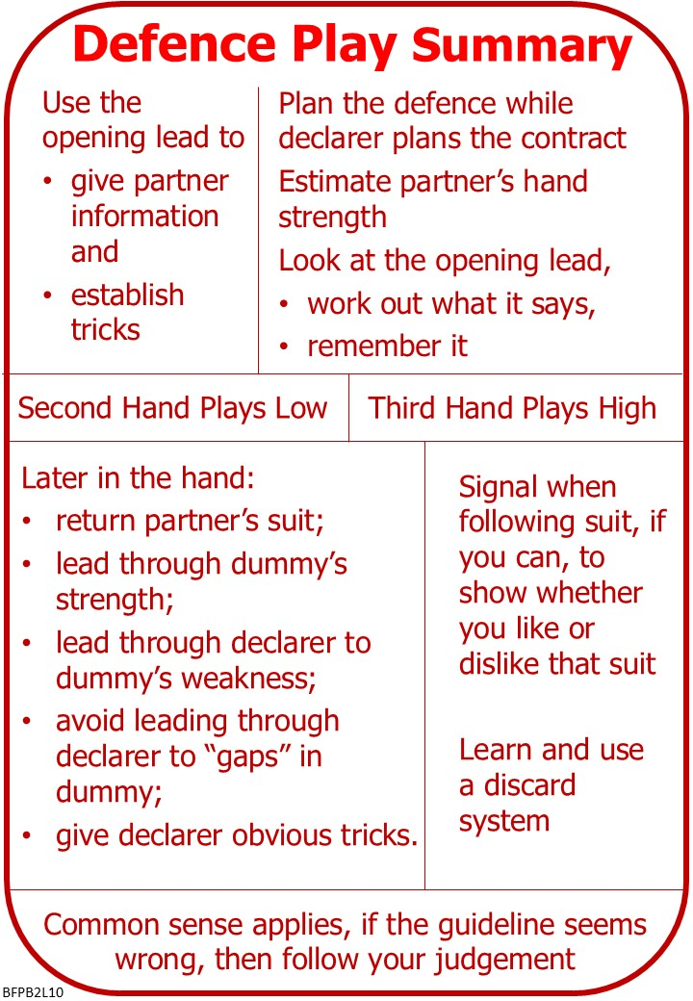
In the BFP Teaching Scheme second group of ten lessons (Bridge 2), this lesson is the tenth,
The topics are summarized in the Bridge 2 Summary.
This may be useful as an aide memoire.
It may also be useful if you get a chance to play with a more experienced player. They can see what you have learned, and what you haven’t!

Please find attached:
Lesson 9 Responders Rebid Quiz with Answers
Lesson 10 Defence Notes
Lesson 10 Defence Quiz
Bridge 2 Summary

On No Fear Bridge:
Menu across the top:
- “Video Courses”
- “Video Courses”
- “Defence”
- Any of these “courses”
And/or
- “Practice Hands and Quizzes”
- “Leads Practice”
- Level 1 – Beginners
- As many as you like, the more practice the better.

If No Fear Bridge is new to you, contact me to get an extended free trial on No Fear Bridge

Invite to Next Lesson
If online send link/joining instructions
If face to face remind venue, day and start time.

