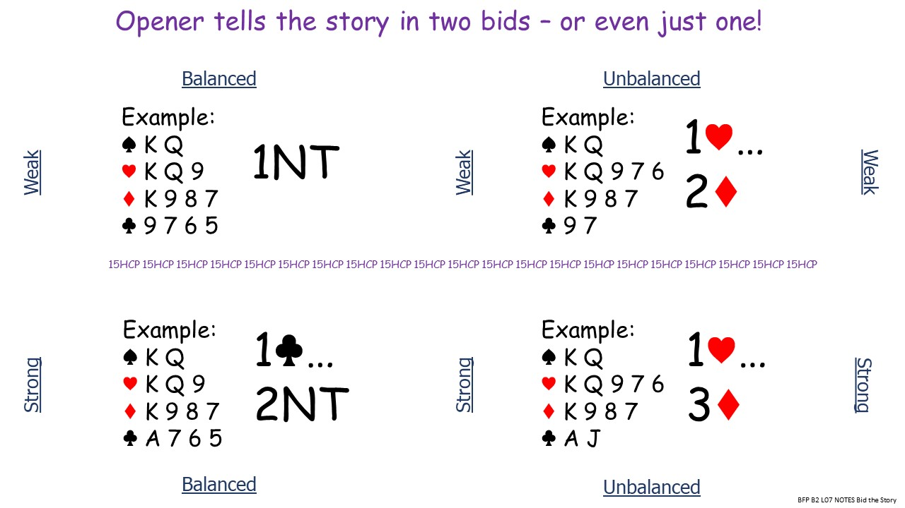
Many auctions consist of three or four bids.
- Typically, openers describe their hand in one bid, or more often two bids.

- Openers one of a suit is wide-ranging ~10-19 HCPs showing longest or equal longest suit.
- Responder’s wide-ranging change of suit reply requests a second bid describing the opening hand further.
- Openers rebid should tell the full story. The shape and HCP range of the hand.

Now it’s up to the responder to decide the best contract.
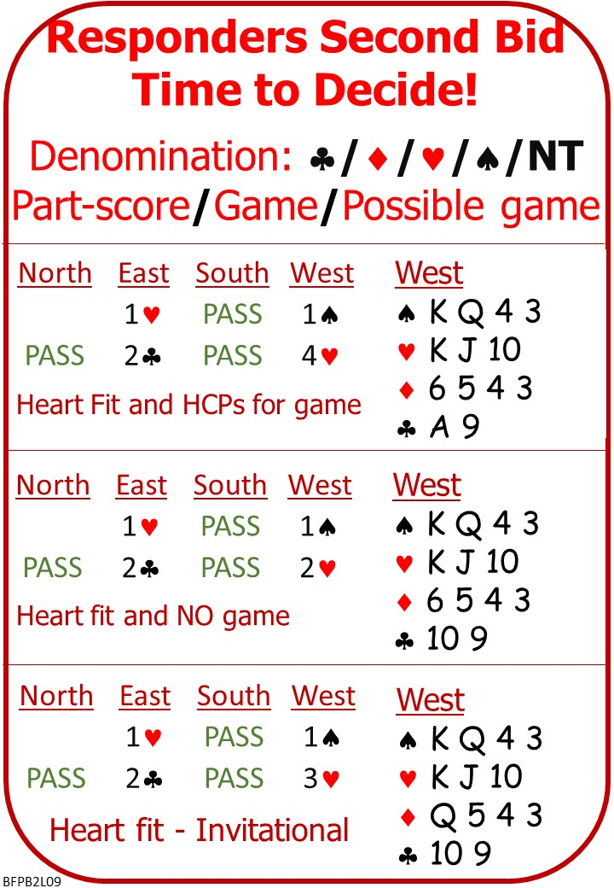

Please find attached:
BFP B2 L08 QUIZ ANSWERS Stayman
BFP B2 L09 NOTES Responders Rebid
BFP B2 L09 QUIZ Responders Rebid

No Fear Bridge

Homepage Top Centre: Practice Hands and Quizzes
Bidding Quizzes
Practice Level 2 - Improvers:
Responder’s 2nd Bid

AND/OR

Homepage Top Centre: Millionaire Quiz
Level 2 - Improvers:
Responder’s 2nd Bid

If No Fear Bridge is new to you, contact me to get an extended free trial on No Fear Bridge

Invite to Next Lesson
If online send link/joining instructions
If face to face remind venue, day and start time.

