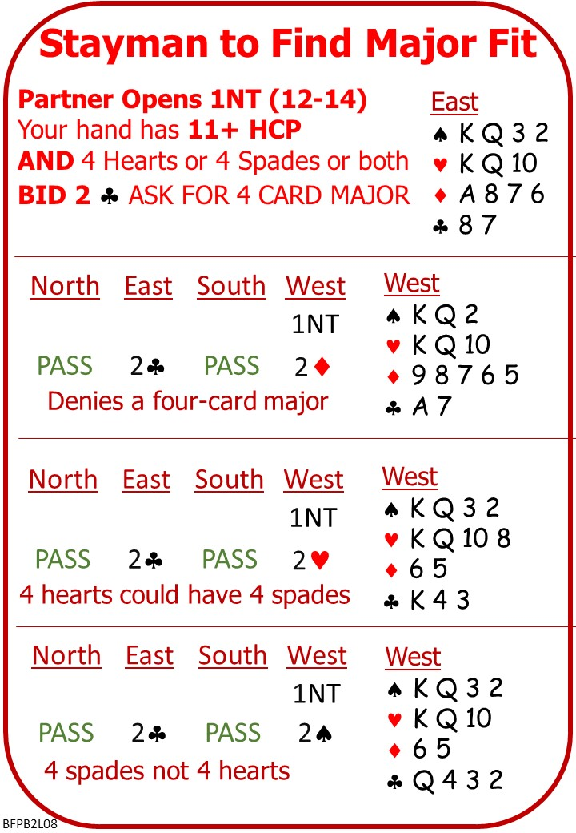
Sometimes one player opens 1NT and the Responder has 13+HCP and a balanced hand and the natural response is to raise to 3NT.

BUT an eight-card major fit may be missed.

Game in a major may be a better score AND there’s a risk of shortage in, perhaps doubleton opposite doubleton elsewhere.

Use Stayman to find an eight-card major fit between two balanced hands.

Please find attached:
- Lesson 7 Quiz with Answers
- Lesson 8 Notes
- Lesson 8 Quiz

On No Fear Bridge: Menu across the top:
Millionaire Level 2 Improvers: Stayman
Bidding Practice Level 1 Beginners: Responding to 1NT
INCLUDE STAYMAN

Invite to Next Lesson

