We looked at what to think about when you are making a plan as declarer in No Trumps.
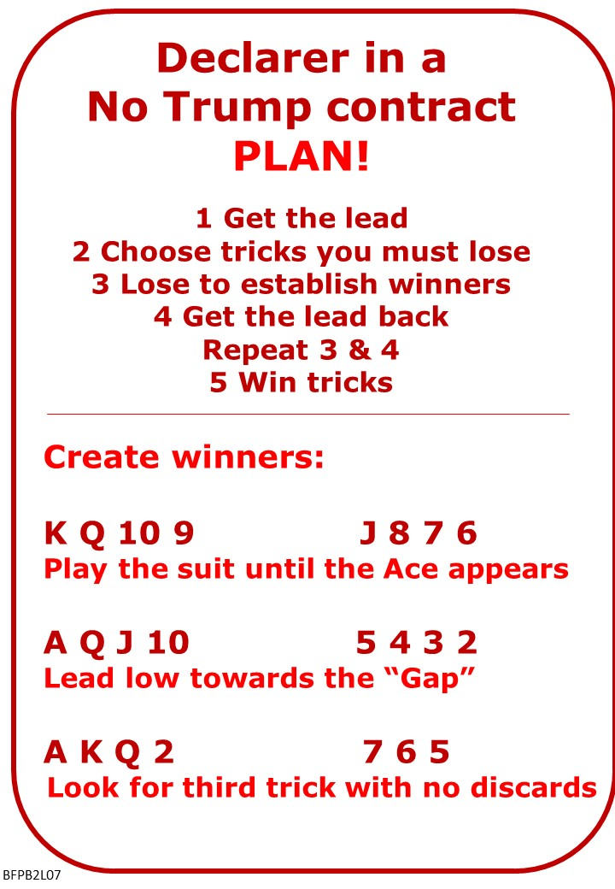
Please find attached:
- B2 Lesson 6 QUIZ ANSWERS Strong Unbalanced Hands
- B2 Lesson 7 NOTES Playing No Trumps
- B2 Lesson 7 QUIZ Playing No Trumps

No Fear Bridge:
Homepage Top Centre: Practice Hands and Quizzes
Declarer Hands
Level 1: Beginners
Setting Up a Long Suit in No Trumps

If No Fear Bridge is new to you, contact me to get an extended free trial on No Fear Bridge

Next Lesson
If online send link/joining instructions
If face to face remind venue, day and start time.

Bernard Magee
Bernard Magee has the largest bridge teaching and coaching website. Most of it is restricted to members paying a subscription.
https://bernardmageebridge.com/

BUT there is a free novice seminar every Monday morning and they are all available for free afterwards.
Here's link to one on YouTube, there's a bit of advertising first, but keep going...
https://www.youtube.com/watch?v=05wmr2cVXNE

