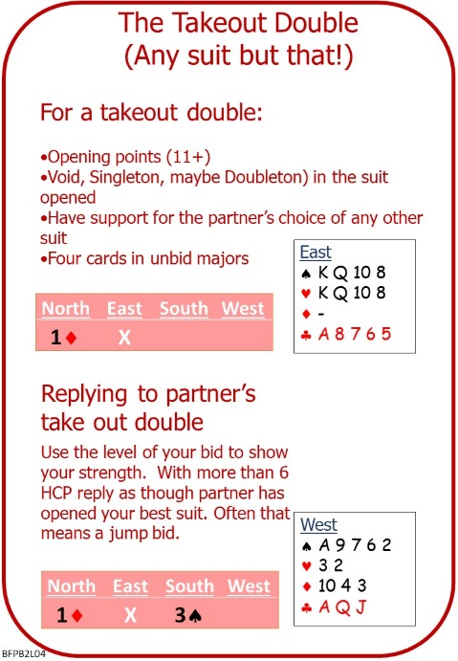
The double call raises the stakes in an auction.
Declarer will get extra scoring points if the doubled contract is made.
The Defence will get extra scoring points if a doubled contract is defeated.
During the auction it’s almost impossible to be sure that a low-level suit contract can be defeated. So, the double is used as an artificial call, to convey a message to partner.

Attached Documents:
- L03 Vulnerability – Doubling - Scoring QUIZ with ANSWERS
- L04 NOTES Take Out Doubles
- L04 HOMEWORK Take Out Doubles

No Fear Bridge:
Homepage Top Centre:
Practice Hands and Quizzes
Bidding Quizzes
Level 3 Intermediate
Take Out Doubles

If No Fear Bridge is new to you, contact me to get an extended free trial on No Fear Bridge

Invite to Next Lesson
If online send link/joining instructions
If face to face remind venue, day and start time.

